**Qube Renderfarm Guide: Houdini (HBatch)**

**Scene setup**

***note: versions of Houdini in the screenshots shown here will be different to the ones in current system because of continuous houdini updates,however it shouldn't affect the overall setup process***

In order to prepare your scene for submission to the renderfarm, the following steps are suggested:

• Place scene file, and associated scene assets (eg. Textures, Sims etc.) in folders, within a single directory

• Make use of relative file paths using the $HIP or $JOB variables when assigning all scene assets

• (If $JOB is being used it can be set in the textport i.e.

set -g JOB = /render/i1234567/*myHoudiniSceneDir*)

• Copy the entire scene folder to your directory within /render on the

tete server.

◦ This can be done using the Connect to Server... option which can

be found in the Places main linux menu, all the way down

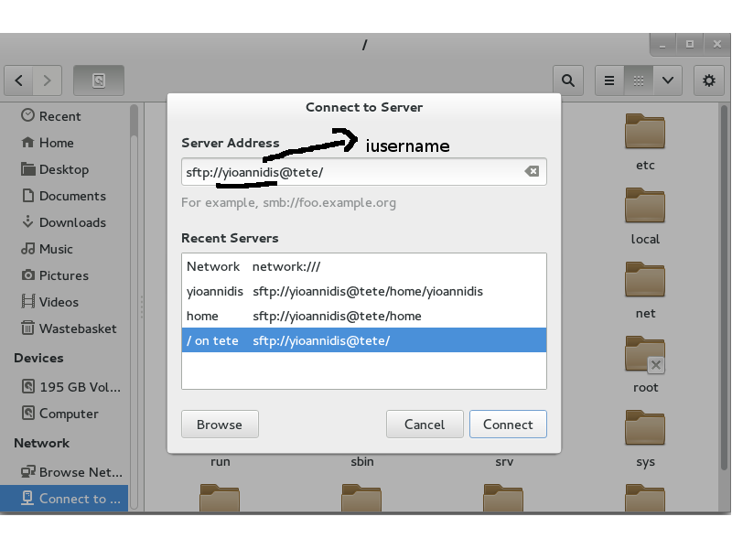

server address: **sftp://iusername@tete/**

◦ It is sensible to add a bookmark to this location, so it can be

easily accessed when setting up and accessing future renders.

◦ Copy and Paste can be used to copy your scene directory into this

directory ready for use on the render farm.

◦ Alternatively files can be copied using the sftp command line tool.

• Start Qube:

• Submit a Houdini job by clicking on: **Submit–CmdRange Job**...

**Suggested Qube Settings**

The following defaults are a good starting point for starting a

Houdini job on the renderfarm.

**-Instances**: Set number of frames to render in parallel **(not more than 40)**

-Frame Range

the following is specified as part of the **Cmd Template** Command

**-Render Output Node**: ex. mantra1

**Cmd Template**: Render command to be executed. This needs to include commands to initialize the HoudiniEnvironment. We recommend starting with the entire template shown here:

*cd /opt/software/sidefx/hfs17.0.416; source houdini_setup_bash;*

*hbatch -R -c "render -V -f QB_FRAME_START QB_FRAME_END mantra1***" /render/username***/folder***/scene***.hipnc*

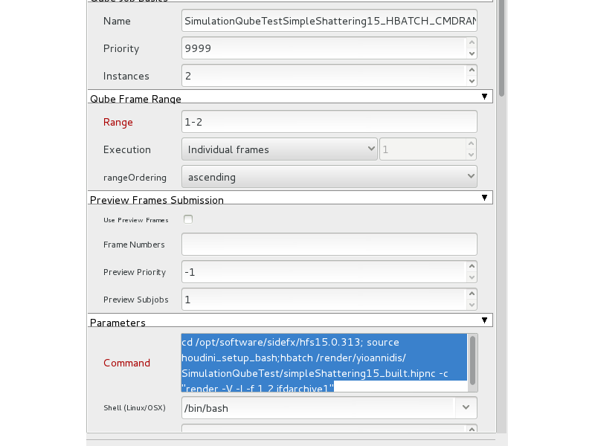

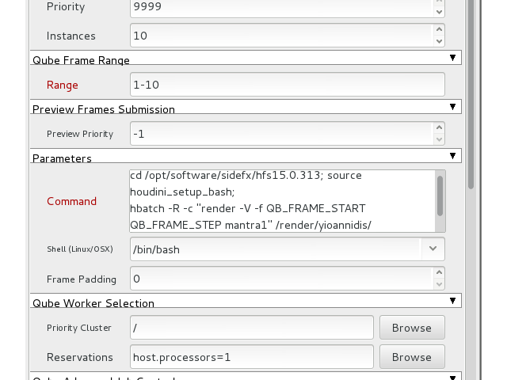

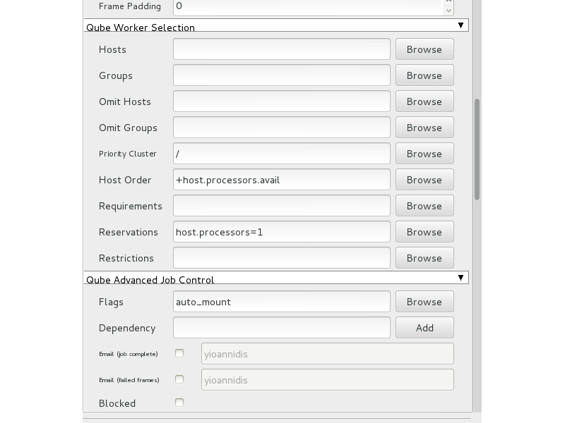

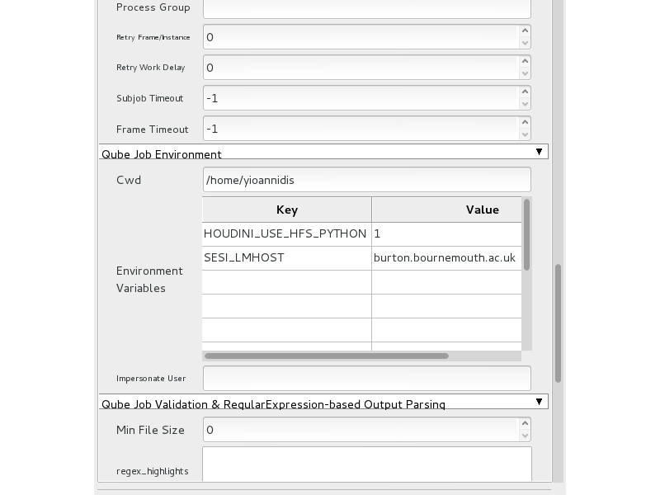

**Environment Variables**: Used to add environment variables.

Must have variable for license server set here