**Qube Renderfarm Guide: Houdini**

**Scene setup**

***note: versions of Houdini in the screenshots shown here will be different to the ones in current system because of continuous houdini updates,however it shouldn't affect the overall setup process***

In order to prepare your scene for submission to the renderfarm, the following steps are suggested:

• Place scene file, and associated scene assets (eg. Textures, Sims etc.) in folders, within a single directory

• Make use of relative file paths using the $HIP or $JOB variables when assigning all scene assets

• (If $JOB is being used it can be set in the textport i.e.

set -g JOB = /render/i1234567/*myHoudiniSceneDir*)

• Copy the entire scene folder to your directory within /render on the

tete server.

◦ This can be done using the Connect to Server... option which can

be found in the Places main linux menu, all the way down

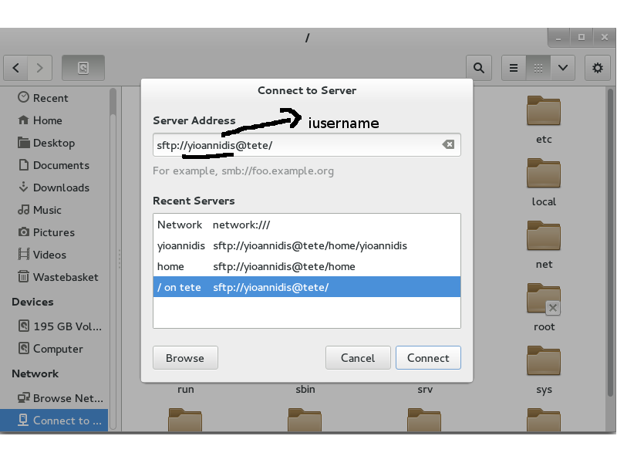

server address: **sftp://iusername@tete/**

◦ It is sensible to add a bookmark to this location, so it can be

easily accessed when setting up and accessing future renders.

◦ Copy and Paste can be used to copy your scene directory into this

directory ready for use on the render farm.

◦ Alternatively files can be copied using the sftp command line tool.

• Start Qube:

• Submit a Houdini job by clicking on: **Submit–Houdini SimpleCmd–Houdini (hrender) Job**...

**Suggested Qube Settings**

The following defaults are a good starting point for starting a

Houdini job on the renderfarm.

**Instances**: Set number of frames to render in parallel (not more than 40)

**Range**: Specify frame range in the format start-end.

**scenefile**: Enter path to scene file to render i.e.

***/render/iusername/******myHoudiniSceneDir/simpleShattering.hipnc***

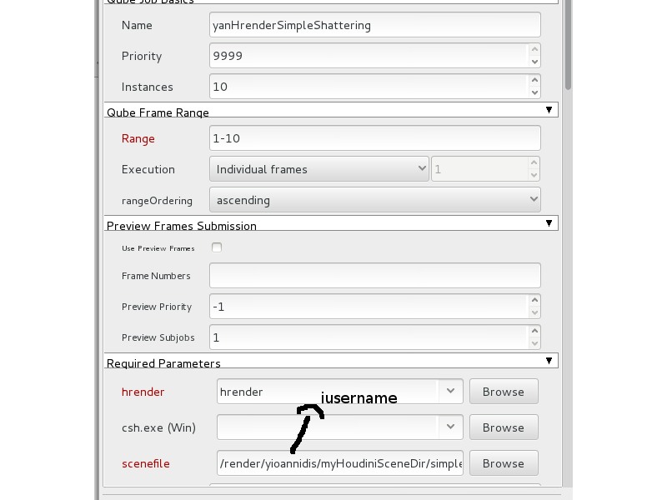

**Driver/Cop**: Select -d for rendering and -c compositing network output

**Driver/Cop Valu**e: Pick your output driver. I.e. /out/mantra1

**R**: Make sure this setting is enabled in order to make sure that a non-graphics render license is used rather than a full Houdini license

**Cmd Template**: Render command to be executed. This needs to include commands to initialize the HoudiniEnvironment. We recommend starting with the entire template shown here:

cd /opt/software/sidefx/*17.0.416*; source houdini_setup_bash;%(csh)s "%(hrender)s" -e -f QB_FRAME_START QB_FRAME_END -i QB_FRAME_STEP %(driver_cop_arg)s %(driver_cop_value)s %(argv)s "%(scenefile)s"

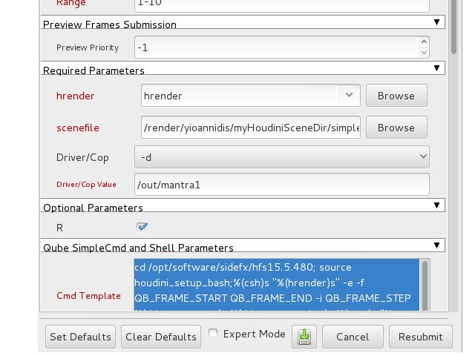

You can use the above command to either render your live scene directly or even generate **ifd** files

for later use

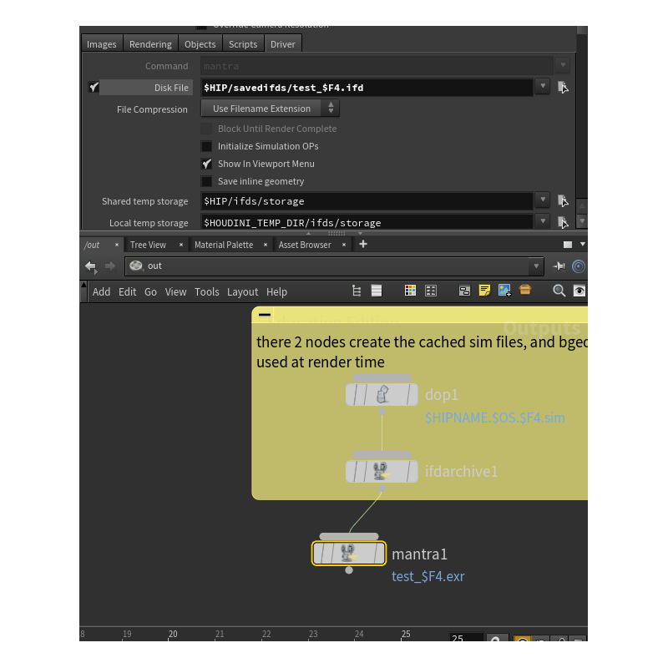

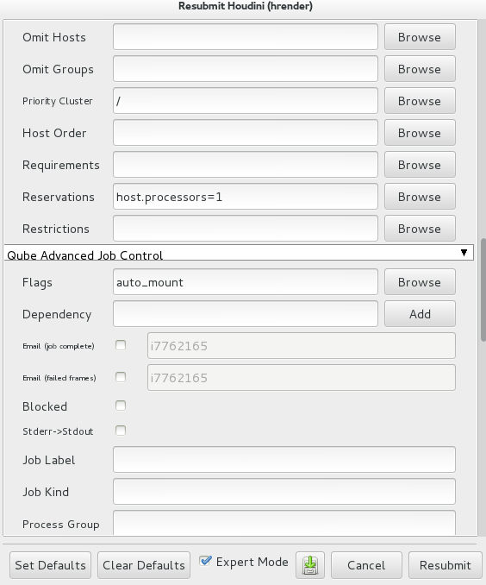

**Environment Variables**: Used to add environment variables.

Must have variable for the license server set here

