**Qube Renderfarm Guide: Houdini Mantra IFD file rendering**

**Scene setup**

***note: versions of Houdini in the screenshots shown here will be different to the ones in current system because of continuous houdini updates,however it shouldn't affect the overall setup process***

In order to prepare your scene for submission to the renderfarm, the following steps are suggested:

• Place scene file, and associated scene assets (eg. Textures, Sims etc.) in folders, within a single directory

• Make use of relative file paths using the $HIP or $JOB variables when assigning all scene assets

• (If $JOB is being used it can be set in the textport i.e.

set -g JOB = /render/**isuername**/**SimulationQubeTest**)

• Copy the entire scene folder to your directory within /render on the

tete server.

◦ This can be done using the Connect to Server... option which can

be found in the Places main linux menu, all the way down

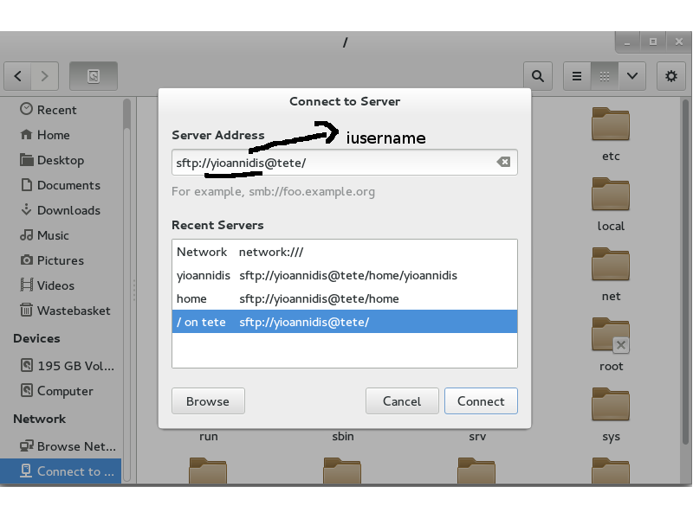

server address: **sftp://iusername@tete/**

◦ It is sensible to add a bookmark to this location, so it can be

easily accessed when setting up and accessing future renders.

◦ Copy and Paste can be used to copy your scene directory into this

directory ready for use on the render farm.

◦ Alternatively files can be copied using the sftp command line tool.

• Start Qube:

• Submit a Houdini job by clicking on: **Submit–Cmdrange Job...**

**Suggested Qube Settings**

The following defaults are a good starting point for starting a

Houdini job on the renderfarm.

Make sure the there is a directory with all the ifd files needed for mantra to read.

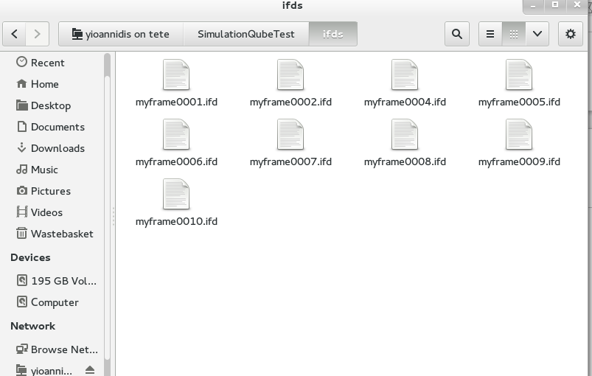

The same applies if you are want to render a Simulation on the farm:

Make sure the there is a directory with all the sim files needed, as well as a similar setup inside the

AutoDopNetwork to export the sim files to it.

Additionally, a Dynamics dop in the Output network needs to be added to render out the sim files from the AutoDopNetwork.

(see scene setup bellow):

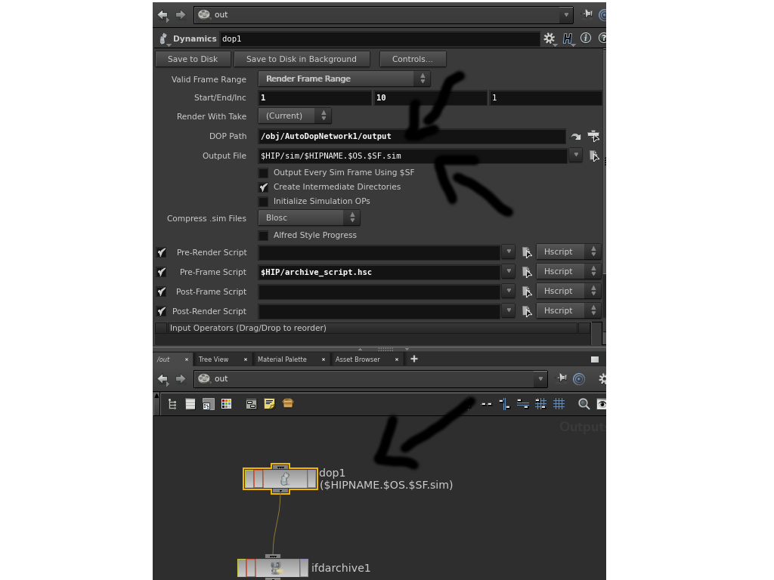

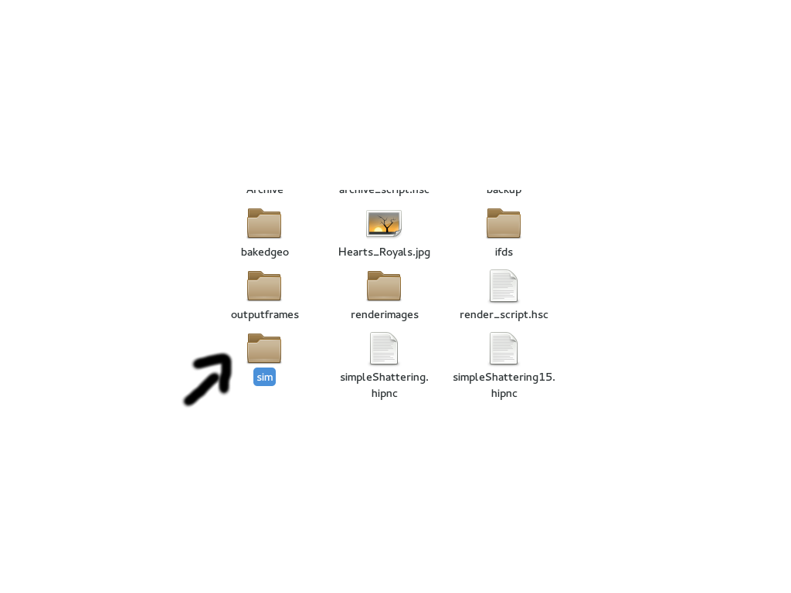

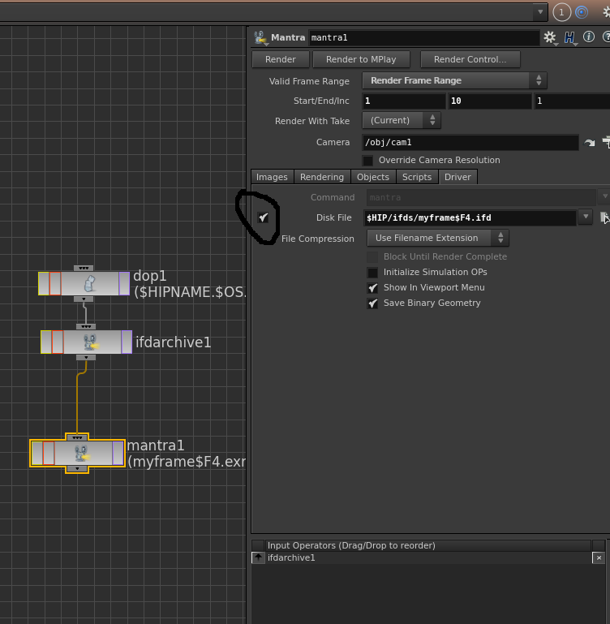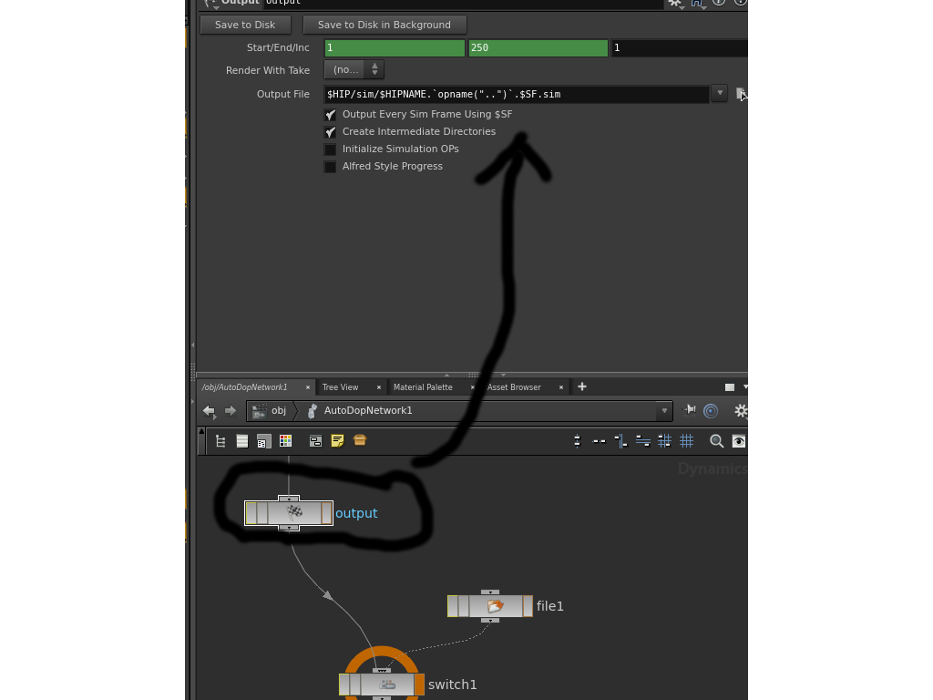

(To generate the ifds refer to the **Qube_Renderfarm_Guide_Houdini_Hrender.docx** guide)

(basically resubmit a HRender job on Qube and remember that the .hipnc scene file you are trying to render needs to have the “Save IFD files to disk” checkbox of your mantra out driver ticked)

**Instances**: Set number of frames to render in parallel (not more than 40)

**Range**: Specify frame range in the format start-end.

**IFD file**: Enter path to the ifd file to render i.e.

***/render/iusername/SimulationQubeTest/ifds/myframe.ifd***

**Command**: Render command to be executed. This needs to include commands to initialize the HoudiniEnvironment. We recommend starting with the entire template shown here:

**cd /opt/hfs*17.0.416*.;source ./houdini_setup_bash;**

**mantra -f /render/iusername/SimulationQubeTest/ifds/myframeQB_FRAME_NUMBER.ifd;**

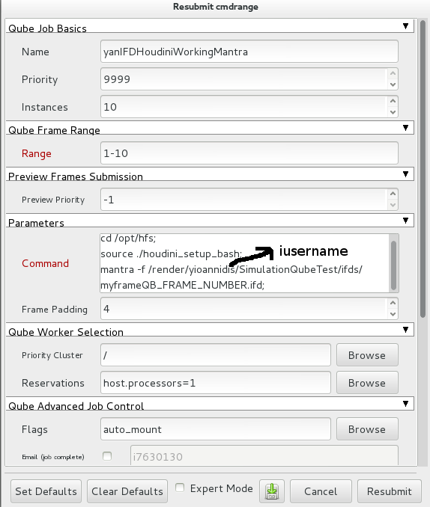

Be careful and use the same frame padding as the one in the scene you generated the ifds from

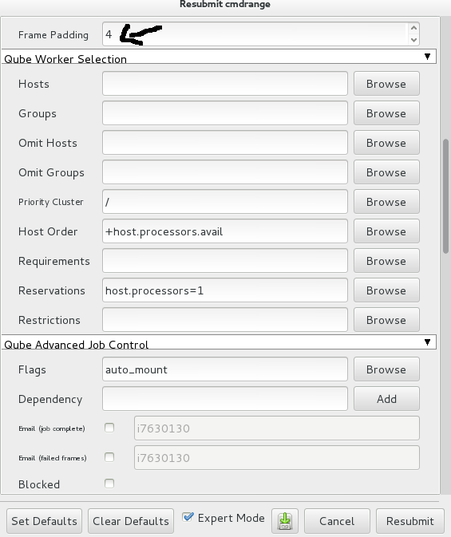

**Environment Variables**: Used to add environment variables.

Must have variable for license server set here

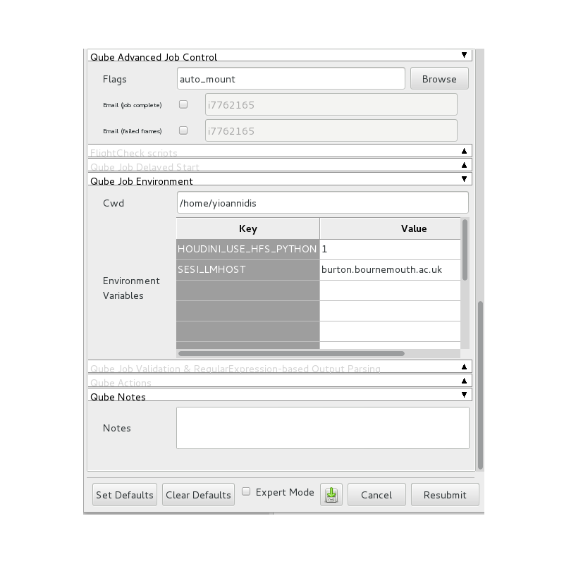

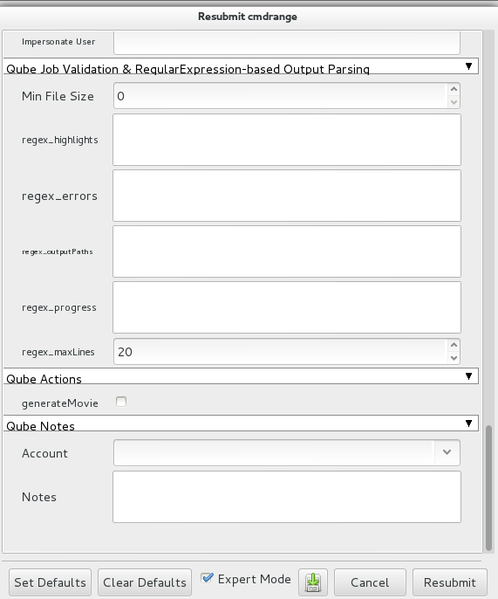

Tips if you find you get dropped frames:

If you see that some of your ifd frame files are dropped for no apparent reason, you can **re-render** and **try to re-generate the IFD files**, which shouldn't take long usually cause they are much faster to generate rather than rendering from the live Houdini scene network.

**OR**

Instead of using a chain in the outputs level in Houdini, just disconnect and render separately each one of them

