Rendering Locally from the Command Line

- Make sure you have sourced the secondary Houdini applications by having the following line in your ~/.bashrc file:

cd /opt/hfs16.0.705/; source houdini_setup_bash > /dev/null; cd;

- open terminal and type:
cd
cp -r /public/mapublic/IoannisIoannidis/WOBBLY_SPHERE ~/
cd ~/ WOBBLY_SPHERE
goHoudini H16_wobbly_sphere_begin.hipnc &

Render The Live Network (heavy)

1) HRENDER (simple & easy script to use):

i) render 1 frame:
- open terminal

to make sure we delete any previously exported sequence of frames under ./render folder:
- type ./clearFrames.sh

- type the following command --> hrender -F 1 -d mantra1 testSim.hipnc

ii) render a sequence with extra options:
- open terminal
- type the command --> hrender -e -f 1 10 -w 640 -h 480 -R -v -d mantra1 testSim.hipnc

2) HBATCH (To open the scene in Hscript mode)

-R option will force a render licence to be used instead of a Houdini licence

i) render a sequence:
- open terminal

- type the following command --> hbatch testSim.hipnc
- type the following test Hscript commands :
echo $HIPNAME
echo $OS
echo $RFSTART
echo $RFEND

- type the following render Hscript command:--> render -V -I -f 1 2 mantra1
- (Press: Control-C to exit the hbatch session when finished rendering)

useful links:

  - https://www.sidefx.com/docs/houdini14.0/commands/render
  - file:///home/yioannidis/Downloads/documentation.pdf

Generate & Render IFD files (light) locally

1)
  - File .. Open .. testSim_IFD_GENERATION.hipnc

- open terminal

- type the command-->hrender -e -f 1 25 -R -v -d mantra1 testSim_IFD_GENERATION.hipnc

open terminal and render 1 frame based on the ifd files generated previously
- type the command-->mantra -f savedifds/test_0001.ifd
OR type ./localMantra.sh

Rendering Remotely on the Renderfarm

- Open a terminal and type : goQube &
- Go to: Places .. Browse Network .. Connect To Server and type :
sftp://YOURUSERNAME@tete
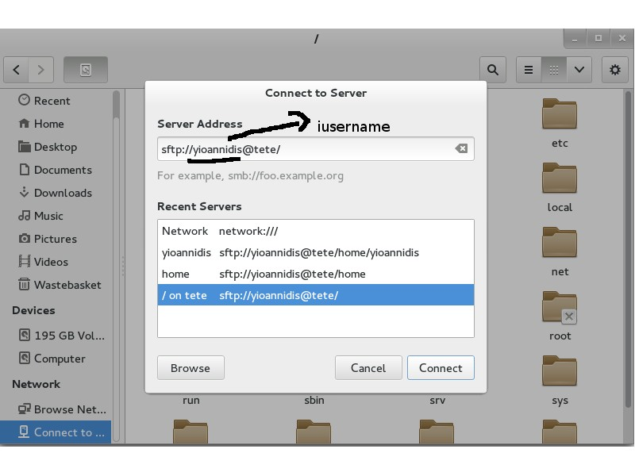

- copy the testSim folder manually across to the server

open terminal and type: goQube &

The RenderFarm itself has:
- 16 Nodes/Workers
- Each of these nodes has 20 cores/threads/slots simultaneously

- So, the farm has in a total in parallel capacity of: 16*20=320 slots/frames

Never, specify more than 40 Instances!

1)Using HRENDER (simple & easy script to use): remotely

ID:21076 Hrender-WOBBLY_SPHERE_v16.0.705

Resubmit this Job:
- filter ID- 21076
- Right Click on the Job
- Left Click Resubmit

Change the following fields on the Resubmit Dialog:
- NAME:YOURUSERNAME_Hrender
- CWD: /home/YOURUSERNAME
- Click Resubmit button

actual command on the resubmit dialog:

cd /opt/software/hfs16.0.705; source houdini_setup_bash;%(csh)s "%(hrender)s" -e -f
QB_FRAME_START QB_FRAME_END -i QB_FRAME_STEP %(driver_cop_arg)s %(driver_cop_value)s %(argv)s "%(scenefile)s"

2)Using HBATCH remotely

ID:21078 HBATCH_CMDRANGE_WOBBLY_SPHERE_16_0_705

Resubmit this Job:
- filter ID- 21078
- Right Click on the Job
- Left Click Resubmit

Change the following fields on the Resubmit Dialog:
- NAME:YOURUSERNAME_Hbatch,
- SCENEFILE: /render/YOURUSERNAME/testSim/testSim.hipnc
- CWD: /home/YOURUSERNAME
- Click Resubmit button

actual command on the resubmit dialog:

cd /opt/software/hfs16.0.705; source houdini_setup_bash;
hbatch -R -c "render -V -f QB_FRAME_START QB_FRAME_END mantra1" /render/YOURUSERNAME/testSim/testSim.hipnc

3)Generate & Render IFD files (light) remotely

ID:21080 HRENDER_GenerateIFDs16GenerateIFDs16_0_705

Resubmit this Job:
- filter ID- 21080
- Right Click on the Job
- Left Click Resubmit

Change the following fields on the Resubmit Dialog:
- NAME:YOURUSERNAME__Hrender_Generated_IFDs
- SCENFILE: /render/yioannidis/testSim/testSim_IFD_GENERATION.hipnc
- CWD: /home/YOURUSERNAME
- Click Resubmit button
actual command on the resubmit dialog:
cd /opt/software/hfs16.0.705; source houdini_setup_bash;%(csh)s "%(hrender)s" -e -f QB_FRAME_START QB_FRAME_END -i QB_FRAME_STEP %(driver_cop_arg)s %(driver_cop_value)s %(argv)s "%(scenefile)s"

4)use mantra to render the ifds

ID:21092 MantraCMDRange16_0_705

Resubmit this Job:
- filter ID- 21092
- Right Click on the Job
- Left Click Resubmit

Change the following fields on the Resubmit Dialog:
- NAME: YOURUSERNAME_CMDRange15
- CWD: /home/YOURUSERNAME
- Click Resubmit button

actual command on the resubmit dialog:
cd /opt/software/hfs16.0.705;source ./houdini_setup_bash;
mantra -f /render/YOURUSERNAME/testSim/savedifds/test_QB_FRAME_NUMBER.ifd;

