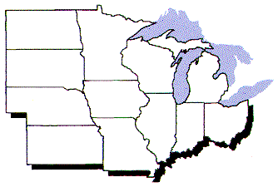
North Central Regional Association
Of Agricultural Experiment Station Directors

Office of the Executive Director
Dr. Arlen Leholm
1450 Linden Drive Room 212D
University of Wisconsin - Madison
Madison, WI 53706-1562

leholm@cals.wisc.edu
Phone (608) 262-2349 · fax (608) 265-6434

To: NCCC170 Members:

Title: Research Advances in Agricultural Statistics

The North Central Regional Association carries out a peer review process on all of its projects. The review process includes penultimate review by the NCRA Multistate Research committee which makes a recommendation on action to the NCRA. The MRC receives input from the Administrative Advisor (AA), the appropriate North Central Administrative Committee(s) (NCACs), and the material prepared by the committee. The following is provided to communicate the rationale for the action by the NCRA at its recent meeting:

This is an excellent committee that provides a platform for experiment station statisticians to exchange information on new statistical procedures that ultimately enhance their ability to support agricultural research. The committee has active participation with representation from several states. The CC format meets the needs of this group very well. Approve project continuation.

Best regards,

Chris Hamilton

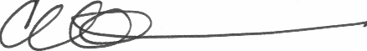

cc: J. Boyer, Administrative Advisor

