|  |  |  |  |
| --- | --- | --- | --- |
| **Version** | **Primary Author(s)** | **Description of Version** | **Date Completed** |
| 1.0 | Chang Hoe Hin | Show questionnaire result and conclude. | 13/5/2025 |

***This document will show the execution of requirements elicitation for the Campus Accessibility Navigation System with Facilities and Event Integration using Questionnaire and Prototype techniques.***

# Table Of Content

Table Of Content 1

Questionnaire 1

Questionnaire (Proof of Execution) 3

What is your role at the university? 3

How important is integration with university events/facilities (e.g: closures due to events, facility used due to event)? 4

How important is it for you to have an up-to-date and accurate campus map in the app? 5

Would missing maintenance updates (e.g: blocked paths, elevator outages) affect your campus navigation? 7

Should administrators validate accessibility info reported by users before it's displayed? 8

How essential is route planning across campus for your daily navigation? 8

Would you use multiple interfaces or modes (e.g: fastest route, event-free route)? 10

How valuable are user surveys and feedback features for you to report navigation issues? 11

How important is integration with university events/facilities (e.g: closures due to events, facility used due to event)? 12

Would you find an event list view useful to plan your routes better? 12

Would you appreciate a feature that suggests accessible routes for users with disabilities? 13

How useful would it be if you could customize your privacy or access settings in the app? 14

Would you be excited about real-time event alerts that let you avoid crowds or disruptions? 16

Are there any other features you'd like to see in the navigation system? 17

What’s your biggest frustration when navigating campus? 18

# Questionnaire

The questionnaire was designed to gather targeted feedback, ensuring a clear understanding of user needs and expectations. Responses were collected from 15 participants using online forms through various end users (Student,Staff,Faculty,Visitor), allowing analysis of user priorities. There’s 14 questions and 2 open ended questions.

|  |  |  |
| --- | --- | --- |
| Question | Kano Category | Justification |
| What is your role at the university? | None | Over 70% of respondents identified as Faculty and Student. Which may introduce bias toward the needs of these groups. |
| Do you have any accessibility needs (e.g: wheelchair access)? | Delighters | Only 36% reported accessibility needs, but this requirement is *critical.* |
| *How important is an up-to-date campus map?* | Dissatisfiers | 80% combined Very/Somewhat important signals up-to-date campus map is a must for end users. |
| *Would missing maintenance updates affect your navigation?* | Dissatisfiers | 87% chose Significantly/Slightly, indicating maintenance updates are very much needed. |
| *Should administrators validate accessibility info?* | Dissatisfiers | 67% demand it for trust, therefore there’s a need for admin to validate *accessibility info.* |
| How essential is route planning across campus for your daily navigation? | Dissatisfiers | 73% say it’s useful but not critical. So, it’s helpful but not essential. |
| Would you use multiple interfaces or modes (e.g: fastest route, event-free route)? | Satisfiers | 7 says definitely and 7 says maybe. Therefore, it’s a bonus feature to have. |
| How valuable are user surveys and feedback features for you to report navigation issues? | Satisfiers | 8 says useful and 6 says very valuable. Therefore, it should be included but it won’t be that impressive to have this feature. |
| How important is integration with university events/facilities (e.g: closures due to events, facility used due to event)? | Satisfiers | Only 13% say it’s not important, so this feature is important for most people. |
| Would you find an event list view useful to plan your routes better? | Satisfiers | The feedback is mixed; therefore, it can be needed or not. |
| Would you appreciate a feature that suggests accessible routes for users with disabilities? | Satisfiers | The feedback is mixed; but it’s still a good feature to have. |
| How useful would it be if you could customize your privacy or access settings in the app? | Delighters | Majority agreed is a good feature to have. |
| Would you be interested in contributing updates (e.g: “path blocked due to construction”) to help others? | Delighters | 9 people neutral and 6 chose yes, so it’s a good feature to have. |
| Would you be excited about real-time event alerts that let you avoid crowds or disruptions? | Delighters | Majority agreed is a good feature to have. |
| Are there any other features you'd like to see in the navigation system? | None | People have different of opinions for this, for more details please view proof of execution section. |
| What’s your biggest frustration when navigating campus? | None | People have different of opinions for this, for more details please view proof of execution section. |

# Questionnaire (Proof of Execution)

## What is your role at the university?

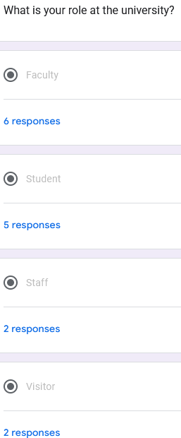

## How important is integration with university events/facilities (e.g: closures due to events, facility used due to event)?

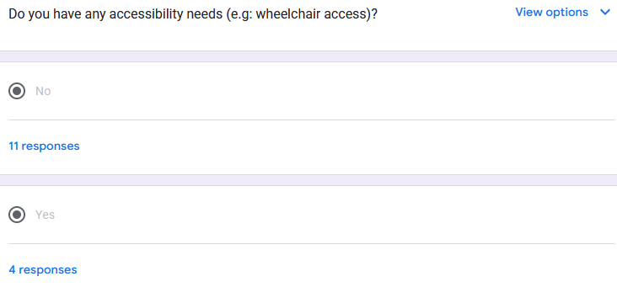

## How important is it for you to have an up-to-date and accurate campus map in the app?

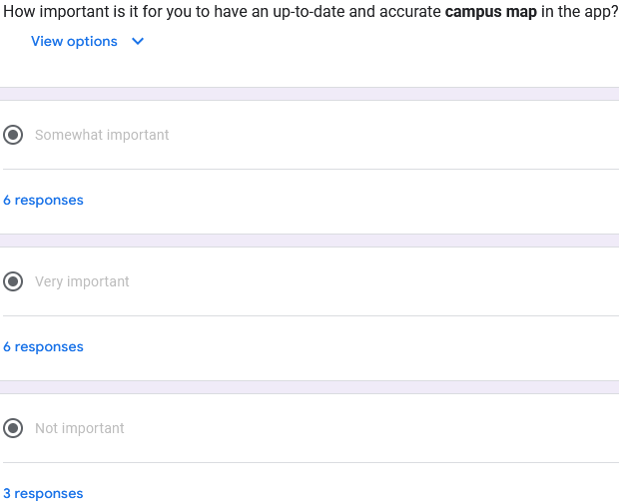

## Would missing maintenance updates (e.g: blocked paths, elevator outages) affect your campus navigation?

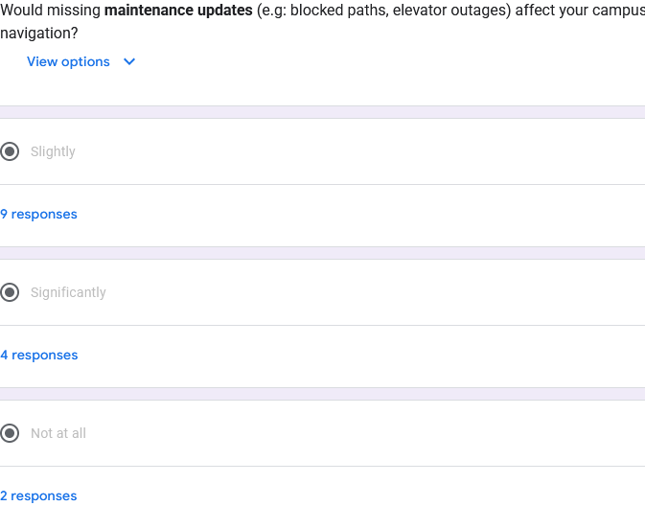

## Should administrators validate accessibility info reported by users before it's displayed?

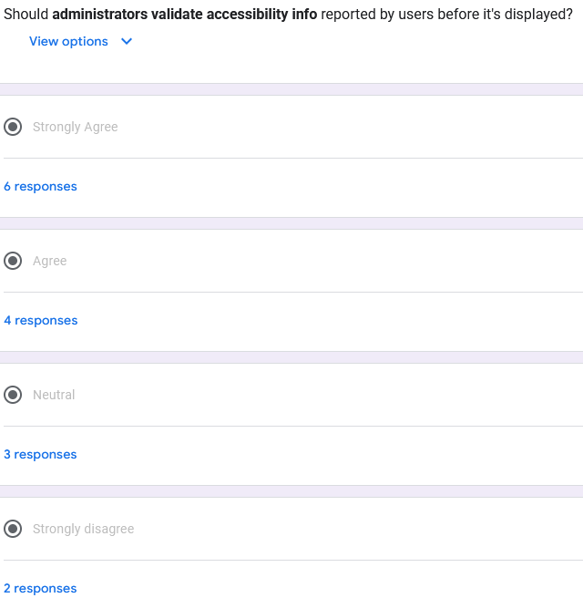

How essential is route planning across campus for your daily navigation?   
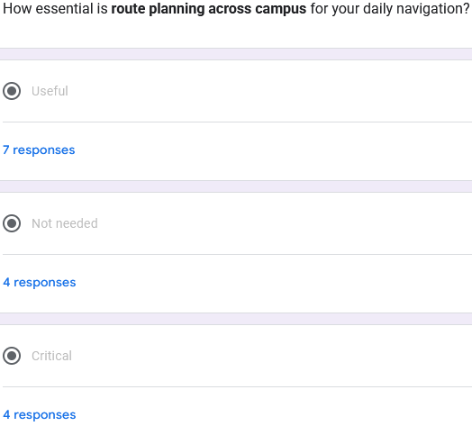

## Would you use multiple interfaces or modes (e.g: fastest route, event-free route)?

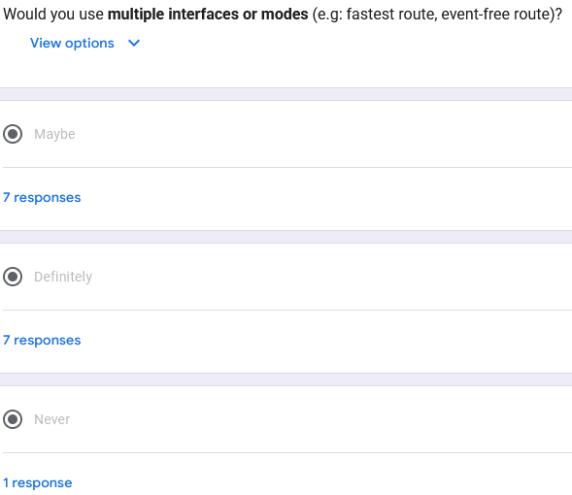

## How valuable are user surveys and feedback features for you to report navigation issues?

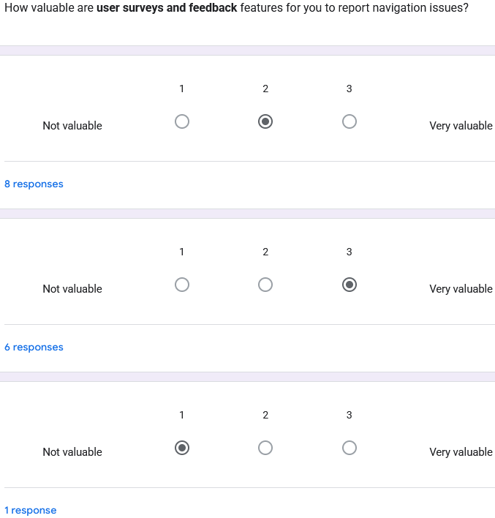

## How important is integration with university events/facilities (e.g: closures due to events, facility used due to event)?

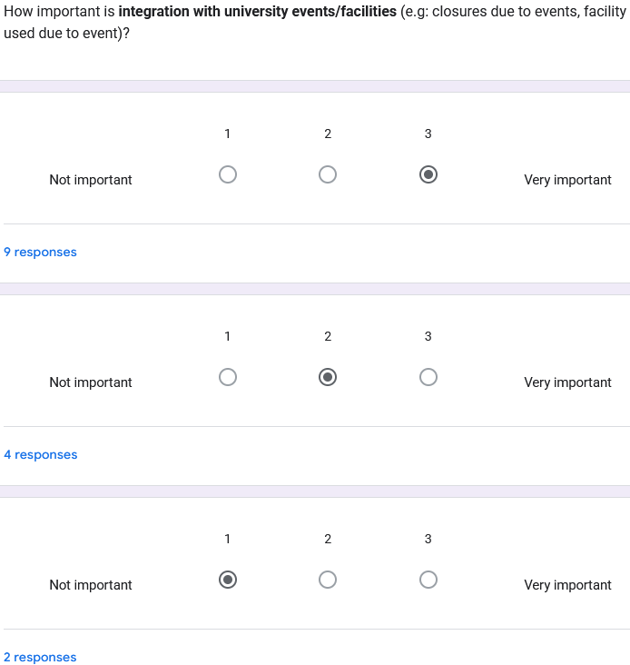

## Would you find an event list view useful to plan your routes better?

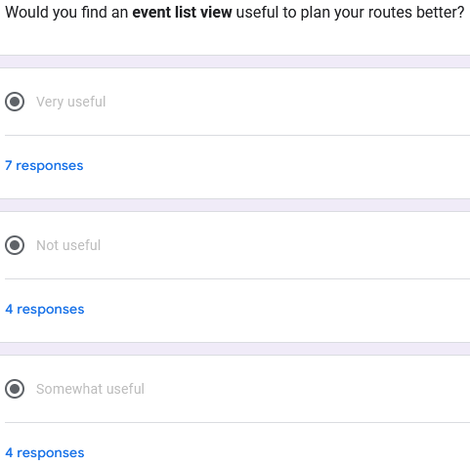

## Would you appreciate a feature that suggests accessible routes for users with disabilities?

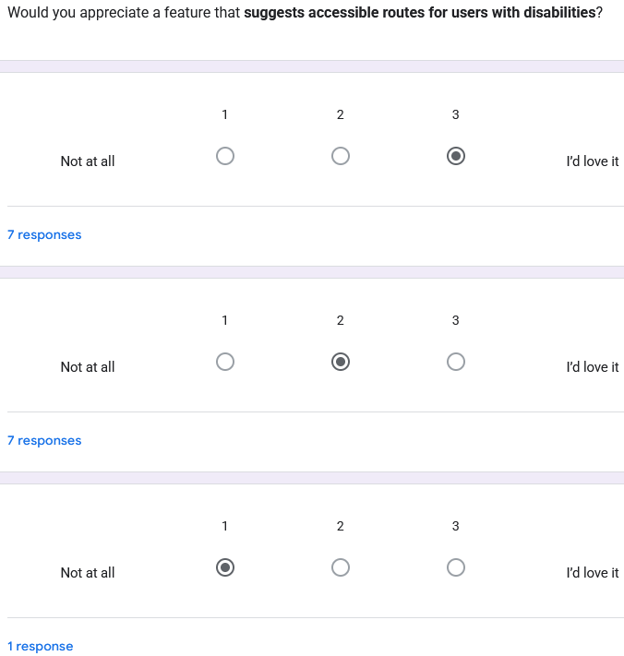

## How useful would it be if you could customize your privacy or access settings in the app?

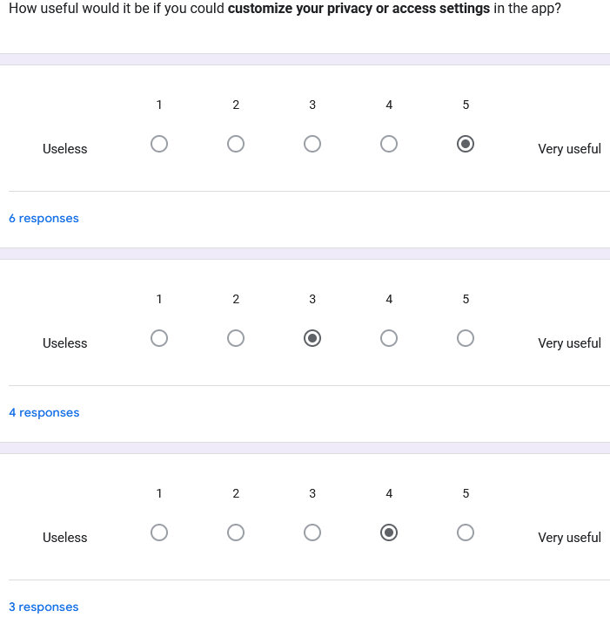

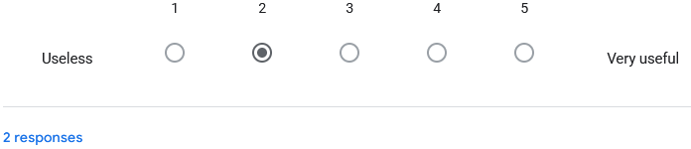Would you be interested in contributing updates (e.g: “path blocked due to construction”) to help others?

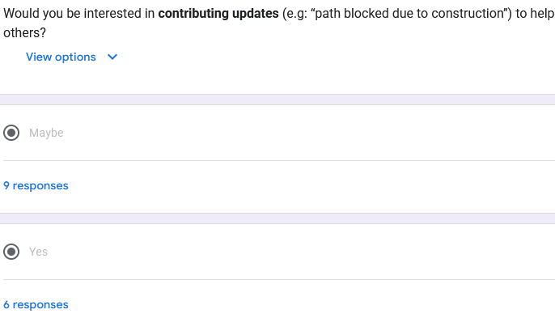

## Would you be excited about real-time event alerts that let you avoid crowds or disruptions?

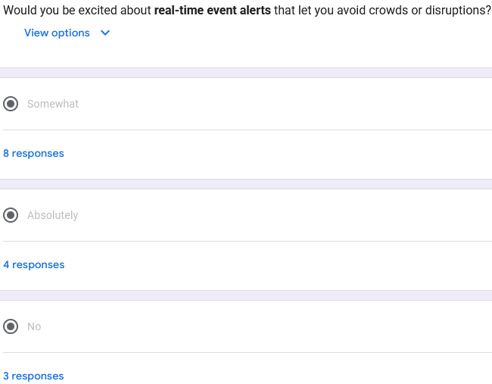

## Are there any other features you'd like to see in the navigation system?

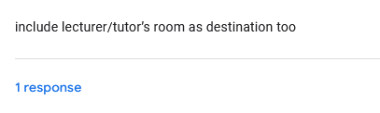

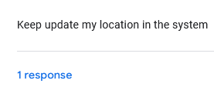

## What’s your biggest frustration when navigating campus?

