|  |  |  |  |
| --- | --- | --- | --- |
| **Version** | **Primary Author(s)** | **Description of Version** | **Date Completed** |
| 1.0 | YEE SI SHUN | Build requirement elicitation plan using Kano Model. | 27/4/2025 |

Requirement Elicitation Plan using Kano Model

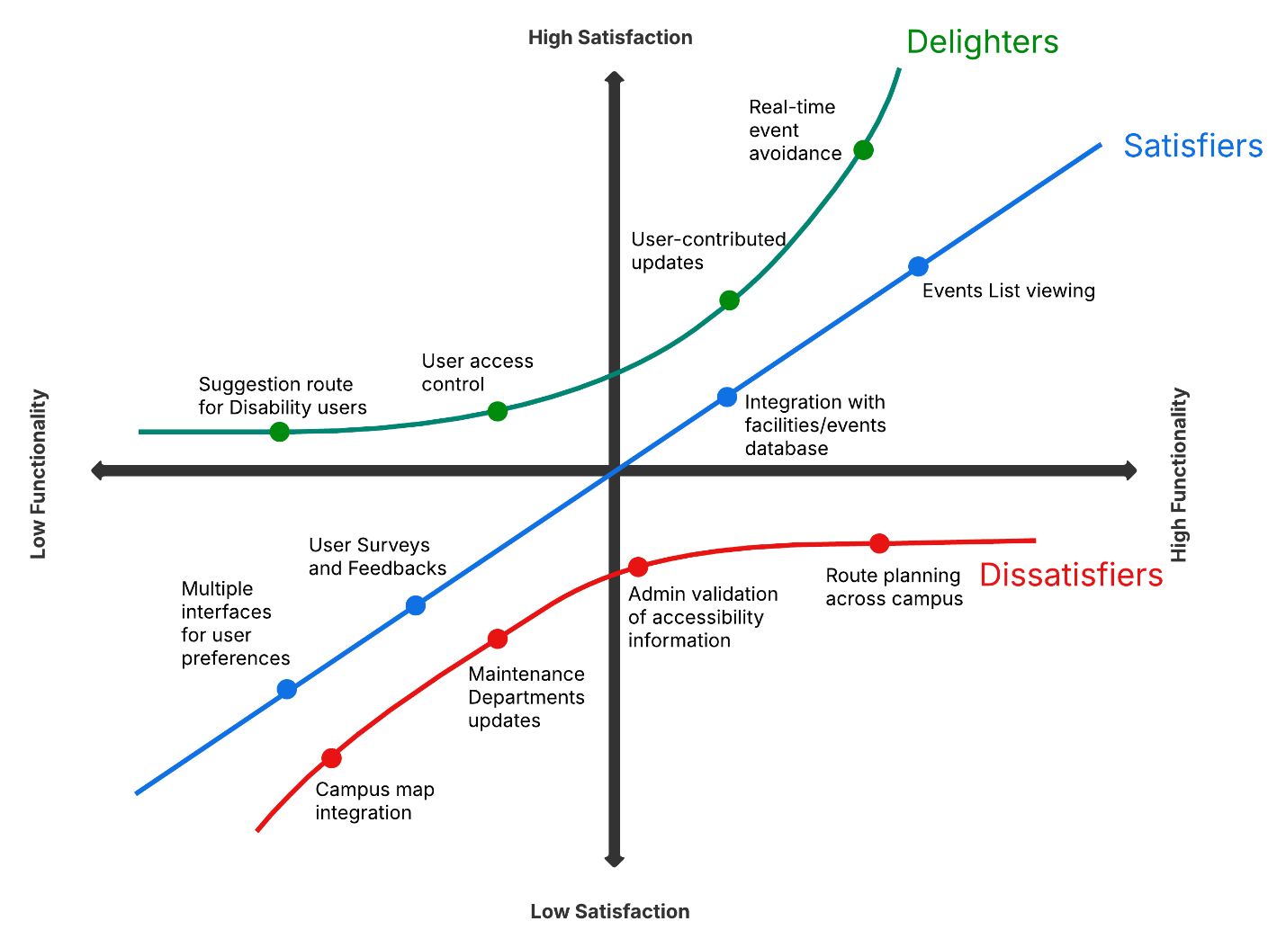

|  |  |  |
| --- | --- | --- |
| **Requirement** | **Kano Category** | **Justification** |
| Campus map integration | Dissatisfiers | Navigation tools should have an accurate campus map. Without it, the system would not fundamentally work |
| Maintenance Departments updates | Dissatisfiers | Critical information (broken elevators or blocked pathways) is reliable and up to date when being managed by university’s departments |
| Administrator validation of accessibility information | Dissatisfiers | Information updated or reported by normal users needed to be verify and accurate by administrator of the university |
| Route planning across campus | Dissatisfiers | Core function of the navigation system which guides the users to explore the university |
| Multiple interfaces for user preferences | Satisfiers | Users able to set preferences like fastest or least events path for flexibility |
| User Surveys and Feedback | Satisfiers | Issues can be report and feedback is important for continuous improvement |
| Integration with facilities/events database | Satisfiers | Navigation data is up to date to ensure accuracy of the route provide |
| Event list viewing | Satisfiers | Visibility of events affecting travel will be listed for informational needs |
| Suggestion route for disability users | Delighters | Personalized routes for users with disabilities |
| User-access control | Delighters | Allow users to customize their personal data visibility |
| User-contributed updates | Delighters | Users able to submit updates about events or obstacles that will need prove by administrator |
| Real-time event avoidance | Delighters | Route will be listed according to events to enhance users exploration experience |