**Figures**

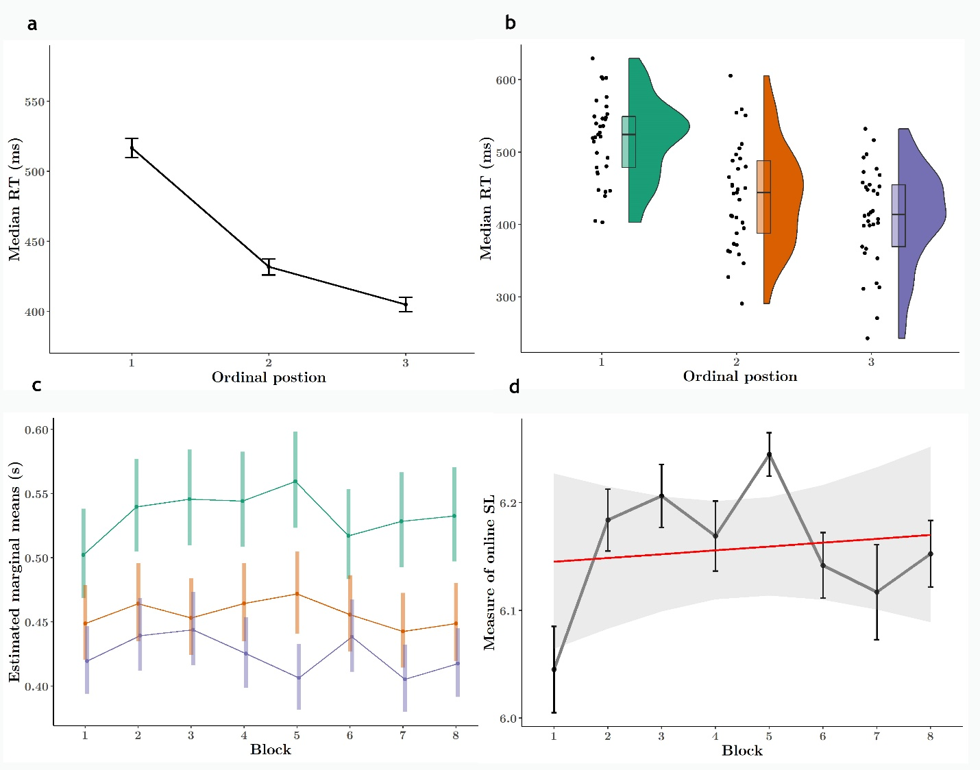

**Figure 1. Online target detection reveal rapid and robust sensitivity to embedded regularities. A. Median Reaction times to target syllables are modulated by ordinal position in pseudowords. Participants responded more slowly to syllables in the word-initial (1st) position (TP = 0.33) than to syllables in the word-medial (2nd) or word-final (3rd) position (TP=1). B. Median reaction times (RTs) for each ordinal position collapsed over blocks. Dots are individual participant medians, jittered along x-axis for visibility. Box plots indicate group median and CI’s, half-violins describe distribution. C. Reaction time effect appears in the first block (within 3 minutes of exposure). This effect was present in block 1 and remained stable throughout subsequent blocks. D. Online measure of SL as a function of block. As per Siegelman et al. 2018, we used this composite measure to evaluate the magnitude of the reaction time effect (specifically, the difference between the log average RT to first – (second & third) position syllables), as a proxy for statistical learning. We observed no significant effect of block on this metric, suggesting that the modulation of RT as a function of target syllable position in the pseudowords had already occurred in the first block.**

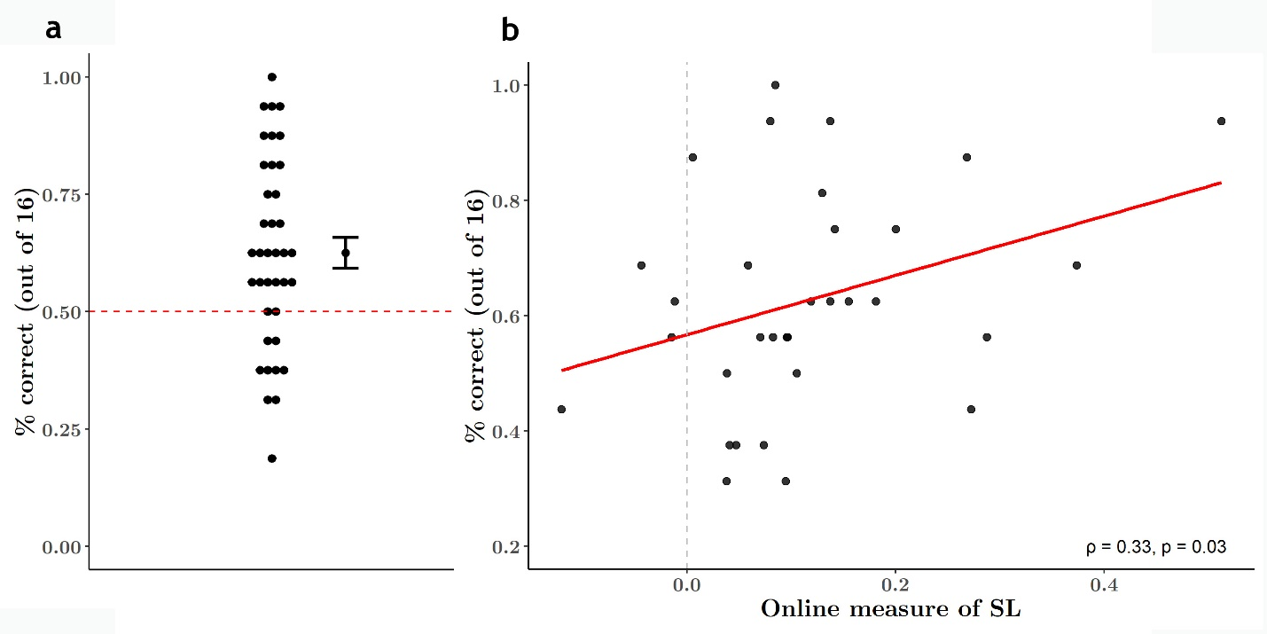

**Figure 2. Pseudoword vs. part-word discrimination. Word recognition performance was above 50% chance level, suggesting participants were able to use implicitly learned regularities during the exposure phase to explicitly discriminate pseudowords from part-word foils. Dot and error bars represent mean and standard error of the mean.**

**Figure 3. Pearson correlation between online measure of SL and word recognition performance for each participant. Correlation is weak and fails to reach significance.**

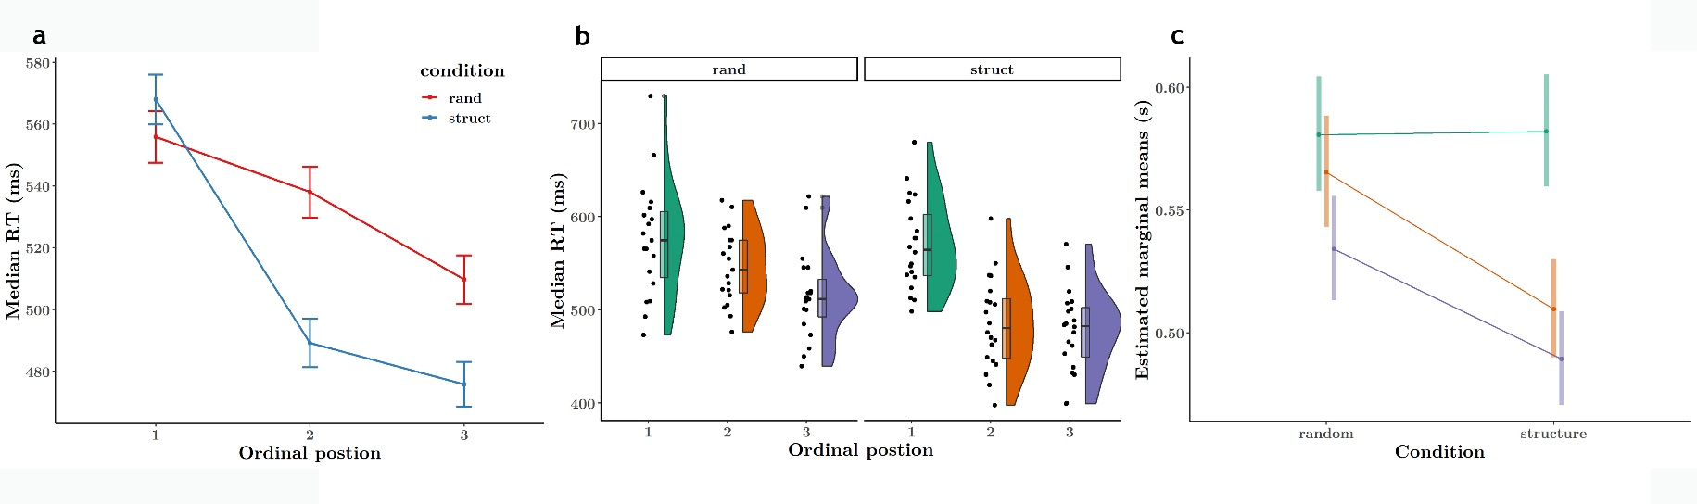

**Figure 4. Reaction time to target syllables modulated by ordinal position. A. RTs to targets in 2nd and 3rd ordinal positions were faster than RTs to 1st position targets for both random and structured conditions. However, the structured condition saw a much more pronounced RT effect. B. Distribution of median RTs to each target position for each participant. C. Linear predictions from GLM modelling RT as a function of ordinal position and condition. RTs to targets in the second and third positions were significantly shortened in the structured condition compared with the random condition. RTs to targets in the first position were unchanged.**

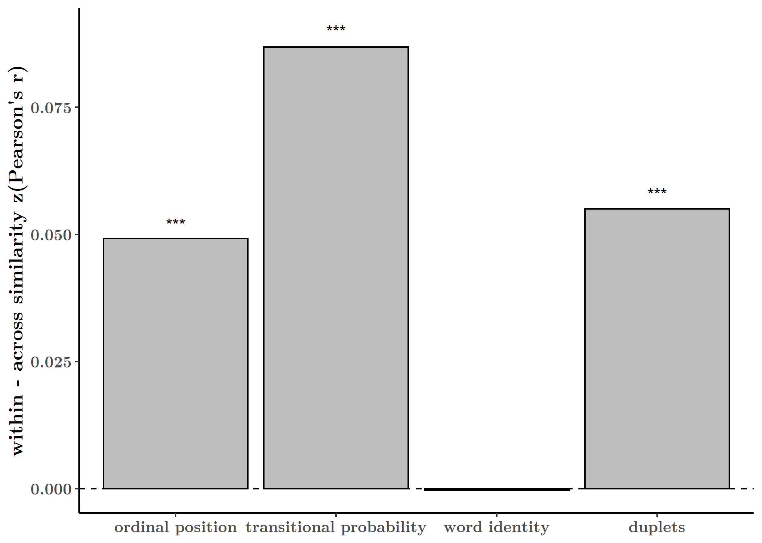

**Figure 5. Within versus across feature similarity.** We calculated the difference in mean similarity (z-transformed Pearson’s r) for four features of the stimulus stream. For each feature, we determined within and across groups: pairs of syllables that share the property versus pairs that do not share the property, respectively. We bootstrapped the observations for each analysis by sampling 200 times with replacement from all participants’s individual similarity matrices (correlation between RT for 12-x-12 syllables).

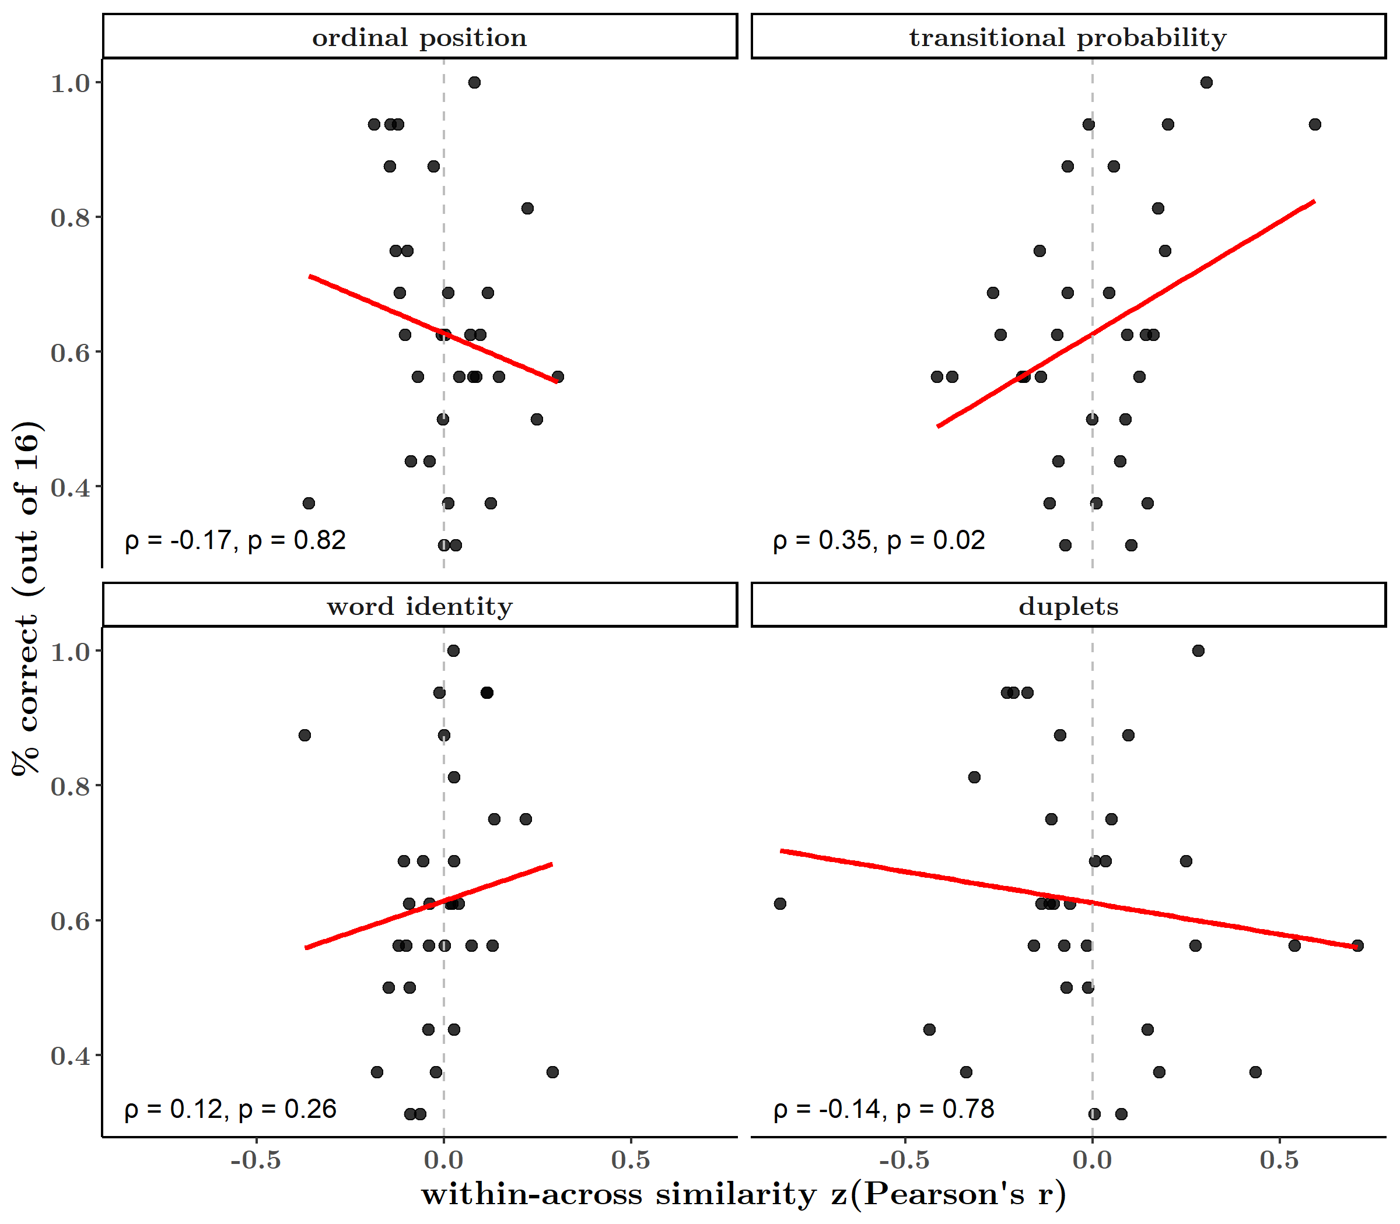

**Figure 6. Correlation between word recognition performance and within vs. across similarity for each stream feature per participant. All features were weakly correlated with offline word recognition, but transitional probability significantly predicts word recognition performance.**

**Supplementary Figures**

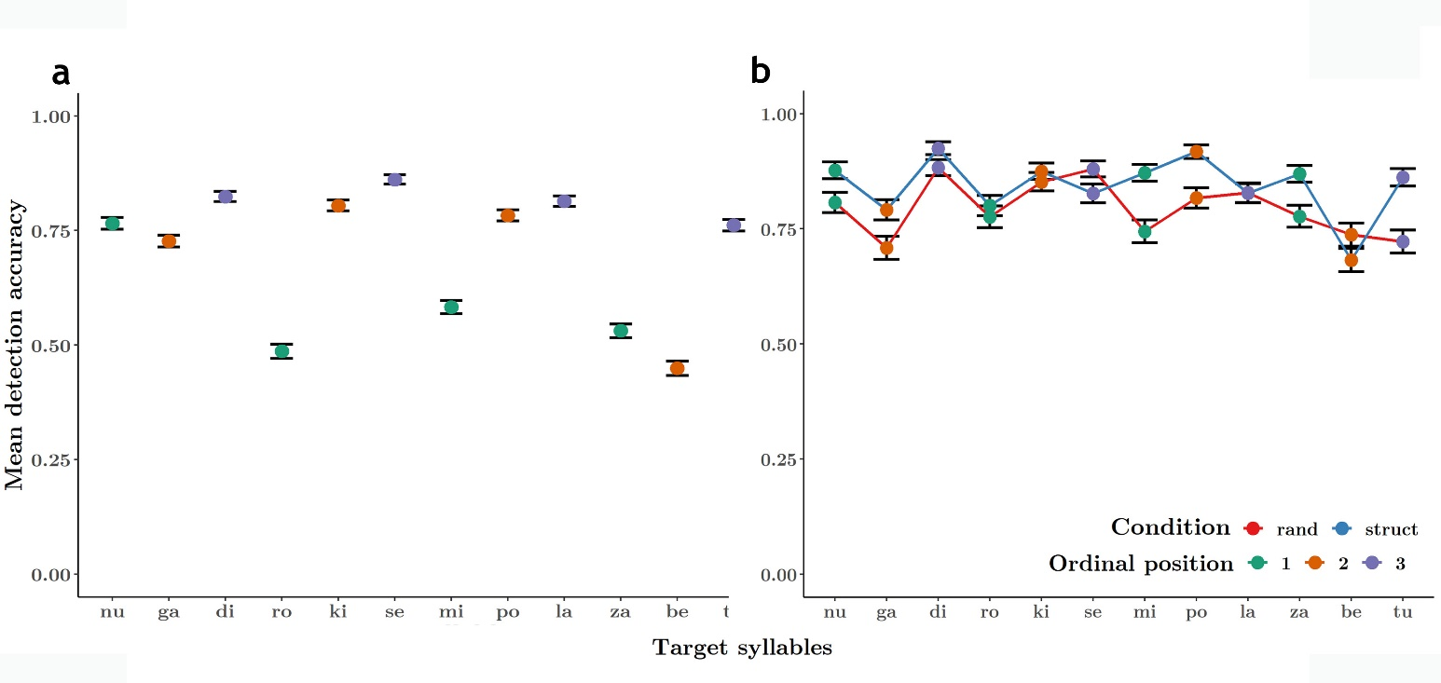

**Figure S1. Accuracy in Experiment 1. Accuracy for each target syllable.**

**Figure S8. Accuracy in Experiment 2. Accuracy for each target syllable in random and structured.**

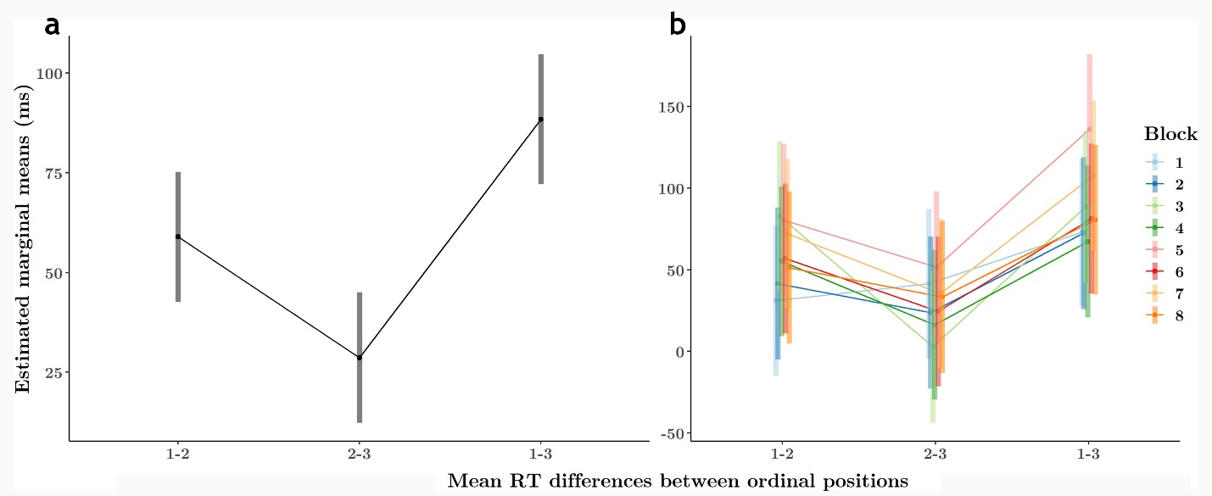

**Figure S1. Mean RT difference between positions 1-2 is greater than between 2-3 over all blocks. Graded RT effect is not monotonic and cannot be ascribed to adaptation or generically faster RTs alone.**

**Figure S2. Mean RT differences between position pairs did not vary significantly as a function of block.**

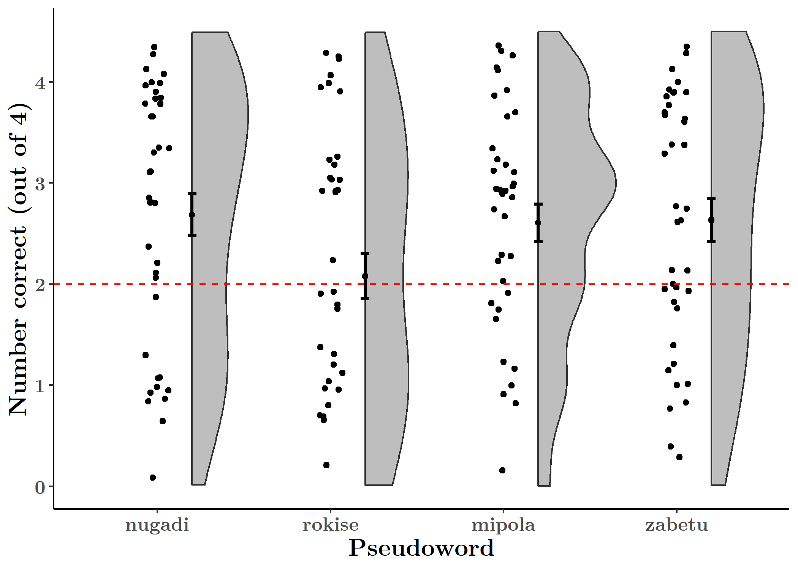

**Figure S3. Preference for pseudowords over part-word foils was present for all but one word. Our overall word recognition performance was therefore not driven by successful discrimination of one word.**

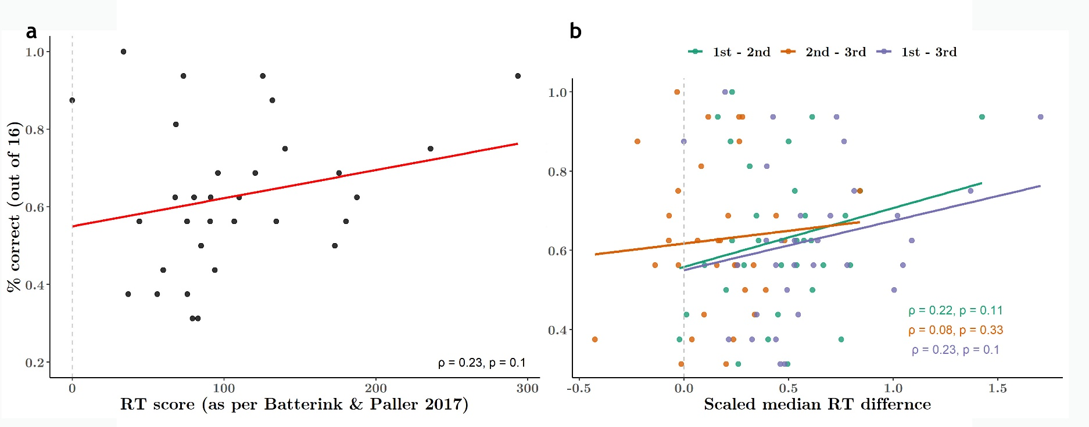

**Figure S4. Correlation between online and offline SL measures as per Batterink & Paller 2017**

**Figure S5.**

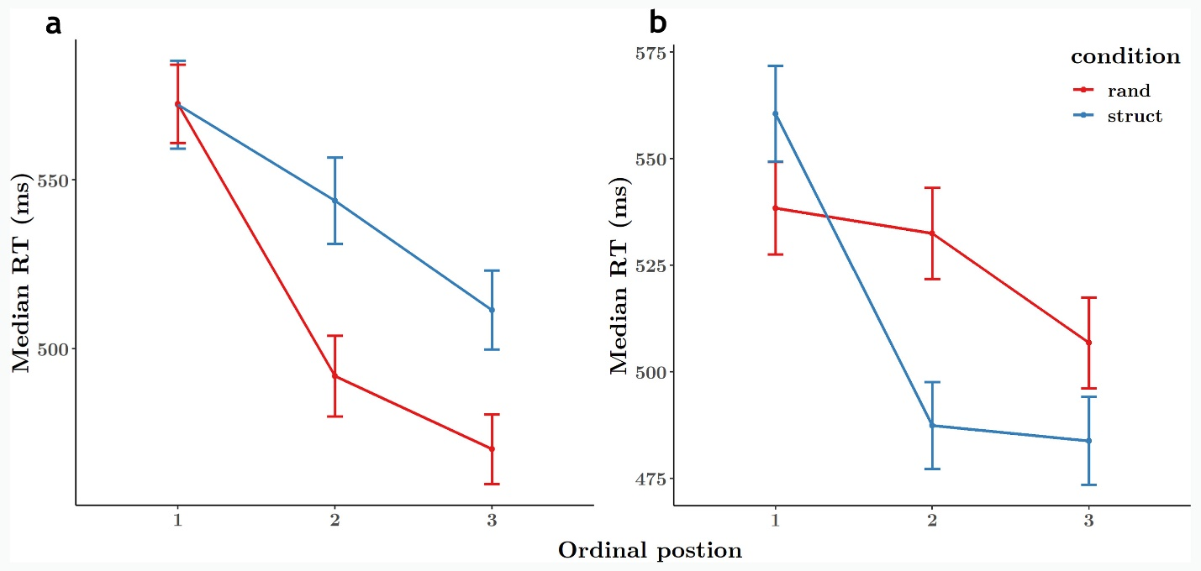

**Figure S6. Graded RT effect for random and structured sessions in both condition orders. A. Median RTs for participants who performed the structured session first and random session second. B. Median RTs for participants who performed the random session first and structured task second.**