For Sale Excellent Icom 756 Pro III HF – 50 MHz Transceiver

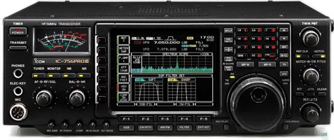

The arrival of a new radio makes it time to reluctantly sell my Icom 756 Pro III. This radio is In excellent condition both functionally and cosmetically. The radio has no scratches or smudges and has always been covered when not in use. The embroidered felt cover with the ICOM logo and the annotation “IC-756 PRO III” comes with the radio. Also included is the original shipping box, instruction manual and HM-36 microphone all in great condition. The Icom 756 Pro III is the final member of the 756 series. It offers improvements in receiver performance and enhanced functionality over older members of the Icom 756 family. It can also copy RTTY directly without the need for a external PC. If you need additional information on the Icom 756 pro III it can be found at http://www.universal-radio.com/catalog/hamhf/3756.html. I am the original owner of the radio and it has always resided in a smoke free, pet free environment. The radio has been used principally for Dxing and rag chewing. Using it, I have worked over 250 countries. The Icom 756 Pro III has very similar capabilities as the Icom 7600 and is offered at one half the 7600’s price. It is the ideal rig for the beginning or advanced ham. It is easy to operate and offers a full set of IF DSP functions including IF filters, twin pass-band tuning, noise reduction and a noise blanker. The radio is offered at $1800 and is located in the San Francisco Bay Area in Northern California. Please contact John K6YP for additional details at k6yp at arrl dot net. Thanks.

