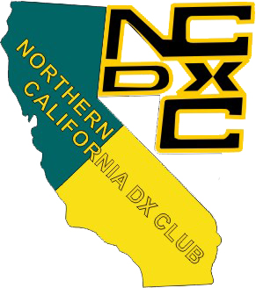

You’re invited to the 2017 NCDXC Summer Picnic
Hello Fellow NCDXC Members,
You and a guest are invited to the 2017 NCDXC Summer Picnic, which will be held at Patriots Corner, in Shoup Park, 400 University Avenue, Los Altos, CA 94022 on Saturday, July 22 2017.
Our picnic begins at 10:00AM; lunch will be served around 12:00PM; the NCDXF donation
will be presented at about 1:00PM and the picnic wraps up at 2:00PM.
For the enjoyment of all our members, this year’s picnic will, once again, be catered by Andy's BBQ. It is important that we have an accurate headcount for our caterer before the picnic. RSVPs cannot be accepted after Sunday, July 16, 2017.
Please RSVP to Bob Lanning, W6OPO, at treasurer@ncdxc.org, and tell him if you’ll be attending and if you’ll be bringing a guest.
Menu selections from Andy’s BBQ:
Sparerib
Beef Brisket
BBQ Chicken
Smoked Sausage Links
BBQ Beans
Potato Salad
Cole Slaw
Corn Cobbettes
Assorted Cookies
Assorted Sodas/Bottled Water
You are welcome to bring a desert if you’d like.
Russ Bentson, K6KLY, will be checking QSL cards for DXCC applications.
From past experience we know it can get hot at Shoup Park in late July. Members and guests attending are encouraged to bring folding chairs and portable shade, if possible or move
into shady areas as needed and perhaps a small folding table as well.
73 & Good DX,
Tony Dowler K6BV
President, NCDXC

