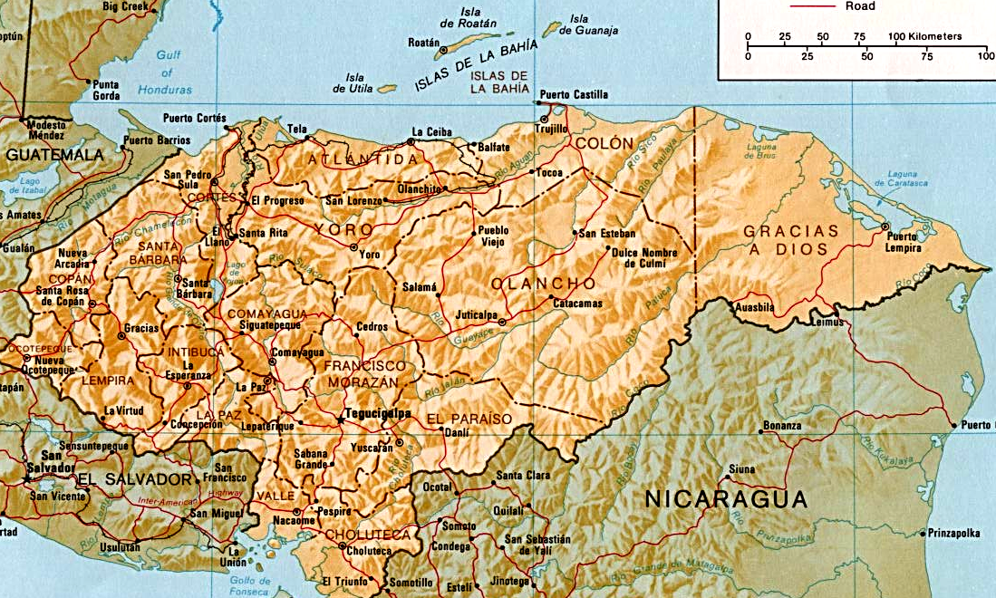

Revised 6
Mar, 2018
Draft

Rus Rus Medical/Dental Team
Gerard Rudy, MD
Brett Applebach, PA
Kayla Innis, RN

Erin Muyrese , RN
Gabriel Chang , RPh
John Chope, Dentist
John Kirckof, Eng, TL
KB0UUP
Charlie Chavez, Intp
Clay Couger, Radio, WC6YJ
Sue Chope, GH

Local Rus Rus People:
Geraldina Coleman, Local
Nurse
Carlos Paz, Clinic Dir,
Interpreter

La Ceiba Admin
John Pope, Proj Dir.
WA0VPJ

Tocoa Surgical Team
Daniel Jaffurs, MD Surg
Audrey Nguyen, MD Surg
Lisa Hayes-Swartz, RN, Comm TL
Jean Yunker, RN
Steve Baker, OR Tech
Craig Gill, CRNA
Susan Wodrich, CRNA
Denis Roussel, Intp
Dawn Duong, GH

-

Santa Fe

\

*
Eng = Engineer
TL = Team Leader
GH = General Helper
Intp = Interpreter

La Ceiba Surgery
- first week -
Steve Moore, MD Surg
Jeff Sarmiento, MD Anes
Anne Jones, RN
Cynthia Scott, RN
Beth Smyth, Surg Ass’t
Steve Rice, Intp,
Comm, TL
Valentina Moore, Intp

Lorette P. Calix, Intp
Sydney Sarmiento, GH
Brady Rajala, GH
* Waspam, Nic

Lisangnipura

Medical/Dental Team
Joe Tombers, MD(Med Dir)
Mark Spiro, MD
Jenni Lange, RN

Anne Lind, Med Tech

Kristen Schroeder, RPh Stu
Sarah Calhoon, RPh Stu
Julia Kattan, DDS
Larry Foster, Radio
KC0JON
Ibraham Hilsacai, Intp
Felix Rodriguez, Intp
Dale Watson, Eng TL
Hilario Nixon, Local Intp

**Yuki Prada, local MD

*

Laka Tabila

Rus Rus

*

PLP Surgery
James Dunn, MD Surg
Meredith Johnson, RN
JoAnn Prater, RN
Amy Mays, RN
Kirstyn Indgjer, CRNA
Pedro Castaneda, Intp
Rick Reiter, Intp
Jim Prater, TL, GH,
Comm

* Carbajales

PLP (Puerto Lempira) Admin
Drew Mathews,
Admin, TL
Marianne Serkland, MD
Grant Hanson, Eng
John Wagner,
Radio WA5VBP

IHS Feb Mission 2018

La Ceiba Eye Team
Jan Brown, Examiner
Charlie Brown, Examiner, N5TYI
Irene Schaper, Examiner, TL
Carlos Scheer, Intp
Carlos Rodriguez, Intp
Mike Stapp, Intp, Radio, KE0WW
Barbara Fleming, GH

Patuca River

Medical/Dental Team
Krausirpi
Yapawas
Doug Pflaum, MD
Paul Farley, MD
Lori Jackson, RN TL
Teri Houle, RN, TL
Walter Tatallon, Intp
Mary Bierman, RPh
Kendra Emste, RPh Stu
Elinor Japp, DDS
Kelly Koehnen, DDS
Bill Roussel, Radio, Eng,
Intp, K5TAS
Deb Lavoie, GH
Andy Martin, Intp, Boat

BelAire Medical/Dental Team
Kory Tuominen, MD

Jenine Graham, NP
Renee Donnelly, EMT

Dewey Essig, RPh, TL

Lauren Kuschel, RPh Stu

Chester Norris, Radio/Eng

KC0DSJ
Alberto Molina, Intp
Idalia Maldanado, GH
Evelyn Castellar, Intp
(local Clinic Dir)

N

Krausirpi *

Gracias Medical/Dental Team
Tom Haus, MD
Amy Sulivan, RN
Louann Dear, RN
Karen DeMorett, RN
Daniel Harren, Med Stu
Dale James, RPh
Kristen Binger, RPh Stu
Roberto Kattan, DDS
Steve Posner, Radio
KX5SP
Josman Gonzales, Intp
Renee Wolters, Intp ??
Dave Anderson, Eng
Char Zimmerman, GH
Anna Haus, GH
Jeanie James, GH
Cheryl Schraeder, GH, TL

* La Esperanza, Nic
Krausirpi *
Yapawas *

Nombres de Jesus *

*

*
Krata
Wampusirpi *
Uhi *
Pranza
*
* Marcovia
* Sulaco

*BelAire

Lisangnipura
*

Ahuas
*

