Equatorial Longitudinal Anomaly
Skewed path opening to Japan March 25, 2025
Major opening to VK became a major opening to Japan from 0224z until 0254z
My antenna was at 240 azimuth while working eight JA stations, when I rotated the antenna to 315 azimuth the signals faded out.
Message string from Tac JA7QVI
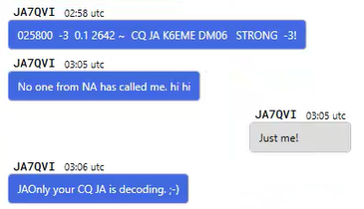
One decode sequence:
023445 -14 0.2 552 ~ K6EME JH1USR QM05
023445 -16 0.0 1105 ~ K6EME JE1GAP 73
023445 -14 0.4 1171 ~ K6EME JA9OGE PM86
