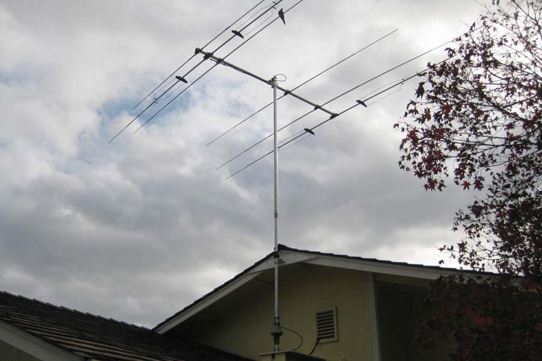
Force 12 C3SS and Rebuilt CD 45II Rotor, Mast & Cables

Here is a plug and play antenna system at an excellent price. The beam is a Force 12 C3SS on a 12 foot boom with only a 13.5 foot turning radius. The antenna has a 4.4 square foot wind cross section and weights 27 lbs. John, K6YP used this C3SS to work his first 250 countries. Then John, K6MM used it to work a couple of hundred more. Phil, AE6K the current owner is moving and would like to sell the antenna. It plays great on 10, 15 and 20 meters having about 4.5 dBd forward gain and significant front to back ratio on each of these bands. The antenna may be used (with an antenna tuner) on 12 and 17 meters). It’s current new price is $1229 from “The New Force 12” where there is more info. http://www.texasantennas.com See the Classic C Series

The CD 45II has been recently rebuilt with parts from Hy-gain, and is perfectly matched to the weight and wind cross section of the C3SS. It comes with the metered control box. Hy-gain currently sells the rotor and control box for $450. See http://www.hy-gain.com for more info.

The package includes mast, base, rotor cable, coax and Poly-Phaser lightning arrestor and is priced to sell at $400 firm. Contact Phil AE6K at 408-410-0969 or email John k6yp@arrl.net.

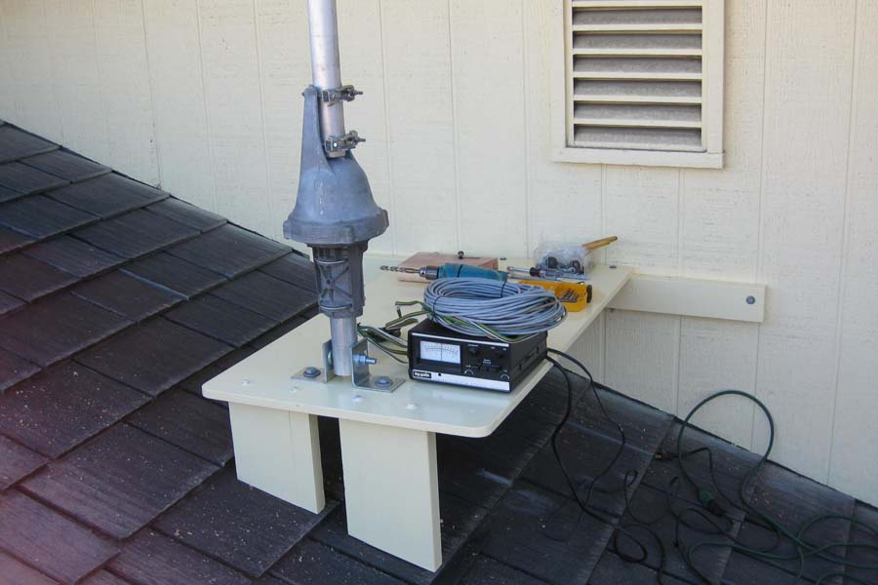
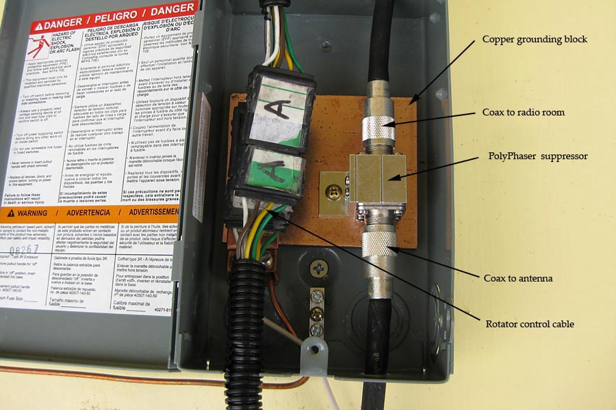
Phil also has a Diamond 2 meter outdoor antenna and mast and coax feed line for $50 firm.

