NC Data4Good Data Crunch from Nov 7-8, 2015

Bringing Pantries and Bus Stops Closer Together

Contributors: Alice Broadhead, Monika Sanghi, Kip Sutter, Clara Sutter, Rex, Lucia Gjeltema

As part of the NC Data4Good data crunch, working with the Triangle United Way to alleviate food insecurity, we tackled the problem of bus accessibility of food pantries in the Triangle. Since a car is an extra expense, it seems reasonable to hope that the bus system of the Triangle would be able to take low income people to supplemental food resources.

Our approach during this one weekend endeavor was to see if at the very least there were bus stops within one mile of each pantry. This would ensure that at least some people would be able to access these pantries by bus, although there would be no guarantee that all the neighborhoods served would be able to access the pantries by bus. We found that the vast majorities of food pantries in Durham County (95%) were served by at least one bus stop within a mile, whereas Orange County only had 67% of pantries served by bus stops and in Wake County a mere 49% of pantries were served by bus stops. Johnston County does not have a bus line, so none of its pantries were served by bus stops.

Clearly there is improvement to be made throughout the Triangle in making pantries more accessible via public transportation. The infrastructure is already present in Orange and Wake counties to make these improvements, so these counties may be the realistic place to start improving pantry accessibility by public transportation.

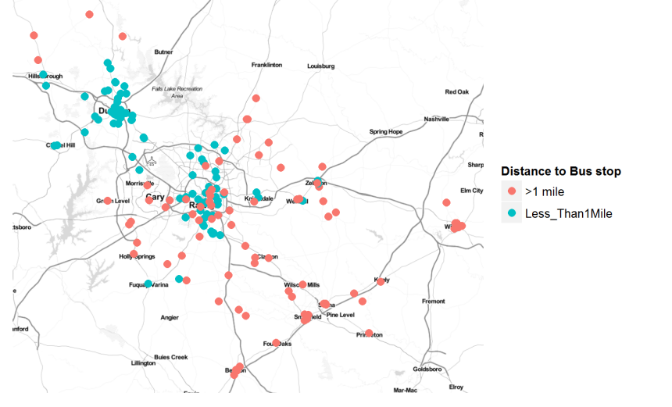

|  | **county** | **Number of food pantries** | **Pantries with a bus stop within 1 mile** | **Percentage of pantries with a bus stop within one mile** |
| --- | --- | --- | --- | --- |
| **0** | Durham | 39 | 37 | 94.87179 |
| **1** | Orange | 6 | 4 | 66.66667 |
| **2** | Wake | 91 | 45 | 49.45055 |
| **3** | Johnston | 33 | 0 | 0 |