**If you build it, they will come: coastal amenities facilitate human engagement in marine protected areas**

Marine protected areas (MPAs), areas in the ocean where fishing is prohibited or restricted, are commonly used as tools to protect biodiversity, recover fisheries, and promote other beneficial human experiences. While the conservation and fisheries impacts of MPAs have been well studied, the impacts of MPAs on other dimensions of human use -- such as recreation, education, and scientific research -- have received less attention. Identifying traits of MPAs that promote or limit human engagement is critical to designing MPA networks that achieve multiple goals effectively, equitably, and with minimal environmental impact.

In our recent paper, we develop a novel and transferable framework for quantifying human engagement in California’s MPA network, one of the largest MPA networks in the world. We assemble and compare diverse indicators of human engagement -- leveraging information from citizen science programs, social media platforms, and government datasets -- that capture recreational, educational, and scientific activities across California’s MPAs.

We find that human engagement is correlated with local population density: unsurprisingly, the more people that live close by, the more people that engage in an MPA. However, we also find that MPAs near tourist destinations, adjacent to state parks and their amenities, and with long sandy beaches generate more engagement than would be expected based on population density alone. Conversely, remote MPAs without sandy beaches or parking lot access had lower than expected human engagement.

What does this mean as the world aims to expand MPA coverage to protect 30% of the ocean by 2030? On one hand, human engagement can be promoted by developing land-based amenities that increase access to coastal MPAs or by locating new MPAs near existing amenities during the design phase. On the other hand, human engagement can be limited by locating MPAs in areas far from population centers, coastal amenities, or sandy beaches. This choice depends on management goals. Our paper provides a transferable framework for current and future MPA networks to track progress towards meeting their own human use objectives.

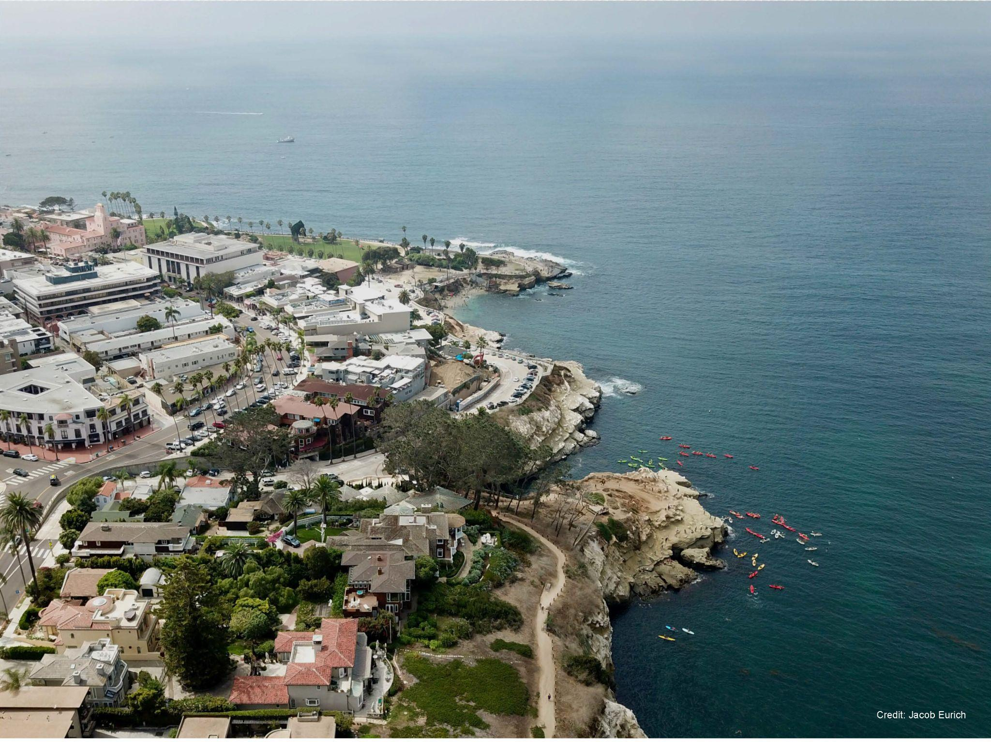

Kayakers exploring the Matlahuayl State Marine Reserve off of La Jolla Cove in San Diego, California, USA. Photo by Jacob Eurich.

**Please provide a Tweet that summarises the key findings of your paper (maximum 280 characters – including spaces and punctuation). Please also include Twitter account details for any authors/institutes (e.g. @PaN_BES), so that they can be tagged in our promotional Tweet.**

We develop a framework for measuring recreational, educational, and scientific engagement in California’s marine protected area network. We find high engagement in MPAs close to population centers, tourist destinations, state parks, and sandy beaches. @ChrisFree14 @PISCOScience

|  |  |
| --- | --- |
| **Author** | **Twitter** |
| Chris Free | @ChrisFree14 |
| Cori Lopazanski | @cori_lopazanski |
| David Gill | @DavidGillMarine |
| David Mouillot |  |
| Jacob Eurich | @JacobEurich |
| Jenn Caselle |  |
| Jenny Dugan |  |
| Joachim Claudet | @JoachimClaudet |
| Josh Smith | @Smith_JoshuaG |
| Julien Brun | @brunj7 |
| Kerry Nickols | @kj_nickols |
| Kristin Kaschner |  |
| Scott Hamilton |  |
| Shelby Ziegler | @slziegler220 |
| Tessa Francis | @tessafrancis |