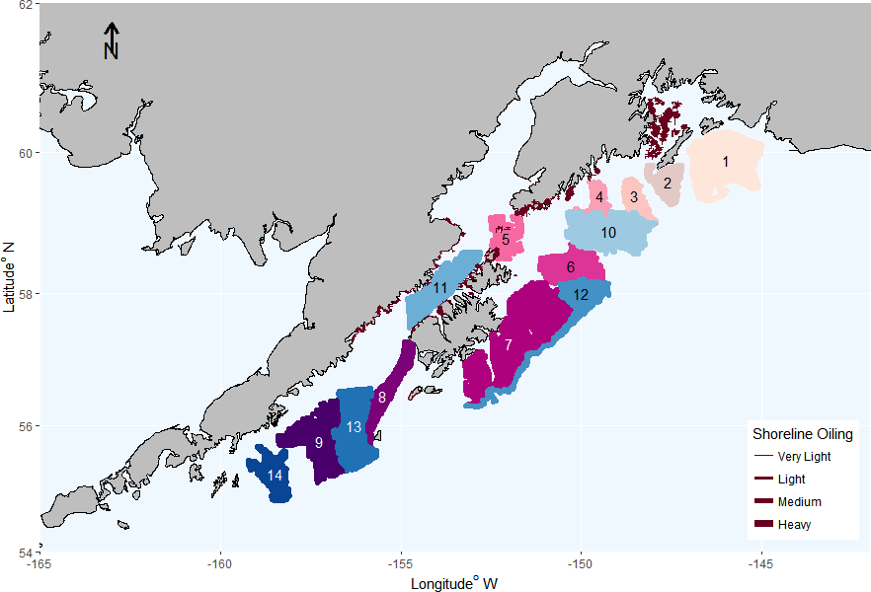

Figure 1: Map of shallow (warm colors) and deep (cool colors) study areas along the central Gulf of Alaska continental shelf. Shoreline oiling is indicated by deep red lines with line weight signifying severity of oiling.

Figure 2a: Alpha diversity (top), beta diversity (middle) and species richness (bottom) of the groundfish assemblage in shallow areas of the Gulf of Alaska (see Figure 1). The boxplots show medians and confidence intervals estimated from bootstrap samples (see methods), which are based on 14 years of data from 1984 to 2015.

Figure 2b: Alpha diversity (top), beta diversity (middle) and species richness (bottom) of the groundfish assemblage in deep areas of the Gulf of Alaska (see Figure 1). The boxplots show medians and confidence intervals estimated from bootstrap samples (see methods), which are based on 14 years of data from 1984 to 2015.

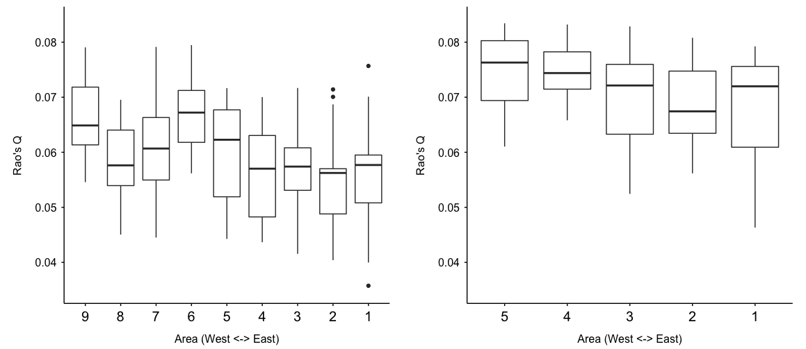

Figure 3: Boxplots of functional diversity (Rao’s Q) for (left) shallow areas 1-9 and (right) deep areas 10-14. Means represent temporal means (1984-2015) for each local area.

Note: for deep areas, 1=10, 2=11, 3=13, 4=15, 5=12 on map in Figure 1. Needs to be corrected.

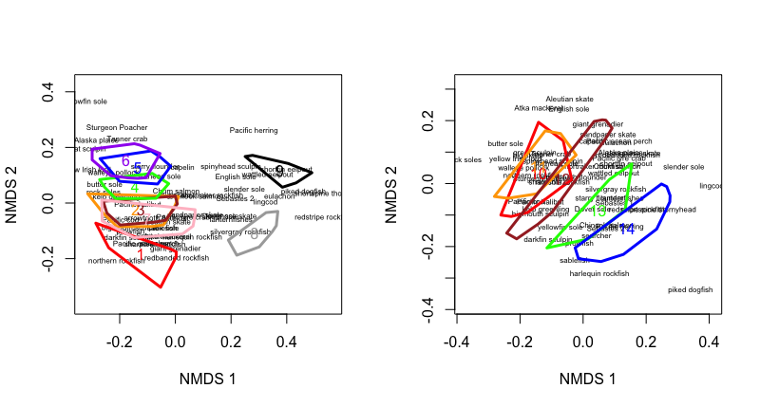
Figure 4. Results of non-metric multidimensional scaling using Wisconsin double standardization and square root transformation for shallow (left) and deep (right) areas. All species contribute equally to the ordinations regardless of relative dominance.

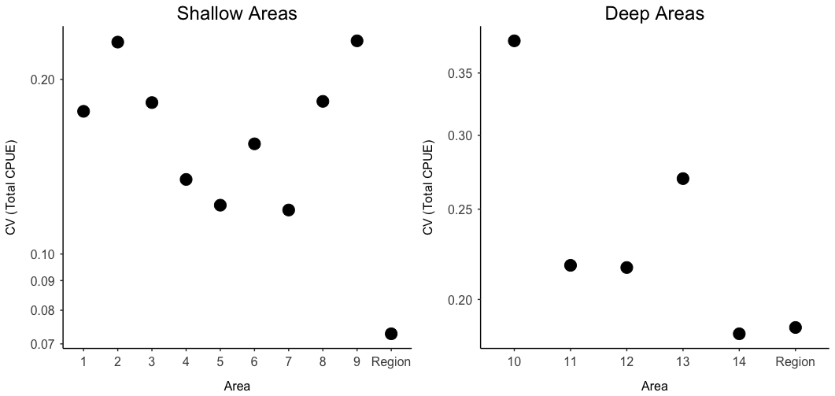

Figure 5. Coefficient of variation (CV) of local communities (i.e. study areas) and regional (Region) communities (i.e. study areas combined). Note difference in axis scales between shallow and deep areas.
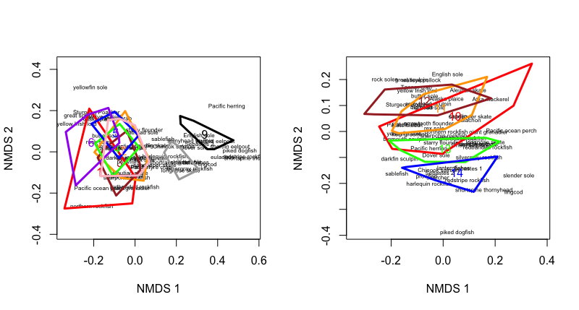

Figure S1. Results of non-metric multidimensional scaling (Hellinger) for shallow (left) and deep (right) areas. Unlike the NMDS presented in Figure 4, density estimates are not standardized to allow each species to equally contribute to the ordinations. Instead, species contribute to ordination results in proportion to their relative dominance in the community.

Supplementary Figure S2?: Time series of alpha and beta diversity, and species richness for shallow areas (50-150m). Red and black lines indicate areas that were likely or not likely exposed to the EVOS. Dotted line denotes year when the EVOS occurred (1989).

Supplementary Figure S3?: Time series of alpha and beta diversity, and species richness for deep areas (>150-300m). Red and black lines indicate areas that were likely or not likely exposed to the EVOS. Dotted line denotes year when the EVOS occurred (1989).

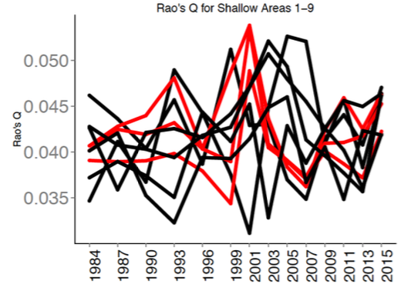

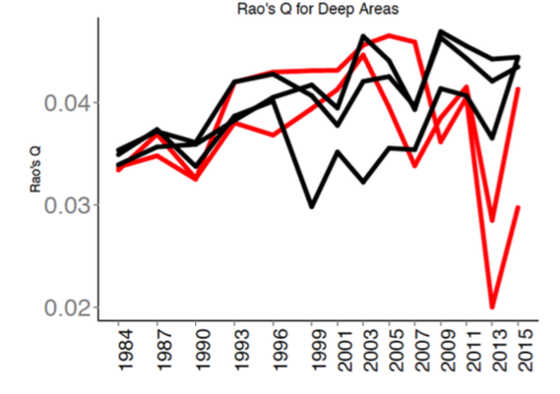

Supplementary Figure S4?: Time series of Rao’s Q, a measure of functional diversity, for shallow (50-150m) and deep (>150-300m) areas. Red and black lines indicate areas that were likely or not likely exposed to the EVOS of 1989.

Ole’s suggestions for figures of interest:

1) Wang and Loreau suggest there should be a relationship between species diversity and reduced temporal variation in local biomass. We have this data for each of the local areas in GOA.
Two panels:
Mean biomass vs. time-average alpha diversity
CV biomass vs. time-average alpha diversity
I know there is vanishingly little variation in Alpha diversity across sites, but the fact that there is variation in CV despite no variation in alpha this seems interesting.

2) I think there are some interesting things to be done with community dissimilarity in both space and time. This could be on raw communities or using some of the functional group information.
- Space-
  - Calculating the pairwise Bray (or gower or whatever) dissimilarities for all sites in each year then
    - Plot dissimilarities vs. distance between areas
    - Plot median dissimilarity vs. year – is there a temporal trend or pattern in variability?
- Time
  - Calculating pairwise dissimilarity for through time for each area (e.g. 1984 vs. 87, 84 vs. 90, 84 vs. 93 etc.)
    - Plot dissimilarity vs. temporal lag
      - Compare among areas

Then compare some of the dissimilarity metrics with metrics of biomass mean, trend, CV.

