LifeWatch WP5 workshop
Semantic Data Integration
Monday 18 may 13:00 – Tuesday 19 may 15:00
IBED Nieuwe Achtergracht 166, 1018 WV Amsterdam
Monday:
13:00 Adress of welcome &
Round-the-table introduction of participants Walter Berendsohn and all

13:30 Introduction Herbert Schentz
14:00 Multilingualism in thesauri Paolo Plini
14:30 UMLS and semantic integration Olivier Bodenreider
15:00 questions and discussion
15:30 coffee break
16:00 Morpho / EML / Metacat / Kepler Matt Jones / remote
16:30 Semantic Integration with OntoBroker Andreas Nierlich
17:00 ORACLE–i.Know and semantic data integration Dirk van Hyfte
17:30 questions and discussion
Tuesday:
9:00 OGC and semantic data integration Patrick Maué
9:30 Semantic data integration on the GBIF network Eamonn o Tuama
10:00 TDWG TAG Roger Hyam / remote
10:30 questions and discussion
11:00 coffee break
11:30 Provenance and Interoperability Simon Miles
12:00 MORIS - connecting data to semantics Herbert Schentz
12:30 ALTER-Net and SERONTO Nic Bertrand
13:00 lunch break
13:30 final discussion
15:00 end of the workshop
The sequence of the presentations may change, as we have to arrange it around the remote presentation of Morpho / EML / Metacat /Kepler which will somehow be a time critical trigger.

Location of the meeting place:
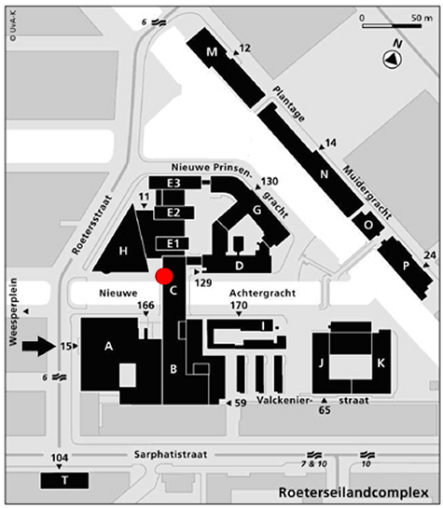 | From the Amsterdam central station: take metro line number 54 (see also www.gvb.nl), and exit on the Weesperplein station; from there it is a walking distance to Roeterseilandcomplex.  Recommended accommodation:  EDEN LANCASTER HOTEL, Plantage Middenlaan 48, NL-1018 DH (www.edenhotelgroup.com); alternative is the NH Tropen Hotel Amsterdam (www.nh-hotels.com)

LIFEWATCH - WP 5 Coordination  Dr. Marie Gebhardt  Botanic Garden und Botanical Museum  Museum Berlin-Dahlem | Freie Universität Berlin  Königin-Luise-Str. 6-8  D-14195 Berlin  Tel.: +49 30 838 50 168  FAX: +49 30 841 729 54  E-mail: m.gebhardt@bgbm.org

Workshop Coordination Umweltbundesamt GmbH
Spittelauer Lände 5
Herbert Schentz A – 1090 Wien
Umweltbundesamt GmbH Tel +43 1 31304 5308
e-mail: Herbert.schentz@umweltbundesamt.at

