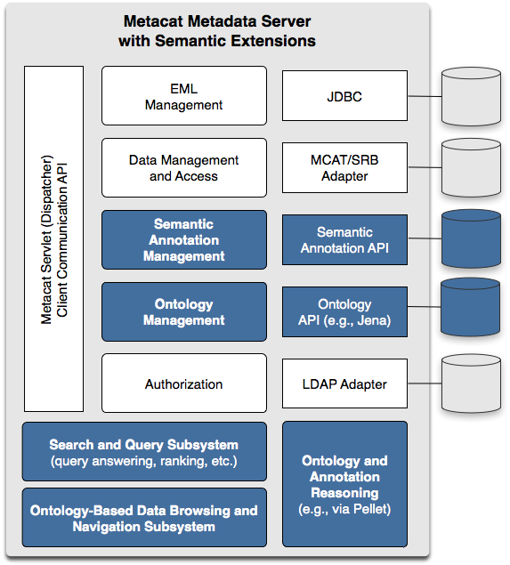
Figure 1: Semantic extensions (highlighted in blue) to the Metacat data and metadata repository support improved precision and recall in searches for scientific data sets.

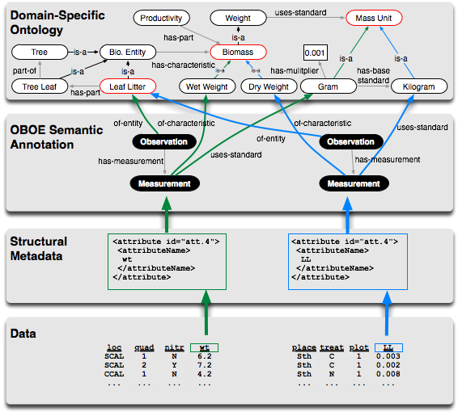
Figure 2. The components of our semantic-search framework including relational data, EML-based metadata, semantic annotations based on OBOE, and OBOE domain-ontology extensions.

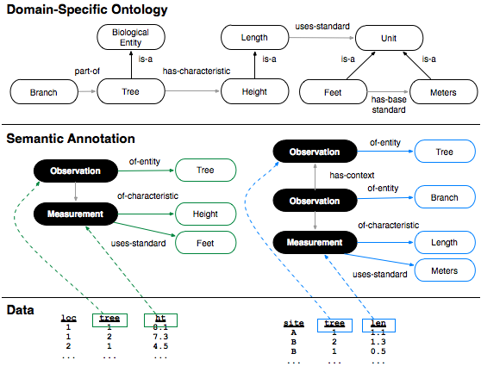
Figure 3. Example annotations demonstrating more precise search results for observation-based structured query.

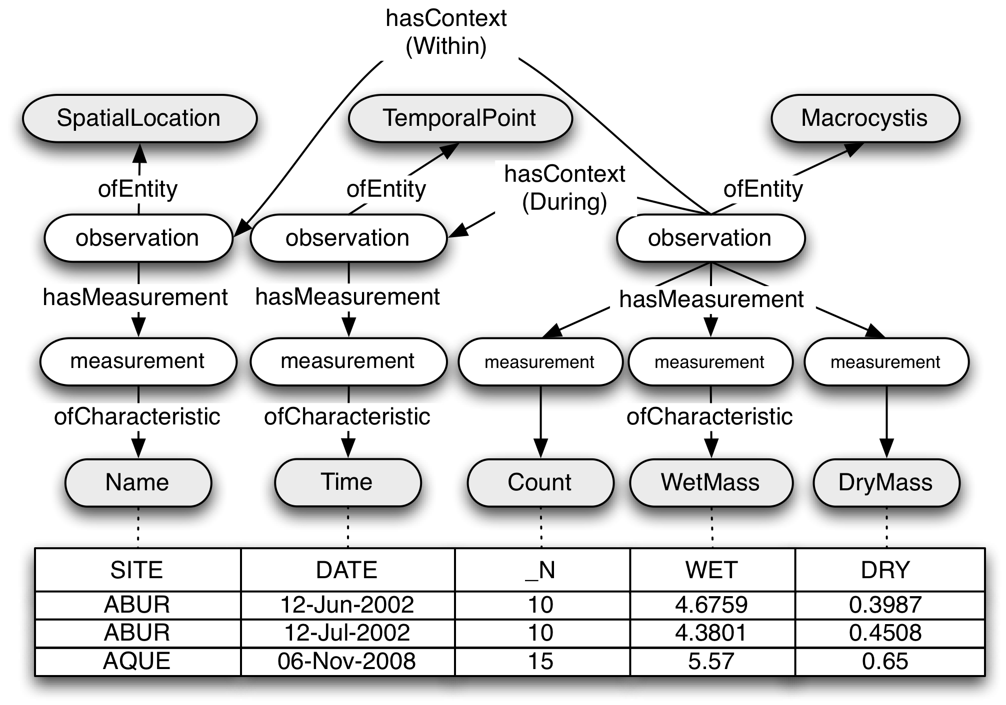
Figure 4. Partial OBOE semantic annotation for Kelp sampling data. Shaded nodes represent ontological concepts; rectangular nodes are data table attributes mapped to OBOE measurement characteristics.

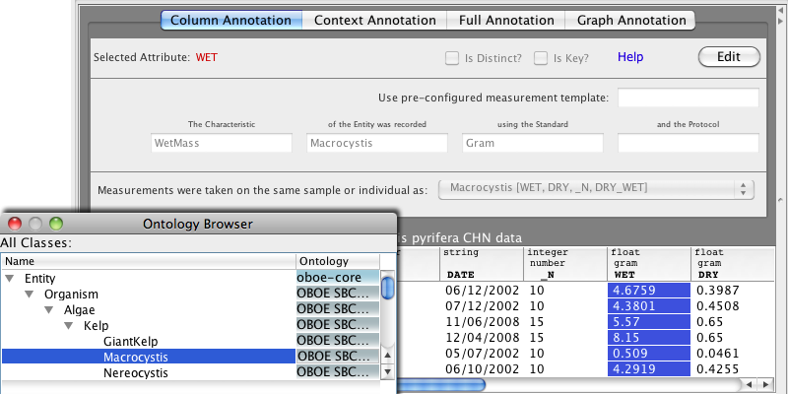
Figure 5. Morpho metadata editor with Semantic plugin. The fill-in-the-blank interface uses natural language descriptions for intuitive editing. A searchable, hierarchical browser is used to select concepts from domain-specific ontologies.

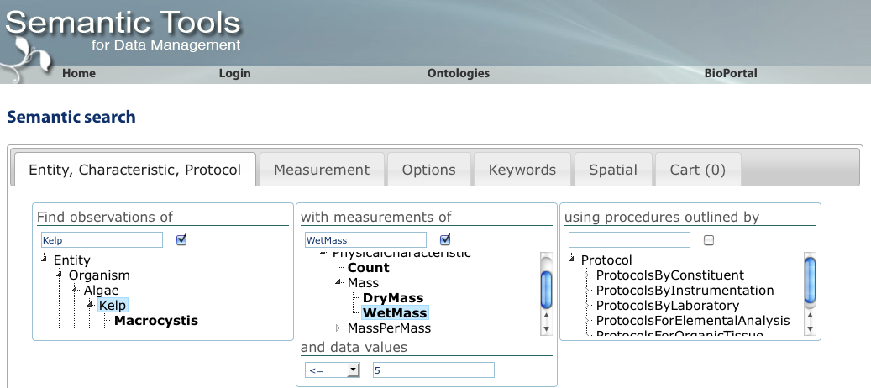
Figure 6. Semantic data query web interface. Data packages containing observations of Kelp Wet Mass less than or equal to 5 [grams] are returned. Additional search options and compound query criteria can be specified within the other tabs. Matches can be saved in the data cart for later exploration.

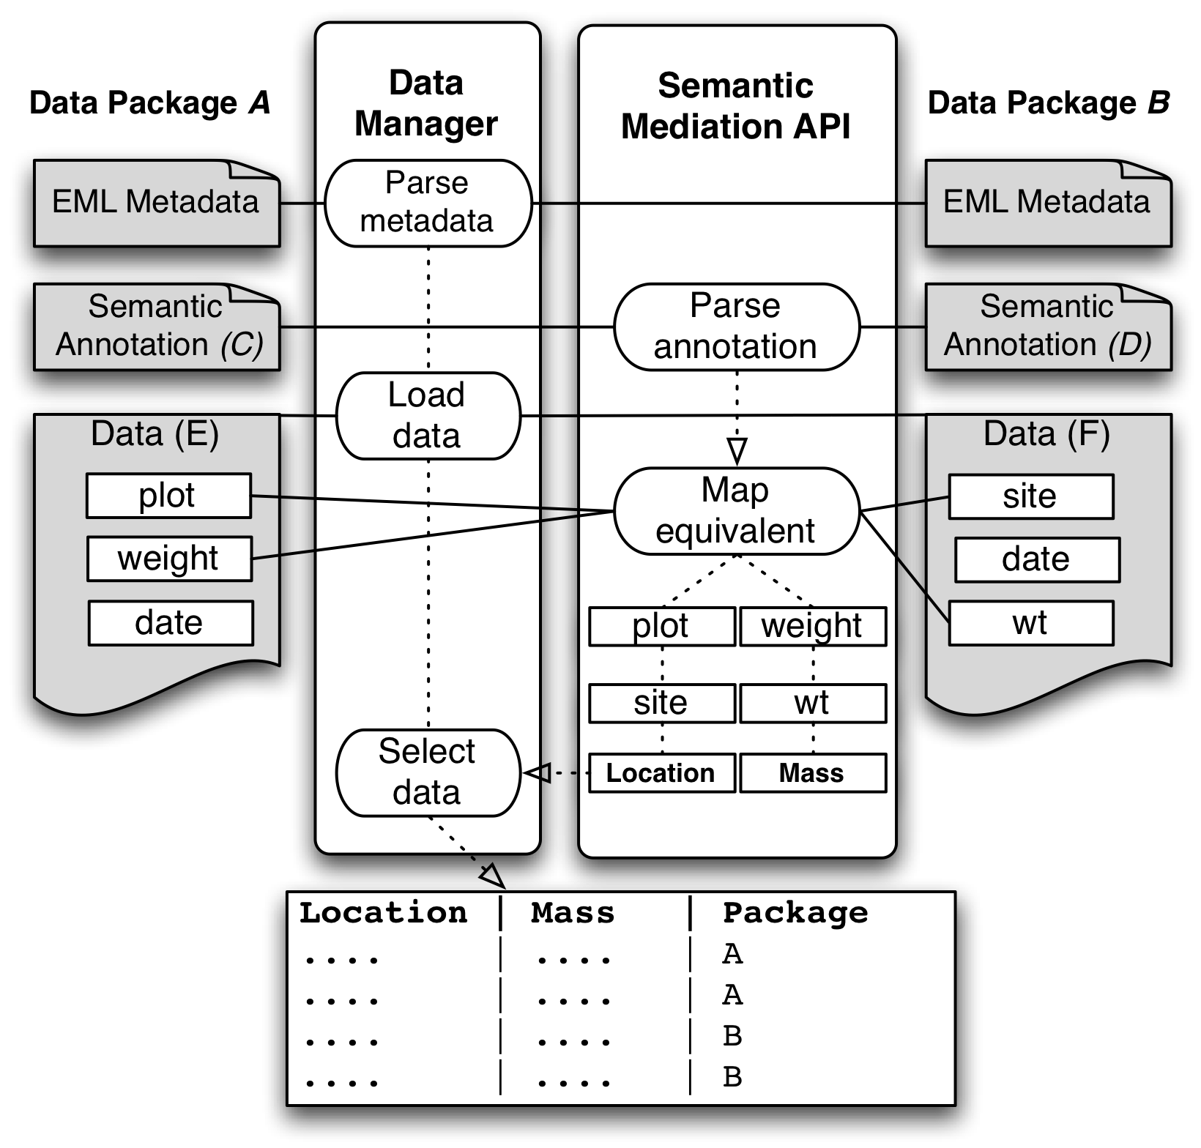
Figure 7. Integration query across multiple data packages (A, B). Annotations (C, D) determine semantically equivalent data attributes contained in the data objects (E, F). Attributes plot and site are considered equivalent measurements of the characteristic Location; attributes weight and wt both map to the same characteristic Mass. The Semantic Mediation API utilizes the Data Manager Library to load and query the source data informed by semantic similarities between the structurally disparate data attributes.

