Example 1: GCE fertilization study (level: moderate)
Data set sample:

Site | Community | Treatment | Replicate | Species_Code | Plant_Mass
GCE6 | BorJun | N | 1 | JROM | 75.13
GCE6 | BorJun | N | 2 | JROM | 179.81
GCE6 | BorJun | N | 3 | JROM | 443.2
GCE6 | BorJun | N | 4 | JROM | 227.53
GCE6 | BorJun | N | 5 | JROM | 176.42
GCE6 | BorJun | N | 6 | JROM | 121.69
GCE6 | BorJun | N | 7 | JROM | 75.91
GCE6 | BorJun | N | 8 | JROM | 38.69
GCE6 | BorJun | C | 1 | JROM | 256.95
GCE6 | BorJun | C | 2 | JROM | 193.5
GCE6 | BorJun | C | 3 | JROM | 192.28
GCE6 | BorJun | C | 4 | JROM | 248.93
… | … | … | … | … | …

Attributes:
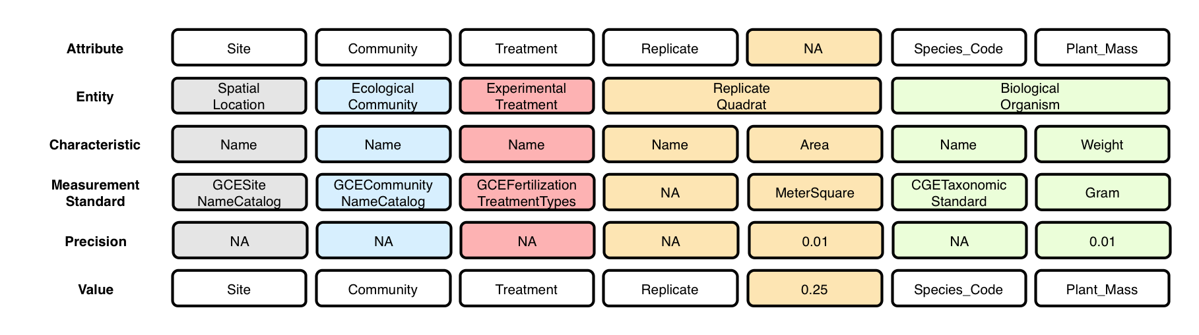

Context (containment) relationships between Entities:
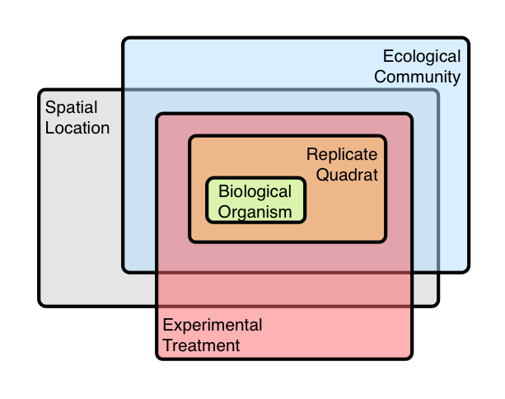
- Experimental Treatment is NOT dependent on Ecological Community or Spatial Location

OBOE model of data set:
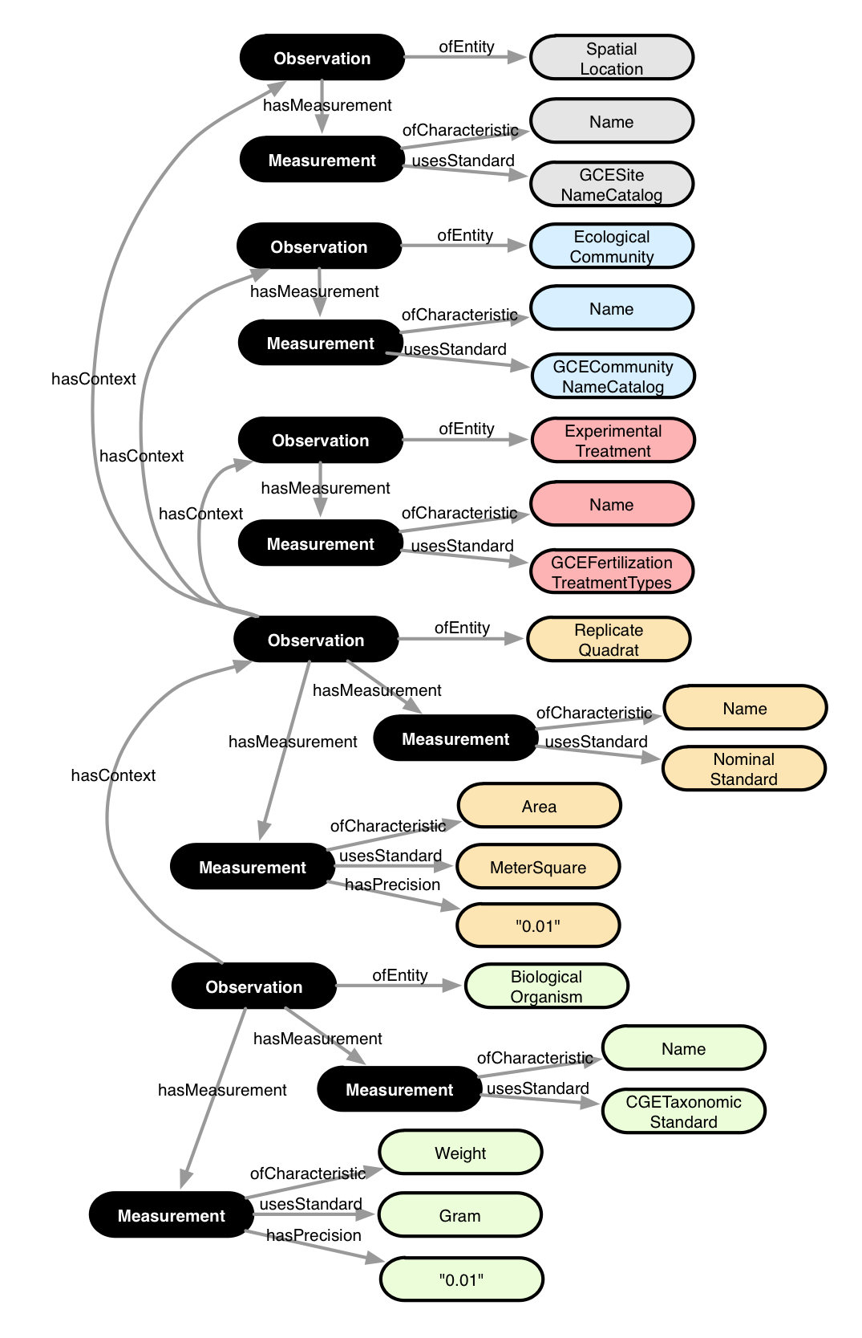

Annotation:

<annotation emlPackage="..." dataTable="..." xmlns:oboe="..." xmlns:ext="...">

<observation label="o1" attributes="Site">
<entity class="ext:SpatialLocation"/>
<measurement>
<characteristic class="oboe:EntityName"/>
<standard class="ext:GCESiteNameCatalog"/>
<value attribute="Site"/>
</measurement>
</observation>

<observation label="o2" attributes="Community">
<entity class="ext:EcologicalCommunity"/>
<measurement>
<characteristic class="oboe:EntityName"/>
<standard class="ext:GCECommunityNameCatalog"/>
<value attribute="Community"/>
</measurement>
</observation>

<observation label="o3" attributes="Treatment">
<entity class="ext:ExperimentalTreatment"/>
<measurement>
<characteristic class="oboe:EntityName"/>
<standard class="ext:GCEFertiliationTreatmentTypes"/>
<value attribute="Treatment"/>
</measurement>
</observation>

<observation label="o4" attributes="Site Community Treatment Replicate">
<entity class="ext:ReplicateQuadrat"/>
<measurement>
<characteristic class="oboe:EntityName"/>
<standard class="oboe:NominalStandard"/>
<value attribute="Replicate"/>
</measurement>
<measurement precision="0.01">
<characteristic class="ext:Area"/>
<standard class="ext:MeterSquare"/>
<value constant="0.25"/>
</measurement>
<context observation="o1" property="oboe:hasContainmentContext"/>
<context observation="o2" property="oboe:hasContainmentContext"/>
<context observation="o3" property="oboe:hasContainmentContext"/>
</observation>

<observation label="o5" attributes="*">
<entity class="ext:BiologicalOrganism"/>
<measurement>
<characteristic class="oboe:EntityName"/>
<standard class="ext:GCETaxonomicStandard"/>
<value attribute="Species_Code"/>
</measurement>
<measurement precision="0.01">
<characteristic class="ext:Weight"/>
<standard class="ext:Gram"/>
<value attribute="Plant_Mass"/>
</measurement>
<context observation="o4" property="oboe:hasContainmentContext"/>
</observation>

</annotation>

