Example 2: Predator-prey study (level: difficult)
Data set sample:

Date | Site | Pred_id | Common | Prey | Prey_Size
01-01-99 | Desert_1 | 34 | eagle | mouse | 0.05
01-01-99 | Desert_1 | 31 | eagle | rat | 0.13
01-01-99 | Desert_2 | 2314 | fox | mouse | 0.08
01-03-99 | Desert_1 | 3213 | fox | mouse | 0.07
01-03-99 | Desert_2 | 2314 | fox | mouse | 0.04
… | … | … | … | … | …

Data attributes:

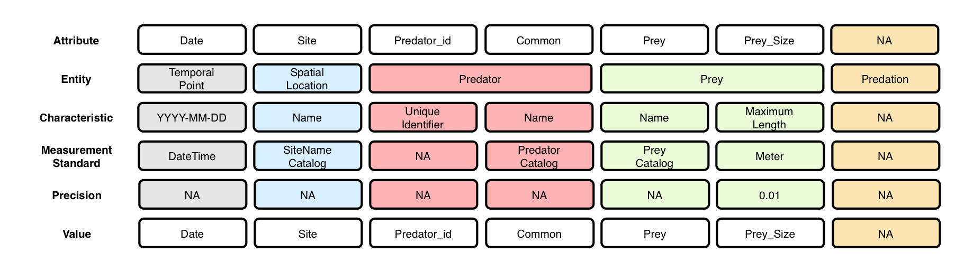

Context (containment) relationships between Entities:

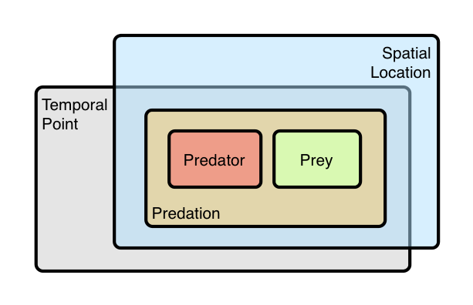

- The Predation event IS dependent on the Spatial Location and the Temporal Point. That is, the Predation event is non-reproducible in another place and time (whereas an Experimental Treatment is, see Example 1)

OBOE model of data set:
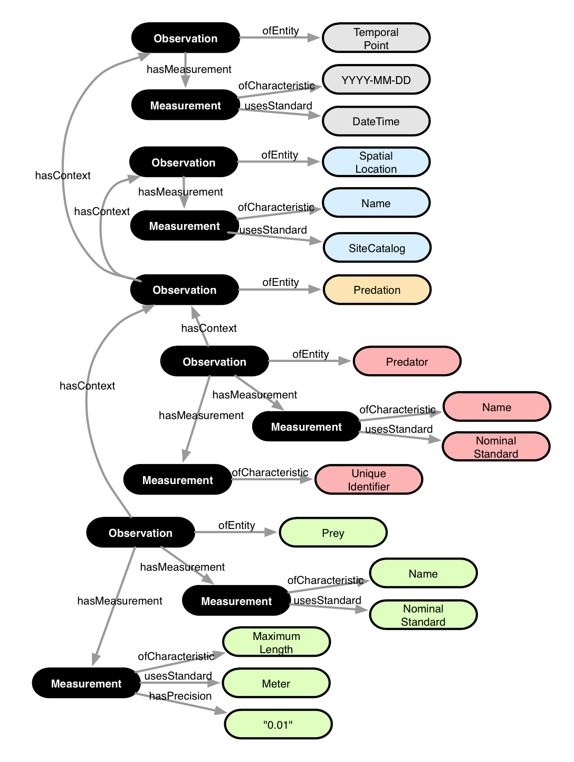

Annotation:

<annotation emlPackage="..." dataTable="..." xmlns:oboe="..." xmlns:ext="...">

<observation label="o1" attributes="Date">
<entity class="ext:TemporalPoint"/>
<measurement>
<characteristic class="ext:Date"/>
<standard class="oboe:DateTime"/>
<value attribute="Date"/>
</measurement>
</observation>

<observation label="o2" attributes="Site">
<entity class="ext:SpatialLocation"/>
<measurement>
<characteristic class="oboe:EntityName"/>
<standard class="ext:SiteCatalog"/>
<value attribute="Site"/>
</measurement>
</observation>

<observation label="o3" attributes="*">
<entity class="ext:Predation"/>
<context observation="o1" property="oboe:hasContainmentContext"/>
<context observation="o2" property="oboe:hasContainmentContext"/>
</observation>

<observation label="o4" attributes="Date Site Predator Predator_Size">
<entity class="ext:Predator"/>
<measurement>
<characteristic class="oboe:EntityName"/>
<standard class="oboe:NominalStandard"/>
<value attribute="Predator"/>
</measurement>
<measurement precision="0.01">
<characteristic class="ext:Maximum"/>
<characteristic class="ext:Length"/>
<standard class="ext:Meter"/>
<value attribute="Predator_Size"/>
</measurement>
<context observation="o3" property="oboe:hasContainmentContext"/>
</observation>

<observation label="o5" attributes="Date Site Prey Prey_Size">
<entity class="ext:Prey"/>
<measurement>
<characteristic class="oboe:EntityName"/>
<standard class="oboe:NominalStandard"/>
<value attribute="Prey"/>
</measurement>
<measurement precision="0.01">
<characteristic class="ext:Maximum"/>
<characteristic class="ext:Length"/>
<standard class="ext:Meter"/>
<value attribute="Prey_Size"/>
</measurement>
<context observation="o3" property="oboe:hasContainmentContext"/>
</observation>

</annotation>

