Example 3: Tree measurements (level: easy)
Data set sample:

Plot | Tree | Species | Ht. | Wth.
1 | 1 | Ssp_1 | 0.85 | 0.05
1 | 2 | Ssp_1 | 0.89 | 0.13
1 | 3 | Ssp_2 | 1.52 | 0.08
1 | 4 | Ssp_3 | 1.45 | 0.07
2 | 1 | Ssp_2 | 1.34 | 0.04
2 | 2 | Ssp_2 | 0.89 | 0.13
3 | 1 | Ssp_1 | 1.52 | 0.08
3 | 2 | Ssp_3 | 1.45 | 0.07
… | … | … | … | …

Data attributes:
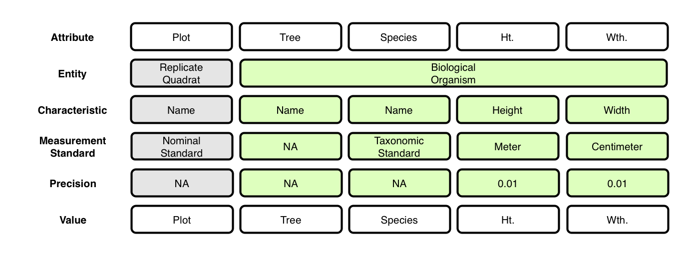
- Note that $Tree attribute is not necessary and probably wouldn’t be recorded.

Context (containment) relationships between Entities:
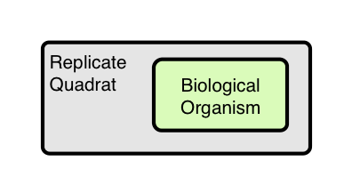
OBOE model of data set:
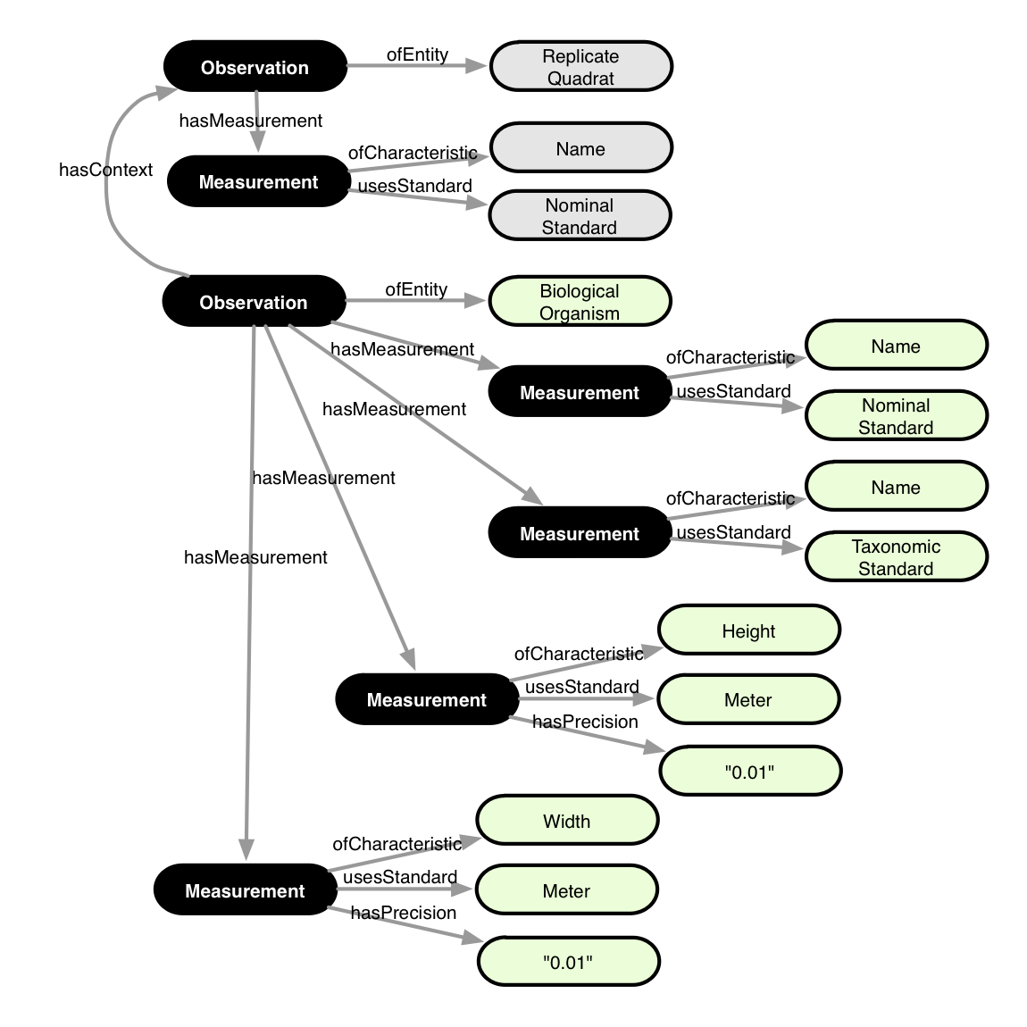
Annotation:

<annotation emlPackage="..." dataTable="..." xmlns:oboe="..." xmlns:ext="...">

<observation label="o1" attributes="Plot">
<entity class="ext:ReplicateQuadrat"/>
<measurement>
<characteristic class="oboe:EntityName"/>
<standard class="oboe:NominalStandard"/>
<value attribute="Plot"/>
</measurement>
</observation>

<observation label="o2" attributes="*">
<entity class="ext:BiologicalOrganism"/>
<measurement>
<characteristic class="oboe:EntityName"/>
<standard class="oboe:NominalStandard"/>
<value attribute="Tree"/>
</measurement>
<measurement>
<characteristic class="oboe:EntityName"/>
<standard class="ext:TaxonomicStandard"/>
<value attribute="Species"/>
</measurement>
<measurement precision="0.01">
<characteristic class="ext:Height"/>
<standard class="ext:Meter"/>
<value attribute="Ht."/>
</measurement>
<measurement precision="0.01">
<characteristic class="ext:Width"/>
<standard class="ext:Centimeter"/>
<value attribute="Wth."/>
</measurement>
<context observation="o1" property="oboe:hasContainmentContext"/>
</observation>

</annotation>

