Example 4: Summary of organism heights in Example 3 data (level: hard)
Data set sample:

Summary produce from Example 3 data (mean height):

 | Spp_1 | Spp_2 | Spp_3 | …
Plot_1 | 0.87 | 1.52 | 1.45 | …
Plot_2 | 0 | 1.12 | 0 | …
Plot_3 | 1.52 | 0 | 1.45 | …
… | … | … | … | …

Data attributes:
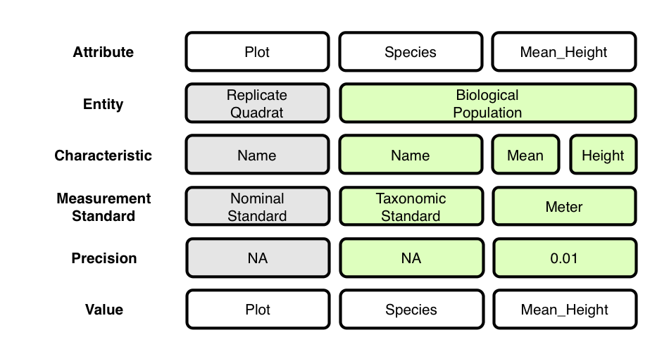
- Shawn – could you suggest how the annotation language would deal with this mapping.

Context (containment) relationships between Entities:
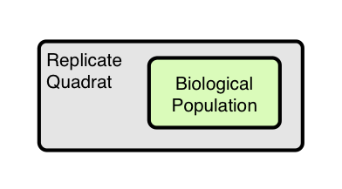
OBOE model of data set:
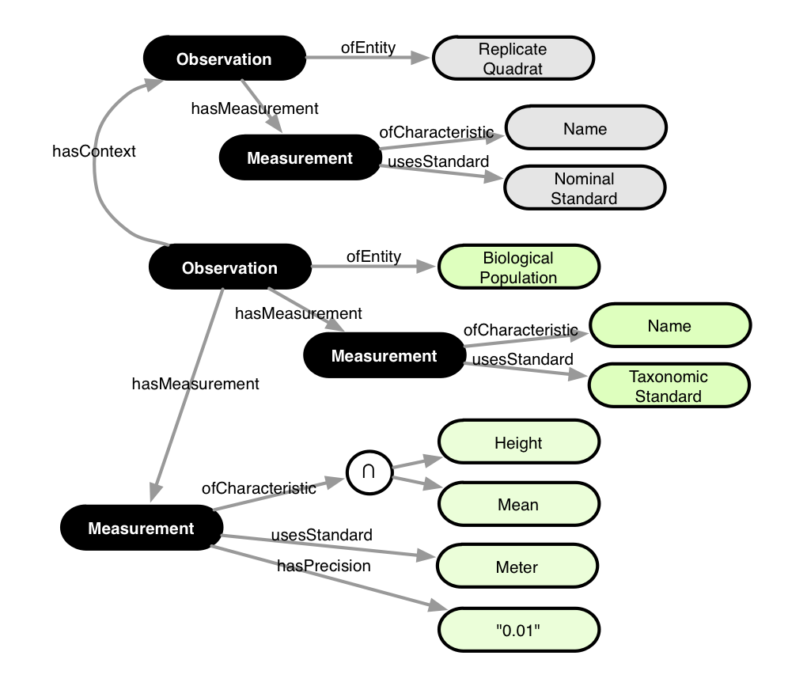

Annotation:

