Example 5: Height data (level: easy)
Data set sample:

Spp_1
0.7
1.2
3.2
3.0
1.2
…

Data attributes:
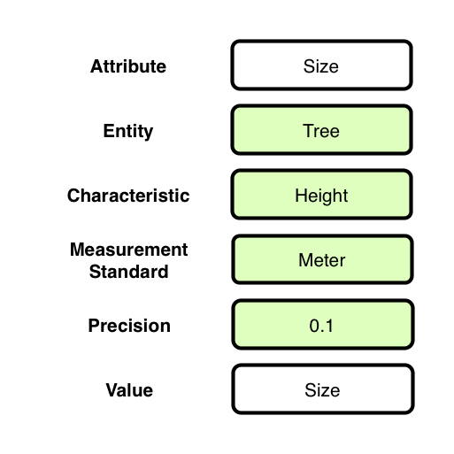

Context (containment) relationships between Entities:
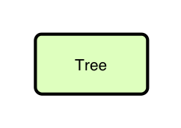
OBOE model of data set:
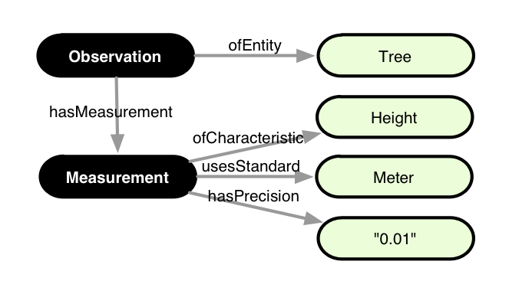

Annotation:

<annotation emlPackage="..." dataTable="..." xmlns:oboe="..." xmlns:ext="...">

<observation label="o1" attributes="Spp_1">
<entity class="ext:Tree"/>
<measurement>
<characteristic class="oboe:EntityName"/>
<standard class="ext:TaxonomicName"/>
<value constant="Spp_1"/>
</measurement>
<measurement precision="0.1">
<characteristic class="ext:Height"/>
<standard class="ext:Meter"/>
<value attribute="Spp_1"/>
</measurement>
</observation>

</annotation>

