Example 6: Specimen record (level: hard)
Data set sample:

Cat | Code | Year | Collector | Long | Lat | Sci_Name | Institution | Species
4815 | Mamm | 1947 | DOWNEY,J. | -109.34 | 37.86 | Mephitis mephitis | ESTOR UMNH | mephitis
6767 | Mamm | 1948 | NEILSON,L. | -109.52 | 40.41 | Mephitis mephitis | ESTOR UMNH | mephitis
6768 | Mamm | 1948 | NEILSON,L. | -109.52 | 40.41 | Mephitis mephitis | ESTOR UMNH | mephitis
… | … | … | … | … | … | … | … | …

Attributes:
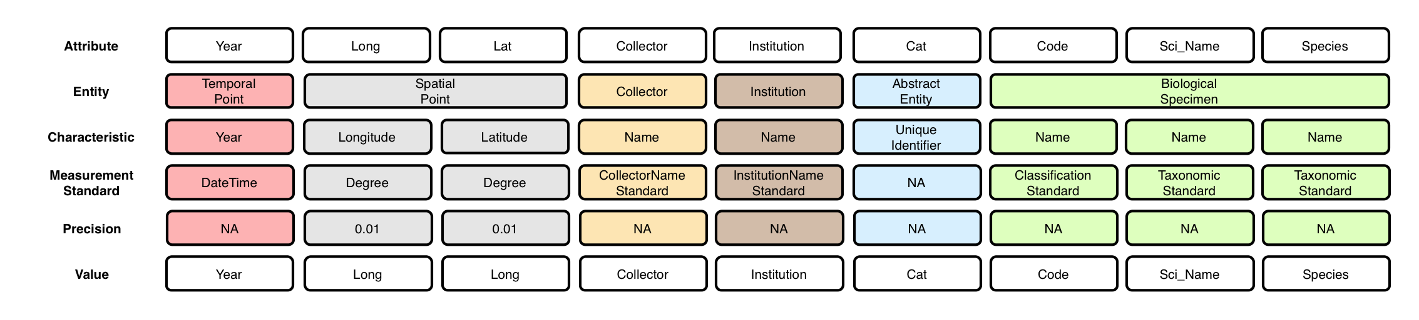
Context (containment) relationships between Entities:
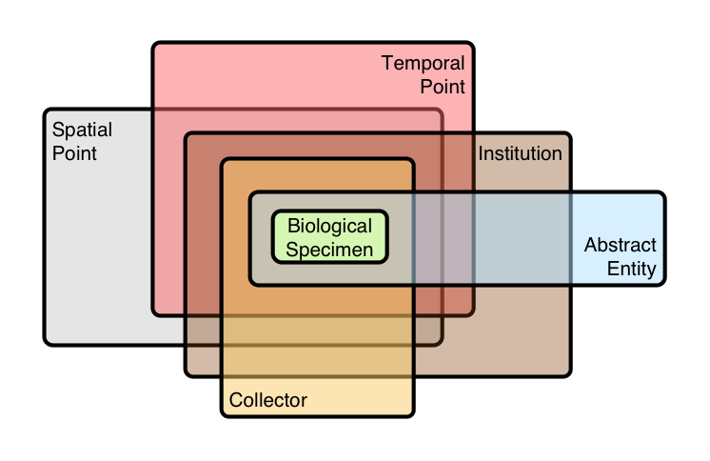

OBOE model of data set:
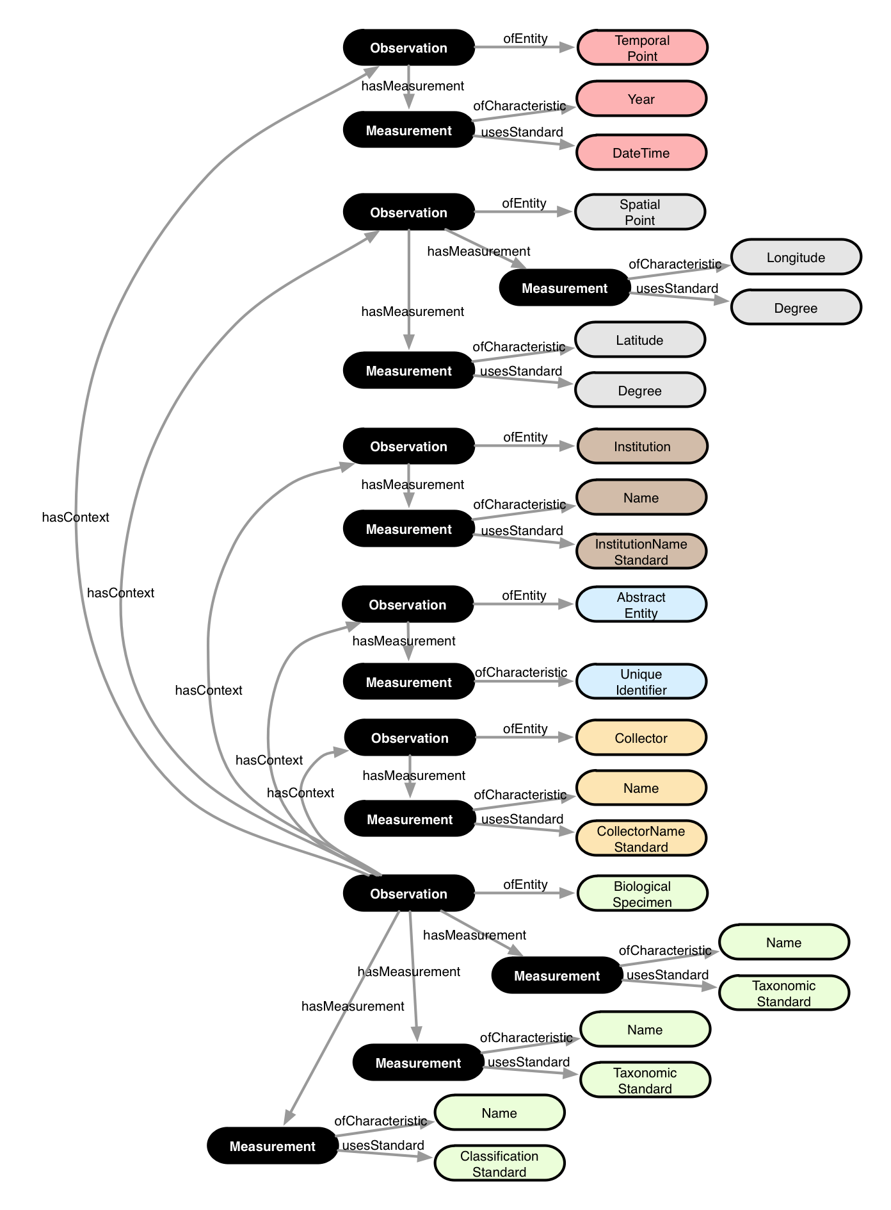

Annotation:

