Example 7: Parasitoid – Parasite – Host (level: very hard)
Data set sample:

Site | Family | Parasitoid | Aphid | Tree
7052 | ADIALYTUS | A. obscuripennis | Laingia psammae | Calamagrostis epigeios
5548 | ADIALYTUS | A. obscuripennis | Sipha sp. | Elytrigia sp.
5451 | ADIALYTUS | A. obscuripennis | Sipha sp. | Hordeum vulgare
5952 | ADIALYTUS | A. obscuripennis | Sipha sp. | Gramineae undet.
6051 | ADIALYTUS | A. obscuripennis | Sipha sp. | Elytrigia repens
7069 | ADIALYTUS | A. obscuripennis | Sipha sp. | Elytrigia sp.
7052 | ADIALYTUS | A. salicaphis | Chaitophorus beuthani | Salix sp.
7052 | ADIALYTUS | A. salicaphis | Chaitophorus leucomelas | Populus nigra
… | … | … | … | …

Data attributes:
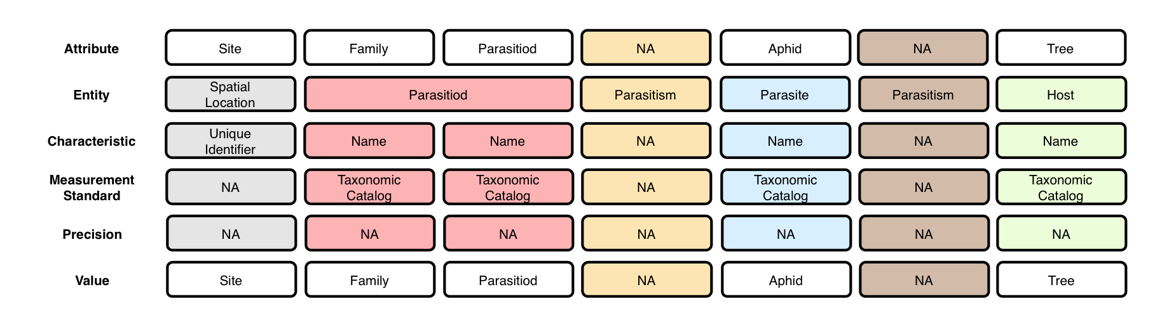

Context (containment) relationships between Entities:
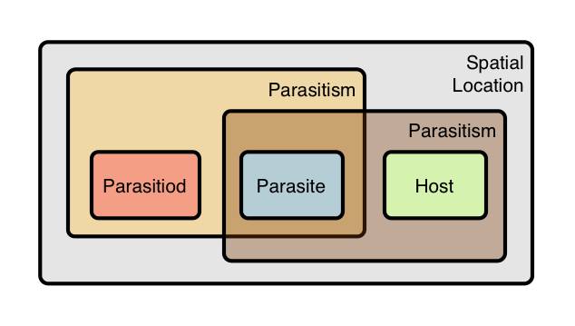

- The Predation event IS dependent on the Spatial Location and the Temporal Point. That is, the Predation event is non-reproducible in another place and time (whereas an Experimental Treatment is, see Example 1)

OBOE model of data set:
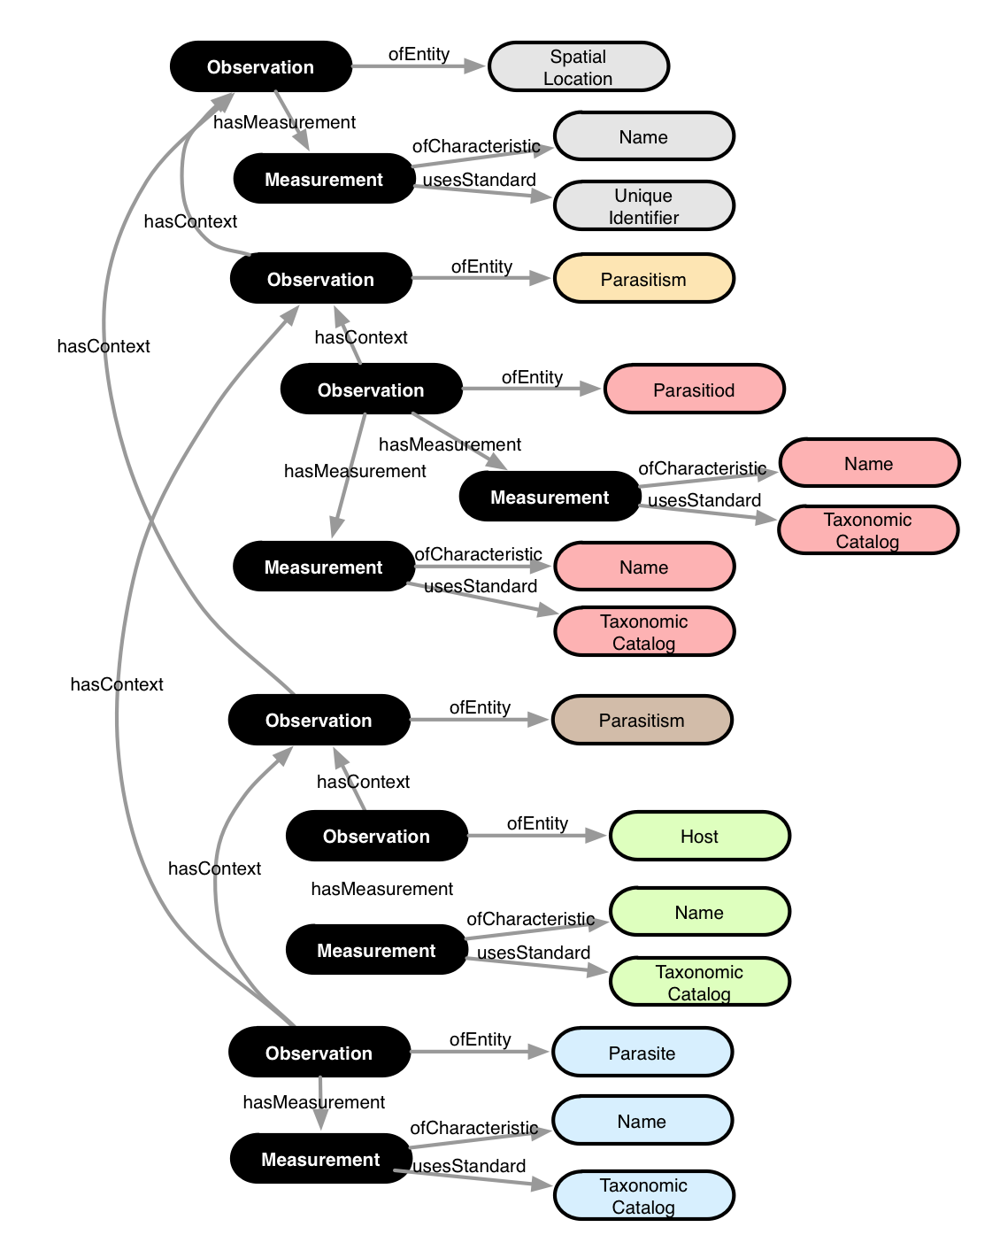

Annotation:

