Example 3: Tree measurements (level: easy)
Data set sample:

A)
Plot | Species | Count
1 | Ssp1 | 5
1 | Ssp2 | 12
1 | Ssp3 | 1
2 | Ssp1 | 7
2 | Ssp2 | 32
3 | Ssp1 | 5
3 | Ssp2 | 21
3 | Ssp3 | 2
… | … | …

B)
Plot | Ssp1_Count | Ssp2_Count | Ssp3_Count | …
1 | 5 | 12 | 1 | …
2 | 7 | 32 | 0 | …
3 | 5 | 21 | 2 | …
… | … | … | … | …

Data attributes:

A and B)
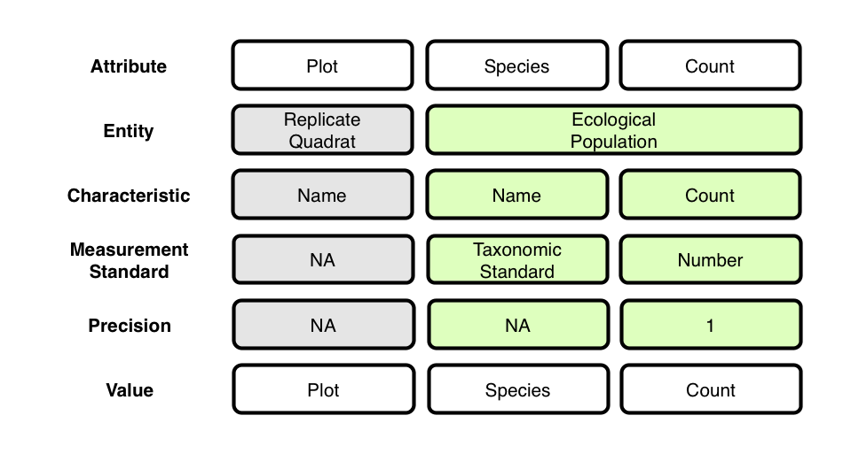

Context (containment) relationships between Entities:

A and B)
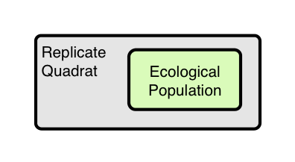

OBOE model of data set:

A and B)
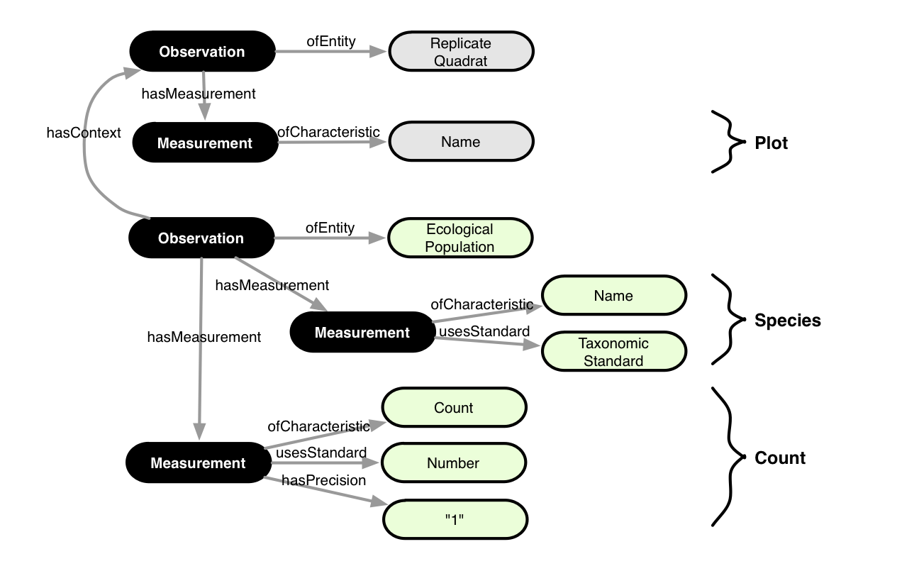
Annotation:

A)

<annotation emlPackage="..." dataTable="..." xmlns:oboe="..." xmlns:ext="...">

<observation label="o1" attributes="Plot">
<entity class="ext:ReplicateQuadrat"/>
<measurement>
<characteristic class="oboe:EntityName"/>
<standard class="oboe:NominalStandard"/>
<value attribute="Plot"/>
</measurement>
</observation>

<observation label="o2" attributes="*">
<entity class="ext:EcologicalPopulation"/>
<measurement>
<characteristic class="oboe:EntityName"/>
<standard class="ext:TaxonomicStandard"/>
<value attribute="Species"/>
</measurement>
<measurement precision="0.01">
<characteristic class="ext:Count"/>
<standard class="ext:Number"/>
<value attribute="Count"/>
</measurement>
<context observation="o1" property="oboe:hasContainmentContext"/>
</observation>

</annotation>

B)

Shawn?

