Example 9: Leaf traits (level: intermediate)
Data set sample:

plot.1 | trt | species | sample.ID | leaf.area | leaf.hyd.mass | leaf.dry.mass | lf.dmc | SLA
29 | w | Acer.negu | 120 | 42.196 | 0.6087 | 0.1405 | 0.23081978 | 300.3274021
42 | w | Acer.negu | 553 | 5.4873 | 0.0712 | 0.0129 | 0.181179775 | 425.372093
32 | w | Acer.negu | 810 | 24.5878 | 0.3534 | 0.0903 | 0.255517827 | 272.290144
30 | w | Acer.negu | 848 | 22.8774 | 0.2976 | 0.0804 | 0.27016129 | 284.5447761

Attributes:
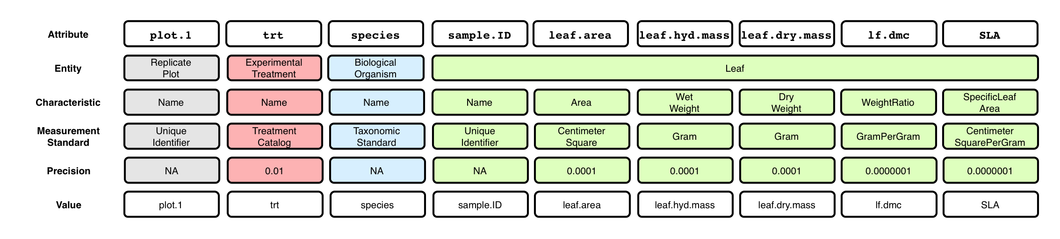

Context (containment) relationships between Entities:
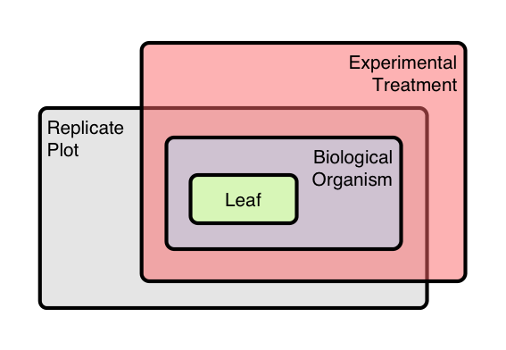

OBOE model of data set:
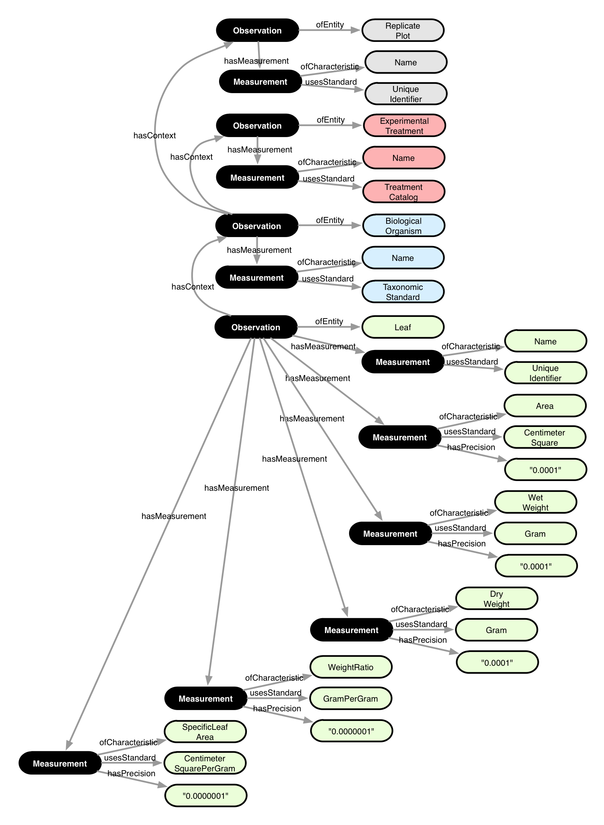

Annotation:

