Tutorial

What is OBOE?
OBOE stands for the Extensible Observation Ontology. OBOE was designed specifically to accurately describe observational data in sufficient detail, and using technology, that facilitates logic-based machine reasoning to help scientists with common research tasks such as finding and merging data sets.

What is an ontology?
Ontologies are formal models that define concepts and their relationships within a scientific domain like ecology. Analogous to mathematical set theory, an ontological “concept” (i.e., set) denotes a collection of “instances” that share common characteristics. The backbone of ontologies is the ‘is-a’ relationship, which states that all instances of a sub-concept (i.e., subset) are also members of a super-concept and therefore inherit all characteristics of the super-concept (Figure 1). For example, Tree would generally be defined as a sub-concept of Plant. There are other commonly used relationships that describe how concepts interact, including ‘part-of’ (or, conversely, ‘has-part’), ‘equivalence’, and ‘disjoint’ relations. In a part-whole (i.e., ‘part-of’ or ‘has-part’) relationship, the instances of one concept (e.g., Tree Branch) are components of instances of another concept (e.g., Tree). These relationships are constrained by the number of instances permitted in the relationship using cardinality restrictions (e.g., a Tree Branch can only be ‘part-of’ one Tree). In an ‘equivalence’ relationship, two concepts denote the same set of instances (e.g., Animals and Metazoans), whereas in a ‘disjoint’ relationship, the instances of the two concepts are mutually exclusive (e.g., Plants and Animals). Relationships and cardinality restrictions are inherited through ‘is-a’ relationships; e.g., instances of the Deme concept have two or more Organism instances as parts, because Deme is a sub-concept of Population.
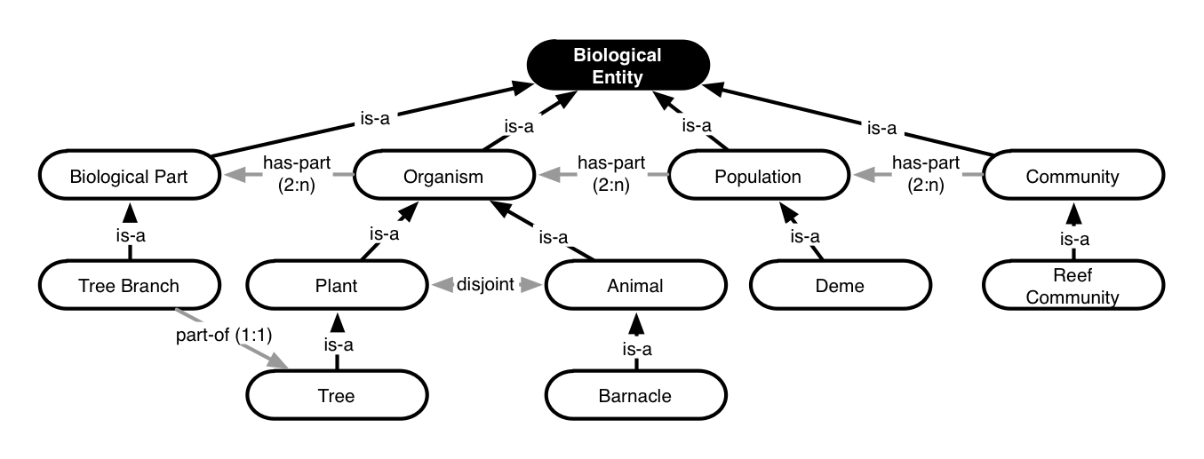
Figure 1. An ontology fragment representing some Biological-Entity concepts and their relationships. In this graphical notation, ellipses denote concepts, arrows denote relationships, and cardinality restrictions are given in parentheses. For example, any instance of Tree Branch is a part of one and only one (i.e., 1:1) instance of a Tree; but, conversely, an instance of Tree has at least two or more (i.e., 2:n) parts that are instances of Biological Part, because ‘has-part’ relationships and cardinality are inherited from super-concepts. This ontology represents only one interpretation of the domain Biological Entity, where other interpretations can similarly be described and possibly interrelated using different ontologies.

Ontology modeling languages such as the Web Ontology Language (OWL) [30] for the Semantic Web [31] are based on a sub-family of mathematical logic called ‘description logic’ [22]. The formal underpinnings of these languages offer advantages over less formal approaches such as controlled vocabularies, thesauri, and concept maps. For example, ontology languages allow precise expressions of the meaning of a scientific assertion that can be checked for consistency and compared with other formal assertions. Through automated reasoning techniques, it is possible to automate the process of determining whether an ontology is internally consistent and to infer new relationships between concepts (beyond those explicitly given in the ontology). For example, in Figure I although Barnacles have Biological Parts (i.e., Barnacle ‘is-a’ Animal, Animal ‘is-a’ Organism, and Organism ‘has-part’ Biological Part), and Tree Branches are Biological Parts (i.e., Tree Branch ‘is-a’ Biological Part), Barnacles cannot have Tree Branches because Animals are ‘disjoint’ from Plants. Although these relationship implications may be obvious to scientists, ontologies enable computers to deduce the implications of long chains of these formal assertions.

The core structure of OBOE

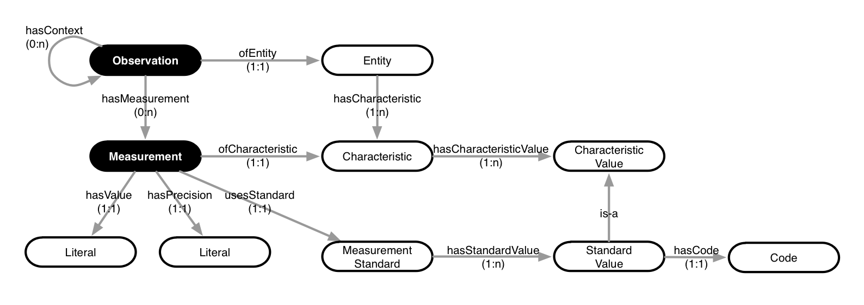
Observation

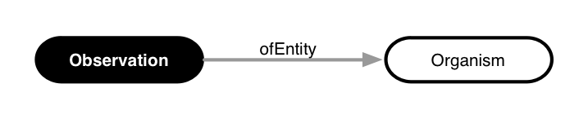

Measurement
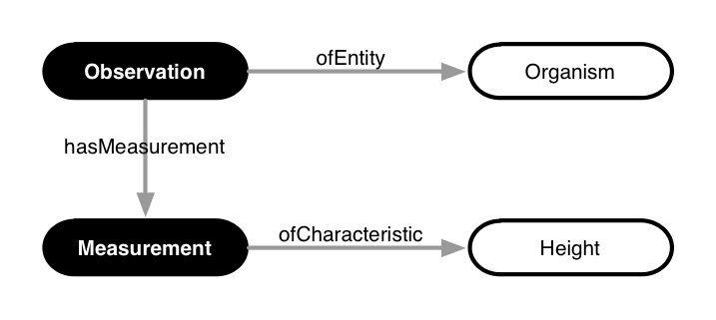

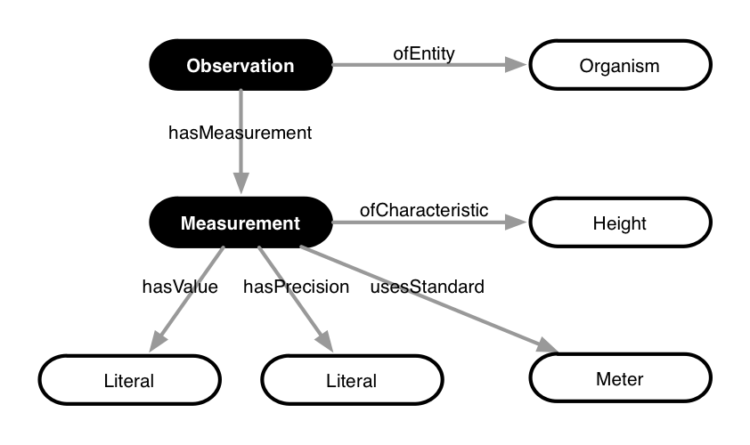
Context

Extending OBOE with more concepts

Annotating data sets with OBOE

Examples of different examples OBOE

- OBOE and Terminology
- Examples

Example 1: Height of a tree

Data set sample

Site | Community | Treatment | Replicate | Species_Code | ITIS_TSN | Plant_Mass | Plant_Mass_m2
GCE6 | BorJun | N | 1 | JROM | 39238 | 75.13 | 300.5
GCE6 | BorJun | N | 2 | JROM | 39238 | 179.81 | 719.2
GCE6 | BorJun | N | 3 | JROM | 39238 | 443.2 | 1772.8
GCE6 | BorJun | N | 4 | JROM | 39238 | 227.53 | 910.1
GCE6 | BorJun | N | 5 | JROM | 39238 | 176.42 | 705.7
GCE6 | BorJun | N | 6 | JROM | 39238 | 121.69 | 486.8
GCE6 | BorJun | N | 7 | JROM | 39238 | 75.91 | 303.6
GCE6 | BorJun | N | 8 | JROM | 39238 | 38.69 | 154.8
GCE6 | BorJun | C | 1 | JROM | 39238 | 256.95 | 1027.8
GCE6 | BorJun | C | 2 | JROM | 39238 | 193.5 | 774
GCE6 | BorJun | C | 3 | JROM | 39238 | 192.28 | 769.1
GCE6 | BorJun | C | 4 | JROM | 39238 | 248.93 | 995.7
GCE6 | BorJun | C | 5 | JROM | 39238 | 330 | 1320
GCE6 | BorJun | C | 6 | JROM | 39238 | 250.84 | 1003.4
GCE6 | BorJun | C | 7 | JROM | 39238 | 167.68 | 670.7
GCE6 | BorJun | C | 8 | JROM | 39238 | 113.87 | 455.5
GCE6 | BorJun | N | 1 | BFRU | 35781 | 1.34 | 5.4
GCE6 | BorJun | N | 2 | BFRU | 35781 | 135.12 | 540.5
GCE6 | BorJun | N | 3 | BFRU | 35781 | 100.33 | 401.3
GCE6 | BorJun | N | 4 | BFRU | 35781 | 337.71 | 1350.8
GCE6 | BorJun | N | 5 | BFRU | 35781 | 186.77 | 747.1
GCE6 | BorJun | N | 6 | BFRU | 35781 | 193.92 | 775.7
GCE6 | BorJun | N | 7 | BFRU | 35781 | 162.35 | 649.4
GCE6 | BorJun | N | 8 | BFRU | 35781 | 242.89 | 971.6
GCE6 | BorJun | C | 1 | BFRU | 35781 | 39.25 | 157
GCE6 | BorJun | C | 2 | BFRU | 35781 | 125.43 | 501.7
GCE6 | BorJun | C | 3 | BFRU | 35781 | 156.25 | 625
GCE6 | BorJun | C | 4 | BFRU | 35781 | 105.86 | 423.4
GCE6 | BorJun | C | 5 | BFRU | 35781 | 328.6 | 1314.4
GCE6 | BorJun | C | 6 | BFRU | 35781 | 122.24 | 489
GCE6 | BorJun | C | 7 | BFRU | 35781 | 177.55 | 710.2
GCE6 | BorJun | C | 8 | BFRU | 35781 | 309.68 | 1238.7
GCE6 | BorJun | N | 1 | BMAR | 192295 | 389.62 | 1558.5
GCE6 | BorJun | N | 2 | BMAR | 192295 | 170.82 | 683.3
GCE6 | BorJun | N | 3 | BMAR | 192295 | 5.09 | 20.4
GCE6 | BorJun | N | 4 | BMAR | 192295 | 23.6 | 94.4
GCE6 | BorJun | N | 5 | BMAR | 192295 | 9.74 | 39
GCE6 | BorJun | N | 6 | BMAR | 192295 | 295.39 | 1181.6
GCE6 | BorJun | N | 7 | BMAR | 192295 | 0 | 0
GCE6 | BorJun | N | 8 | BMAR | 192295 | 0 | 0
GCE6 | BorJun | C | 1 | BMAR | 192295 | 170.82 | 683.3
GCE6 | BorJun | C | 2 | BMAR | 192295 | 48.36 | 193.4
GCE6 | BorJun | C | 3 | BMAR | 192295 | 0 | 0
GCE6 | BorJun | C | 4 | BMAR | 192295 | 51.63 | 206.5
GCE6 | BorJun | C | 5 | BMAR | 192295 | 0 | 0
GCE6 | BorJun | C | 6 | BMAR | 192295 | 0 | 0
GCE6 | BorJun | C | 7 | BMAR | 192295 | 0 | 0
GCE6 | BorJun | C | 8 | BMAR | 192295 | 0 | 0
GCE6 | SpaBor | N | 1 | SALT | 41267 | 590.22 | 2360.9
GCE6 | SpaBor | N | 2 | SALT | 41267 | 815.28 | 3261.1
GCE6 | SpaBor | N | 3 | SALT | 41267 | 686.35 | 2745.4
GCE6 | SpaBor | N | 4 | SALT | 41267 | 599.72 | 2398.9
GCE6 | SpaBor | N | 5 | SALT | 41267 | 1590.63 | 6362.5

