Other Collaborators
We have been collaborating with the Scientific Observations Network (SONet), which is an NSF-funded INTEROP project focused on advancing a core semantic model of scientific observations. Semtools is basing much of its development effort on the observation model being evaluated in the SONet project. Initially we are using the OBOE model as the core and building an annotation framework around that model. As the SONet project progresses we hope to produce a generic solution that allows interoperability with different observation models and ontology authoring approaches. The SONet team has provided valuable insight into authoring domain-specific ontologies and defining best-practices regarding ontology construction.

Activities 2009-2010
After focusing on the development of a prototype semantic search system for Metacat in the first year of the project, we’ve turned our attention to the process of actually annotating observational data so that it can be discovered using these specialized semantic search strategies. Through a weekly feedback loop between the PIs and development team, we’ve honed a new plug-in for the Morpho data management application that allows users to annotate packages and also to locate data packages that have previously been annotated. Morpho development has coincided with authoring a domain-specific ontology that effectively describes data collected at the Santa Barbara Coastal LTER.

At the core of our development is the Semtools API that can be used in both Metacat and Morpho for managing annotations and ontologies. The common features of the library provide an opaque interface for leveraging semantics. The abstracted and centralized API buffers us from the vagaries of rapidly evolving Knowledge Representation technologies. For instance, we were able to switch from Jena API to OWL API as the ontology management library without having to refactor other systems that were utilizing the existing Semtools API.

The Annotation Plugin for Morpho augments the existing data table view with a tabbed interface that highlights different aspects of the annotation process: Summary, Column, and Context. Given the complexity inherent in formally describing observational data, the team has tried to minimize confusion by keeping the focus of the annotation activity on the actual data table being annotated. Furthermore, we’ve adopted a fill-in-the-blank format for collecting the crucial facts that comprise a complete annotation. These self-explanatory, natural language sentences prompt the user for information and also provide built-in help.

The search interface for locating annotated data packages has been directly informed by enhancements to the fill-in-the-blank approach. Sharing similar user interface motifs makes the transition from semantic data locator/consumer to semantic data provider all the more natural. We expect users will initially interact with the plugin’s search facilities before tackling their own data as annotators.

The search interface strikes a balance between expressivity and simplicity. Inspired by a familiar “smart playlist” criteria building interface, the search panel can be used to create compound nested queries that maximize search precision, and reduce false positives. To complement search precision, we use result-ranking to maintain broad recall with the “best” or “closest” matches appearing at the beginning of the search results. Having a solid interface for defining search criteria allows us to continue our focus on evaluating structured, ontology-based query strategies.

Findings 2008-2009
In developing our Annotation plugin for Morpho, we’ve found that the inherent complexity of fully describing an observational data table requires compact visualization of the annotation in-progress. Graph-based representations of the annotation – used extensively in the SONet for illustrating OBOE – show promise for effectively conveying the structure of the observation model as applied to a specific data table. Moreover, the succinct fill-in-the-blank summaries of each observation and their relationship[s] to one another encourage a casual description that is in fact formally rigorous and adheres to our strict Entity/Characteristic/Standard/Protocol annotation model.

Figure 1 shows a sample data set that has been partially annotated against the OBOE model. The biomass column ‘wt’ is annotated: “The WetBiomass of the GiantKelp was recorded in Grams.”
Figure 2 graphs this annotation and also contextualizes the biomass observation Within a Subplot that is itself located Within a Plot. Context is an integral piece to the observation model as it determines how the data should be interpreted and analyzed.

Domain-specific ontologies. In order to evaluate the effectiveness of the Morpho Annotation Plugin we’ve developed an extension to the OBOE ontology that can be applied to existing real-life datasets collected by the Santa Barbara Coastal LTER. O’Brien has selected a subset of data that investigates the nitrogen supply in giant kelp forests. The ontology formalizes such classes as the observation Entity (GiantKelp), Characteristic (WetBiomass), Measurement Standard (Gram), and Protocol (wet vs. dry). <TODO: more from Margaret?>

Outreach Activities
Outreach activities for the project have principally been through papers on Semtools and SONet related work:

David Thau and Shawn Bowers. Best Effort Data Exchange of
Taxonomically Organized Data. International Workshop on New Trends in
Information Integration (NTII), In conjunction with ICDE, 2010.

Shawn Bowers, Joshua S. Madin, Mark P. Schildhauer: Owlifier: Creating
OWL-DL ontologies from simple spreadsheet-based knowledge
descriptions. Ecological Informatics 5(1): 19-25, 2010.

David Thau, Shawn Bowers, Bertram Ludäscher: Merging Sets of
Taxonomically Organized Data Using Concept Mappings under Uncertainty.
OTM Conferences (2): 1103-1120, 2009.

Chad Berkley, Shawn Bowers, Matthew B. Jones, Joshua S. Madin, Mark
Schildhauer: Improving Data Discovery for Metadata Repositories through Semantic Search. CISIS: 1152-1159, 2009.

Contributions within discipline
There [seems to be] movement within the ecological sciences to develop ontologies for organizing and formalizing what was observed and how. Our initial work with OBOE and the Morpho Annotation Plugin has illuminated questions about how these different ontologies can be unified and connected.

Contributions to Resources for Science and Technology
The relative newness of knowledge representation and the use of ontologies to express and formalize information in a way that machines can ‘understand’ puts our real-life use of the technology at the forefront of the art. TODO…there’s got to be more here.

Special Reporting Requirements

During the first year of the award, we have spent only a small fraction of the awarded funds, and expect to have $465,557.27 remaining at the end of the first year. There are several reasons for this slow expenditure rate. First, due to budget cuts we removed the portion of the project dealing with the creation of a core model for scientific observations, instead opting to collaborate with the SONet project on that activity. This core model is required before tools can be developed under Semtools, so we wanted to delay work on the tools until the SONet activity was established. Second, we were able to leverage the end of the SEEK project to employ Chad Berkely as a software engineer to do the initial prototyping work on the semantic extensions to Metacat described in the Activities and Findings section. This allowed us to explore our initial prototypes without using Semtools funds during the first year, thereby increasing our overall ability to meet project goals. Third, the final budget from NSF did not allow us to fund a developer for three full years, and so we decided that it would benefit the project to delay the start of the developer until our plans for tool extension were fully mature.

Our spending on this project will increase significantly in August, 2009, as we will be starting to employ Benjamin Leinfelder on the project to begin development in August. Leinfelder will continue full time on the project, and we will also begin to spend the PI summer salaries. We fully expect to spend the funds as originally allocated to complete project goals.

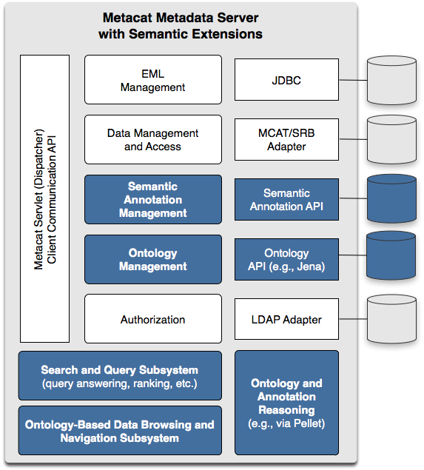
Figure 1: Semantic extensions (highlighted in blue) to the Metacat data and metadata repository support improved precision and recall in searches for scientific data sets.

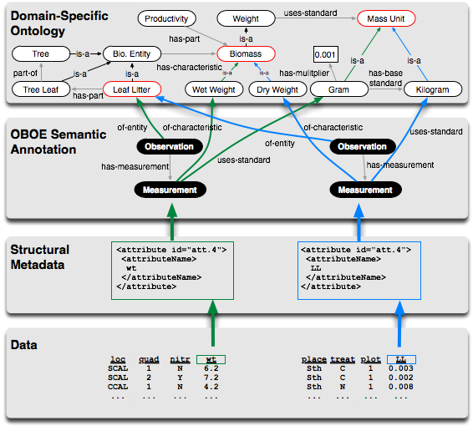
Figure 2. The components of our semantic-search framework including relational data, EML-based metadata, semantic annotations based on OBOE, and OBOE domain-ontology extensions.

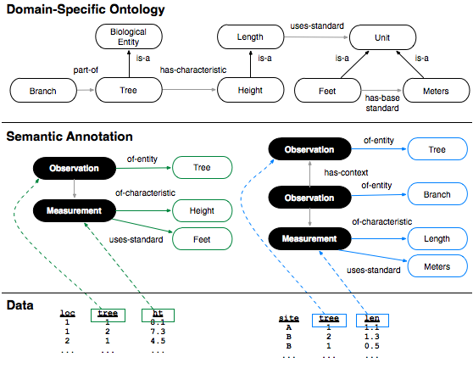
Figure 3. Example annotations demonstrating more precise search results for observation-based structured query.

