Some issues about concept-based taxonomic data model

1. Introduction
2. Concept-based Model
3. The Evolvement of Taxonomic Concept and Operational Relationship
4. A concept-based model focusing on inter-concept relationships
5. Discussion
6. Summery

1. Introduction

Taxonomic system is a highly dynamic and controversial world. Organisms are categorized and labeled by Taxonomists according to specific nomenclatural rules. Given that all taxonomists rigorously obey the same nomenclatural system, the result of their classification process could be very different, due to the difference in their perspectives in classifying criteria, favorite taxonomic characteristics and set of specimens. Even the same Taxonomist may have different opinions about a taxon at different time. So it is often the case that different names are applied to the same taxon and several taxa are labeled by the same name. These conflicts have brought great inaccuracy, even fallacy into biological analysis on taxon-related data.

Another challenge is to integrate taxonomic data from different data sources. There are a bunch of taxonomic data providers, such as ITIS, USDA PLANTS, which favorite different standards and offer data in different taxonomic groups and formats. There is great demand to integrate the data from these providers.

A lot of work has been undertaken to resolve the taxonomic conflicts. It seems that concept-based data model is getting the focus of concentration. The first part of this paper will devoted to overview taxonomic concept and discuss some weaknesses of current concept-based models. Based on an intuitive feeling that the best solution comes from the actual taxonomic practices that drives the development of taxonomic system, Taxonomists’ practices were described and possible clues for taxonomic data model were discussed. As a result, a new concept-based data model was proposed.

2. Taxonomic concept and Concept-based taxonomic data model

Taxonomic Concept
A taxonomic concept is a group of biological objects categorized by an individual or a group according to explicit or implicit criteria. So ‘taxonomic concept’ is a highly subjective concept and is so called ‘potential taxon’.

A taxonomic concept should be understood as a result of strict categorizing process carried out by Taxonomists according to standard nomenclatural and taxonomic rules. Common name and surrogating codes should not be regarded as taxonomic concepts. This restriction is very important for define a concise and accurate taxonomic concept object.

Concept-based Taxonomic Data Model
Taxonomic concept offered a possibility to model the complexity of taxonomic system. A lot of Taxonomic Data Models, such as ITIS, VegBank, SEEK Taxon have been proposed and implemented to serve different applications. While these models may differ from each other in data schemas, implementation methods and serve purposes, they share more or less the same core structure to take name-reference couple as concept and define phylogenetic connection as inter-concept relationship.

Name-reference Couple
Taxonomic concepts are labeled by the combination of their scientific names and the references where they were firstly cited. Name-reference solution is workable but may cause confusion and introduce redundant information without clear specification because scientific name itself could include references. For example, Carya illinoinensis (Wangenheim) K Koch, Dendrologie 1:593. 1869 will have several options of name-reference combination as following.

Possible name-reference couples of Carya illinoinensis
Name | Reference
Carya illinoinensis | Wangenheim, ?
Carya illinoinensis | K Koch, Dendrologie 1:593. 1869
Carya illinoinensis (Wangenheim) | K Koch, Dendrologie 1:593. 1869
Carya illinoinensis (Wangenheim) K Koch | K Koch, Dendrologie 1:593. 1869
Carya illinoinensis | Stone, FNA 3:419. 1997
Carya illinoinensis (Wangenheim) | Stone, FNA 3:419. 1997
Carya illinoinensis (Wangenheim) K Koch | Stone, FNA 3:419. 1997

At most, we have 3 concepts here created by 3 scientists, Wangeneim, K Koch and Stone, given that Stone created his own concept instead of borrowing the complete concept from K Koch. Without concise definition, it is possible to have 7 records for only 3 concepts. 4 records will be unnecessary redundant information. Considering the huge volume of concepts, these duplications will waste great storage space and the worse, dramatically retard the performance of data operation.

Another possible source of redundancy lies in reference. Reference itself is a very coarse concept and could mean anything that could be referred to by others. For a taxonomic concept, its reference could be the publication where it was created, the Flora books where it was colleted and the local field guides where it was cited. The only reference we need for a concept is the one we can refer to as the origin of that concept. To collect an existing concept in a Flora book does not necessarily create a new concept, unless the collector changes at lease one aspect of that concept.

Therefore, the range of Name and Reference should be refined to precisely and concisely define a concept. Name should be scientific name without any reference attachment (Author, publication & Date). Reference of a concept should include the author who created the concept, the publication where the concept originally described and the date when the concept was created. Based on this, we can get a much more concise version for above example as following.

Concise version of name-reference couples of Carya illinoinensis
Name | Reference
Carya illinoinensis | Wangenheim, ?
Carya illinoinensis | K Koch, Dendrologie 1:593. 1869
Carya illinoinensis | Stone, FNA 3:419. 1997

By truncating the full scientific name, we lose some historical information implied in the reference part of a name. We only get three concepts with the same nice name Carya illinoinensis, but have no idea who created it and who revised it later. So we need another data entry to explicitly describe the concept relationship.

Inter-concept relationship

Synonym Relationship
Synonym Relationship defines the congruent relationship of two concepts. This excludes the relationship between a concept and its common names.

Phylogenetic Relationship
Phylogenetic relationship defines the relative position of one concept to another along the phylogenetic path. Parent-child is the basic relationship to define the whole phylogenetic tree.

Operational Relationship
Operational relationship defines the evolving process from one concept to another. For example, given that species A was split by some taxonomist into two new species A1 and A2, the operational relationship would be like ‘A1 & A2 is split from A’.

All current taxonomic data models focus on first two types of relationships but ignore the third one. However, the operational relationship is at least the same important as the other two. Phylogenetic relationship describes what the taxonomic system is, while operational relationship records how the taxonomic system evolved driven by taxonomists’ activities. Information about taxonomists’ activities, i.e., how to create a new concept, is very instrumental to fully understand a concept in its historical context.

3. The Evolvement of Taxonomic Concept and Operational Relationship
Taxonomic concepts are dynamically changing. As we have a phylogenetic tree of concepts, we also have an operational tree which documents how concepts are created through taxonomists’ operations. These operations include adding new concepts, splitting, merging and moving existing concepts.

Adding new concepts
When taxonomists work with a set of new specimens and can not find a right place to fit in the current taxonomic system, they create new concepts and add them into a proper position in the current system.

Fig. here

Splitting existing concepts
When a taxonomist reevaluates the specimens of an existing concept and finds that some specimens are taxonomically so different from others that they should be treated as separate groups, he or she then splits the current concept into several new concepts and put them back into proper places in the current system.

Fig. here

Merging existing concepts
When a taxonomist reevaluates several existing concepts and finds that they are taxonomically homogenous enough to be summed up into one group, he or she then merge them up to a new concept and fit it in the current system.

Fig. here

Moving concepts
When a taxonomist re-evaluates an existing concept and finds that it is taxonomically closer to another concept than its current parent concept in the phylogenetic tree, he or she then moves over to a new place.

Fig. here

If we take Organism as a super concept to contain all living objects in the world, then every new concept should have at least one operational relationship with others. Evolvement of taxonomic system is actually the history of operations imposed on taxonomic concepts by taxonomists. Operational relationship between concepts will give us a full view of taxonomic history, which, together with synonymic and phylogenetic relationships, conveys abundant semantic information for evaluating, querying and comparing concepts.

4. A concept-based model focusing on inter-concept relationships

Based on above discussion, we propose a concept-based model with concise definitions of Name of Reference and with emphasis on inter-concept relations. We are not intended to offer a full data model here since other objects like Common Name and Status are beyond of what this paper is mainly talking about.

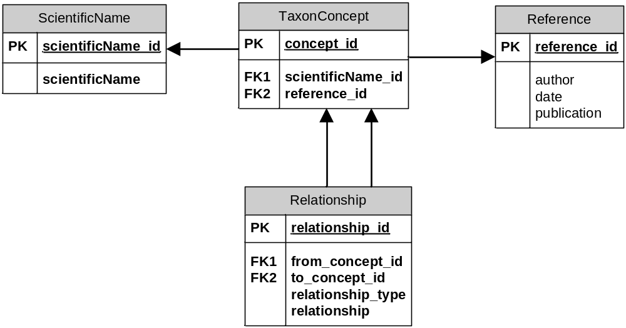

Concept-based data model focusing on inter-concept relationship

Descriptions of Tables and Fields
ScientificName

scientificName_id | unique id for scientific name
scientificName | Scientific taxon name without any reference attachment (author, publication and date)

Reference
reference_id | unique id for reference
author | the author who created the concept
date | the date when the concept was created
publication | where the concept was created

TaxonConcept
concept_id | unique id for concept
scientificName_id | foreign key to ScientificName. scientificName_id
reference_id | foreign key to Reference. reference_id

Relationship
relationship_id | unique id for relationship
from_concept_id | foreign key to TaxonConcept.concept_id
to_concept_id | foreign key to TaxonConcept.concept_id
relationship_type | the type of relationship from concept pointed by from_concept_id to the concept pointed by to_concept_id. The value could be one of three options:  - synonymic  - phylogenetic  - operational
relationship | the relationship from concept pointed by from_concept_id to the concept pointed by to_concept_id. The value depends on the value of relationship_type.  if relationship_type= synonymic, relationship only has one value: synonym  if relationship_type= phylogenetic, relationship only has one value: parent/son  if relationship_type= operational, relationship has 4 options:  - new  - split from  - merge from  - move from

5. Discussion

Redundancy

Minimizing - if not eliminating - redundancy is a major objective in database design. Redundancy not only causes physical inefficiency, but also increases the potential for inconsistency and imposes prohibitive integrity burdens at the logical level on both users and the system, of which many practitioners are not even aware. Conceptual confusion and/or poor logical design are often the major reasons for redundancy (http://www.dbdebunk.com/page/page/847595.htm).

Taxonomic data is a good example of complicate data which contains highly heterogeneous data objects and multi-to-multi relationships among these objects. Careful conceptual design is the first and the most important step to a sensible, concise and integrate taxonomic data model.

Separation of name and reference is a good practice at conceptual level to represent taxonomic concepts, because the name and the person who uses the name are two different objects. Considering many taxonomists could label their concepts by the same name and as well one taxonomist could label different concepts with different names, the separation will greatly decrease the redundancy and at the same time, conceptually clarifies taxonomic concept as name-reference couple. However, this design still has chance to be misunderstood during its implementation. According to international nomenclatural rules or taxonomic conventions, taxon name could include the reference information (name of its authors, dates and publications), and hence it is possible to put a name with reference as the Name and put the reference again as Reference.

Integrity means the integration relationship among data objects. For example, once a taxon concept exists, the name and reference of this concept must exits, or the integrity lost. More connections exist among data objects, more chances to lose the integrity. Unnecessary links should be avoided as much as possible. For example, Concept already links Name to Reference, it is not necessary for Name to have another link to Reference. Concept can access Reference through its link to Reference, so it is not necessary to duplicate all the Reference information as its own fields.

It is difficult, if not impossible, to eliminate redundancy, especially for a complex system like taxonomic data. Sometimes, redundancy helps to simplify data object models. For example, in the data model proposed in this paper, three types of inter-concept relationships are stored in one table instead of separated three different ones. How to control this kind of redundancy is an application- and individual-specific issue. But conceptual and logic redundancy should be eliminated all the time.

Reference
Reference is almost everywhere in taxonomic data model. Concepts have references to record their origins. The status of a concept may have a reference to show where the status was stated. Different usages of a concept may have references to describe where the usages occurred. Is it better to have one reference entry with mixed types of references or several different ones with specific utilities?

Although one mixed reference entry (object/table), in some extant, may simplify the model structure, it, for sure, introduces conceptual confusion. Moreover, one big reference entry will greatly increases the system burden in data traffic considering that the reference is expected to be the most frequently visited information in query, comparison and other data operations. At last, one mixed entry may introduce redundancy because not all the fields in the entry are required for each type of reference. For example, a concept reference only needs three fields, author, date and publication, while a usage reference may require more detailed information, such as article title, volume and pages.

Since the idea of one mixed reference entry is doubtable and considering that taxonomic concept is a conceptually independent object, it is suggestible to separate the reference of concept from others. This separation makes the data model more coherent conceptually, more efficient physically and more controllable logically.

Summery

To achieve a coherent, concise and efficient taxonomic data model, restrictions are suggested to be applied to the two components of a taxonomic concept - Name and Reference. Name should be a ‘pure’ taxon scientific name without reference attachments. Reference should concept-specific and separated from other kinds of references. Redundancy introduced by conceptual confusion and poor logic design should be eliminated all the time.

Operational relationship is a very important inter-concept relationship, which together with synonymic and phylogenetic relationships documents a full view of the taxonomic concept world.

