NCEMS – CURE: Mass Spectrometry Theory Review

2025-08-20 by Ian Sitarik

**Table of Contents**

(I) Mass Spectrometry in Proteomics: Introduction 2

(II) Top-Down vs. Bottom-Up Proteomics 2

Bottom-Up Proteomics (BUP) 3

Top-Down Proteomics (TDP) 3

(III) Core Components of a Mass Spectrometer 4

Ion Source 4

Mass Analyzer 4

Detector 4

Tandem MS (MS/MS) 5

(IV) From Protein to Spectrum: The Proteomics Pipeline 5

General steps in collecting mass spectrometry proteomics data 5

Protein Extraction and Digestion 5

Peptide Separation 5

Mass Spectrometry Analysis 5

Data Interpretation 5

Biophysical Principles at Work 6

Ionization Efficiency 6

Mass Resolution 6

Fragmentation Patterns 6

Quantification 6

(V) Why Mass Spectrometry Works for Proteomics 6

Sensitivity 6

Specificity 6

Throughput 6

(VI) Applications of Mass Spectrometry in Proteomics 7

Protein Identification 7

Quantitative Proteomics 7

Post-Translational Modification (PTM) Mapping 7

Biomarker Discovery 7

Proteoform Characterization 7

Protein–Protein Interaction (PPI) Mapping 7

Subcellular or Spatial Proteomics 7

Chemical Proteomics / Drug Target Profiling 8

Environmental and Microbial Proteomics 8

# (I) Mass Spectrometry in Proteomics: Introduction

Mass spectrometry (MS) has revolutionized the field of proteomics, the large-scale study of proteins, by enabling the identification, quantification, and structural characterization of thousands of proteins from complex biological samples. At its core, *mass spectrometry* is an analytical technique that measures the *mass-to-charge ratio (m/z)* of ionized molecules. In proteomics, MS is used to analyze peptides and proteins after enzymatic digestion (typically with trypsin), producing characteristic *mass spectra* that act as molecular fingerprints. Selected Recent Proteomics Papers

1. *“Mass spectrometry‑based proteomics data from thousands of HeLa control samples”* (*Scientific Data*, 2024)  
   Provided a curated dataset of 7,444 HeLa cell line runs with rich metadata and search output to support machine learning benchmarking and reproducibility in MS‑based proteomics ([Nature](https://www.nature.com/articles/s41597-024-02922-z)).
2. *“A multi‑species benchmark for training and validating mass spectrometry proteomics machine learning models”* (*Scientific Data*, Nov 2024)  
   Released 2.8 million high-confidence peptide–spectrum matches across nine species to advance machine learning applications in proteomics ([Nature](https://www.nature.com/articles/s41597-024-04068-4)).
3. *“Quantifiable peptide library bridges the gap for proteomics‑based biomarker discovery and validation on breast cancer”* (*Scientific Reports*, 2023)  
   Developed a synthetic peptide library (PepQuant) covering ~850 blood‑detectable proteins and validated nine breast cancer biomarkers with ROC AUC ~0.91 in clinical serum/plasma samples ([Nature](https://www.nature.com/articles/s41597-025-04829-9), [Nature](https://www.nature.com/articles/s41598-023-36159-4)).
4. *“Proteome‑wide profiling and mapping of post translational modifications in human hearts”* (*Scientific Reports*, 2021)  
   Performed high-resolution MS to identify over 150 distinct PTMs across human cardiac tissues, creating a comprehensive atlas of protein modifications in human hearts ([Nature](https://www.nature.com/articles/s41598-021-81986-y)).
5. *“Single‑cell proteomics as a tool to characterize cellular hierarchies”* (*Nature Biotechnology*, June 2021)  
   Advanced understanding of protein expression in single mammalian cells during differentiation using mass spectrometry–based single-cell workflows (e.g., scDVP, SCoPE) ([ScienceDirect](https://www.nature.com/articles/s41467-021-23667-y)).

Would you like to include any *Science* journal examples or expand this list with applications such as clinical biomarker discovery or PTM mapping?

# (II) Top-Down vs. Bottom-Up Proteomics

Mass spectrometry-based proteomics can be broadly divided into *bottom-up* and *top-down* approaches, each offering unique strengths and challenges depending on the biological question:

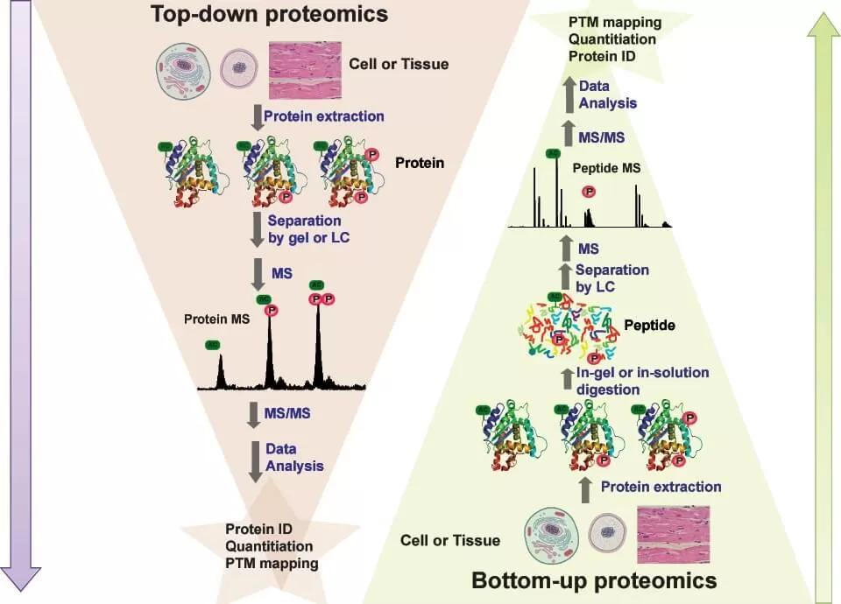  
* https://www.metwarebio.com/top-down-vs-bottom-up-proteomics-protein-analysis/

## Bottom-Up Proteomics (BUP)

Definition: Proteins are enzymatically digested (e.g., with trypsin) into peptides before MS analysis.

Advantages:

* High sensitivity and scalability.
* Amenable to complex samples (e.g., tissues, biofluids).
* Compatible with isobaric labeling for *quantitative comparisons*.

Limitations:

* Loses information about *intact proteoforms* (e.g., isoforms, co-occurring PTMs).
* *Protein inference* is sometimes ambiguous (many peptides map to multiple proteins).

## Top-Down Proteomics (TDP)

Definition: Intact proteins are directly ionized and analyzed without prior digestion.

Advantages:

* Preserves the *complete proteoform,* including sequence variants, splice isoforms, and multiple PTMs on a single molecule.
* Ideal for studying *post-translational modification crosstalk*, proteoform diversity, and protein complexes.

Limitations:

* Lower throughput and dynamic range.
* Challenging for high-mass proteins or highly complex mixtures.
* Requires high-resolution instruments and specialized fragmentation techniques (e.g., ETD, ECD).

# (III) Core Components of a Mass Spectrometer

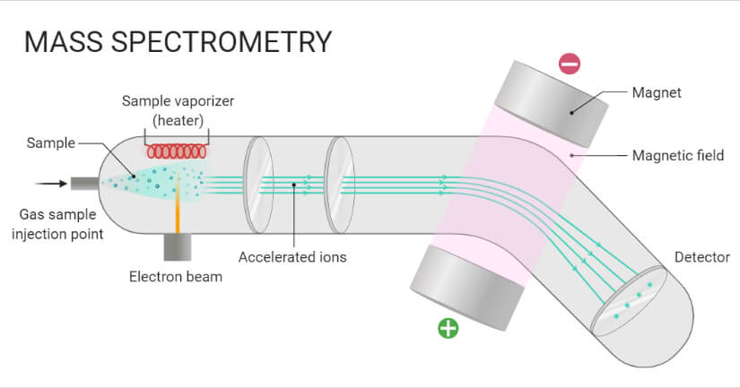  
* <https://microbenotes.com/mass-spectrometry-ms-principle-working-instrumentation-steps-applications/>

## Ion Source

Purpose: Converts neutral peptides into gas-phase ions.

* *Electrospray Ionization (ESI)*: Soft ionization method ideal for peptides and proteins.
* *Matrix-Assisted Laser Desorption/Ionization (MALDI)*: Pulsed ionization used for imaging and intact proteins.

## Mass Analyzer

Purpose: Separates ions based on their *mass-to-charge ratio (m/z)*.

* *Quadrupole*: Selects ions of specific m/z before fragmentation.
* *Time-of-Flight (TOF)*: Measures the time ions take to reach the detector.
* *Orbitrap* and *Fourier Transform Ion Cyclotron Resonance (FTICR)*: High-resolution analyzers based on ion motion in electric or magnetic fields.

## Detector

Purpose: Records the number and intensity of ions at each m/z value.

## Tandem MS (MS/MS)

Purpose: Ions are selected, fragmented (usually by *collision-induced dissociation*), and the fragments are analyzed to determine amino acid sequences.

# (IV) From Protein to Spectrum: The Proteomics Pipeline

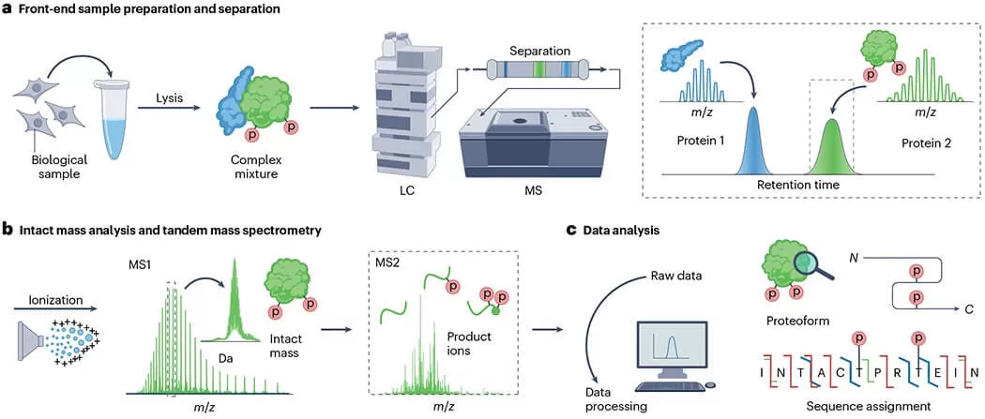  
* <https://www.metwarebio.com/top-down-vs-bottom-up-proteomics-protein-analysis/>

## General steps in collecting mass spectrometry proteomics data

### Protein Extraction and Digestion

Proteins are extracted from biological samples and enzymatically digested (e.g., with trypsin) into peptides.

### Peptide Separation

Using *liquid chromatography (LC)*, peptides are separated based on hydrophobicity to reduce sample complexity.

### Mass Spectrometry Analysis

Peptides are ionized and sent into the mass spectrometer for *MS1* (precursor) and *MS2* (fragment) scans.

### Data Interpretation

Spectra are interpreted by:

* *Database searching* (e.g., SEQUEST, MSFragger)
* *De novo sequencing*
* *Spectral library matching*

## Biophysical Principles at Work

### Ionization Efficiency

Depends on peptide charge states, surface area, and solvent composition.

### Mass Resolution

Determines the ability to distinguish closely related m/z values.

### Fragmentation Patterns

Governed by bond energetics — most common are *b- and y-ions* in peptide backbones.

### Quantification

Achieved via:

* *Label-free* methods (ion intensities or spectral counts)
* *Stable isotope labeling* (SILAC, TMT, iTRAQ)

# (V) Why Mass Spectrometry Works for Proteomics

Mass spectrometry is uniquely suited for large-scale proteomic analysis due to a combination of sensitivity, specificity, and throughput that other biochemical techniques (e.g. ELISA, western blotting) cannot match in a single platform.

## Sensitivity

Mass spectrometers can detect attomole to femtomole quantities of peptides, translating to nanogram or even femtogram levels of proteins, depending on the ionization method and instrument used. Biological systems often contain low-abundance regulatory proteins such as transcription factors or signaling intermediates (e.g., kinases), which are present at sub-nanomolar concentrations. MS can detect these molecules even when they’re vastly outnumbered by structural proteins like actin or tubulin.

## Specificity

MS provides molecular specificity through two key mechanisms:

* *High mass accuracy* (often <1 ppm in Orbitraps or FT-ICR analyzers), allowing precise discrimination of peptides differing by a single amino acid or modification.
* *Fragmentation spectra (MS/MS)*, which generate sequence-specific fragment ions enabling unambiguous identification of peptides.

MS achieves specificity based on physical principles of mass and fragmentation behavior, making it especially powerful for identifying isobaric peptides, mutations, or post-translational modifications (PTMs).

## Throughput

Modern MS instruments can identify and quantify thousands of proteins in a single run, often in under 2 hours, thanks to sophisticated acquisition strategies:

* *Data-Dependent Acquisition (DDA)*: The instrument selects the most intense precursor ions for fragmentation in real time. Efficient for discovery but biased toward abundant peptides.
* *Data-Independent Acquisition (DIA)*: The entire m/z range is systematically fragmented in predefined windows. Enables comprehensive, reproducible detection of even low-abundance peptides across samples.

Proteomics experiments often require comparisons across dozens or hundreds of samples (e.g., time-course, treatment vs. control, single-cell datasets). MS can scale to this need using multiplexed labeling (e.g., TMT/iTRAQ) and high-speed acquisition (up to 40+ MS/MS scans/sec).

# (VI) Applications of Mass Spectrometry in Proteomics

Mass spectrometry is central to nearly every facet of modern proteomics, enabling both broad discovery and targeted hypothesis-driven studies. Below is a list of the most common and impactful applications:

## Protein Identification

Determining the identity of proteins in complex biological samples by matching peptide fragmentation spectra to database sequences. This forms the foundation of bottom-up proteomics, enabling proteome-scale mapping in tissues, cells, and biofluids.

## Quantitative Proteomics

Measuring relative or absolute protein abundance across different conditions using techniques like label-free quantification, SILAC or isobaric tags (TMT/iTRAQ). Enables global analysis of protein expression changes in response to drugs, disease, or environment.

## Post-Translational Modification (PTM) Mapping

Detecting and localizing modifications like phosphorylation, acetylation, ubiquitination, and glycosylation on specific residues. Crucial for understanding dynamic cellular signaling, protein regulation, and disease mechanisms.

## Biomarker Discovery

Identifying proteins whose abundance or modification state correlates with a disease state, therapeutic response, or clinical outcome. Common in cancer, cardiovascular, and neurodegenerative disease research, often using biofluids like plasma or urine.

## Proteoform Characterization

Using top-down proteomics to analyze intact proteins and reveal isoforms, splice variants, and combinatorial PTMs. Essential for studying protein complexity beyond the gene or peptide level.

## Protein–Protein Interaction (PPI) Mapping

Identifying physical interactions via co-immunoprecipitation (co-IP), affinity purification–MS (AP-MS), or cross-linking MS. Reveals protein complex architecture and regulatory networks.

## Subcellular or Spatial Proteomics

Determining protein composition in specific organelles (e.g., mitochondria, nucleus) or spatially resolved tissue regions using methods like laser capture microdissection or imaging mass spectrometry.

## Chemical Proteomics / Drug Target Profiling

MS can identify drug–protein interactions or characterize target engagement using techniques like activity-based protein profiling (ABPP) or thermal shift proteomics. Common in pharmacology and chemical biology.

## Environmental and Microbial Proteomics

Profiling microbial communities or single species under environmental stress or nutrient shifts. Important in metaproteomics, synthetic biology, and host–microbe interaction studies.