
University of Humanities and Economics in Lodz

COURSE: Web Technologies

Task TITLE: Task 1

DONE BY: Alessio Flore INDEX NUMBER: 176515

SUPERVISOR: Jarosław Wojciechowski Msc Post dip. PhD

DATE: …………6/10/2026……..

Task 1. Report from video 1 at address …

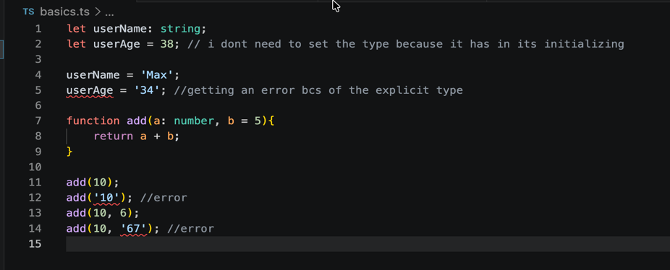 | My session primarily involved testing basics of typescript and the differences with Javascript:  -Basic types  -Flexible types  -Types errors  -Object types  -Functions, the “never” type in functions  -Key,Value types
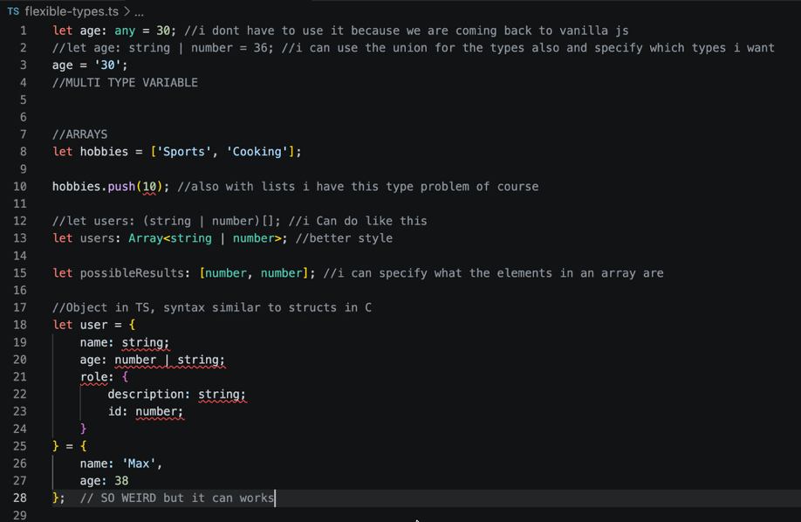 | Why is good to use Typescript and not only Javascript?  Ts is safer, it has an explicit types method, in Js you have only multi type variables, so this will get to errors and problems in the code.  In ts it’s easier to debug the code, you don’t get warnings but errors will show up from the start and you can work in it from the beginning.  It is much easier to maintain than Js if the code is big.  Typescript is an extension of Javascript, so it is needed to compile first the .ts files to .js files so the browser can execute them. Basically Ts has much more value on the developer side.  In the file choice.ts and .js is interesting to see how Ts can make us save a lot of time with the syntax, using enum in Ts is so fast in this example to see how we can create different roles, in javascript when we compile it looks worse because we should have to use a function to make it work.
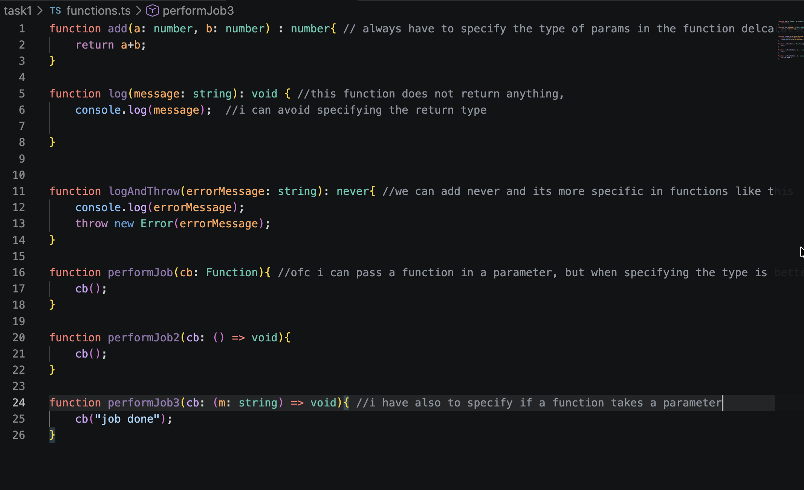
Here the focus was on functions and mainly on how to specify the parameters of the functions and their type, as always we have to specify the type of the given parameters and even if we pass a function to another function we have to indicate which parameters are there.
When a function returns never it means that the execution is going to interrupt, it is important for the style of the code to specify that so we can always notice what is going to happen if we use a variable like that.

