**邏輯設計實驗 - Lab05 2018/04/11 09:10~12:00**

Lab05實習內容：

1. BCD to 7-segment decoder
2. 將0-6 BCD數值用7-segment 顯示器表示

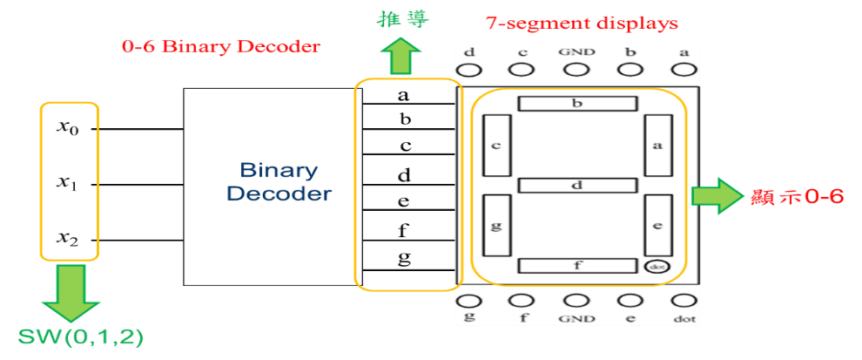

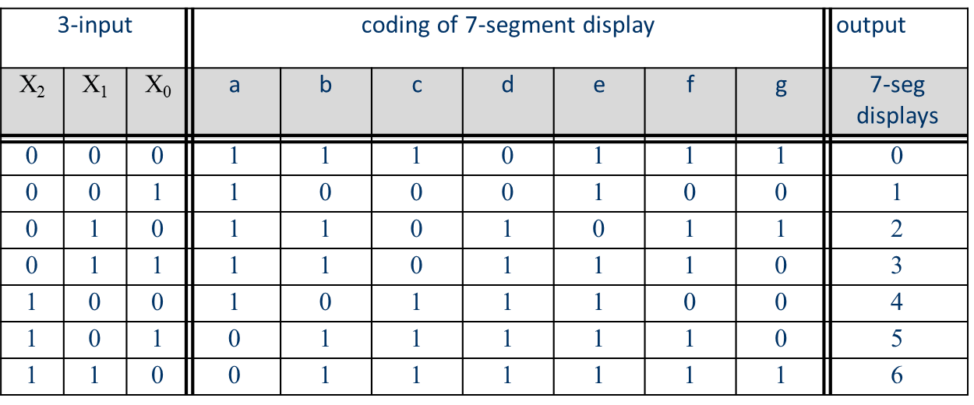

◎TTL IC Connection diagram：

C:\Users\LPCA\Desktop\642.pngNOT gate (7404) 2-input AND gate (7408) 2-input OR gate (7432)

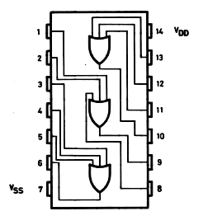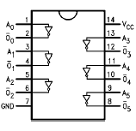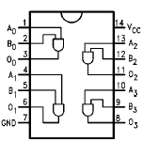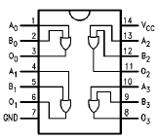

組別:___________

組員:___________ 學號:___________ 分數:___________

組員:___________ 學號:___________ 分數:___________