**邏輯設計實驗–Lab14 2018/06/20 09:10~12:00**

Lab14實習內容：

完成Candy Vending Machine:

* 每次投幣金額5塊或10塊，達15塊即掉一顆糖果
* 販賣機目前餘額顯示在平台上的BCD

Input : 1. pulse [A] (D:按一次代表投幣10塊)

2. pulse [B] (N:按一次代表投幣5塊)

Output：z : LED(7) (是否有掉糖果)、BCD(餘額顯示)

* **本次實作請使用”Mealy Type”！**
* **D-FF中的Preset跟Clear都要”接訊號”**

Candy

Vending

Machine

D(十塊)

N(五塊)

LED(是否掉糖果)

BCD(顯示餘額)

* 糖果販賣機狀態機圖
* 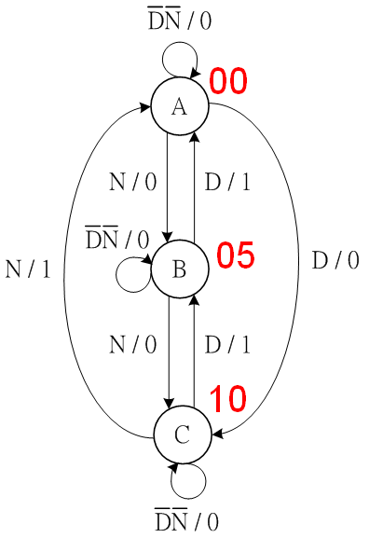狀態轉換表：

|  |  |  |  |
| --- | --- | --- | --- |
| **Present state** | **Next state** | | |
| DN= 00 01 10 | | |
| A | A | B | C |
| B | B | C | A |
| C | C | A | B |

* Design circuit diagram：Candy Vending Machine

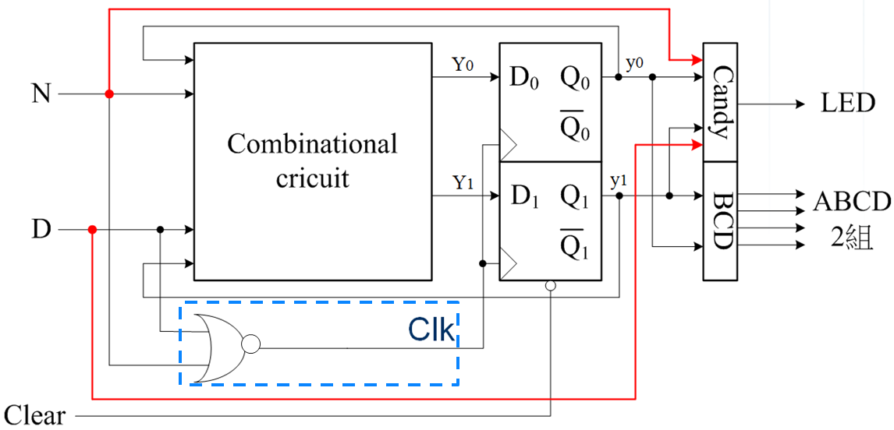

* 請完成下面的真值表，並以卡諾圖簡化完成電路：

|  |  |  |  |  |  |  |  |  |  |  |
| --- | --- | --- | --- | --- | --- | --- | --- | --- | --- | --- |
| **Present**  **state** | | | **Next State** | | | | **Output Candy** | | | |
| DN= 00 01 10 11 | | | | 00 01 10 11 | | | |
|  | y1 | y0 | Y1 Y0 | | | | z | | | |
| A | 0 | 0 | 00 |  |  | x |  |  |  | x |
| B | 0 | 1 |  |  |  | x |  |  |  | x |
| C | 1 | 0 |  |  |  | x |  |  |  | x |
| X | 1 | 1 | x | x | x | x | x | x | x | x |

◎TTL IC Connection diagram：

AND2 gate (7408) OR2 gate (7432) NOT gate (7404)

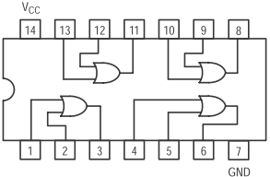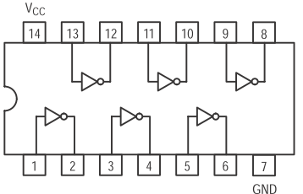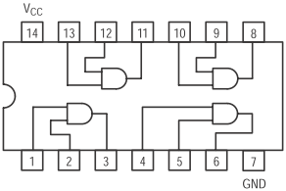

D-FF(7474)

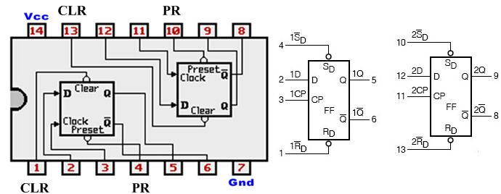

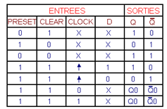

組別:___________

組員:___________ 學號:___________ 分數:___________

組員:___________ 學號:___________ 分數:___________