Ngô Công Huấn - 21520881

Github: [NCHzzz/lab5_mobile](https://github.com/NCHzzz/lab5_mobile)

Alarm

Recap

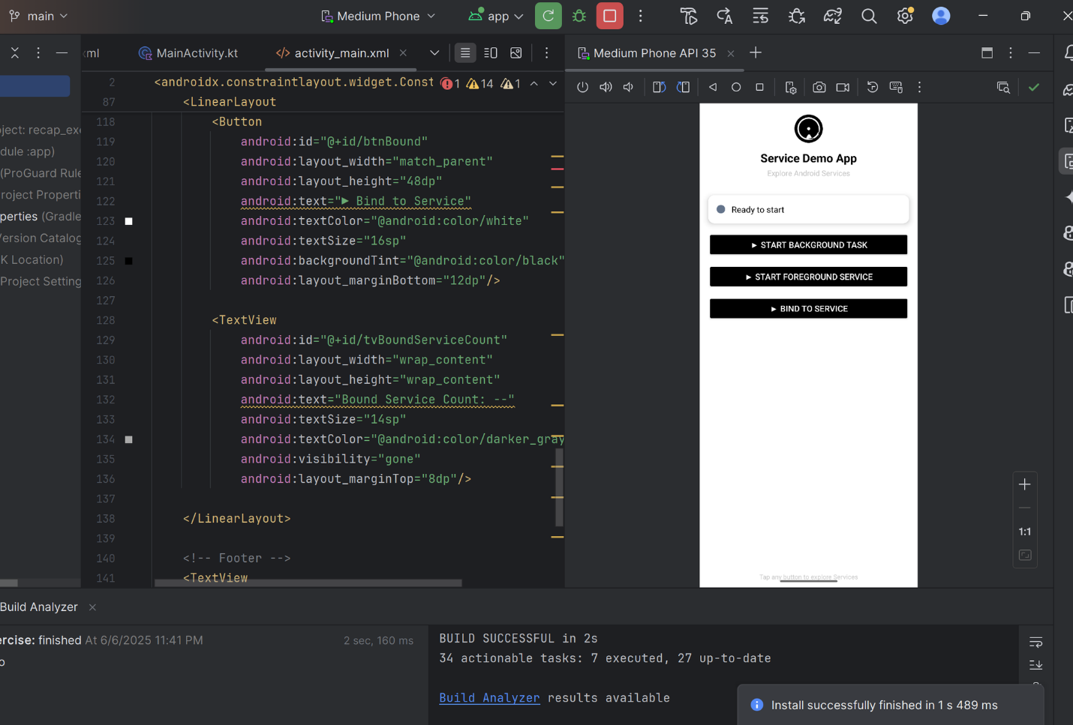

Health app

