Use case
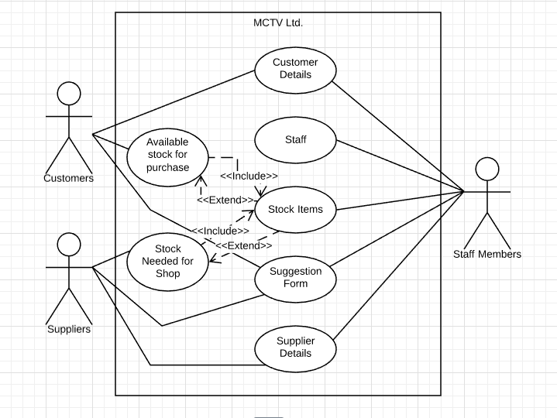

Scope
The scope of this use case is

Description
This use case describes .

Flow Description

Precondition
The system is idle.

Activation
This use case starts when a .

Main flow
- .
- .

Alternate flow
(A1 )
- The system

Exceptional flow
-

Termination
The system

Post condition
The system

