MEME 4 Feature Highlights – Draft 1

Diagram of MEME4 interaction:

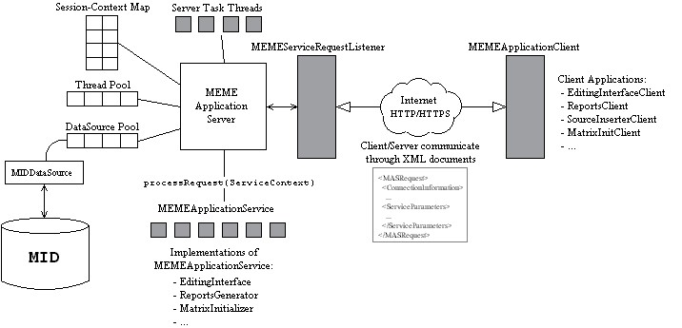

Diagram of entire UMLS Life-cycle
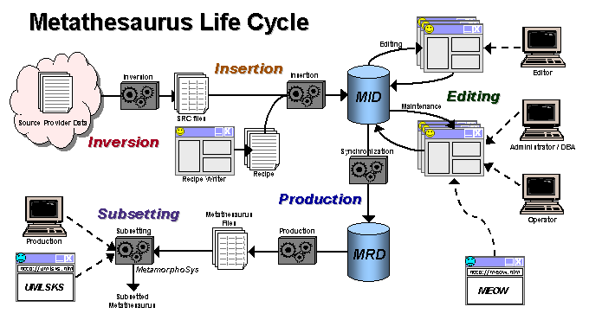

- Original source files QA’d and converted to standard format (SRC) – process termed “inversion”.
- Recipe writer used to create Recipe for “insertion” (XML document which is converted to a script. (+QA)
- Insertion into MID. (Note: now insertion directly touches the database. Want everything to go through a service in the future.)
- Editing and QA done in the MID.
- Data transformed and put in the MRD database. This contains historical data. All releasable states stored, so in theory can compare any two points in time.
- Production release converted to MR files, and Metamorphosys used to create subsets.
- Inversion through MRD considered “MEME” functions.

Specific features:

- Formal insertion technology (articulates how merging should take place – conditions, etc.)
  - Recipe writer
  - Integrities
  - QA Tools
- Data Model
  - Atom = Name+Source+TermType+Code
    - Has unique identifier that persists
    - Can tell what’s new by computing Ids
  - Concept = Collection of “synonymous” atoms
  - Relationships
  - Attributes
    - Atom level attributes, like definitions
    - Concept level attributes, like STY
- Actions: Changes made to data via “actions”
  - Atomic actions (row level changes to table)
  - Molecular actions = higher level editor actions like
    - Merge
    - Split
    - Insert
    - Delete
    - Approve concept
    - Total recall (undo – can theoretically go back to beginning starting date, but that’s a kind of fiction – in reality, can do an undo chain from a starting date (presumably not too distant in the past.). There is an “action harvester” that collects up a chain of actions.
    - Note: Not check in/ check out model – rather there are sets of mutually exclusive concepts that different editors work on. So the only conflicts that should occur are when someone editing a concept relationship touches a concept someone else is working on. Then undo gets messed up and Apelon tries to fix it.
- MEME architecture model
  - Services (receiving requests)
    - Concept Reports
    - DB server Admin (start, shut down, statistics, performance graphs, etc.
    - Actions (individual and batch)
      - Merge,
      - Split,
      - etc. Can do most things in batch that can do singly.
    - Merging (There is a service for bulk merging)
    - Get Data (get concept, get relationship, etc.)
    - Content View (UMLS specific probably)
    - Mapping API
    - Finder (for looking up data in the MID)
    - Worklists (for retrieving lists of concepts to edit)
    - EXTENSIBLE
  - Clients (sending requests)
    - Jekyll – editing interface (developed by MDS – talks to a number of the web services.)
    - Web Applications
    - WMS (Worklist Manager) (Is this a client app?)
  - Net in the middle
  - There is a client for every service (Java for all and PERL for most)

- QA – CGI scripts written before MEME4
  - Conservation of Mass (e.g. compare files to look for changes in numbers of concepts, etc. Also available through a web page.)
  - Semantic Validation – Huge script with rules about how things should be connected, e.g. every atom has a valid concept ID, etc. etc. (Rules are configurable.) Queries designed so that every query returns 0 if the conditions are met and data clean. Otherwise returns sets of errors for review.
- Editing Management
  - Query based system for partitioning all concepts into “bins”
    - mutually exclusive bins
    - QA bins
    - Ad-hoc definitions for bins
  - Bins can be partitioned into “worklists” or “checklists”. Which can be assigned to editors to drive the editing process
  - Queries can be used to define editing based on certain QA tasks (for example in Meta editing we require editors to add a semantic type to each concept, a defined QA bin allows managers to create a list of concepts that need to be edited for this specific purpose).
  - Worklists/checklists integrate with the editing interface
  - Worklists/checklists can be “clustered” to allow editor to perform an editing task (like resolving potential missed synonymy) by reviewing a collection of known related/potentially synonyomous concepts.

