Architecture Specification
for
NCI Protégé Extension
Version 1.0, Release 1.0

Last Updated: August 17, 2006

Owner: <name>
Telephone: <number>
Email: <address>

National Cancer Institute Center for Bioinformatics
6116 Executive Blvd.
Rockville, MD 20852


Contents
List of Tables ii
List of Figures iii
1. Overview 1
1.1 Purpose of this Specification 1
1.2 Background: Core Protégé and OWL Plug-in 2
1.3 About the NCIEdit Tab Plug-In 3
2. UI Component Architecture 5
2.1 About the Edit tab 6
2.2 About the Split Tab 21
2.3 About the Pre-Merge Tab 23
2.4 About the Merge Tab 25
2.5 About the Pre-Retire Tab 25
2.6 About the Retire Tab 28
2.7 About the Report Writer Tab 28
2.8 About the Batch Loader Tab 31
2.9 About the Batch Editor Tab 34
2.10 About the Partonomy Tree Tab 37
2.11 About the Copy Tab 40
2.12 About the NCIEdit Tab Plug-In Utility Classes 42
3. Performance Considerations 43
4. Third-party Tool Dependencies and Requirements 44
5. Document Revision History 45
6. Document Approval 46
6.1 Approvers List 46
6.2 Reviewers List 46

List of Tables
Table 1. UI components of the Edit tab 6
Table 2. UI components of the Basic Data sub-tab 9
Table 3. UI Components of the Relations sub-tab 12
Table 4. UI Components of the Properties sub-tab 16
Table 5. UI Components of the Split tab 21
Table 6. UI Components of the Pre-Merge tab 23
Table 7. UI Components of the Merge tab 25
Table 8. UI Components of the Pre-Retire tab 26
Table 9. UI Components of the Retire tab 28
Table 10. UI Components of the Report Writer tab 29
Table 11. UI Components of the Batch Loader tab 31
Table 12. UI Components of the Batch Editor tab 34
Table 13. Data elements for a batch file 35
Table 14. UI components of the Partonomy Tree tab 37
Table 15. UI components of the Copy tab 40
Table 16. Utility classes 42
Table 17. NCIEditTab architecture/standards usage 42
Table 18. Third-party tool requirements/dependencies 44
Table 19. <Document Title> Document Change Log 45
Table 20. Approvers for this document 46
Table 21. Reviewers for this document 46

List of Figures
Figure 1. OWL plug-in main user interface 2
Figure 2. Multi-user editing environment of NCI Protégé extension 4
Figure 3. NCI Protégé Extension configuration 4
Figure 4. NCIEditTab user interface design 5
Figure 5. Edit tab 6
Figure 6. Message confirming deletion of data 8
Figure 7. Create New Annotation Property dialog box for FULL_SYN data 10
Figure 8. Create New Annotation Property dialog box for definitions 11
Figure 9. Relations sub-tab 12
Figure 10. Create a Restriction dialog box 13
Figure 11. Select a class dialog box 14
Figure 12. Add an Object-Valued Property dialog box 15
Figure 13. Properties sub-tab 16
Figure 14. Select Property dialog box 17
Figure 15. Add Annotation dialog box 17
Figure 16. Select Property dialog box 19
Figure 17. Create <Property Name> Annotation Property dialog box 19
Figure 18. Review window 20
Figure 19. Split tab 21
Figure 20. Tree representation of a class 22
Figure 21. Enter Class Identifiers dialog box 22
Figure 22. Pre-Merge tab 23
Figure 23. Enter Notes dialog box 24
Figure 24. Merge tab 25
Figure 25. Pre-Retire tab 26
Figure 26. Retire tab 28
Figure 27. Report Writer tab 29
Figure 28. Sample report: Lymph_Node_Sinus 30
Figure 29. Batch Loader tab 31
Figure 30. Batch Loader input file format 32
Figure 31. Batch Loader dialog box 32
Figure 32. Sample batch loader log file 33
Figure 33. Batch Editor tab 34
Figure 34. Batch Input file 35
Figure 35. Sample Batch Editor log file 36
Figure 36. Partonomy Tree tab 37
Figure 37. Select Transitive Properties dialog box 38
Figure 38. Sample partonomy tree 39
Figure 39. Copy tab 40

Overview

Purpose of this Specification
This design document details the design of the Protégé/OWL NCIEdit Plug-In (abbreviated as NCIEdit Tab Plug-In), Release 1.0. It describes the major user interface components that make up NCIEdit Tab, interfaces to other products, third-party tool requirements or dependencies, and document review and approval requirements.
The intended audience for this document includes, but is not limited to, the following teams: development, management, product support technical personnel, technical communication, and technical consultants.

Background: Core Protégé and OWL Plug-in
The base system of Protégé is an open-source development environment for ontologies and knowledge-based systems. The OWL Plug-in is an extension of Protégé with support for the Web Ontology Language (OWL).
The base systems of Protégé and the OWL Plug-in are being developed at Stanford Medical Informatics. Protégé and the OWL plug-in support ontology editing in a multi-user client/server environment. A group of users at geographically dispersed locations can edit the same ontology data concurrently.
Figure 1 shows the main user interface of the OWL Plug-in.
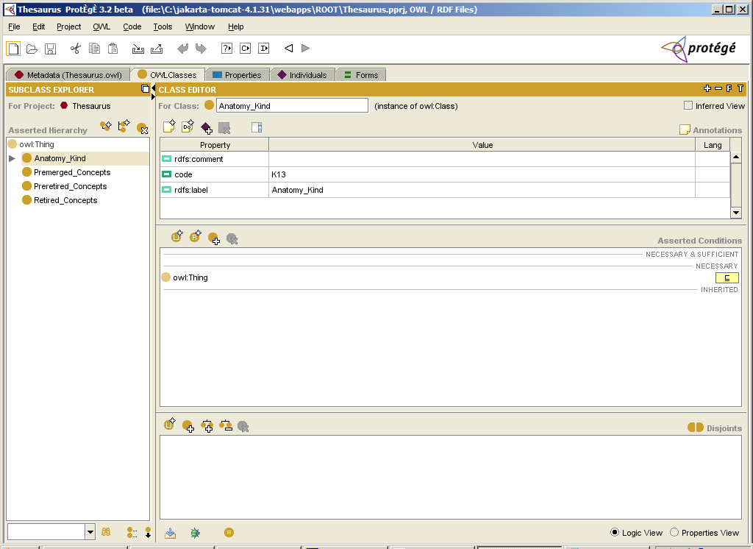
Figure 1. OWL plug-in main user interface

About the NCIEdit Tab Plug-In
The NCIEdit Tab Plug-In is a Protégé tab plug-in being developed for an NCICB-specific editing environment. This plug-in provides additional editing capabilities that are not available in the Protégé OWL Plug-in.
The NCIEdit Tab Plug-In enables NCICB users to do the following:
- Automatically assign a unique code to each newly created OWL named class
Note: For simplicity, this document will refer to an OWL named class as simply a class.
- Use a customized dialog box to edit synonyms with source data (FULL_SYN properties)
- Use a customized dialog box to edit definitions with qualifiers (DEFINITION properties)
- Parse XML-formatted complex annotation property values (such as DEFINITION, GO_ANNOTATION, and LONG_DEFINITION) and properly display the corresponding qualifiers
- Set edit restrictions (OWL anonymous class) and classes through different UI components
- Edit object-valued annotation properties (associations between classes) through a separate UI component
Note: In the OWL Plug-in, all annotation properties are shown in the same table.
- Edit simple and complex annotation properties (such as GO_ANNOTATION and LONG_DEFINITION) through different UI components
- Split an existing class into two classes
- Flag two existing classes for a merge (the pre-merge action)
- Merge one class with another
- Flag existing classes for retirement (the pre-retire action)
- Retire a class
- Generate reports
- Load a batch of classes to the knowledge base
- Edit a batch of classes
- Generate a partonomy tree
- Clone classes
- Edit two classes at the same time using cut and paste functions
- Alert a user of any change made by other users to ensure data integrity
- Enforce NCI-specific editing business rules.

Figure 2 and Figure 3 on page 4 show a top-level architecture of the Protégé ontology editing environment in which the NCI Protégé Extension will be used.
Figure 2 shows a Protégé server running at a centralized location. The server is connected to a MySQL database that enables all clients to access the common knowledge base.
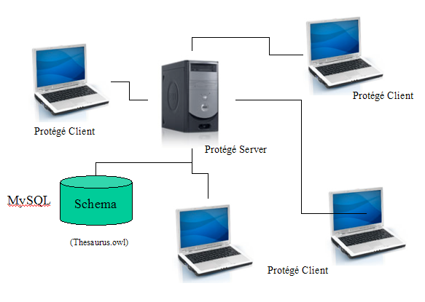
Figure 2. Multi-user editing environment of NCI Protégé extension
Figure 3 shows the location of the configuration files used by the NCI Protégé Extension. The code generator server assigns a unique code to classes.
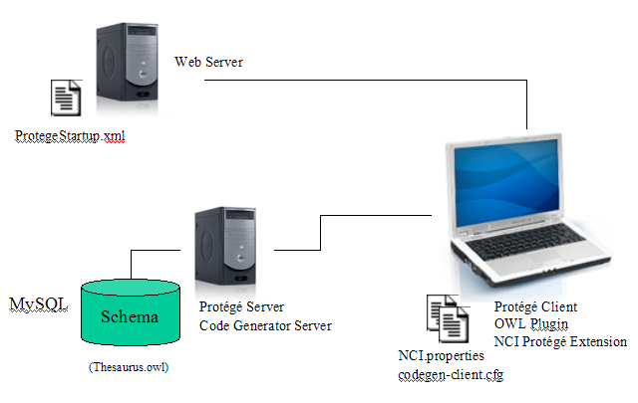
Figure 3. NCI Protégé Extension configuration

UI Component Architecture
The NCIEdit Tab Plug-In is a Protégé tab widget plug-in. All Protégé tab widgets extend AbstractTabWidget and implement the initialize( ) method of AbstractTabWidget.
The NCIEdit Tab Plug-In starts with the NCIEditTab class, which extends AbstractTabWidget. The initialize( ) method of the NCIEditTab class is used to construct a user interface with the look and feel shown in Figure 4.
Note: The initialize method also instantiates several utility classes. For more details, see About the NCIEdit Tab Plug-In Utility Classes on page 42.
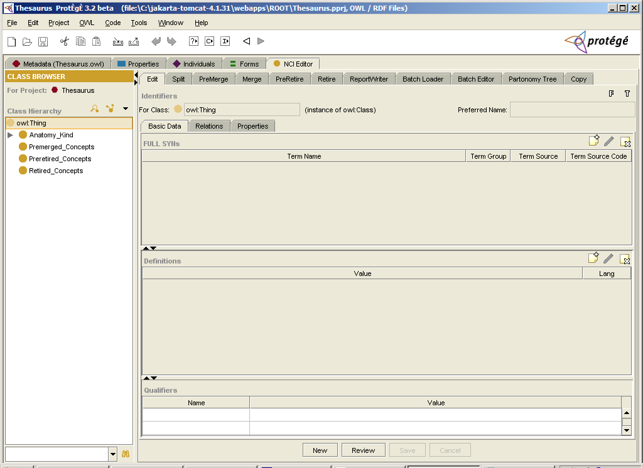
Figure 4. NCIEditTab user interface design
The vertical pane in the left side of the main window is a container for a class browser. This component enables users to browse the taxonomy of an underlying ontology and provides a means to search the ontology for classes or concepts that match user-specified search criteria.
On the right is a tabbed pane with the following tabs: Edit, Split, Pre-merge, Merge, Pre-retire, Retire, Report Writer, Batch Loader, Batch Editor, Partonomy Tree, and Copy. Each tab has its own interface components, which are covered in this specification.

About the Edit tab
The Edit tab is used to maintain annotation and relation data for classes, including the following:
- Special annotation properties that uniquely identify a class, such as the name, preferred name, and code
- Basic data about a class, including FULL_SYN annotation properties, DEFINITION annotation properties, and DEFINITION qualifiers
- Relation data, including restrictions, named superclasses, and associations
- Other annotation property data, including simple properties such as an annotation property without qualifiers, and complex properties such as GO_ANNOTATION and LONG DEFINITION, with one or many qualifiers.

Figure 5 illustrates the UI components of the Edit tab.
Identifiers panel
Sub-tabs
New, Review, Save, and Cancel buttons
Form (F) and Type (T) buttons
FULL_SYN table with buttons
(Create, Edit, Delete)
Definitions table with buttons
(Create, Edit, Delete)
Qualifiers table
Figure 5. Edit tab
Table 1 describes each UI component and references relevant sections in this specification.
Table 1. UI components of the Edit tab
UI Component | Description
Identifiers panel | Shows class identifiers.
Form button (F) | Provides a shortcut to the original OWL Form Tab.
Type button (T) | Opens an OWL plug-in Class Editor window, which enables users to see the Inferred View of the selected class.
Basic Data sub-tab | See The Basic Data Sub-tab on page 9.
Relations sub-tab | See The Relations Sub-tab on page 12.
Properties sub-tab | See page The Properties Sub-tab on page 16.
New button | Creates a new class.
Review button | Launches a window for previewing all data of the selected class.  For more details, see The Review Window on page 20.
Save button | Saves all changes made to the selected class to the knowledge base.
Cancel button | Discards all actions performed on the selected class.

Conventions for Buttons
Many of the tabbed components include buttons in the header areas and on a button panel at the bottom of the interface. Buttons are sometimes unavailable until a user performs a task such as selecting a table row. For tabs that use a Class Hierarchy, a button may be unavailable until a user selects a class.

The Create, Edit, and Delete Procedures
Each of the sub-tabs under the Edit tab is divided into various UI components. Each of these components has its own header area, which includes buttons for creating, editing, and deleting data. The buttons are generally available after certain other actions occur (e.g., the user selects a table row or specifies values in a dialog box). The procedures triggered by these buttons are similar for each UI component, with minor variations that are noted throughout this specification. Following are the basic steps for each procedure.

Creating Data
To create data, users follow these steps:
- Click the Create button in the component header area.
This action opens a dialog box for creating data.
- Specify name and qualifier values.
- Click OK to create a new property, or click Cancel to abort the procedure.
If a user creates new data, the data appears in the table below the component header area.

Editing Data
To edit previously created data, users follow these steps:
- Select the table row for the data to be edited.
- Click the Edit button in the component header area.
This action opens a dialog box that is similar to the one used for creating data. The dialog box title includes the word edit, and the previously created data values are displayed.
- Make any necessary changes.
- Click OK to accept the changes, or click Cancel to abort the procedure.

Deleting Data
To delete previously created data, users follow these steps:
- Select the table row for the data to be deleted.
- Click the Delete button in the component header area.
A message box similar to the one shown in Figure 6 appears.
- Click Yes to confirm deletion, or click No to cancel deletion.
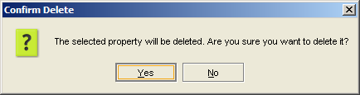
Figure 6. Message confirming deletion of data

The Basic Data Sub-tab
The Basic Data sub-tab is the first of the three Edit sub-tabs. Its layout is shown in Figure 5 on page 6. Table 2 describes each UI component and references relevant sections in this specification.
Table 2. UI components of the Basic Data sub-tab
UI Component | Description
FULL_SYN | Displays FULL_SYN values. The header area provides three buttons for creating, editing, and deleting FULL_SYN annotation properties.  For more details, see Using the FULL_SYN Component on page 9.
Definitions | Displays definition values. The header area provides three buttons for creating, editing, and deleting definition properties.  For more details, see Using the Definitions Component on page 11.
Qualifiers | Displays qualifier values for definition properties. To edit these values, users click the Edit button in the header area of the Definitions component.

Using the FULL_SYN Component
The FULL_SYN component of the Basic Data sub-tab provides a four-column table that displays the name and three qualifier values of a FULL_SYN property. The header area provides three buttons that enable users to create, edit, and delete FULL_SYN annotation properties.
Example 1 shows the FULL_SYN annotation property for a Blood class. The term name and three qualifiers (Term Group, Term Source, and Term Source Code) are stored in the knowledge base in XML format. The column on the right shows the corresponding XML value for the Term Name and the three qualifiers.
Example 1. FULL_SYN annotation
Class: | Blood
Term Name: | peripheral blood | Syn_Term_Name
Term Group: | PT | Syn_Term_Type
Term Source: | NCI_GLOSS | Syn_Source
Term Source Code: | CDR0000046011 | Syn_Source_Code

Note: Unlike the OWL plug-in, which displays property values in their native XML format, the Protégé extension displays these values under their respective column headings for easy identification.

The FULL_SYN component uses consistent dialog box interfaces for creating, editing, and deleting data:
- When a user clicks the Create button in the FULL_SYN header area, the Create New Annotation Property dialog box shown in Figure 7 opens. Users can specify values for term names and term qualifiers, then OK to accept them or Cancel to abort the procedure.
- When a user clicks the Edit button, a similar dialog box opens. The title bar of the dialog box reads Edit an Annotation Property, and the values of the selected property are displayed.
- When a user clicks the Delete button, the standard message prompt shown in Figure 6 on page 8 appears.

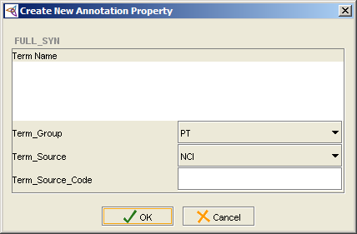
Figure 7. Create New Annotation Property dialog box for FULL_SYN data

Using the Definitions Component
The Definitions component of the Basic Data sub-tab provides a two-column table that displays the values for definition properties. Each definition property can have the following qualifiers:
- Definition attribution (optional)
- Definition reviewer name
- Definition review date
- Definition source

Note: These values appear in a separate table labeled Qualifiers. All entries in the Qualifier table are non-editable until a user clicks the Edit button in the Definitions area.

The Definitions component uses consistent dialog box interfaces for creating, editing, and deleting data:
- When a user clicks the Create button in the Definitions header area, the Create New Annotation Property dialog box shown in Figure 8 opens. Users can specify definition values, then click OK to accept them or Cancel to abort the procedure.
- When a user clicks the Edit button, a similar dialog box opens. The title bar of the dialog box reads Edit an Annotation Property, and the values of the selected property are displayed.
- When a user clicks the Delete button, the standard message prompt shown in Figure 6 on page 8 appears.

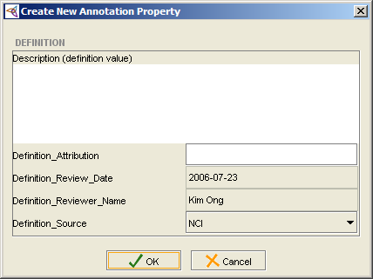
Figure 8. Create New Annotation Property dialog box for definitions

The Relations Sub-tab
Figure 9 shows the layout of the Relations sub-tab.
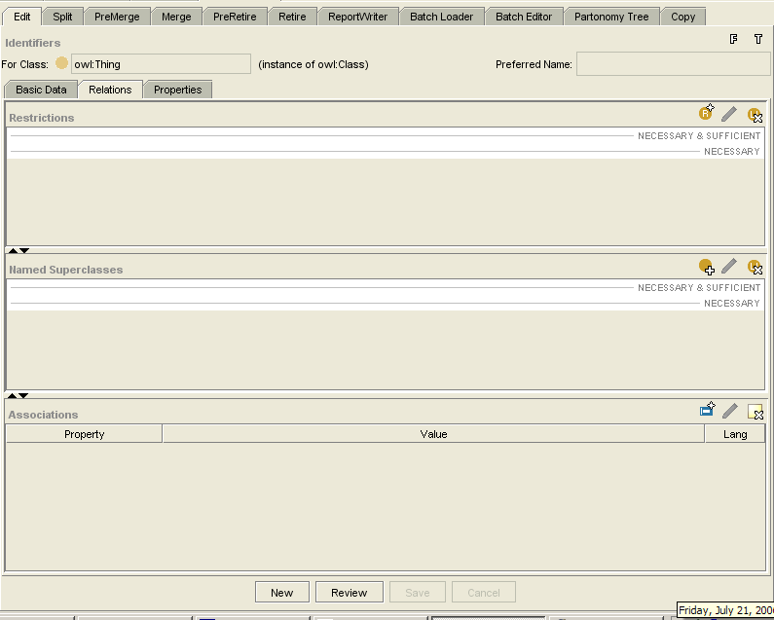
Restrictions component
with buttons
Named Superclasses component
with buttons
Associations component
with buttons
Figure 9. Relations sub-tab
Table 3 describes the sub-tab UI components and references relevant sections in this specification.
Table 3. UI Components of the Relations sub-tab
UI Component | Description
Restrictions | Displays restriction values. The header area provides three buttons for creating, editing, and deleting restrictions.  For more details, see Using the Restrictions Component on page 13.
Named Superclasses | Displays named superclass values. The header area provides three buttons for creating, editing, and deleting named superclasses.  For more details, see Using the Named Superclasses Component on page 14.
Associations | Displays association values. The header area provides three buttons for creating, editing, and deleting associations.  For more details, see Using the Associations Component on page 15.

Using the Restrictions Component
The Restrictions component uses consistent dialog box interfaces for creating, editing, and deleting data:
- When a user clicks the Create button in the Restrictions header area, the Create a Restriction dialog box shown in Figure 10 opens. Users can specify restriction values, then click OK to accept them or Cancel to abort the procedure.
- When a user clicks the Edit button, a similar dialog box opens. The title bar of the dialog box reads Edit a Restriction, and the values of the selected property are displayed.
- When a user clicks the Delete button, the standard message prompt shown in Figure 6 on page 8 appears.

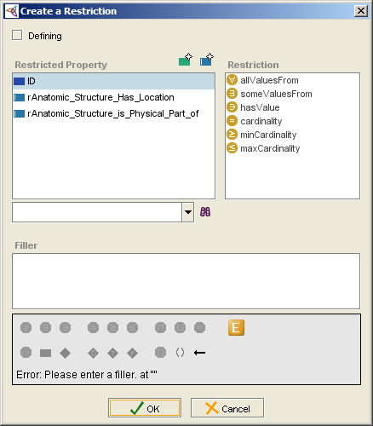
Figure 10. Create a Restriction dialog box

Using the Named Superclasses Component
The Named Superclasses component uses consistent dialog box interfaces for creating, editing, and deleting data:
- When a user clicks the Create button in the Named Superclasses header area, the Select a class dialog box shown in Figure 11 opens. Users can specify named superclass values, then click OK to accept them or Cancel to abort the procedure.
- When a user clicks the Edit button, a similar dialog box opens. The title bar of the dialog box reads Edit a Named Superclass, and the values of the selected property are displayed.
- When a user clicks the Delete button, the standard message prompt shown in Figure 6 on page 8 appears.

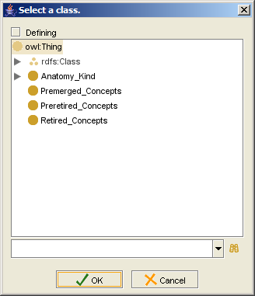
Figure 11. Select a class dialog box

Using the Associations Component
The Associations component uses consistent dialog box interfaces for creating, editing, and deleting data:
- When a user clicks the Create button in the Associations header area, the Add an Object-Valued Property dialog box shown in Figure 12 opens. Users can specify association values, then click OK to accept them or Cancel to abort the procedure.
- When a user clicks the Edit button, a similar dialog box opens. The title bar of the dialog box reads Edit an Object-Valued Property, and the values of the selected association are displayed.
- When a user clicks the Delete button, the standard message prompt shown in Figure 6 on page 8 appears.

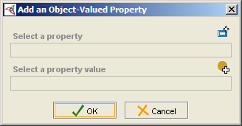
Figure 12. Add an Object-Valued Property dialog box

The Properties Sub-tab
Figure 13 shows the layout of the Properties sub-tab.
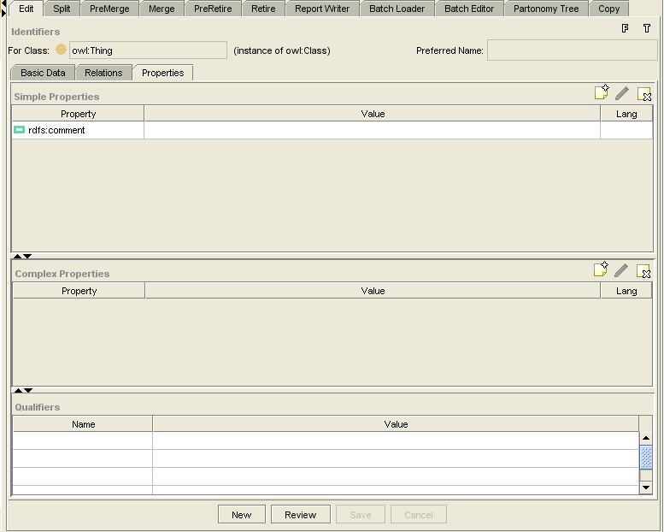
Complex Properties component
with buttons
Qualifiers component

Simple Properties component
with buttons
Figure 13. Properties sub-tab
Table 4 describes the sub-tab UI components and references relevant sections.
Table 4. UI Components of the Properties sub-tab
UI Component | Description
Simple Properties | Displays simple property values. The header area provides three buttons for creating, editing, and deleting simple properties.  For more details, see Using the Simple Properties Component on page 17.
Complex Properties | Displays complex property values. The header area provides three buttons for creating, editing, and deleting complex properties.  For more details, see Using the Complex Properties Component on page 18.
Qualifiers | Displays qualifier values for complex properties. To edit these values, users must click the Edit button in the header area of the Complex Properties component.

Using the Simple Properties Component
The Simple Properties component uses consistent dialog box interfaces for creating, editing, and deleting data:
- When a user clicks the Create button in the Restrictions header area, the Select Property dialog box shown in Figure 14 opens. The user follows these steps:
- Selects a property value, then clicks OK. This action opens the Add Annotation dialog box shown in Figure 15.
- Specifies a value for the new property.
- Clicks OK to accept the new property, or clicks Cancel to abort the procedure.
- When a user clicks the Edit button, a similar dialog box opens. The title bar of the dialog box reads Edit Annotation, and the values of the selected property are displayed.
- When a user clicks the Delete button, the standard message prompt shown in Figure 6 on page 8 appears.

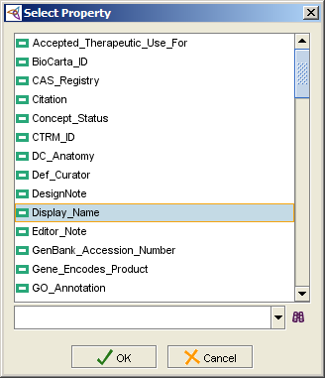
Figure 14. Select Property dialog box
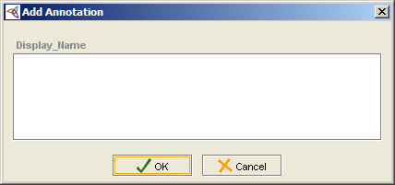
Figure 15. Add Annotation dialog box

Using the Complex Properties Component
Each complex annotation property can have many qualifiers. For example, a GO_ANNOTATION property can have the following qualifiers:
- GO_ID
- GO_Source_Data
- GO_Evidence
- GO_Source

A LONG_DEFINITION property can have the same qualifiers as the regular DEFINITION property described earlier:
- Definition attribution (optional)
- Definition reviewer name
- Definition review date
- Definition source

All qualifier names and values appear in a separate Qualifiers table shown in Figure 13 on page 16. To edit qualifier values, users click the Edit button in the header area of the Complex Properties component.
The Complex Properties component uses consistent dialog box interfaces for creating, editing, and deleting data:
- When a user clicks the Create button in the Restrictions header area, the Select Property dialog box shown in Figure 16 on page 19 opens. The user follows these steps:
- Selects a property value, then clicks OK. This action opens the Create <Property Name> Annotation Property dialog box shown in Figure 17 on page 19.
- Specifies a value for the new property.
- Clicks OK to accept the new property, or clicks Cancel to abort the procedure.
- When a user clicks the Edit button, a similar dialog box opens. The title bar of the dialog box reads Edit <Property Name> Annotation Property, and the values of the selected property are displayed.
- When a user clicks the Delete button, the standard message prompt shown in Figure 6 on page 8 appears.

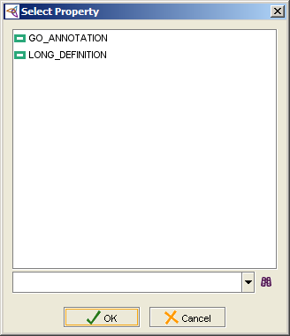
Figure 16. Select Property dialog box

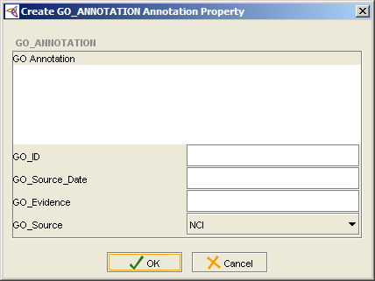
Figure 17. Create <Property Name> Annotation Property dialog box

The Review Window
The set of buttons at the bottom of the Edit tab includes a Review button. Clicking this button opens a window that displays all data of a selected class. The windows title bar reads Review <Property Name>.
Figure 18 shows an example of the Review window.
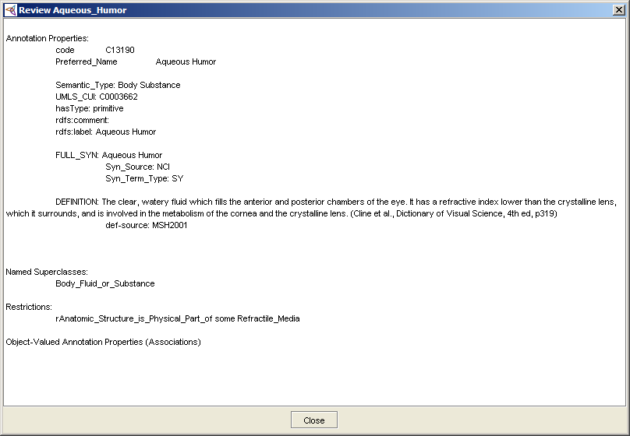
Figure 18. Review window

About the Split Tab
The Split tab includes two horizontal panes that display, respectively, existing concepts and new concepts. Figure 19 shows the design of this tab.
Class Browser (NCIEditTab component)
Split tab

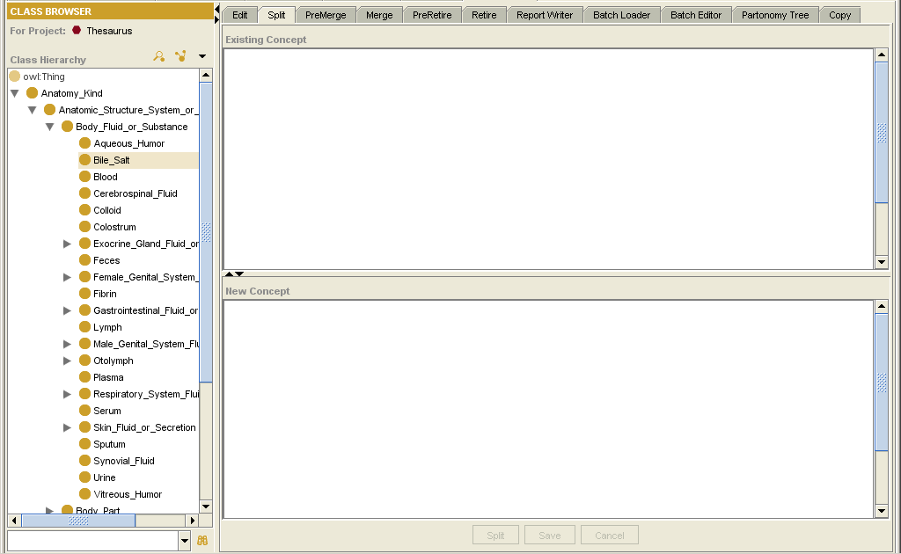
Existing Concept pane
New Concept pane
Split, Save, and Cancel buttons
Figure 19. Split tab
Table 5 describes each UI component and references relevant sections in this specification.
Table 5. UI Components of the Split tab
UI Component | Description
Existing Concept pane | Shows a tree representation of a selected existing class. See Figure 20 on page 22.
New Concept pane | Shows a tree representation of a new class that has been cloned from an existing class.
Split button | Creates a new class based on the content of the class shown in the Existing Concept pane. This is known as cloning a class.
Save button | Saves a newly created class to the knowledge base.
Cancel button | Aborts the operation.

Using the Split Tab
Using the Split tab, users can perform the following tasks:
- Drag a class from the Class Hierarchy on the left and drop it into the Existing Concept pane. Figure 20 shows a sample tree representation.
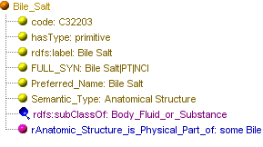
Figure 20. Tree representation of a class

- Click the Split button to clone a new class based on the content of the selected existing class.
This action opens the Enter Class Identifiers dialog box shown in Figure 21. Here, users add a label and a preferred name for the new class, then click OK.
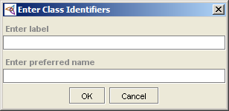
Figure 21. Enter Class Identifiers dialog box
The new class is represented by a tree appearing in the New Concept pane.
- (Optional) Edit a class using a right-click menu that offers the following commands:
- Expand | - Add Property
- Delete | - Add Restriction
- Modify Property | - Add Parent
- Modify Restriction | - Add Association

- Click the Save button to save the new class to the knowledge base, or
Click the Cancel button abort the operation.

Assigned Properties for a Split Class
To establish an audit trail, the new class is assigned a Split_From annotation property. The value of the property is the code of the original class.

About the Pre-Merge Tab
The Pre-Merge tab enables users to flag two classes for a merge. Figure 22 shows the design of this tab.
Class Browser (NCIEditTab component)
Pre-Merge tab

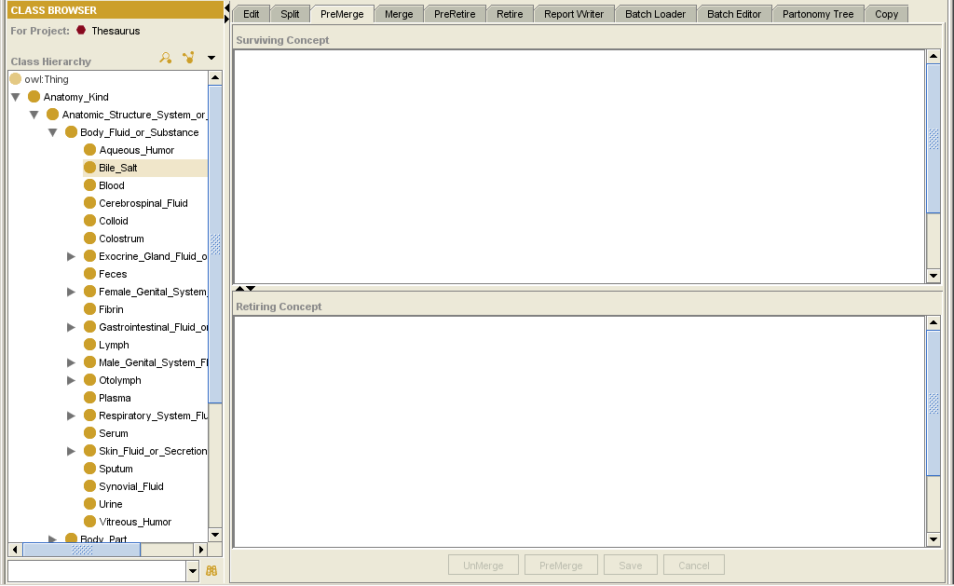
Surviving Concept pane
Retiring Concept pane
Unmerge, Pre-merge, Save, and Cancel buttons
Figure 22. Pre-Merge tab
Table 6 describes each UI component and references relevant sections in this specification.
Table 6. UI Components of the Pre-Merge tab
UI Component | Description
Surviving Concept pane | Shows a tree representation of a selected class that has been designated as a surviving class.
Retiring Concept pane | Shows a tree representation of a selected class that has been designated as a  retiring class.
Unmerge button | Removes a previously set pre-merge flag.
Pre-merge button | Flags two classes for a merge.
Save button | Saves concepts with the properties described in Assigned Properties for a Merged Class on 24.
Cancel button | Reverses a pre-merge operation. All users can perform this function.

Using the Pre-Merge Tab
Using the Pre-Merge tab, users follow these steps:
- Drag a class from the Class Hierarchy on the left and drop it into the Surviving Concept pane.
- Drag a class from the Class Hierarchy on the left and drop it into the Retiring Concept pane.
- Click the Pre-Merge button to flag the two selected classes for a merge.
This action opens the Enter Notes dialog box shown in Figure 23.
- Specify values for an Editor’s Note and a Design Note, then click OK to add the values to the retiring class as annotation properties; or
Click Cancel to abort the operation.
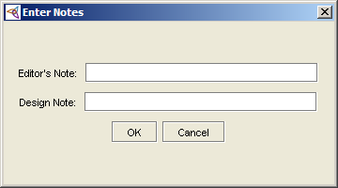
Figure 23. Enter Notes dialog box
Note: Only an authorized user such a lead editor can perform a merge action.

Assigned Properties for a Merged Class
For the purpose of cross-referencing, the following annotation properties are assigned:
- Surviving concept = Merge_Source
- Retiring concept = Merge_Target
Note: The value of each property is the code of the referenced class.
- For easy identification by the user who actually performs the merge action, a superclass called Pre-retired_Concepts is assigned to the retiring concept until the merge action is complete.

About the Merge Tab
The Merge tab enables authorized users to merge two concepts that have already been flagged for a merge using the pre-merge action. Figure 24 shows the design of this tab.
Class Browser (NCIEditTab component)
Merge tab

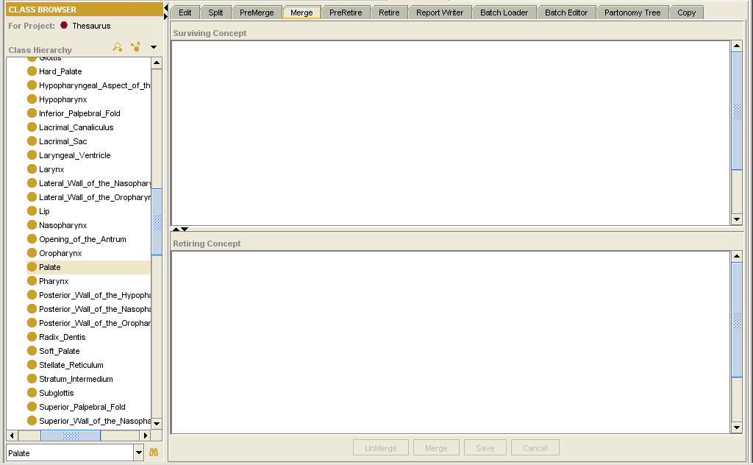
Surviving Concept pane
Retiring Concept pane
Unmerge, Merge, Save, and Cancel buttons

Figure 24. Merge tab
Table 7 describes each UI component and references relevant sections in this specification.
Table 7. UI Components of the Merge tab
UI Component | Description
Surviving Concept pane | Shows a tree representation of a selected class that has been flagged for a merge. This class has a Merge_Source annotation property.
Retiring Concept pane | Shows a tree representation of a selected class that has been designated as a  retiring class.
Unmerge button | Removes a previously set pre-merge flag.
Merge button | Flags two classes for a merge.
Save button | Merges the classes and saves the changes to the knowledge base.
Cancel button | Reverses a pre-merge operation. All users can perform this function.

About the Pre-Retire Tab
The Pre-Retire tab enables users to suggest a class for retirement. The design of this tab is shown in Figure 25.
Class Browser (NCIEditTab component)
Pre-Retire tab
Subclasses and Referencing Classes
sub-tabs
Class Editor

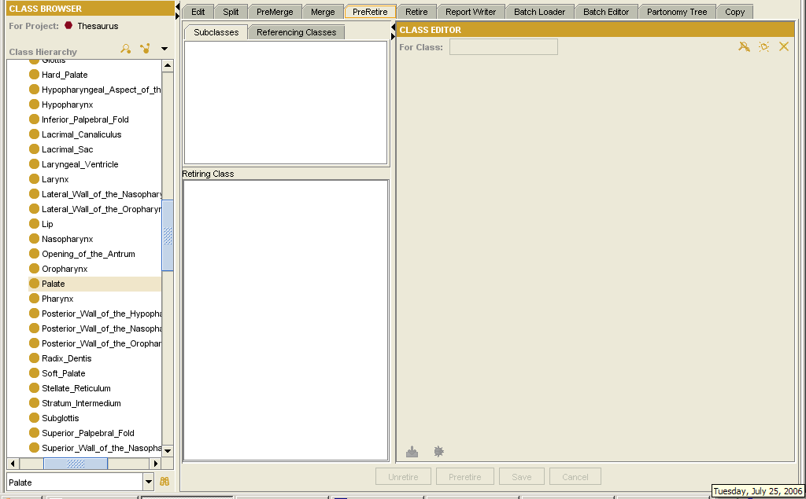
Retiring Class pane
Unretire, Pre-retire, Save, and Cancel buttons

Figure 25. Pre-Retire tab
Table 8 describes each UI component and references relevant sections in this specification.
Table 8. UI Components of the Pre-Retire tab
UI Component | Description
Subclasses sub-tab | Shows the names of all subclasses of the currently selected class.
Referencing Classes sub-tab | Shows the names of all subclasses that have the currently selected class as a referred class.
Retiring Classes pane | Shows a tree representation of a selected class that has been designated as a retiring class.
Class Editor | Used to re-tree a selected subclass (that is, assign the subclass to another superclass) or display and modify a selected referring class. This component is an existing OWL plug-in.
Unretire button | Reverses a pre-retire action.
Pre-retire button | Flags a selected class for retirement. Similar to the pre-merge action, the user provides a Scope Note and Editor Note. See Figure 23 on page 24.
Save button | Saves a selected class to the knowledge base with a pre-retire flag.
Cancel button | Discards changes made to a selected class.

Eligibility of Classes for Retirement
A class is eligible for retirement when it meets the following conditions:
- It does not have any subclasses.
- It is not the value of any restriction that belongs to any other class.
In other words, all subclasses of this class must be re-treed (that is, reassigned to another super-class), and all restrictions belonging to a referring class must either be removed or redirected to another class before retirement of a class can take place.

Using the Pre-Retire Tab
Using the Pre-Retire tab, users can perform the following tasks:
- Drag a class from the Class Hierarchy on the left and drop it into the Retiring Class pane. This action triggers the following events:
- The Subclasses sub-tab shows the names of all subclasses of the selected class.
- The Referring Classes sub-tab shows the names of all other classes that have the selected class as a referred class.
Example 2. Referred class
Assume that the class Plasma has the restriction Anatomic_Structure_is_Physical_part_of Blood. When a user drags the class Blood from the Class Hierarchy to the Retiring Class Tree Panel, the class name Plasma appears in the Referencing Class tab. This is because Plasma has a restriction with a filler value equaling the class name of the selected class Blood.
- Re-tree a subclass by selecting the name of that subclass from the Subclasses sub-tab.
This action causes data about the selected subclass to appear in the Class Editor panel. Users can then use this panel to re-tree the subclass.
- Modify the restrictions of a subclass by selecting a subclass name from the Referring Classes sub-tab.
This action causes the data about the selected subclass to appear in the Class Editor panel. Users can then modify the restrictions to satisfy the pre-conditions described in Eligibility of Classes for Retire.
Note: Like the merge action, only authorized users can perform a retire action.

About the Retire Tab
The Retire tab enables authorized users to perform a retire action on a class that has been flagged by a pre-retire action. Figure 26 shows the design of the Retire tab.
Class Browser (NCIEditTab component)
Retire tab
Tree pane

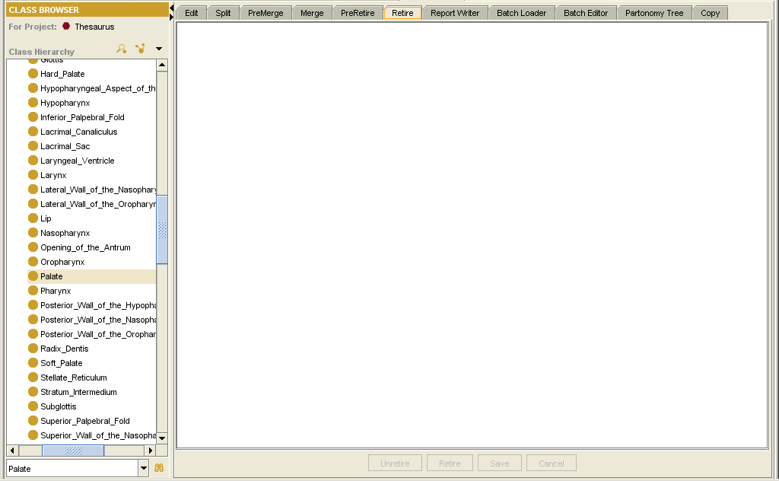
Unretire, Pre-retire, Save, and Cancel buttons

Figure 26. Retire tab
Table 9 describes each UI component and references relevant sections in this specification.
Table 9. UI Components of the Retire tab
UI Component | Description
Tree pane (right side) | Shows a tree representation of a selected class that has been flagged for retirement. The user drags a class from the Class Hierarchy and drops it into this pane.
Unretire button | Removes a previously set pre-retire flag.
Retire button | Retires a class.
Save button | Saves changes to the knowledge base and formally retires the class by re-treeing it from pre-retired to retired.
Cancel button | Aborts the retire operation.

About the Report Writer Tab
The Report Writer tab enables users to produce reports for selected classes. shows the design of this tab.
Class Browser (NCIEditTab component)
Report Writer tab
Text display area

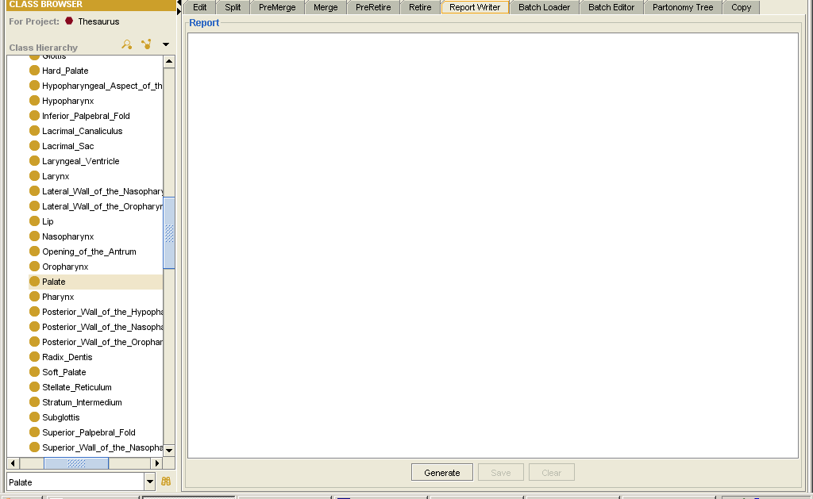
Generate, Save, and Clear buttons

Figure 27. Report Writer tab
Table 10 describes each UI component and references relevant sections in this specification.
Table 10. UI Components of the Report Writer tab
UI Component | Description
Text display area (right side) | Displays the content of a report generated from a selected class in the Class Hierarchy.
Generate button | Triggers the display of report content for a selected class.
Save button | Saves the report to an ASCII file.
Clear button | Clears the text display area.

Figure 28 shows a sample report generated from the class Lymph_Node_Sinus.
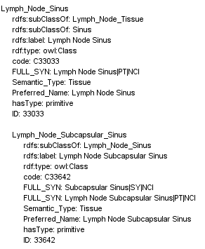
Figure 28. Sample report: Lymph_Node_Sinus

About the Batch Loader Tab
The Batch Loader tab loads a batch of classes into the knowledge base. Figure 29 shows the design of this tab.
Class Browser (NCIEditTab component)
Batch Loader tab
Log display area
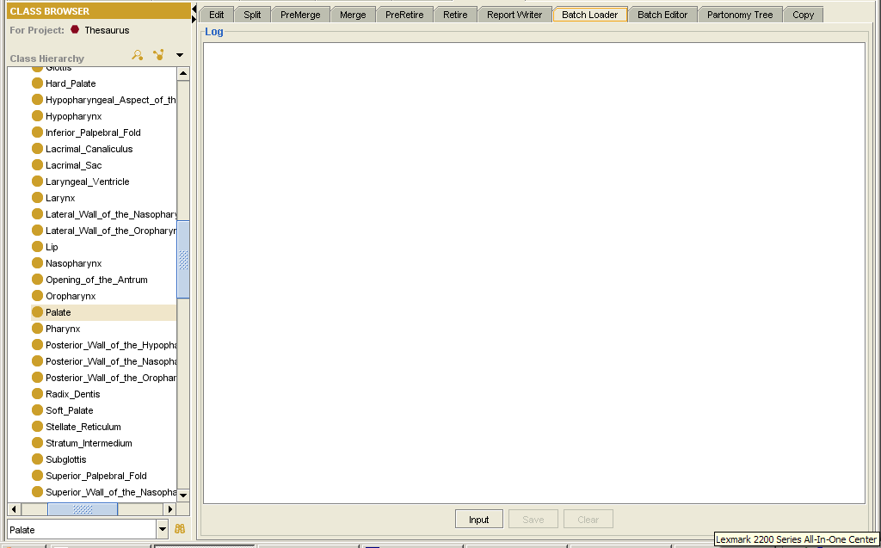
Input, Save, and Clear buttons

Figure 29. Batch Loader tab
Table 11 describes each UI component and references relevant sections in this specification.
Table 11. UI Components of the Batch Loader tab
UI Component | Description
Log display area (right side) | Displays the log status (that is, the status of the batch load).
Input button | Accepts a tab-delimited input file and starts the batch load process.
Save button | Saves the log to an ASCII file.
Clear button | Clears the text display area.

Using the Batch Loader Tab

Preparing a Batch Input File
To load a batch of classes into the knowledge base, users must first prepare a tab-delimited input file as shown in Figure 30. Each input line should contain a subclass name, the preferred name of the subclass, and the superclass of the subclass.
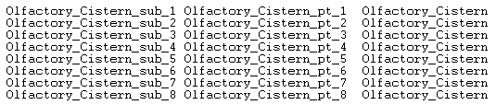
Figure 30. Batch Loader input file format

Loading a Batch File
To load the prepared file, users follow these steps:
- Click the Input button.
The dialog box shown in Figure 31 appears.
- Click the Browse buttons to locate the input file and an output log file.
- Click the Start button.
A progress bar shows that the load has begun. The batch load process produces the following results:
- The classes appearing in the first field of each input line are created and placed under a superclass as specified in the third field of each input line.
- Each class is automatically assigned annotation properties.
- When the process is completed, a log similar to the one shown Figure 32 (on the following page) appears in the text area.
- (Optional) Click the Save button to save the log to an ASCII file.

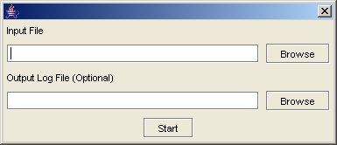
Figure 31. Batch Loader dialog box

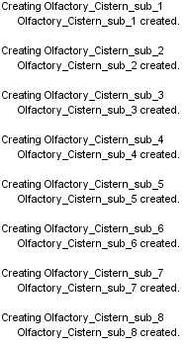
Figure 32. Sample batch loader log file

About the Batch Editor Tab
The Batch Editor tab enables users to edit a batch of classes. Figure 33 shows the design of this tab.
Class Browser (NCIEditTab component)
Batch Editor tab
Log display area

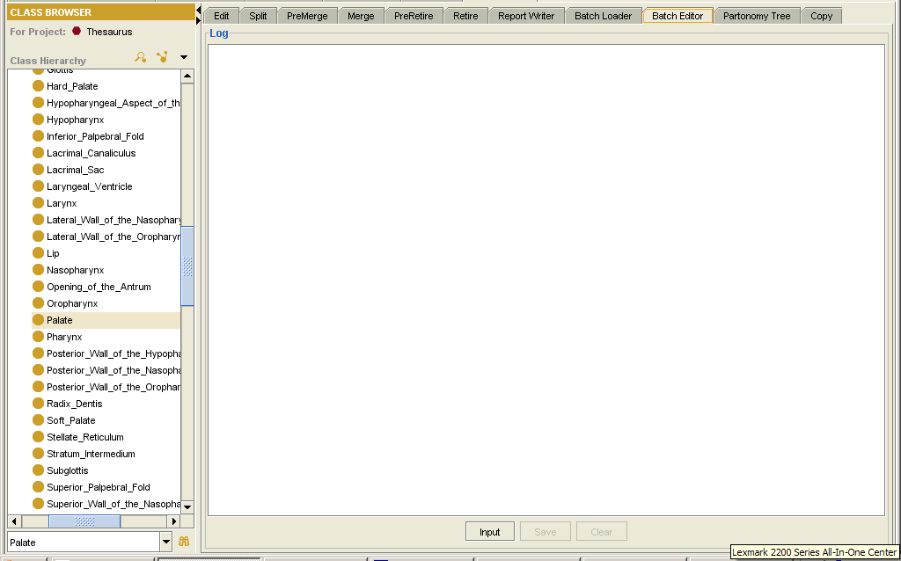
Input, Save, and Clear buttons

Figure 33. Batch Editor tab
Table 12 describes each UI component and references relevant sections in this specification.
Table 12. UI Components of the Batch Editor tab
UI Component | Description
Log display area (right side) | Displays the log status (that is, the status of the batch edit process).
Input button | Accepts a tab-delimited input file and starts the batch edit process.
Save button | Saves the log to an ASCII file.
Clear button | Clears the text display area.

Using the Batch Editor Tab

Preparing a Batch Input File
To load a batch of classes into the knowledge base, users must first prepare a tab-delimited input file as shown in Figure 34.
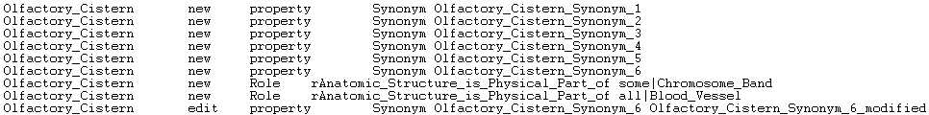
Figure 34. Batch Input file
Each input line of the batch file should contain the data elements specified in Table 13.
Table 13. Data elements for a batch file
Data Field Number | Description
1 | Class Name
2 | New/Edit
3 | Attribute Type (Property/Role)
4 | Attribute Name (Property Name/Role Name)
5 | Old Value (and modifier if applicable)
6 | New Value (and modifier if applicable)

Loading a Batch File
To load the prepared file, users follow these steps:
- Click the Input button.
The dialog box shown in Figure 31 on page 32 appears.
- Click the Browse buttons to locate the input file and an output log file.
- Click the Start button.
A progress bar shows that the load has begun. The batch load process produces the following results:
- The classes appearing in the first field of each input line are created and placed under a superclass as specified in the third field of each input line.
- Each class is automatically assigned some annotation properties.
- When the process is completed, a log similar to the one shown Figure 35 (on the following page) appears in the text area.
- (Optional) Click the Save button to save the log to an ASCII file.

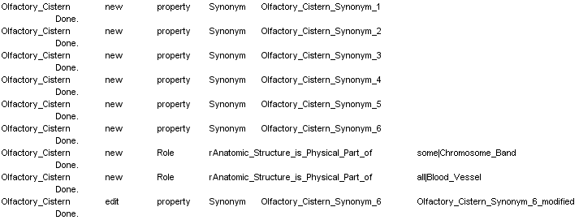
Figure 35. Sample Batch Editor log file

About the Partonomy Tree Tab
The Partonomy tree tab enables users to select a root class and display it as a partonomy tree. Figure 36 shows the design of this tab.
Class Browser (NCIEditTab component)
Partonomy Tree tab
Tree view pane

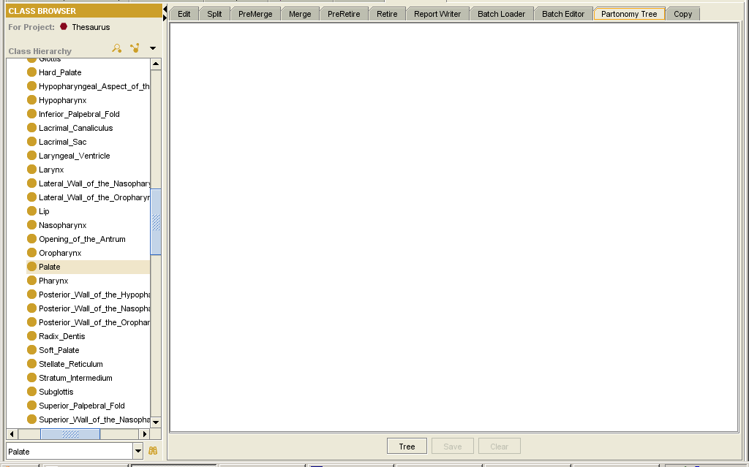
Tree, Save, and Clear buttons

Figure 36. Partonomy Tree tab
Table 14 describes each UI component and references relevant sections in this specification.
Table 14. UI components of the Partonomy Tree tab
UI Component | Description
Tree view pane (right side) | Displays a partonomy tree generated from a selected root class.
Tree button | Triggers the generation of a partonomy tree from a selected root class.
Save button | Saves the partonomy tree as an ASCII file.
Clear button | Clears the tree view pane.

Partonomy Tree Defined
A partonomy tree shows a class to which other classes are connected by part_of relations.

Using the Partonomy Tree Tab
To generate a partonomy tree, users follow these steps:
- Select a root class from the Class Hierarchy.
- Click the Tree button.
This action opens the Select Transitive Properties dialog box, shown in Figure 37.
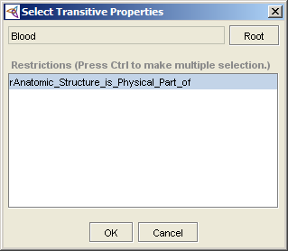
Figure 37. Select Transitive Properties dialog box
- Select one or more restriction names from the list box.
- Click OK to generate the partonomy tree.
- (Optional) Click the Save button to save the tree to an ASCII file.
Figure 38 shows a sample partonomy tree stemming from the root class Blood.
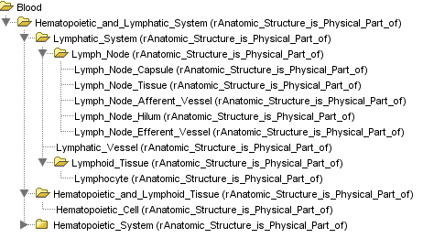
Figure 38. Sample partonomy tree

About the Copy Tab
The Copy tab enables users to edit two classes simultaneously and clone new classes from existing classes. Figure 39 shows the design of this tab.
Class Browser (NCIEditTab component)
Copy tab
Split view panes

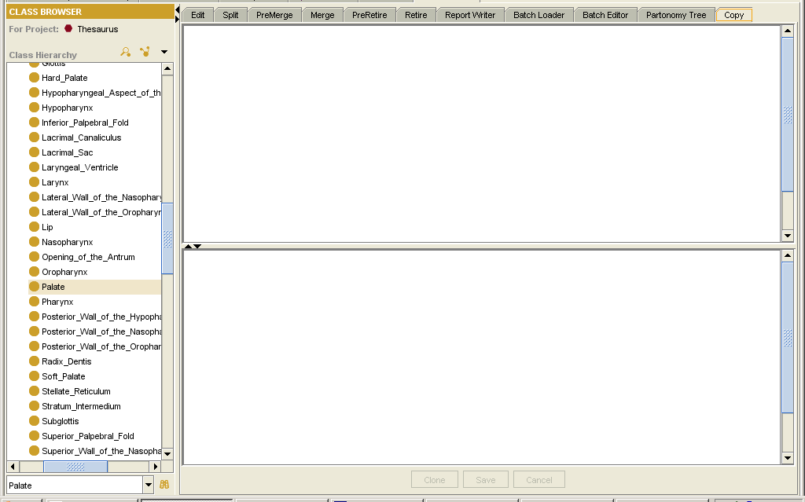
Clone, Save, and Cancel buttons

Figure 39. Copy tab
Table 15 describes each UI component and references relevant sections in this specification.
Table 15. UI components of the Copy tab
UI Component | Description
Split view panes (right side) | Display selected classes from the Class Hierarchy.
Clone button | Creates a clone of the selected class.
Save button | Saves changes to the knowledge base.
Clear button | Clears the split view panes.

Using the Copy Tab
To copy a class, users follow these steps:
- Drag an existing class from the Class Hierarchy and drop it into the upper tree pane.
- Click the Clone button to clone the selected class.
The Class Identifiers dialog box shown in Figure 21 on page 22 appears.
- Specify a label and a preferred name for the new class, then click OK.
This action generates a new class. The tree representation of this new class is shown in the lower pane.
- (Optional) Use the Copy and Paste commands to copy attributes from one class to another.
- Click the Save button to save changes to the knowledge base.

Editing a Selected Class
Users can edit a selected class by right-clicking the pane in which the class is displayed. The right-click menu offers the following commands:

- Expand | - Add Property
- Delete | - Add Restriction
- Modify Property | - Add Parent
- Modify Restriction | - Add Association

About the NCIEdit Tab Plug-In Utility Classes
The initialization of the NCIEdit Tab Plug-In instantiates the following classes:
- OWLWrapper
- NCICodeGenerator
- EventListener
- NCIEditFilter
- DataHandler

The utility of each class is described in Table 16.
Table 16. Utility classes
Class | Description
OWLWrapper | Contains common methods that are called by edit tabs.
NCICodeGenerator | Retrieves a code from the centralized code generator server.
EventListener | Detects events dispatched by the Protégé server when a class has been modified or a subclass has been added or removed by other users.
NCIEditFilter | Checks to determine whether a class meets all NCI-specific editing business rules.
DataHandler | Performs the Save action.

Table 17. NCIEditTab architecture/standards usage
NCIEditTab component | Level of use | Notes
Edit Tab | Fully uses
Split | Fully uses
Pre-merge | Fully uses
Merge | Fully uses | Authorized user only
Pre-retire | Fully uses
Retire | Fully uses | Authorized user only
Report Writer | Fully uses
Batch Loader | Fully uses
Batch Editor | Fully uses
Partonomy Tree | Fully uses
Copy | Fully uses

Level of use
Fully uses/complies
Partially uses/complies
Does not use/comply

Performance Considerations
In this section, describe the product’s degree of scalability. Note any known limits to the product’s performance and scalability.

Third-party Tool Dependencies
and Requirements
Table 18 describes the third-party tools on which this product depends. It includes the version of each product, as well as any database drivers that are supported.
Table 18. Third-party tool requirements/dependencies
Tool | Version | Used for
Base Protégé |  | Dependency
Protégé OWL Plug-In |  | Dependency
MySQL |  | Repository of knowledge base
Tomcat Servlet Engine |  | Publish ProtegeStartUp.xml
History Plug-Ins |  | Log history data
Other jar files
Jdom.jar
Xmlrpc.jar
Xerces.jar

Document Revision History
This section is used to record revisions to this document. Content changes to this document are indicated by revision bars ( | ) in the left margin unless a complete rewrite is indicated.
In the Change Description and Explanation column of the following change log, indicate the inspection date on which each document version is based. Entries in this log must be maintained for at least three years.
In the Status column, use one of the following designations:
- D = Draft
- A = For Review and Approval
- R = Re-approval, Plan of Record Change
To add a row to the end of the Change Log, click in the last cell of the table and press Tab.

Table 19. <Document Title> Document Change Log
Version/Date | Author | Change Description and Explanation | Status
mm/dd/yy | name | Text | D/A/R

Document Approval

Approvers List
List names from Product Launch Process Responsibility Matrix.

The individuals whose names are listed in this section are the approvers for the <document title>. All approvers must provide written approval before the next steps in the product launch process can begin.
Table 20. Approvers for this document
Title | Name
Technical Director (for the product) | name
Senior Development Manager (for the product) | name
Solutions Manager (for the product) | name
List names from Product Launch Process Responsibility Matrix.

Reviewers List
The individuals whose names are listed in this section are the reviewers for the <document title>. Though reviewers do not have to formally approve this document, all reviewers are encouraged to review and comment on the document. If necessary, reviewers should review only those sections that are relevant to their areas of responsibility, rather than reviewing the entire document.
Table 21. Reviewers for this document
Title | Name
Development Manager(s) for the product | name
caCORE architecture steering committee representative | name
Development team | name

Note to Authors: The End of Document indicator must remain in the document if single sequential page numbering is used. If page numbering style X of Y is used (e.g., 1 of 50), then the End Of Document indicator may be removed.
When using the page numbering style X of Y, Microsoft Word does not automatically update the total number of pages (the Y value) when viewing the document in Page Layout format. To update the total number of pages in Page Layout format, the user must select the View Normal option and then the View Page Layout option. The page numbers are always printed correctly.

END OF DOCUMENT

