1. Per yesterday’s email thread, the history file should not be used. This is not actually part of the MedDRA schema.

From the MedDRA documentation: The meddra_history_english.asc and meddra_release.asc files are optional files for use with the MedDRA Desktop Browser (MDB) release 3.0.2 Beta and up. These files are not part of the MedDRA schema.

Active/inactive should be determined from the “llt_currency” field in llt.asc. Here is an example of an LLT that would be inactive.

(I don’t think the history file needs to be used all, we don’t need to show people every edit)

Note also the “T-1” label..

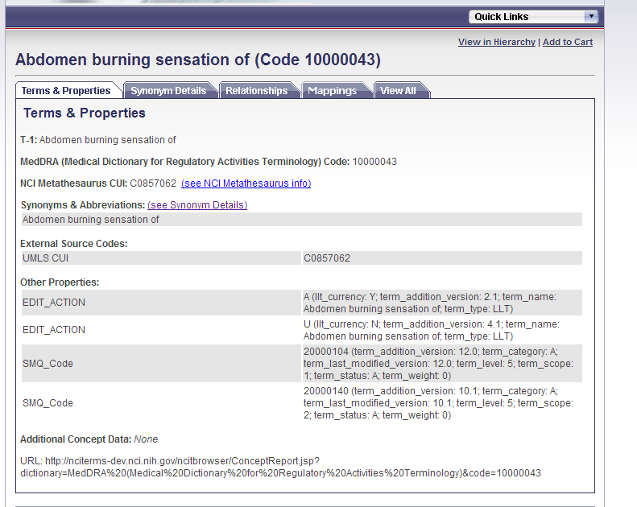

1. Here is an example of an SMQ and an SMQ member:

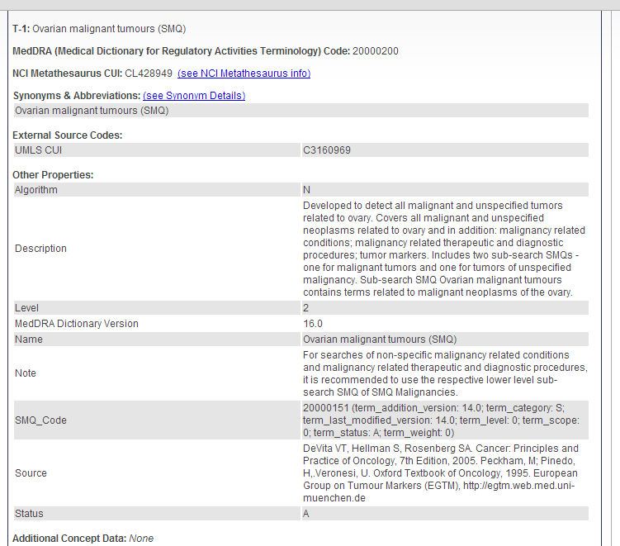

Notice how the “SMQ_Code” value includes a lot of stuff. Basically this data is being derived from the smq_content file, which means that the data you are seeing here is actually about this term (20000200) within the SMQ 20000151. So, e.g. 20000200 was added to 20000151 in MedDRA 14.0. I guess what you’re seeing here is technically correct, but we think of this information as an attribute on the relationship between the SMQ and its parent. I think maybe the expedient thing here would be to:

1. Change the name of the property from “SMQ_Code” to something like “SMQ membership.”
2. If possible, resolve the name of name of the SMQ it’s a member of (i.e. don’t just put the meaningless code), or make the code a hyperlink.

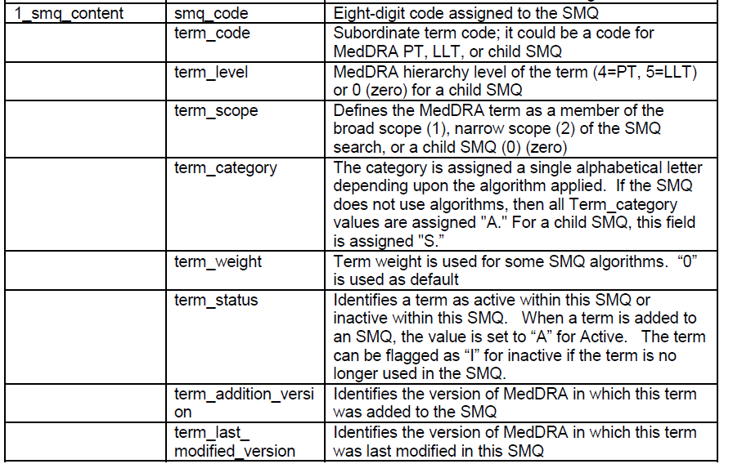

1. Problem with Hierarchy: This shouldn’t be a child of “SMQ”, just of “Hepatic disorders (SMQ). Note also that in RRF we represent the SMQ “hierarchy” with relationships. I can see how it could go either way, but note that SMQs are not included in the official “hierarchy” representation, they are part of a “list” file, which indicates membership, not hierarchy. (I am also not sure if this is affecting the tree, i.e. if we are running into the case where a concept can have different children in different trees).

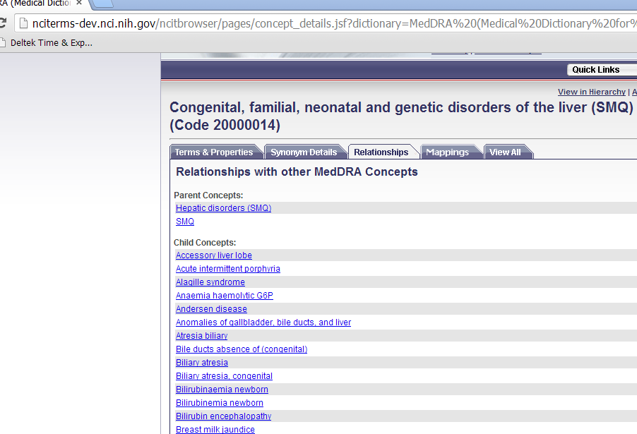

1. This is another hierarchy issue, which I think we have seen before and is not necessarily MedDRA related. There are two different lists under “Skin ulcer” … this doesn’t seem to be an issue of partial hierarchy, e.g. “Digital ulcer” shows up in the first case but not the 2nd. At first I thought it had to do with the fact that “Digital ulcer” is erroneously considered inactive, but I decided that doesn’t make sense.

Strange that “digital ulcer” does not show up as a child of “Skin ulcer” … not sure why this doesn’t show up, but maybe it has to do with the fact that “Digital ulcer” is erroneously considered inactive.

