How to Setup FileZilla

This is a quick guide to help setting up FileZilla in order to connect to the NIH SFTP server cancerinfo.nci.nih.gov and download PDQ XML data.

It is assumed that the software has already been installed on your computer.

# Setup

* Start the software by double-clicking the FileZilla icon or right-click the icon and select “Open”.
* With the FileZilla window open click the File menu and select “Site Manager …”. The following window should display:  
    
  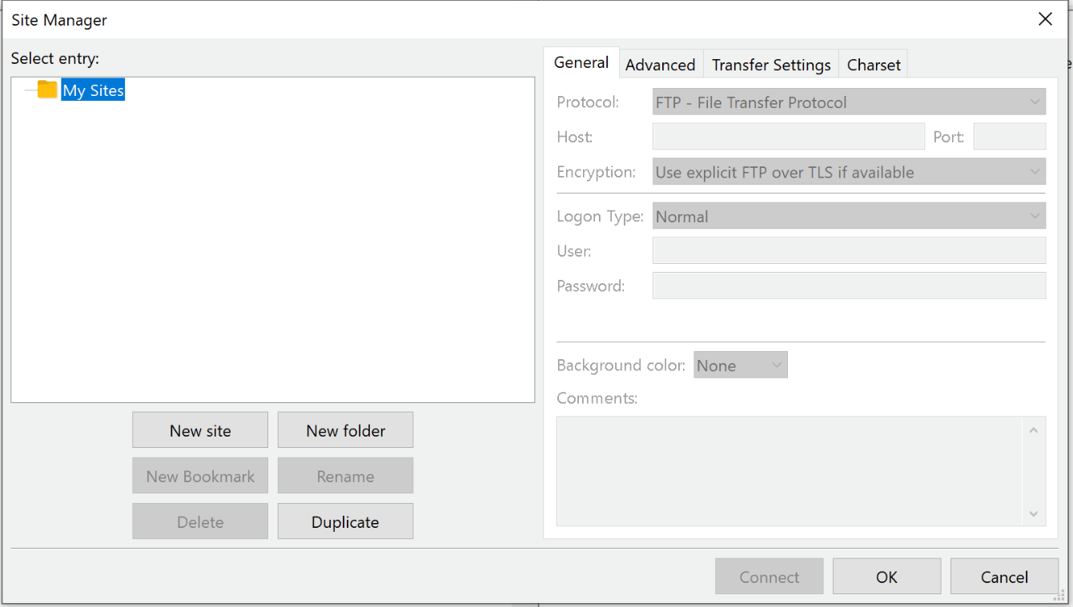
* Click the “New site” button on the left side of the window to setup a new site to connect to.  
  Graphical user interface, application

  Description automatically generated
* On the left-hand side, while the default name (“New site”) for the new site is highlighted, replace the name for this site to something more meaningful, i.e. “*PDQ Download*”, and hit return to save the new name.
* On the right-hand side, with the “General” tab selected, click the drop-down menu button of the “Protocol” entry field and select the option “SFTP – SSH File Transfer Protocol”  
  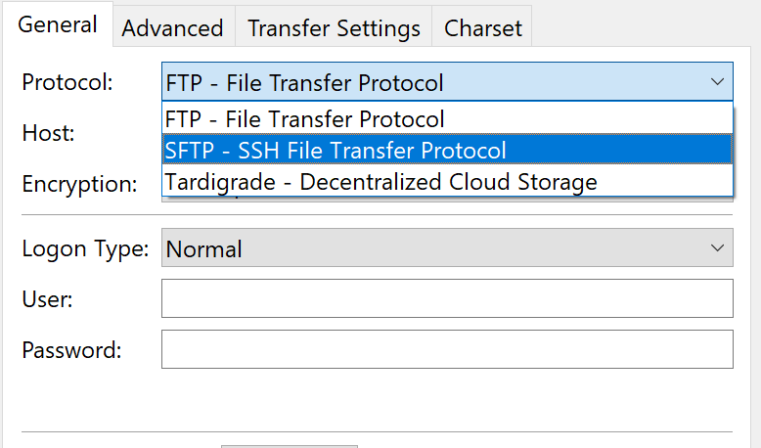
* Press the Tab key to move the cursor to the “Host” entry field and enter: *cancerinfo.nci.nih.gov*
* Leave the Port entry blank
* Tab to the “Logon Type” field and select “Key file”  
  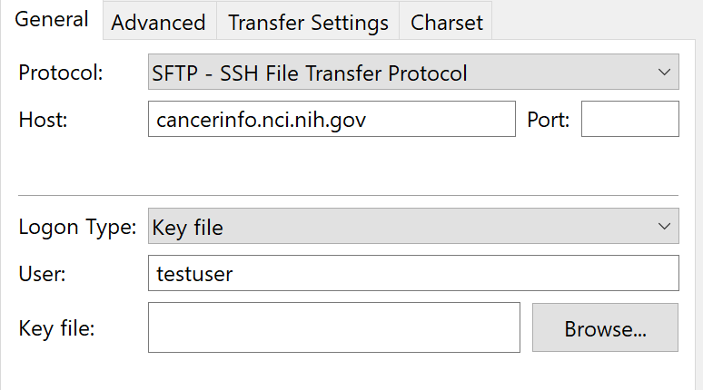
* Tab to the “User” field and enter your PDQ user ID assigned to your organization.
* For the “Key file” click the “Browse” button and navigate to the directory storing your private SSH key and select that key file.  
  **Note**:   
  If multiple persons are sharing the user account to download PDQ data, everyone must use the same private SSH key.
* Press “OK” to close this window and save the information entered.

# Connection

Once the connection to the FTP server has been setup you’ll be able to

* Open the “File” menu and select “Site manager …”
* Select and highlight the site to connect to (i.e. “*PDQ Download*”) and
* Click the “Connect” button