Northwestern University

Monthly Status Report
Annotation and Image Markup (AIM)
12XS577
September 2013
Pattanasak Mongkolwat
p-mongkolwat@northwestern.edu
Reported: October 10, 2013

Contents
Project Background/Objectives 2
Personnel Roster 2
Contract Overview 3
Current Project Status 3
Update AIM wiki pages 3
ClearCanvas 4
AIM Library 4.1 4
CMake and AIM 4.0 and 4.1 library 4
AIM Workstation 5
XNAT 6
AIM 4.0 RESTFul interface with AIM Data Service 6
AIM on GitHub and SFTP 7
AIM DOS 7
AIM ATS 7
DICOM Segmentation 8
AIM in African Continent 13
Description of Work Completed During the Month 14
External Meetings 14
Project Progress 17
Status of Milestones 17
Work Planned for Next Month 17
Travel Planned for Next Month 17
Issue Management 17
Risk Management 17
External Dependencies 18
Status of Deliverables 18

Project Background/Objectives
The objective of this project is to continue to develop the Annotation and Imaging Markup (AIM) software library and tools based on the AIM v4.0 model to meet the challenge of targeted multiple imaging domains, including Radiology and Radiation Oncology. The AIM model establishes a solid foundation for the growth of AIM in specific areas such as clinical trials and life science. The AIM standard has demonstrated its usefulness by collecting the descriptive information of images with user-generated graphical symbols, computational results, and textual descriptors placed on the images in a single common information source. The AIM model is necessarily complex and comprehensive. Typically, users do not want to understand the model comprehensively. We consider AIM users as belonging to one of two types: end-user or software developer. We provide them with appropriate software products and a programming library along with a referenced implementation of the library.
The AIM template is designed to abstract the complexity and reduce the number of activities for both types of AIM users. A template consists of a collection of questions and corresponding answers to each question. It increases AIM usability and improves experiences for users who create AIM data in their specific domain areas.
The AIM template project has two components: AIM Template Builder (ATB) and AIM Template Service (ATS). ATB has been developed to allow creation and modification of AIM templates via a software application with a simple graphical user interface. A template constrains AIM users to consistently create structured AIM data with standardized semantic vocabulary and controlled terminologies. ATS allows AIM users to search, share, download, and upload their templates.
The outcome of the project includes the AIM 4.0 foundation model, AIM 4.0 imaging model for (but not limited to) Radiology and Oncology, AIM toolkit (library in C++ and a conversion tool), AIM workstation, and AIM template software. The AIM software products will enable imaging interpreters, image researchers, and associated sciences personnel from different domains to adopt standardized annotations and imaging markup in conducting their clinical trials and translation medicine research.

Personnel Roster
Personnel | Roles | Organization
Pattanasak (Pat) Mongkolwat | Principal Investigator (PI), project manager and software engineer | Northwestern University
Vladimir Kleper | Researcher and software engineer | Northwestern University
Skip Talbot | Software engineer | Northwestern University
David Clunie | Consultant (DICOM, imaging and clinical expert) | PixelMed Publishing, LLC
Gregory Sharp | Consultant (CMake)
Daniel Rubin | Consultant (AIM and clinical expert) | Stanford University
Carolyn Klinger | Consultant (Technical Writer)
Tin Tran | Quality Assurance (QA) | SAIC-F

Contract Overview
The purpose of this project is to provide guidelines for extending the AIM model to enhance existing AIM tools (C++ toolkit, ATS and AIM for ClearCanvas workstation), develop additional AIM capabilities, and provide support in line with the historical workload and available resources.
The AIM project consists of the AIM information model, C++ Application Programming Interfaces (APIs), ATS, and AIM-enabled workstations. At the end of this research and development phase, we will accomplish the following.
- First, deliver a technical document on how to extend the AIM foundation model and library.
- Second, deliver the AIM C++ toolkit for Linux, OS X, and Windows platforms.
- Third, ATS shall have a Representational State Transfer (REST, RESTful conforms to REST constraints) APIs for other applications to consume ATS services.
- Fourth, AIM on ClearCanvas workstation will support creation and use of DICOM segmentation objects along with related AIM objects. The workstation will create and store AIM 4.0, import imaging studies from the eXtensible Neuroimaging Archive Toolkit (XNAT), communicate with AIM Data Service via RESTful APIs, validate markup creation and integrate a centralized imaging security service. An AIM plugin for the ClearCanvas workstation will be provided. A demonstration of the workstation installed on Amazon cloud will be provided.
- Fifth, AIM Data Object Service (DOS) will offer web services to create and manipulate AIM data.
The following tools were used in this project.
- Altova XMLSpy 2013 (Altova)
- Berkeley DB XML by Oracle
- Boost C++ library version 1.34.1 (Boost.org)
- caCORE SDK 4.1.1 (caBIG®)
- CMake 2.8.x and above
- DCMTK version 3.6.x (OFFIS e. V.)
- Eclipse (Eclipse Foundation, Inc.) for Windows and Linux
- Enterprise Architect version 10.x (Sparx Systems)
- Homebrew Package Installer for Mac OS X
- Java JDK 6 (Sun Microsystems)
- Linux OSes (Debian 6.0.x and above and Ubuntu version 11 and above)
- Mac OS X 10.7.5 (Lion)
- Microsoft Visual Studio 2008 and 2010 (Microsoft) with STL
- Xcode 4.6.x and Xcode command line utilities
- Xerces XML library version 3.0.1 (Apache Software Foundation)

Current Project Status

Update AIM wiki pages
We continue to update the AIM pages on the NCI Wiki as needed with new information as well as weekly and monthly reports. We updated the release notes and user’s manual for the AIM workstation 4.0.

ClearCanvas
We continue to have many discussions with Jasper, the ClearCanvas engineer assigned to the AIM team.
The first week of September, the AIM team discussed the following issues with the ClearCanvas team:
    - There is no code in the workstation that interpolates between slices. MPR code uses VTK functionality for its operations.
    - ClearCanvas does not support the use of KO to reference “deleted” instances by their UID. Similar functionality might be coming up as part of CC future work to allow editing/replacing existing KO objects.
    - Series deletion already works in 4.1.
    - We provided AIM Template overview.
    - We reviewed proposed segmentation UI and the UI design seems to be fine.
    - We talked about segmentation graphics implementation details and agreed on the way to go.
    - Our new segmentation implementation would reside in a separate workstation plugin for now.

During the second week, the AIM team discussed the following issues with Jasper.
- There was a short, front-end architecture meeting with ClearCanvas.
- We discussed whether implementation should use WinForms or WPF .NET technologies for Segmentation user interface construction. The consensus was that either one would work as long as technologies don't need to mix. For now, we decided to use WPF due to its power and flexibility.

During the third week of September, the AIM team discussed the following issues with the ClearCanvas team:
- We asked whether the workstation supports opacity in its graphic layers. It looks like opacity is supported. There should be implementation examples in the PET CT code. We will need to get this part of the code from ClearCanvas.
- Additionally, we touched on code organization and location for any new DICOM IODs. The conclusion was that they can be located with the rest of Segmentation code for now.
- We promised to share the CC Segmentation requirements document that we are working on with David Clunie when the document is ready.

The fourth week of September, the AIM team worked with Jasper as follows.
- We are going to share the Segmentation requirement document with ClearCanvas.
- Jasper asked us if the AIM plugin is ready for ClearCanvas to take it. We said that all major development is done. Only bug fixes and code cleanup remains.
- We talked about strange workstation behavior on my machine where Workstation Explorer would show different studies depending on whether workstation was run as Administrator or not. We looked at Vlad’s machine. Eventually, it came down to my machine in the past running an old workstation build from before we fixed data folder permissions and to how Windows deals with situations where user does not have write access to ProgramData and Program Files folders.
Windows created a shadow ProgramData folder in my Windows profile that was read before the actual folder. Once we deleted that old shadow folder, workstation was able to function properly.

CMake and 4.1 library
During the first week of September, the AIM team performed the following tasks.
- End-to-end CMake implementation and testing on CentOS 6.4
- OS X packaging - will be a .zip file
- .rpm files will be created for Linux platforms as well as .deb and .tar.gz
- Our next meeting is in two weeks on September 12, 2013
We also provided support to the Emory team on AIM library 3.x Linux 64-bit.
During the second week of September, the AIM team asked Greg to update the CMake document.
During the third week of September, the AIM team worked on the following issues.
- Worked with Tin on compiling the AIM library on Mac OS X.
- Investigated why there are different test results between dev and QA for OSX build.
- Building generated Xcode projects on OSX is still under investigation.
- Documented and implemented Package Maker method of creating and deploying built binaries on OSX. Whether Package Maker to be used or not is still under discussion.
- Updated CMake files to use additional Linux search paths during dependency discovery stage.
- Updated documentation for xerces installation location configuration on Linux.
- Updated documentation for installation of rpm-built (CentOS) / rpm (Debian) packages for doing rpm builds on Linux.
- Updated instructions for deb / rpm installations.
- Vlad needs to investigate AIMLibTest failures. That might be happening due to earlier changes in coded elements validation requirements.
During the fourth week of September, the AIM team worked with Greg on the following issues.
- Xcode will not be supported. There are outstanding CMake Xcode issues with DCMTK that prevent Xcode support. Greg will email us a description of the OSX DCMTK CMake issue to log into JIRA. We can track the issue for future DCMTK updates.
- There will be one more Xcode test performed against the latest code from DCMTK to see if CMake support issues are fixed.
- Documentation will be updated to direct users to build using "make" on OSX
- Documentation will be updated with installation instructions for binaries on each supported platform.
- Documentation was updated with build instructions for CentOS 6.4 32-bit.
- Documentation will be updated with Windows packaging instructions.
- All instructions will be migrated to a readme.txt file in the AIMLib directory.

AIM Workstation
The 4.0 workstation is ready for release. We continue to implement the AIM 4.1 workstation, upgrading the workstation to the latest source code from ClearCanvas. We continue working on implementing DICOM segmentation, an addition to the existing ClearCanvas workstation to support DICOM segmentation capability on the workstation 4.5.
During the first week of September, the AIM team worked on the following issues.
Workstation 4.0
- Waiting for QA result
- Done - Add menu items for XNAT, AIM Data Service, etc. (https://tracker.nci.nih.gov/browse/AIMWS-200)
- Changed title "Send Annotations to Data Service" (https://tracker.nci.nih.gov/browse/AIMWS-199)
- Fixes for Data Service result display crashes (https://tracker.nci.nih.gov/browse/AIMWS-198)
- Error appears when there is no value in Imaging Observation Characteristic from an AIM XML document retrieved from a data service (https://tracker.nci.nih.gov/browse/AIMWS-196)
- Empty annotation causes problem on the UI (https://tracker.nci.nih.gov/browse/AIMWS-201)
- AIM Data Service Search Filters are not returning the correct results. (https://tracker.nci.nih.gov/browse/AIMWS-179)
- API key credential expiration time was not working properly (https://tracker.nci.nih.gov/browse/AIMWS-202)

Workstation 4.1
- Changes similar to the AIM Workstation 4.0 changes made to this version as well.
- There is a problem with workstation service installer that requires administrative privilege. Need to discuss with ClearCanvas team member.
- Pending QA results for 4.0, a new build for workstation 4.1 is forthcoming.
During the second week of September, the AIM team worked on the following issues for AIM workstation 4.0 and 4.1.
Workstation 4.0
- Waiting for QA result
Workstation 4.1 (Code update the latest ClearCanvas code on GitHub)
- AIM Workstation 4.1 was waiting on QA results for workstation 4.0. There will be a new test build coming out this week.
- One carry-over known issue is the implementation of setting directory permissions during setup.
During the third week of September, the AIM team worked on the following issues for AIM workstation 4.0 and 4.1.
Workstation 4.0
- Workstation 4.0 final build (Released version)
- Waiting for approval
Workstation 4.1 (Updated code to the latest ClearCanvas code on GitHub)
- Alpha 3 build released
- It is no longer required to run the workstation as Windows Administrator. The workstation installer is setting data folder permissions.
During the fourth week of September, the AIM team worked on the following issues for AIM workstation 4.0 and 4.1.
Workstation 4.0
- Waiting for a public release
Workstation 4.1 (Updated to the latest ClearCanvas code on GitHub)
- There is a problem with workstation service installer that requires administrative privilege. Need to discuss with ClearCanvas team member.
- Released an alpha version for QA.

XNAT
During the first week of September, the AIM team worked on the following issues.
- The XNAT status tool icon is not updating properly using PNG icon, https://tracker.nci.nih.gov/browse/AIMWS-181. (QA for workstation 4.1)
- Deleting of the imported files does not always work, https://tracker.nci.nih.gov/browse/AIMWS-182. (QA for workstation 4.1)

AIM 4.0 RESTFul interface with AIM Data Service
The AIM team continued to work with Emory as follows.
The first week of September 2013, the AIM team worked with Emory team to fix the following problems with AIM Data Service 2.0
- Not returning AIM XML documents without Anatomic Entity, Anatomic Entity Characteristic, Imaging Observation, etc.
- Find and Retrieve methods (Emory fixes)
The team also worked on the following issue.
- Reopen - AIM Data Service Search Filters are not returning the correct results. https://tracker.nci.nih.gov/browse/AIMWS-179
During the second week of September, the AIM team worked with Emory team to fix problems with AIM Data Service 2.0.
- Allow empty URL
- Emory team fixed returning AIM XML documents without Anatomic Entity, Anatomic Entity Characteristic, Imaging Observation, etc.
- Find and Retrieve methods (Emory fixes)
- Emory Fixed - AIM Data Service Search Filters are not returning the correct results. https://tracker.nci.nih.gov/browse/AIMWS-179

AIM DOS
The component is ready for integration with ATS. We are waiting to start fixing ATS AppScan issues.

AIM ATS
The AIM team started working on AppScan issues in the first week of September.
- It was observed that ATS still requires Java 6 for code compilation but the code runs on later versions of Java.
- Fixed missing ATS login form in newer browsers when running over HTTPS due to browsers not loading non-secure external JavaScript files.

The second week of September, the AIM team worked on the following issues.
- ATS AppScan issues
- Implemented validation of template download page parameters.
- We will next add parameter validator/sanitizer to other ATS APIs.

The third week of September, the AIM team worked on the following issues.
In progress:
- Application cookies are a source of security issues (AIMES-212). Waiting for another app scan test.
- The remaining work is on the new REST API and AIM DOS.
Fixed:
- Adjust HTTP headers (AIMES-211). Additionally, with the clarifications we received from the AppScan team, we can consider most of the AppScan issued solved and AIMES-211 should be closed as invalid.
- Perform early validation for each accepted parameter by the server. This affects every server URL. (AIMES-210)

The fourth week of September, the AIM team was working on the following issues.
- Released a build in which all known AppScan issues are fixed: http://www.hightail.com/download/OGhmS3dzNnk1aVlpR01UQw
- ATS 1.1 Login page has links that navigate to the wrong page: https://tracker.nci.nih.gov/browse/AIMES-196
- ATS code to read keystore password for HTTPS is hardcoded with a password and should not be: https://tracker.nci.nih.gov/browse/AIMES-198
- Login page and other parameters need to be passed over HTTPS/SSL. Switch ATS to work over SSL/HTTPS only: https://tracker.nci.nih.gov/browse/AIMES-209
- Perform early validation for each accepted parameter by the server. This affects every server URL.: https://tracker.nci.nih.gov/browse/AIMES-210
- Adjust HTTP headers: https://tracker.nci.nih.gov/browse/AIMES-211
- We are continuing work on updated ATS RESTful API and AIM DOS features.

Extending AIM
The AIM team continues to work on the documentation used to extend the AIM foundation model. The team also updated a procedure to govern new requirements and additions to the AIM model as well as supporting software. The first version of the document for both extending AIM and AIM governance were sent to the project manager and NCI officers for review and comment.

DICOM Segmentation
The AIM team and David Clunie worked on the following issues during the first week of September.
- Received requirements document from David
- Updated the requirement for GUIs
- Skip has created the empty project, component, tool, and container UI controls for the segmentation project and will be checking them in this morning. We can easily update them.
During the second week of September, the AIM team worked on the following issues.
- Telephone conference with David to discuss implementation issues
- Updated the requirement for GUIs (see attached)
- In the process of creating and binding the UI controls (in WPF) to the data model in the component.
- Created a tree-like data model that will contain all of the segmentation objects, their child segmentation objects, and hierarchical collections of selected categories, types, and modifiers.
- The model will be populated with values when a segmentation object is read from file, or as the user enters values from the controls.
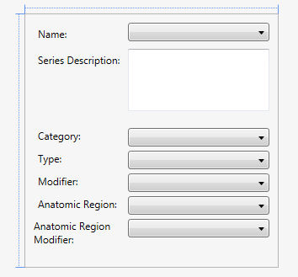

During the third week of September, the AIM team worked on the following issues.
- E-mail exchanged with David to discuss implementation issues
- Create DICOM Segmentation button (AIMWS-203)
- Create DICOM Segmentation button to launch DICOM segmentation panel (AIMWS-204)
- DICOM Segmentation Panel (AIMWS-205)
- Most of the UI data model is in place. A few changes will need to be made as the model evolves, and as we flesh out some more of the details concerning storing the ROIs.
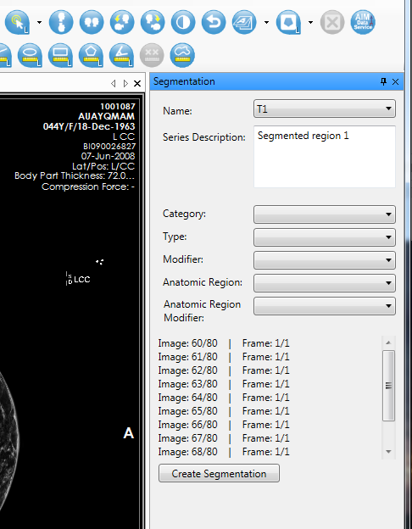
- The data model is bound to the controls, which is what the screenshot shows. The component has a hierarchical tree of segmentation objects.
- Updated the requirement for GUIs

During the fourth week of September, the AIM team worked on the following issues. See the figure below.
- Added the Volume ROIs fields and Opacity slider, which is bound to the values from the selected segmentation.
- The following figure shows the current state of the UI and a polygonal ROI that the segmentation component is using.
- You can now edit the label of polygonal ROIs and the select them from the UI to be used as a segmentation object.
- Added functions in place to collect all the graphics in the study and select which ones are available for Segmentation creation.
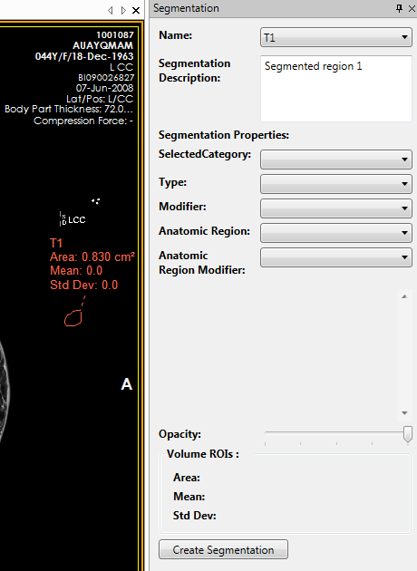

Description of Work Completed During the Month

External Meetings
Date | Topic | Project Attendees (Optional)
September 2013 | JIRA issues (addition and updates) | Pat, Vlad, Skip
September 2013 | Weekly telephone conference  - Continued weekly report  - Ulli asked the AIM team to create AIM governance procedure and related document.  - Discussed that AIM governance should be separate from the extending AIM document | Ed Helton, Jonathan Lin, Ulli Wagner, Hemant Undale, Tin, Vlad, Skip, Pat
September 2013 | Worked with SAIC-F project managers  - Submitted AIM governance document for review and comment | Ulli, Mick Benham, Alex Konev, Vlad, Skip and Pat
September  2013 | Participated in NCI Case Report Form Harmonization Working Group on Imaging. | Pat
September 2013 | Work with QA team at SAIC-F  - Worked on fixing AIM Data Service search filter issues. Skip identified that these were server-side issues. He informed Nadir about them.  - Imaging Physical Entities: Search for ‘xxxxx” returns results when there should not be any.  - Imaging Observations: Search for ‘xxxxx” returns results when should not be any.  - Imaging Observation Characteristics: Search for ‘xxxxx” returns results when there should not be any.  - Imaging Physical Entity Characteristics: Search for ‘xxxxx” returns results when there should not be any.  - Study Instance UID: Search for anything still returns two results with no Study Instance UID.  - Annotation Name: Search for anything still returns two results with no Study Instance UID.  - Skip informed Tin that the above issues were fixed.  - Worked on AIM workstation 4.0 and 4.1 bug issues  - Worked on CMake Linux and Windows (AIM Lib 4.1)  - Telephone call and e-mail exchanges with Tin on CMake and Mac OS X  - Requested Tin to verify AIM workstation JIRA issues  - Submitted AIM workstation 4.0 for QA  - Worked on AppScan issues  - Sent e-mails to Mikol about AppScan test issues  - Fixed warning message when starting AIM workstation. This was related to a non-ClearCanvas plugin  - Answered which parameters were used to perform test AIMES-210.  - Sent AIM library 4.1 test bundle for QA  - Requested a new AppScan test | Tin, Mikol Ware, Vlad, Skip and Pat
September 2013 | Worked with AIM Data Service team at Emory on the following:  - Submitted and retrieved "empty" annotations to data service. Worked with Emory team to test the data service.  - Consulted with Nadir about the public using the test AIM Data Service 2.0 URL . Emory will not always support this test URL. The AIM team will not include it in AIM workstation releases.  - Skip worked on allowing empty an AIM Data Service URL on the workstation. | Nadir Saghar, Ashish Sharma, Vlad, Skip and Pat
September 2013 | Worked with Carolyn Klinger on  - Continued to update AIM wiki.  - Weekly reports on wiki  - https://wiki.nci.nih.gov/x/AoSYCQ  - Monthly report on wiki  - https://wiki.nci.nih.gov/x/goB8C  - Updated AIM workstation user’s guide.  - Sent extending AIM document for review  - Worked on AIM 4.1 workstation release notes and user’s manual  - Sent extending AIM document for review and comment  - Sent AIM governance document for review and comment  - QA: Requested a QA person to be added to the AIM project personnel and received | Carolyn Klinger, Jonathan Lin, Ulli Wagner and Pat
September 2013 | Worked with Gregory Sharp on CMake  - Telephone conferences  - Exchanged e-mails about features required on Windows, Linux, and Mac OS X.  - Sent detailed errors about Xcode to Greg | Gregory Sharp, Vlad Kleper, Pat
September 2013 | Worked with University College Hospital, Ibadan, Nigeria  - AIM template for proforma stroke | Mayowa Ojo Owolabi, Issa Kehinde, Pat
September 2013 | DICOM Segmentation  - Telephone conferences with David  - Sent updated images on the design of DICOM segmentation GUI. See detail above.  - Exchanged e-mails about requirements and design of segmentation implementations.  - Received sample DICOM segmentation object  - Segmentation object imported into the workstation with the Series Details dialog box showing the study of the segmentation object  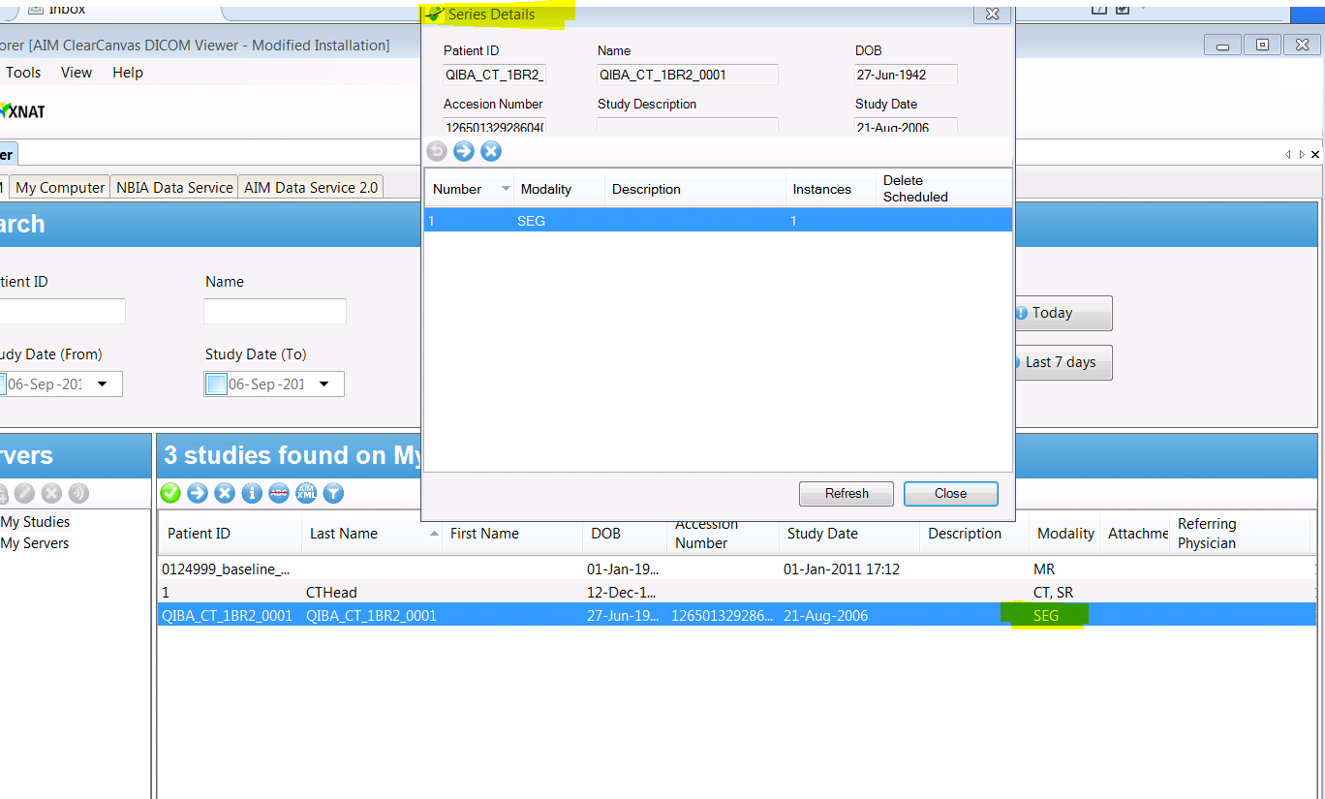 | David Clunie, Vlad, Skip, ClearCanvas team and Pat
September 2013 | Work with NBIA team  - Continued to participate in NBIA User Interface Improvements telephone conference and e-mail exchanges. | Pan Qinyan, Vlad, Skip and Pat
September 2013 | Worked with Justin Kirby and John Freymann (CIP)  - E-mail exchanges with Blackford folks for telephone conference on Sep 24th.  - Participated in telephone conference call about Blackford’s image registration plug-in on ClearCanvas workstation. Provided AIM workstation 4.0 and 4.1 alpha builds  - Worked on AIM 4.1 installation on Amazon E2C and telephone conference | Justin Kirby, John Freymann, Skip Amiot, Peter Maxwell, Richard Moffett, Larry Tarbox, and Pat
September 2013 | Consultation  - Telephone conference with Daniel about AIM 4.x and ATB  - Answered Hakan’s e-mails | Daniel Rubin, Debra Willrett, Camille Kurtz, Martin O’Connor, Hakan Bulu
September 2013 | Worked with ClearCanvas  - Exchanged e-mails related to code upgrade.  - Telephone conferences with Jasper Yeh.  - Sent segmentation requirements to Jasper | Jasper, Vlad, Skip, and Pat

Project Progress
Activity | Description
NCI’s JIRA | Continue updating:  - AIM Enterprise Service (ATB & ATS), https://tracker.nci.nih.gov/browse/AIMES  - AIM Model, https://tracker.nci.nih.gov/browse/AIMWS  - AIM Workstation, https://tracker.nci.nih.gov/browse/AIM
Software upload to SFTP | - Upload software products to NCI’s SFTP

Status of Milestones
Milestone | Delivery Date | Status
AIM FY’13 design document |  | Ongoing

Work Planned for Next Month
Activity | Description
AIM FY’13 Design | In progress
AIM DICOM Segmentation Support | In progress
ATS AppScan update | In progress
AIM library 4.1 with CMake | Delivered an alpha version for QA
AIM 4.0 workstation | Waiting for public release approval
AIM 4.1 workstation | Delivered an alpha version for QA

Travel Planned for Next Month
Attendees | Travel Purpose | Description
Not applicable

Issue Management
No issues at this time.

Risk Management
ID | Description | Owner | Potential Impact | Priority (H, M, L) | Status (Open, Closed)
1 | NBIA and caGRID 1.4 test | NCIP | Software development may not be fully working with the new NBIA and caGRID 1.4. | H | Open

External Dependencies
Dependency | Date | Status | Comments
NBIA | Current | Waiting | We are waiting for NBIA in order to test caGRID authentication in C#.

Status of Deliverables
See MS Project.

