Northwestern University

Monthly Status Report
Annotation and Image Markup (AIM)
12XS577
June 2013
Pattanasak Mongkolwat
p-mongkolwat@northwestern.edu
Reported: July 10, 2013

Contents
Project Background/Objectives 2
Personnel Roster 2
Contract Overview 3
Current Project Status 3
Update AIM wiki pages 3
AIM 4.0 Library and Workstation 4
CMake and AIM 4.0 library 4
AIM Workstation 5
ClearCanvas 6
XNAT 6
AIM 4.0 RESTFul interface with AIM Data Service 6
AIM on GitHub 8
Working with QA team 9
AIM Model and Toolkit at SIIM 2013 9
AIM DOS 10
AIM ATS Appscan evaluation 11
DICOM Segmentation 11
Description of Work Completed During the Month 13
External Meetings 13
Project Progress 17
Status of Milestones 17
Work Planned for Next Month 17
Travel Planned for Next Month 18
Issue Management 18
Risk Management 18
External Dependencies 18
Status of Deliverables 18

Project Background/Objectives
The objective of this project is to continue to develop the Annotation and Imaging Markup (AIM) software library and tools based on the AIM v4.0 model to meet the challenge of targeted multiple imaging domains, including Radiology and Radiation Oncology. The AIM model establishes a solid foundation for the growth of AIM in specific areas such as clinical trials and life science. The AIM standard has demonstrated its usefulness by collecting the descriptive information of images with user-generated graphical symbols, computational results, and textual descriptors placed on the images in a single common information source. The AIM model is necessarily complex and comprehensive. Typically, users do not want to understand the model comprehensively. We consider AIM users as belonging to one of two types: end-user or software developer. We provide them with appropriate software products and a programming library along with a referenced implementation of the library.
The AIM template is designed to abstract the complexity and reduce the number of activities for both types of AIM users. A template consists of a collection of questions and corresponding answers to each question. It increases AIM usability and improves experiences for users who create AIM data in their specific domain areas.
The AIM template project has two components: AIM Template Builder (ATB) and AIM Template Service (ATS). ATB has been developed to allow creation and modification of AIM templates via a software application with a simple graphical user interface. A template constrains AIM users to consistently create structured AIM data with standardized semantic vocabulary and controlled terminologies. ATS allows AIM users to search, share, download, and upload their templates.
The outcome of the project includes the AIM 4.0 foundation model, AIM 4.0 imaging model for (but not limited to) Radiology and Oncology, AIM toolkit (library in C++ and a conversion tool), AIM workstation, and AIM template software. The AIM software products will enable imaging interpreters, image researchers, and associated sciences personnel from different domains to adopt standardized annotations and imaging markup in conducting their clinical trials and translation medicine research.

Personnel Roster
Personnel | Roles | Organization
Pattanasak (Pat) Mongkolwat | Principal Investigator (PI), project manager and software engineer | Northwestern University
Vladimir Kleper | Researcher and software engineer | Northwestern University
Skip Talbot | Software engineer | Northwestern University
David Clunie | Consultant (DICOM, imaging and clinical expert) | PixelMed Publishing, LLC
Gregory Sharp | Consultant (CMake) | -
Daniel Rubin | Consultant (AIM and clinical expert) | Stanford University
Carolyn Klinger | Technical Writer | National Cancer Institute
Tin Tran | Quality Assurance (QA) | SAIC-F

Contract Overview
The purpose of this project is to provide guidelines for extending the AIM model to enhance existing AIM tools (C++ toolkit, ATS and AIM for ClearCanvas workstation), develop additional AIM capabilities, and provide support in line with the historical workload and available resources.
The AIM project consists of the AIM information model, C++ Application Programming Interfaces (APIs), ATS, and AIM-enabled workstations. At the end of this research and development phase, we will accomplish the following.
- First, deliver a technical document on how to extend the AIM foundation model and library.
- Second, deliver the AIM C++ toolkit for Linux, OS X, and Windows platforms.
- Third, ATS shall have a Representational State Transfer (REST, RESTful conforms to REST constraints) APIs for other applications to consume ATS services.
- Fourth, AIM on ClearCanvas workstation will support creation and use of DICOM segmentation objects along with related AIM objects. The workstation will create and store AIM 4.0, import imaging studies from the eXtensible Neuroimaging Archive Toolkit (XNAT), communicate with AIM Data Service via RESTful APIs, validate markup creation and integrate a centralized imaging security service. An AIM plugin for the ClearCanvas workstation will be provided. A demonstration of the workstation installed on Amazon cloud will be provided.
- Fifth, AIM Data Object Service (DOS) will offer web services to create and manipulate AIM data.
The following tools were used in this project.
- Altova XMLSpy 2013 (Altova)
- Berkeley DB XML by Oracle
- Boost C++ library version 1.34.1 (Boost.org)
- caCORE SDK 4.1.1 (caBIG®)
- CMake 2.8.x and above
- DCMTK version 3.6.x (OFFIS e. V.)
- Eclipse (Eclipse Foundation, Inc.) for Windows and Linux
- Enterprise Architect version 10.x (Sparx Systems)
- Homebrew Package Installer for Mac OS X
- Java JDK 6 (Sun Microsystems)
- Linux OSes (Debian 6.0.x and above and Ubuntu version 11 and above)
- Mac OS X 10.7.5 (Lion)
- Microsoft Visual Studio 2008 and 2010 (Microsoft) with STL
- Xcode 4.6.x and Xcode command line utilities
- Xerces XML library version 3.0.1 (Apache Software Foundation)

Current Project Status

Update AIM wiki pages
We updated the AIM pages on the NCI Wiki as needed. We updated the ATB 2.0 user’s manual adding how a user can include conditional logic to AIM templates.

AIM 4.0 Library and Workstation
We provided the QA team with AIM 3.5.0.1 and 4.0 workstation for testing purposes. We continue to implement the AIM 4.1 workstation, upgrading the workstation to the latest source code from ClearCanvas. We started working on implementing DICOM segmentation, an addition to existing ClearCanvas workstation to support DICOM segmentation capability on the workstation 4.5.
During the second week of June, the AIM team worked on the following issues.
- Vlad fixed an issue where the annotation name was not updating or resetting properly when opening a new template when an empty image box is selected (what Tin showed during the last meeting).
- New workstation 3.5.0.1 and 4.0 were release for testing purposes last week.
- For workstation 4.1, we continued making it work with the latest ClearCanvas code from GitHub and with .NET 4.0. Specifically, we debugged and tested of AIM Annotation and Login plugins functionality.
- We will talk to David Clunie this week about DICOM segmentation implementation.
During the third week of June, the AIM team worked on the following issues.
- We renamed folders for Windows Xerces-C components to reflect Visual Studio year of the component in the folders' names, e.g. xercesc-3.1/2008_x86, etc.
- On Windows, people would need to install Visual C++ run-time libraries from Microsoft. We already do this during workstation installation.
- On Windows, depending on the version of Visual Studio used to compile the AIMLib, people may need to install two different versions of VC run-times: one for Xerces library and the other for the AIMLib, if AIMLib is compiled with Visual Studio 2010 or later.
- I'll do a Windows test build with VS 2010 to check that AIMLib still functions properly.
- Telephone conference will be on June 27th due to week of June 20th being the NAMIC Project week.
During the fourth week of June, the AIM team worked on the following issues.
- AIM library 4.1
  - Renamed AIM Converter option for AIM XML to "XML" to be consistent with AIM SR option "SR".
  - Modified code to return more errors reported by AIM Converter if any are encountered during conversion.

CMake and AIM 4.0 library
Greg and the AIM team worked on the following issues during the first week of June.
- Worked on installation and uninstallation scripts. Verified that debug builds are functional.
- Worked on instructions used to compile AIM toolkit on Linux and Mac OS X.
- QA results
- The AIM team had a telephone conference with Greg.

During the second week of June, Greg and the AIM team performed the following tasks.

- Linux installation/uninstallation scripts are almost complete
- Linux AIMLib versioning is implemented
- There will be no hardcoded paths to AIMLib in the AIM Converter executable (no rpath). AIMLib has to be centrally installed on the system to function properly.
- For Unix-like systems, we decided to create platform-specific installation packages, e.g .deb file for Ubuntu; .dmg file OS X. Then users would use local package manager tool to install the package on their systems.
- C++ header files will not be installed - people can get AIMLib source and compile with that.

During the third week of June, Greg and the AIM team performed the following tasks.
a. We renamed folders for Windows Xerces-C components to reflect Visual Studio year of the component in the folders' names, e.g. xercesc-3.1/2008_x86, etc.
b. On Windows, people would need to install Visual C++ run-time libraries from Microsoft. We already do this during workstation installation.
c. On Windows, depending on the version of Visual Studio used to compile the AIMLib, people may need to install two different versions of VC run-times: one for Xerces library and the other for the AIMLib, if AIMLib is compiled with Visual Studio 2010 or later.
d. I'll do a Windows test build with VS 2010 to check that AIMLib still functions properly.
e. Telephone conference will be on June 27th due to week of June 20th being the NAMIC Project week.
Due to NAMIC programming week, there is no update for CMake.

AIM Workstation
The AIM team released a beta AIM 3.5.0.1 and 4.0 workstation for testing purposes. The QA found a few errors, which are: 1) cannot create an AIM instance with an AIM template that contains a question that is not set to display (https://tracker.nci.nih.gov/browse/AIMWS-162) and 2) Display group label (https://tracker.nci.nih.gov/browse/AIMWS-163). The latest fixes are being ported across all three code bases for workstation version 3.5.0.1, 4.0 and 4.1.
The AIM team continues to work on workstation 4.1 with an initial build of just the AIM Annotation plugin together with the latest ClearCanvas code from GitHub. In early June, the AIM team converted Microsoft Visual Studio projects to Visual Studio 2010. AIM Annotation component's code changes are being tested right now. Once the main AIM Annotation functionality is operational, we'll continue with satellite projects (NBIA, AIM Data Service, XNAT, etc.) conversions.
a. 3.5.0.1
i. Continued QA
ii. Bug https://tracker.nci.nih.gov/browse/AIMWS-169
iii. Common changes include fix for Annotation Name not being created when template is opened then all studies are closed and then opened a study again. Also, removed incorrect prompts to restore template data when no restore was actually happening.
iv. AIM User's Guide 3.5 URL was updated. A couple of new builds were released to QA.
b. 4.0
i. Continued QA
ii. AIM User's Guide 4.0 URL was updated. Fixed AIMLib bug when midnight time (00:00:00) was reported as error that prevented a new annotation from being created.
c. 4.1
i. Continued implementation of AIM components on ClearCanvas source code from GitHub.
ii. Implemented annotation creation.
iii. Validated that created annotations are valid AIM 4.0 objects.
iv. Currently, Vlad is working on displaying AIM 4.0 annotations in the workstation Explorer view and validating that all basic functions work as expected.
d. We replied to QA questions about workstation features and their expected behavior.
During the fourth week of June, the AIM team worked on the following issues.
- For 3.5.0.1, we released a new build to QA that fixes the issue of using a template after doing a reset. If nothing new comes up, we'll be ready for release.
- For 4.0, there was an update for AIM Lib 4.0 dependencies. Overall, we are waiting on AIM Data Service 2.0 implementation. If there will be no data service in the AIM WS 4.0, we can do another QA build.
- For 4.1, we are able to read/write annotations using the new ClearCanvas code. Also, the work continues on implementing new infrastructure for annotation tracking within the workstation (AIM annotation cache and AIM Annotation Monitor). This new infrastructure will allow us to track additions and removal of individual annotations from DICOM studies. Different plugins will use these facilities to get updates when annotations change in a study.
As to be able to release a new workstation by the end of this week, I'd say that probably is not going to happen. After the annotation monitoring infrastructure is done, Vlad still has a few plugins to convert and test with the new code. He will concentrate on this, but realistically estimate would be another week to week and a half is needed.

ClearCanvas
The AIM team had a telephone conference with ClearCanvas team. ClearCanvas team agrees to implement AIM on the open source and commercial workstation.
There is an issue with software license between GPL-3 used by ClearCanvas and BSD-3 used by the AIM team. Below is the response from ClearCanvas.
If ClearCanvas team members find bugs, or if they need to mitigate safety risks that are identified in AIM, those code changes would be put back into the GPL-3 code on GitHub, so if someone were to use the version of AIM that's maintained on GitHub, they would benefit from those changes.
As well, if they improve on standards-based things like DICOM SR support in AIM, they would contribute that back to the GitHub code.
The areas where they would not contribute back to AIM would be things like interoperability changes that make AIM work well with our research PACS, which is a commercial product.
The AIM team will ensure that any changes on AIM on ClearCanvas GitHub propagate to the main trunk of AIM GitHub.

XNAT
The AIM team provided an XNAT live demonstration on AIM on ClearCanvas workstation to NCI’s AIM project officers and project manager. XNAT’s Dlls were sent to the QA team to test the implemented XNAT functionalities in mid May 2013.

AIM 4.0 RESTFul interface with AIM Data Service
The AIM team continued to work with Emory as follows.
Week of June 3th, 2013.
Skip can login with the test credentials, and then use the provided API key to query the data service. He still needs to finish up binding the UI to create the query and show the search results, however.
Week of June 10th, 2013.
  - Skip is currently trying to get the annotation submission part of the API to work by configuring the web client to upload XML. He has been in contact with Nadir to help configure that.
  - Skip has been able to authenticate with the STS and retrieve and submit annotations, but he currently has some difficulty getting find results back from the server. He has been going back and forth with Nadir trying to get the right configuration, but there seems to be some issues in the http headers. It may be how he creates or formats the URL.
  - He has additional work on the GUI to do for the query/retrieve process. He has a static class that handles calls to the data service API, and data structures in place for the search criteria and results. He does not have them all bound to the GUI though as he is still working out kinks in making calls to the web service.
  - He will also work on retrieving and submitting annotations through the workstation.
Week of June 17th, 2013.
a. Skip was hoping to have some screen shots of the data service in action for the meeting tomorrow, but hit a couple snags that are holding him back. He has the web service plugged into the workstation. He is working through some issues with the login prompt and handling of the credentials. The issues are related to the controls and plugins within ClearCanvas, specifically how the forms controls and ClearCanvas tools and components are interacting. He had them hardwired previously for my testing of the web service, which works fine, but creating the prompt turned out to be a rather big chore.
Week of June 24th, 2013
      - The following screenshot shows the search criteria and search results from the web service in the workstation GUI. It shows three results because I submitted the same annotation (with different UIDs) to the service three times while I was testing.
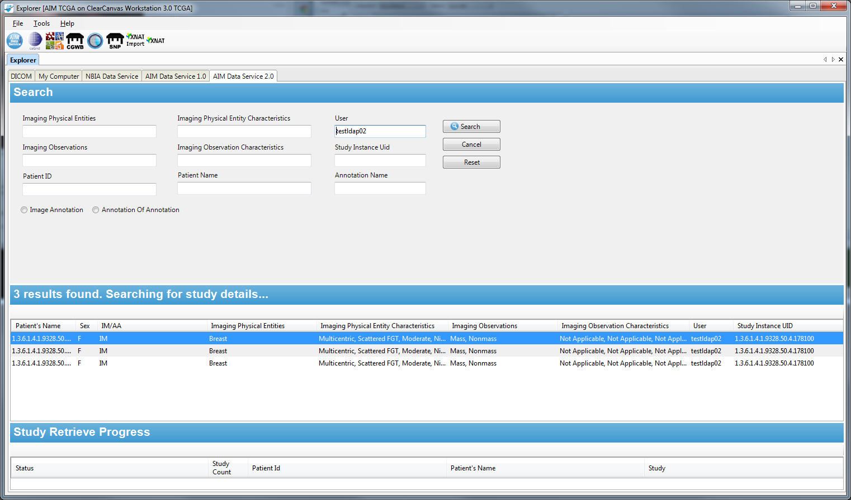
      - Here's a screen shot of the login prompt with the test username and password.
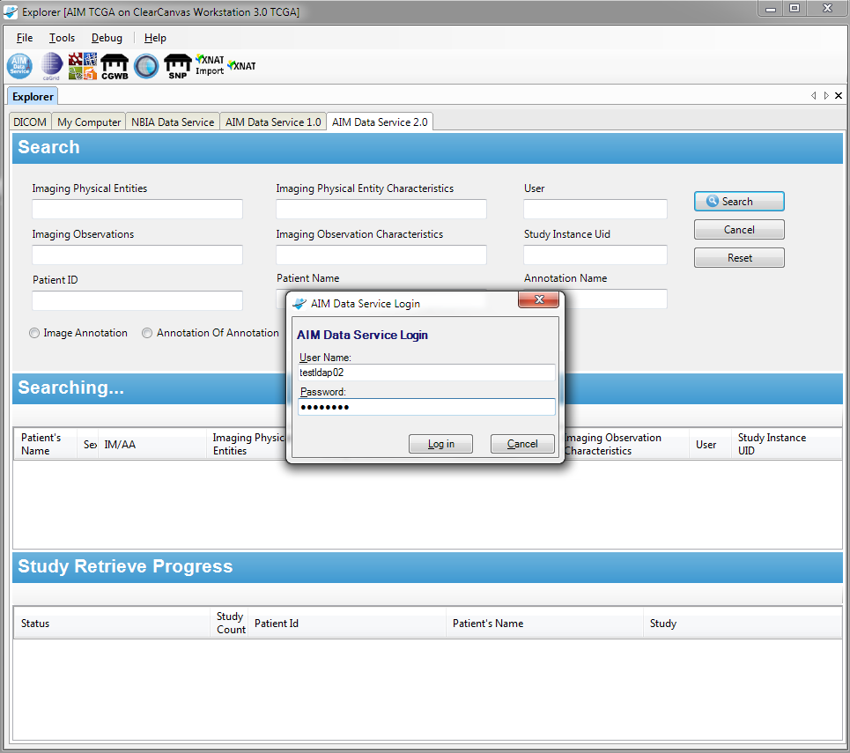
- Working to finish up the retrieve and deposit process

AIM on GitHub
The AIM team informed the GitHub team about incorrect copyright information in two source paths, namely AIMToolkit_v3.0.2_rv11/source/AIMLib and AIMToolkit_v4.0.0_rv44/source/AIMLib. AIM source code and related documents are now available on GitHub under https://github.com/NCIP/annotation-and-image-markup. The AIM team has downloaded and verified information on GitHub. See the figure below.
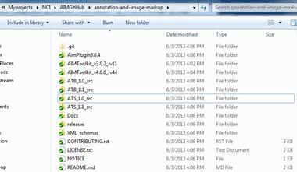
There were some problems with accessing large files from GitHub. They cannot be retrieved. The AIM team informed GitHub team and Ulli Wagner. Ulli worked on a solution using secured FTP server.
There was an issue with the content of the copyright for the AIM project. The AIM team asked the GitHub team to make the appropriate changes.

Working with QA team
The AIM team started working with the QA team to test the AIM Workstations and CMake with the AIM 4.0 library.
  - Continue to test workstation version 3.5.0.1 and 4.0.
  - Continue to test ATS deployments in 32 and 64-bit.
  - Continue to fix and test XNAT on workstation 4.0.
  - Continue to test CMake test.
  - Worked on ATS

AIM Model and Toolkit at SIIM 2013
The AIM team presented a poster and live demonstration of AIM software products at SIIM 2013 annual meeting. There were two live presentation sessions on June 6th and 7th at 12pm to 1:30pm. Poster hours of display:
Thursday, June 6: 11:00 am – 4:30 pm
Friday, June 7: 11:00 am – 4:30 pm
Saturday, June 9: 11:00 am – 1:30 pm
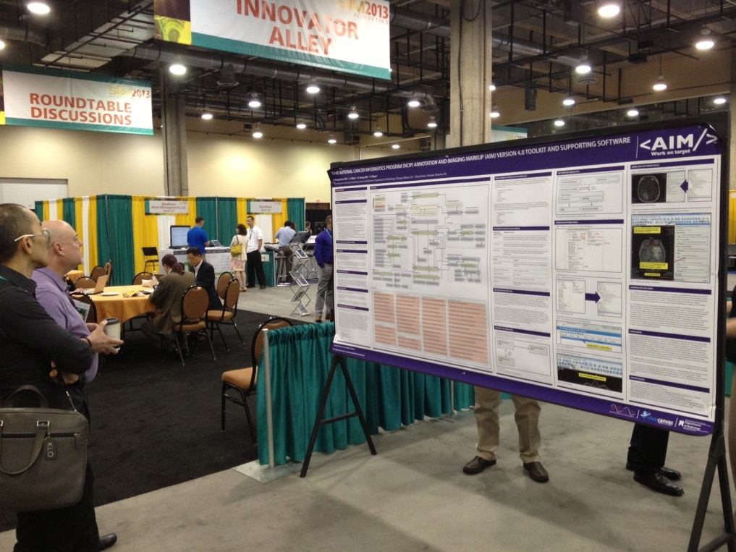
The following people left their business cards after finishing an AIM discussion. There were about ten groups of people who stopped by the demonstration area but did not leave any business card.
- Richard Moffett from Blackfordanalysis
- Thusitha Mabotuwana from Philips
- Kayo Olufowobi from MPROD Server
- Paul Nagy from John Hopkins University
- Norman Young from ClearCanvas
  - Pat sent the AIM 2013 poster to Richard and Thusitha per their requests.
- Presentation: Thursday and Friday 12pm – 1:30pm
  - Over fifteen visits
  - Richard Moffett (Registration)
- Need follow up meeting with CIP team (John, Justin and Carl)
  - Accuracy with 1-2 slices margin
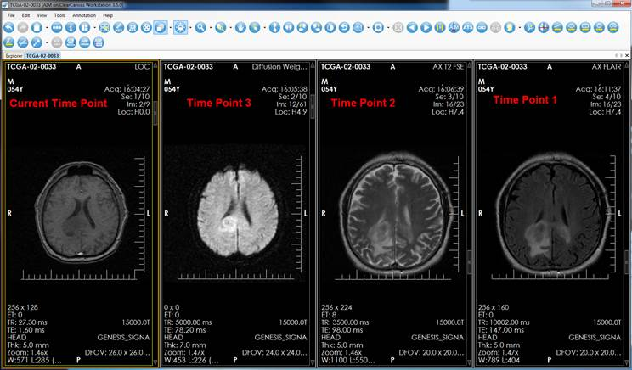
    - Thusitha Mabotuwana (Philips)
    - ClearCanvas
      - AIM Plug-in for commercial workstation
        - CIP
        - TBI at NIH
      - AIM for zero client footprint
        - CIP (Amazon EC2 vs zero client)
        - ClearCanvas needs to create a support for detachable “shell” component
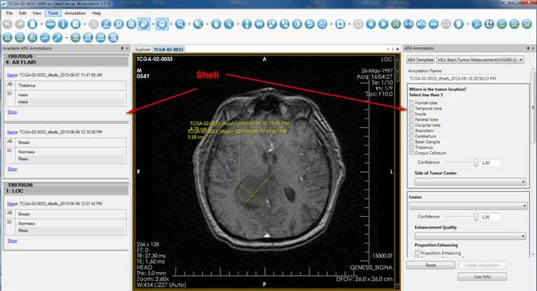

AIM DOS
The AIM team has started to implement the AIM DOS functionality for ATS. It consists of two major parts. The first part is a simple XML schema used to collect necessary AIM data without using ISO 21090. The second part is a web service with RESTful interface to submit a XML document created based on the schema to generate a full AIM 4.0 XML document or DICOM SR object. We are working on the simple XML schema.
Week of June 24th, 2013
- Working on simpler AIM XML schema.
- Working on mapping simple AIM XML schema to AIM 4.0 XML schema

AIM ATS Appscan evaluation
We are grouping the issues into broad categories by the type of work that is required to address the issues. While AppScan did not test for and uncover critical ATS problems that affect immediate application functionality and performance, the identified issues may potentially adversely affect user security and perceived ATS reliability.

Problem Group | Estimated Solution | Estimated Time
Login page and other parameters need to be passed over HTTPS/SSL. Switch ATS to work over SSL/HTTPS only. | 1. Configure server to work over SSL/HTTPS  2. Verify that ATS can correctly function over SSL/HTTPS  3. Make necessary code changes to ensure that ATS will always run over SSL/HTTPS | 1 = 3 days  2 & 3 = 2 weeks
Perform early validation for each accepted parameter by the server. This affects every server URL. | 1. Create and use validators for each application parameter.  2. Change code to never report original input parameters back to client in error messages.  3. Change code to report errors as soon as expected parameters' validation fails  4. Audit code to make sure that only explicitly validated parameters are used. | 1 = 4 days  2 = 4 days  3 & 4 = 5 days
Adjust HTTP headers | 1. Clarify what are the exact issues that AppScan identified  2. Research and implement identified required changes | 1 = 1 day  2 = TBD
Application cookies as a source of security issues | 1. Clarify how cookies are tested by AppScan  2. Determine if this is still an issue if ATS is switch to run over SSL/HTTPS  3. Define and implement any other changes | 1 & 2 = 2 days  3 = TDB
Week of June 24th, 2013.
- During our call last week, we figured out ATS HTTPS/SSL configuration options.
- It mostly worked, except for two issues.
  - First, some browsers block non-HTTPS content within a page delivered over HTTPS. This affected our login page as it links to a JQuery script in the Google CDN over HTTP. ATS code modification is required.
  - The second issue was STS self-signed certificate and its import into the local Java Trust Store. If I understood it correctly, Tin is saying that he can use ATS over HTTPS with his STS LDAP account now. He probably figured out the correct STS certificate creation and importation steps for a local java Trust Store.
- We'll be waiting for Tin to create documentation that describes the steps.
- Pat asked Tin to get another AppScan right away as only two unencrypted login issues are fixed by this new SSL configuration.
- The rest of the AppScan issues remain until we perform further code modifications.

DICOM Segmentation
The AIM team and David Clunie set up a meeting agenda on June 13th, 2013 as follows.
- Discuss segmentation deliverables and time line
- Discuss available samples of segmentation objects
- Discuss available toolkit options
- Discuss user interface requirements from user perspective
- Discuss use cases that influence the design
- Discuss validation of objects strategy

a. Two hours telephone conference with David Clunie
i. Timeline
ii. Scope
iii. DICOM segmentation
iv. Multi frame objects, enhanced CT/MR
v. Existing ClearCanvas workstation
b. David will write requirement and design documents to define scope and how DICOM segmentation will work on the AIM workstation
c. DICOM Segmentation sources
i. David’s
ii. Siemen
iii. QIBA
iv. Other sources, e.g. 3D slicer and Daniel’s Rubin group (maybe)
d. Implementation
i. Extend workstation library
ii. GUI and user interaction

Description of Work Completed During the Month

External Meetings
Date | Topic | Project Attendees (Optional)
June 2013 | JIRA issues (addition and updates) | Pat, Vlad, Skip
June 2013 | Weekly telephone conference  - Continued weekly report  - Reported problem downloading a large file (>1MB) from GitHub. We will use secured FTP server hosted at NCI to fix this problem.  - Interim solution is to revert back to SVN. Carolyn Klinger performed URL changes. | Ed Helton, Jonathan Lin, Ulli Wagner, Tin, Vlad, Skip, Pat
June 2013 | Worked with SAIC-F project managers  - Provided Ulli with an estimate for TCIA integration with AIM on ClearCanvas workstation  - Requested the use of NCIP logo on the poster | Ulli, Alex Konev, Vlad, Skip and Pat
June 2013 | Participated in NCI Case Report Form Harmonization Working Group on Imaging | Pat
June 2013 | Presented AIM status update to NCIP Imaging WS | Pat
June 2013 | Presented AIM model and related software at SIIM 2013 Open Source Plug Fest | Pat
June 2013 | ATS  - Reviewed Appscan results  - Created a response to the Appscan results along with estimated time required for improving ATS  - Exchanged e-mails and worked on installing ATS using HTTPS  - Web conference with Tin, Vlad and Pat to configure HTTPS | Tin, Qinyan, Vlad and Pat
June 2013 | Work with QA team at SAIC-F  - Exchanged and answered e-mails related to AIM tools and products  - ATS authentication did not work because the STS service was down.  - ATS configuration, folder name on Unix shall not include space in a directory path.  - Worked on STS installation using HTTPS  - Exchanged e-mails about AIM & CMake Test  - Test environment  - Test instructions  - Telephone conference  - Exchanged e-mails about AIM workstation version 3.5.0.1 and 4.tests and releases  - Tin reported errors on found on workstations  - https://tracker.nci.nih.gov/browse/AIMWS-162  - Informed Tin that workstation will only import DICOM images  - Worked on STS installation  - Sent Tin AIM templates documents for testing purposes  - Accepted a recommendation to provide a full complete version number for all future build of workstation  - Web conferencing with Tin, Vlad and Pat on installing ATS using HTTPS  - Answered question about NBIA feature on the workstation | Tin, Vlad, Skip, Qinyan and Pat
June 2013 | Worked with Carolyn Klinger on  - Created, reviewed and posted AIM monthly report  - Corrected incorrect URLs (e.g. AIM Workstation)  - Worked on AIM workstation Release Notes  - https://wiki.nci.nih.gov/x/poF4B  - Participated in a web conference about ATB  - Worked on and reviewed ATB 2.0 user’s guide  - Worked on release notes for AIM workstation 4.0  - Sent instructions on “How to create a lexicon file to be imported to ATB 2.0” to be included in ATB 2.0 user’s manual  - Worked on a temporary solution for AIM software download because GitHub does not allow a large file download  - Provided tools and technology used in the AIM project to be posted on AIM wiki  - Worked on the new format for weekly report  - AIM Tech Stack, https://wiki.nci.nih.gov/x/z4X3Ag  - Updated release notes for workstation 3.5.0.1 (AIMWS-164, AIMWS-169)  - Web conference for AIM 4.0 XNAT feature to be used for AIM 4.0 user’s manual  - Added ANIVATR notification about its capability to transcode only between AIM DICOM SR objects and AIM XML documents | Carolyn Klinger and Pat
June 2013 | Worked with Gregory Sharp on CMake  - Telephone conferences  - Exchanged e-mails compiling Windows, Linux and Mac OS X related issues | Gregory Sharp, Vlad Kleper, Pat
June 2013 | DICOM Segmentation  - Discussed with David about the plan to implement DICOM during SIIM 2013 meeting.  - Exchanged e-mails to set up a telephone and web conference  - Requested a web conference session from Ulli  - Two hours telephone conference with David Clunie  i. Timeline  ii. Scope  iii. DICOM segmentation  iv. Multi frame objects, enhanced CT/MR  v. Existing ClearCanvas workstation  vi. David will write requirement and design documents to define scope and how DICOM segmentation will work on the AIM workstation  - DICOM Segmentation sources  i. David’s  ii. Siemen  iii. QIBA  iv. Other sources, e.g. 3D slicer and Daniel’s Rubin group (maybe)  - Telephone call with ClearCanvas  - ClearCanvas on GitHub (ClearCanvas code + AIM) for public  - ClearCanvas team will take GitHub code and modify as needed for FDA, CE, Health Canada approval  - No SDK to create plug-in | David Clunie, Vlad, Skip, ClearCanvas team and Pat
June 2013 | Worked GitHub team  - Received a path to AIM GitHub, https://github.com/NCIP/annotation-and-image-markup  - Worked on incorrect copyright on AIM project with GitHub team members  - Sent and Received e-mails to GitHub team members about copyright text for AIM related source code  - Provided correct copyright information for correction  - Informed GitHub team and Ulli that AIM users could not download AIM software products  - Responded and participated inNBIA, AIM, IVIM GitHub migration close-out meeting  - Vlad attended NBIA, AIM, IVIM – OSDI close out teleconference meeting | Qinyan Pan, Yogesh Prasai, Scott Gustafson, Ulli Wagner, Vald and Pat
June 2013 | Worked with Justin Kirby (CIP)  - Justin informed the AIM team that Group Label for Anatomic Entity. Fixed as shown in figure.  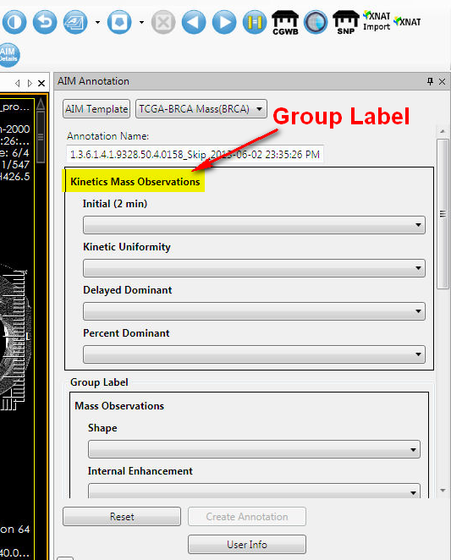  https://tracker.nci.nih.gov/browse/AIMWS-163  Fixed another problem found by the AIM team  https://tracker.nci.nih.gov/browse/AIMWS-165  - John requested Pat to meet with ClearCanvas about zero footprint viewer and Richard Moffett about image registration.  - Telephone conference with John and Justin about the two meeting with ClearCanvas and Richard.  - Telephone conference with John, Justin and Blackford Analysis team (Richard) about image registration and segmentation on AIM on ClearCanvas workstation (6/21/2013). | Justin Kirby, John Freymann, Skip and Pat
June 2013 | Consultation  - Provided instructions how to create a CSV file for ATB lexicon  - Showed Daniel how to use ATB 2.0 user’s guide  - Set up a time to work with Daniel on how to extend AIM document | Daniel Rubin, Debra Willrett and Vlad
June 2013 | Worked with ClearCanvas  - Exchanged e-mails to set up a telephone conference  - Meeting agenda (June 14th)  - Update the current AIM implementation to the latest code of ClearCanvas workstation on GitHub  - Vlad will provide a progress report and timeline  - How to deploy AIM with commercial version of the workstation  - DICOM Segmentation implementation, library implementation issues  - Clinton, any tips and concerns  - Plan to support AIM features on zero footprint workstation  - Brief discussion about Richard (Blackford Analysis) on image registration  - Should be set up a demo with Cancer Imaging Program folks (John Freymann, Justin Kirby and Carl Jeffery)? If so, when and who should contact NCI.  - E-mail exchanges with ClearCanvas team to set up a weekly meeting on AIM 4.0 implementation | Clinton Chau, Julia Geer and Vlad
June 2013 | Worked with Emory team on AIM Data Service  - Skip and Nadir continued to test and work on AIM Data Service 2.0 for the AIM team to test.  http://imaging.cci.emory.edu/wiki/display/CXFIVIM/AIME+-+ClearCanvas+Integration | Nadir, Vlad, Skip and Pat

Project Progress
Activity | Description
NCI’s JIRA | Continue updating:  - AIM Enterprise Service (ATB & ATS), https://tracker.nci.nih.gov/browse/AIMES  - AIM Model, https://tracker.nci.nih.gov/browse/AIMWS  - AIM Workstation, https://tracker.nci.nih.gov/browse/AIM
AIM SVN for GitHub | - Verified AIM 3.0, AIM foundation, AIM 4.0 and related source code to the models

Status of Milestones
Milestone | Delivery Date | Status
AIM FY’13 design document |  | Ongoing
AIM 3.5.0.1 workstation | 06/26/2013 | Final
AIM FY’13 design document |  | Ongoing

Work Planned for Next Month
Activity | Description
AIM FY’13 Design | In progress
AIM 4.0 with CMake | In progress
AIM 4.0 workstation | Delivered a beta version for QA
AIM 4.0 RESTFul interface with AIM Data Service | In progress
Bug fixes for AIM workstation, ATB and ATS | In progress

Travel Planned for Next Month
Attendees | Travel Purpose | Description
Not applicable

Issue Management
No issues at this time.

Risk Management
ID | Description | Owner | Potential Impact | Priority (H, M, L) | Status (Open, Closed)
1 | NBIA and caGRID 1.4 test | NCIP | Software development may not be fully working with the new NBIA and caGRID 1.4 | H | Open

External Dependencies
Dependency | Date | Status | Comments
NBIA | Today - | Waiting | We are waiting for NBIA in order to test caGRID authentication in C#.

Status of Deliverables
See MS Project.

