Northwestern University

Monthly Status Report
Annotation and Image Markup (AIM)
12XS577
November 2013
Pattanasak Mongkolwat
p-mongkolwat@northwestern.edu
Reported: December 10, 2013

Contents
Project Background/Objectives 2
Personnel Roster 2
Contract Overview 3
Current Project Status 3
Update AIM wiki pages 3
Lexicons for ATB 2.0 4
ClearCanvas 4
CMake and 4.1 library 5
AIM Workstation 6
AIM ATS and AIM DOS 6
AIM Workstation on Amazon Cloud (E2C) 7
Extending AIM 9
DICOM Segmentation 10
Description of Work Completed During the Month 12
External Meetings 12
Project Progress 16
Status of Milestones 16
Work Planned for Next Month 16
Travel Planned for Next Month 16
Issue Management 16
Risk Management 16
External Dependencies 17
Status of Deliverables 17

Project Background/Objectives
The objective of this project is to continue to develop the Annotation and Imaging Markup (AIM) software library and tools based on the AIM v4.0 model to meet the challenge of targeted multiple imaging domains, including Radiology and Radiation Oncology. The AIM model establishes a solid foundation for the growth of AIM in specific areas such as clinical trials and life science. The AIM standard has demonstrated its usefulness by collecting the descriptive information of images with user-generated graphical symbols, computational results, and textual descriptors placed on the images in a single common information source. The AIM model is necessarily complex and comprehensive. Typically, users do not want to understand the model comprehensively. We consider AIM users as belonging to one of two types: end-user or software developer. We provide them with appropriate software products and a programming library along with a referenced implementation of the library.
The AIM template is designed to abstract the complexity and reduce the number of activities for both types of AIM users. A template consists of a collection of questions and corresponding answers to each question. It increases AIM usability and improves experiences for users who create AIM data in their specific domain areas.
The AIM template project has two components: AIM Template Builder (ATB) and AIM Template Service (ATS). ATB has been developed to allow creation and modification of AIM templates via a software application with a simple graphical user interface. A template constrains AIM users to consistently create structured AIM data with standardized semantic vocabulary and controlled terminologies. ATS allows AIM users to search, share, download, and upload their templates.
The outcome of the project includes the AIM 4.0 Foundation model, AIM 4.0 imaging model for (but not limited to) radiology and oncology, AIM toolkit (library in C++ and a conversion tool), AIM workstation, and AIM template software. The AIM software products will enable imaging interpreters, image researchers, and associated sciences personnel from different domains to adopt standardized annotations and imaging markup in conducting their clinical trials and translation medicine research.

Personnel Roster
Personnel | Roles | Organization
Pattanasak (Pat) Mongkolwat | Principal Investigator (PI), project manager and software engineer | Northwestern University
Vladimir Kleper | Researcher and software engineer | Northwestern University
Skip Talbot | Software engineer | Northwestern University
David Clunie | Consultant (DICOM, imaging and clinical expert) | PixelMed Publishing, LLC
Gregory Sharp | Consultant (CMake)
Daniel Rubin | Consultant (AIM and clinical expert) | Stanford University
Carolyn Klinger | Consultant (Technical Writer) | Independent
Tin Tran | Quality Assurance (QA) | SAIC-F

Contract Overview
The purpose of this project is to provide guidelines for extending the AIM model to enhance existing AIM tools (C++ toolkit, ATS and AIM for ClearCanvas workstation), develop additional AIM capabilities, and provide support in-line with the historical workload and available resources.
The AIM project consists of the AIM information model, C++ Application Programming Interfaces (APIs), ATS, and AIM-enabled workstations. At the end of this research and development phase, we will accomplish the following.
- First, deliver a technical document on how to extend the AIM foundation model and library.
- Second, deliver the AIM C++ toolkit for Linux, OS X, and Windows platforms.
- Third, ATS shall have Representational State Transfer (REST, RESTful conforms to REST constraints) APIs for other applications to consume ATS services.
- Fourth, AIM on ClearCanvas workstation will support creation and use of DICOM segmentation objects along with related AIM objects. The workstation will create and store AIM 4.0, import imaging studies from the eXtensible Neuroimaging Archive Toolkit (XNAT), communicate with the AIM Data Service via RESTful APIs, validate markup creation, and integrate a centralized imaging security service. An AIM plugin for the ClearCanvas workstation will be provided. A demonstration of the workstation installed on Amazon cloud will be provided.
- Fifth, AIM Data Object Service (DOS) will offer web services to create and manipulate AIM data.
The following tools were used in this project.
- Altova XMLSpy 2013 (Altova)
- Berkeley DB XML by Oracle
- Boost C++ library version 1.34.1 (Boost.org)
- caCORE SDK 4.1.1 (caBIG®)
- CMake 2.8.x and above
- DCMTK version 3.6.x (OFFIS e. V.)
- Eclipse (Eclipse Foundation, Inc.) for Windows and Linux
- Enterprise Architect version 10.x (Sparx Systems)
- Homebrew Package Installer for Mac OS X
- Java JDK 6 (Sun Microsystems)
- Linux OSes (Debian 6.0.x and above and Ubuntu version 11 and above)
- Mac OS X 10.7.5 (Lion)
- Microsoft Visual Studio 2008 and 2010 (Microsoft) with STL
- Windows XP SP3 and Windows 7 64-bit
- Xcode 4.6.x and Xcode command line utilities
- Xerces XML library version 3.0.1 (Apache Software Foundation)

Current Project Status

Update AIM wiki pages
We continue to update the AIM pages on the NCI Wiki as needed with new information as well as weekly and monthly reports. The AIM workstation 4.1 has been approved for public use. The workstation user’s guide is available for public viewing at https://wiki.nci.nih.gov/x/XgiGCQ. The workstation download is located at http://cbiit-download.nci.nih.gov/aim/releases/AIM_WS/4.1.0.0/AIM_WS_4.1.0.0_x86.rar.

Lexicons for ATB 2.0
The AIM team received the RadLex 3.10 lexicon from RSNA members Robert Boden and Brendan Wright, per Daniel Rubin’s request. The team converted the RadLex lexicon from an Excel file to a format readable by ATB 2.0.
The AIM team worked on a conversion from NCI Metathesaurus lexicon to a format readable by ATB 2.0. The two formats were uploaded to the AIM wiki site for public use, https://wiki.nci.nih.gov/x/z4X3Ag.
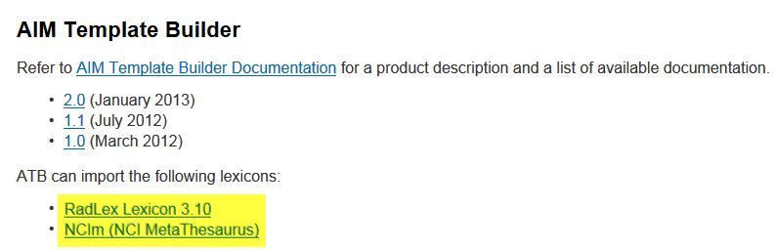

ClearCanvas
We continue to have many discussions with Jasper, the ClearCanvas engineer assigned to the AIM team.
The first week of November, the AIM team discussed the following issues with the ClearCanvas team:
    - We discussed the potential disappearance from display of DICOM study attributes when a newly-created AIM DICOM SR object is missing those attributes. The consensus was that the AIM object needs to have those attributes values set.
    - We discussed implementation details for displaying a dynamically overlayed text. We were advised that the architecture can support it. We would need to implement and use a new type of Control Graphic that would manage visibility of the overlays.

During the second week of November, the AIM team discussed the following issues with Jasper.
- A decision was made to make the SopInstanceReferenceMacro class public in the ClearCanvas code base since we need it in our implementation.
- There are newly implemented DICOM IODs that are not available on GitHub yet. We need some of them. The new code will either be pushed to the GitHub soon or it will be shared with us adhoc for now.
- There is already a CIELabColor class in the DICOM toolkit. We'll use that in our implementation.

During the third week of November, the AIM team discussed the following issues with the ClearCanvas team:
- During our weekly call with ClearCanvas, we learned that some parts of the Segmentation code that we are working on already exist but have not been released to GitHub.
- We asked for access to the code. The new code was pushed to GitHub this week.
- We discussed issues with markup text labels not being saved until the user selects a different drawing on an image. We were told that there are a couple of events available that would help us with the issue.

During the fourth week of November, the AIM team worked with Jasper as follows.
- The AIM team has a regular meeting to discuss issues related to DICOM segmentation. See DICOM segmentation for details.

CMake and 4.1 library
During the first week of November, the AIM team performed the following tasks.
- Xcode build against DCMTK development branch was tested. While it appears that Xcode configuration is working with the latest DCMTK source, there is no new official DCMTK release/bundle available.
- We decided to add a note to the readme.txt file to explicitly state that using Xcode is not a supported configuration on OSX in this release of AIM Toolkit. Users should work with Unix to make files.
- There is a potential for conflict between our private DCMTK and a system-installed DCMTK during the CMake build. We'll be adding a note to readme.txt about it.
- Our next meeting is on Friday, November 8, 2013, @ 9:30 CDT
During the second week of November, the AIM team worked on the following issues.
- Made AIMConverter report errors to the correct output stream (stderr).
- Added support for propagating study attributes (Accession Number, Study Date, Study Time, Referring Physician Name and Study Description) to the AIM DICOM SR object.
- AIMToolkit was internally tested on the 32-bit Ubuntu. There was one compilation issue discovered and fixed.
- Do we need to create another test bundle for QA?
- CMake meeting from last week was rescheduled for this Friday
During the third week, the AIM team worked on the following issues.
- Worked on release package for AIM library 4.1 with CMake
- Worked with Carolyn Klinger making release notes for public access
During the fourth week, the AIM team worked with Greg on the following issues.
- Release notes for public use: https://wiki.nci.nih.gov/x/SAbHB
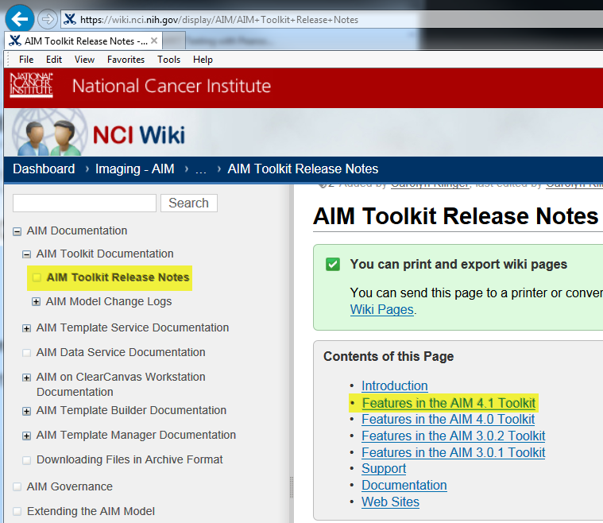
- The code is on Github: https://github.com/NCIP/annotation-and-image-markup/tree/master/AIMToolkit_v4.1.0_rv44 .
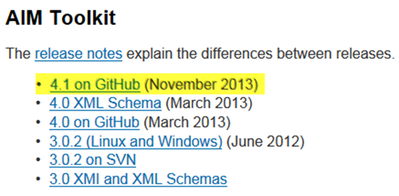

AIM Workstation
The 4.0 workstation has been released for public use. We continue to work on software bugs for AIM 4.1 workstation. We created many Workstation 4.1 alpha versions for QA. We will continue working on implementing DICOM segmentation, an addition to the existing ClearCanvas workstation, to support the DICOM segmentation capability on Workstation 4.5.
During the first week of November, the AIM team worked on the following issues.
Workstation 4.0
- Released

Workstation 4.1
- Release build sent to QA
- Uploaded to NCI SFTP site, http://cbiit-download.nci.nih.gov/aim/releases/AIM_WS/4.1.0.0/AIM_WS_4.1.0.0_x86.rar
- Waiting for approval and release announcement
During the second week of November, the AIM team worked on the following issues for the AIM Workstation 4.1.
Workstation 4.1 (Code updated to the latest ClearCanvas code on GitHub)
- Waiting for approval and release announcement
During the third week of November, the AIM team worked on the following issues for AIM Workstation 4.1.
Workstation 4.1 (Updated code to the latest ClearCanvas code on GitHub)
- Waiting for approval and release announcement
During the fourth week of November, the AIM team worked on the following issues for AIM Workstation 4.1.
Workstation 4.1
- Approved and release announcement
  - Release notes, https://wiki.nci.nih.gov/x/poF4B
- Workstation download, http://cbiit-download.nci.nih.gov/aim/releases/AIM_WS/4.1.0.0/AIM_WS_4.1.0.0_x86.rar
  - User’s guide, https://wiki.nci.nih.gov/x/XgiGCQ

AIM ATS and AIM DOS
The AIM team continued to work on ATS and AIM DOS during the first week of November.
- Created a new test build and sent it to QA. This is an ATS test build. All reported App Scan issues are fixed. It should be ready for another App Scan.
- AIM DOS is waiting to be tested with ATS.
- Continued internal testing and debugging of AIM DOS APIs.
- Created "convert" API unit tests.
- Implemented infrastructure for AIM DOS API help page and created placeholder help content.
- The code also includes early versions of AIM DOS APIs (/api/aim/):
1. /api/aim/create - creates an AIM XML document base on a simpler AIM DOS XML file
2. /api/aim/convert - converts from one type of AIM document to another (e.g. from DICOM SR to XML)
3. QA person may just browse to the URLs and submit web forms. For the Convert API to work, you'd need to specify full path to the AIM Converter executable in the serverConfig.txt file. Attached is a sample XML file for creating a complex AIM document and the XML schema for validating AIM DOS documents.

During the second week of November, the AIM team worked on the following issues.
- Debugged template uploading issues found by QA. Thought the issues were not reproduced locally, added more error handling to the code.
- Created new QA test bundle and sent it out
- Fixed: ATS 1.1 Login page has links that navigate to the wrong page, https://tracker.nci.nih.gov/browse/AIMES-196
- Fixed: Clearing\Deleting Allowed Users from a templates permission setting does not get saved, https://tracker.nci.nih.gov/browse/AIMES-194

The third week of November, the AIM team was working on the following issues.
- We exchanged a number of emails regarding ATS over HTTPS/SSL setup with QA. This is still work in progress.

During the fourth week of November, the AIM team worked on the following issues.
- For the ATS, on Thursday and on Monday we had WebEx sessions with QA to figure out why test servers often fail to provide connection and get 100% CPU load when running with SSL/HTTPS on. The initial assumption that high security settings on Windows firewall were blocking access to Java was proved incorrect by a test with a different VM.
- Currently, we are trying to recreate the situation locally to determine the exact reason behind the connection failures.

AIM Workstation on Amazon Cloud (E2C)
The AIM team installed a release version of AIM workstation 4.1 on Amazon Cloud E2C. The workstation functions fine on Windows 2008. See the figure below.
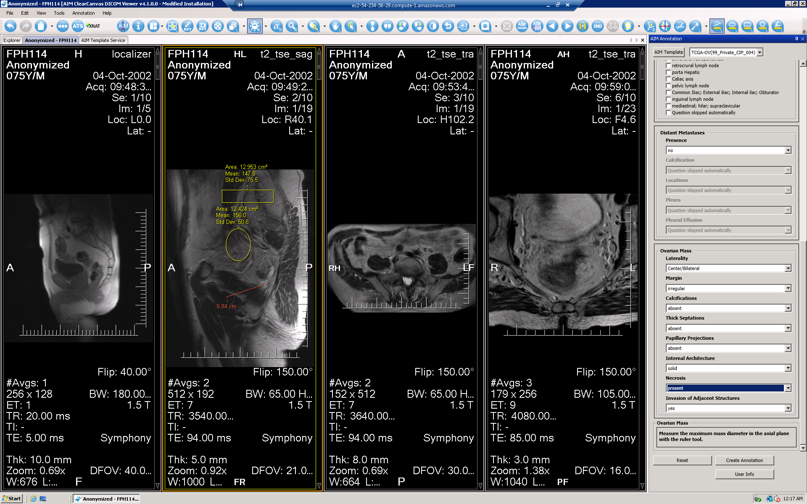
During the first week of November, the AIM team worked with Justin Kirby. He likes the new features, skipping questions, and the notification of a missing answer from a question. The login information is as follows.
- Use Windows RDP to log in.
  - Server is running 24x7 and requires startup.
  - http://aws.amazon.com/
    - Pat’s account
  - Address for RDP: ec2-54-234-56-29.compute-1.amazonaws.com (currently running)
  - Password: Aimws41##
During the second week of November, the AIM team worked with the QA team on the testing issue on the workstation EC2.
- QA
  - Tin wanted to capture some performance numbers and was not able to successfully complete the download of the NBIA studies. The system resources were maxed out.
Studies (Study Instance UID) | Retrieval Time (sec) | Study Size
1.3.6.1.4.1.9328.50.4.156950 | 9 min 47 sec – Error processing received images | 600 MB
1.3.6.1.4.1.9328.50.4.178100 | 8 min 27 sec – Error processing received images | 539 MB
1.3.6.1.4.1.9328.50.4.179180 | 7 min 30 sec - Error processing received images | 462 MB
1.3.6.1.4.1.9328.50.4.180115 | X | 556 MB
1.3.6.1.4.1.9328.50.4.206594 | X | 596 MB
1.3.6.1.4.1.9328.50.4.220339 | X | 664 MB
1.3.6.1.4.1.9328.50.4.235252 | X | 568 MB

- Closed: Install an AIM workstation on Amazon cloud, https://tracker.nci.nih.gov/browse/AIMWS-151
  - Server is running 24x7
  - Username: Administrator
  - Password: Aimws41##
  - Address for RDP: ec2-54-234-56-29.compute-1.amazonaws.com (currently running)

During the third week of November, the AIM team worked with the QA team on testing issue on the workstation EC2.
- Restarted the VM and able to download a study

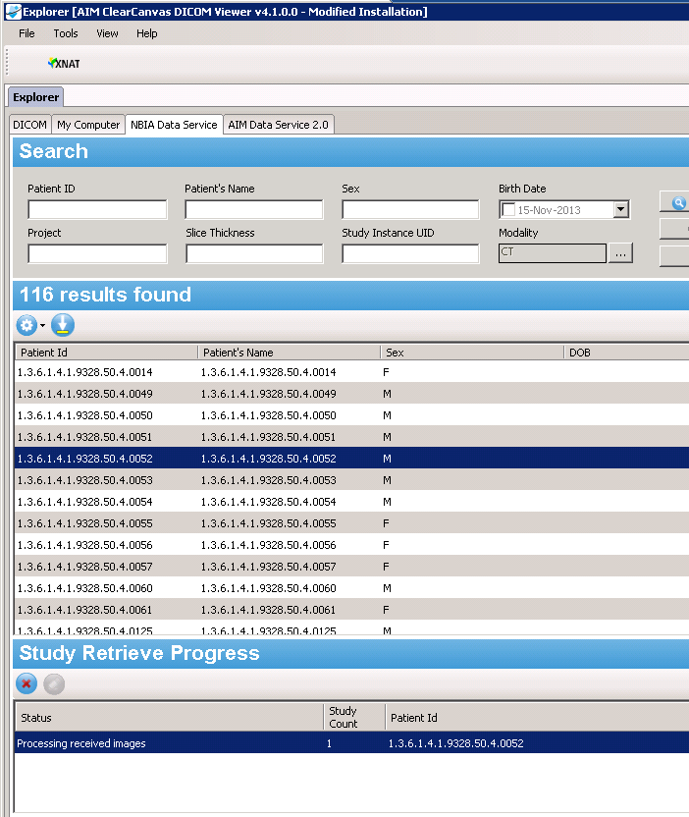
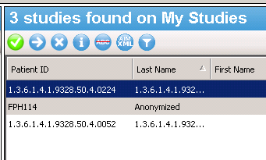
- Server is running 24x7
  - Username: Administrator
  - Password: Aimws41##
  - Address for RDP: ec2-54-205-90-214.compute-1.amazonaws.com (currently running)
During the fourth week of November, the AIM team finished the work on installing and testing AIM 4.1 workstation on Amazon cloud (EC2). The issue is now closed, https://tracker.nci.nih.gov/browse/AIMWS-151.

Extending AIM
The team reviewed the document and modified the document per Ulli’s and Daniel’s suggestions. The team is waiting for comments from Ulli, Jonathan, and Ed.
During the third week of November, the AIM team received an approval from Uill to release the document on AIM wiki. The team worked with Carolyn Klinger to release the document for public viewing.

DICOM Segmentation
The AIM team and David Clunie worked on the following issues during the first week of November.
- Calculation of Volume ROI statistics is now available in the segmentation component.
- The volume, mean, and standard deviation of the pixel intensity are calculated and displayed when the segmented region is created (after clicking Create Segmentation). These values are not available until after the polygons are converted into pixel images and these stats are not saved in the DICOM segmentation object per the specifications, but rather recalculated by the workstation.
- There are a couple bugs that need to be fixed in the UI including handling for renaming of Polygon ROI graphics after they've been added to segmentation objects, and discrepancies in the lab color conversion.
- The remaining tasks for the segmentation project include the import and export of the DICOM segmentation objects.
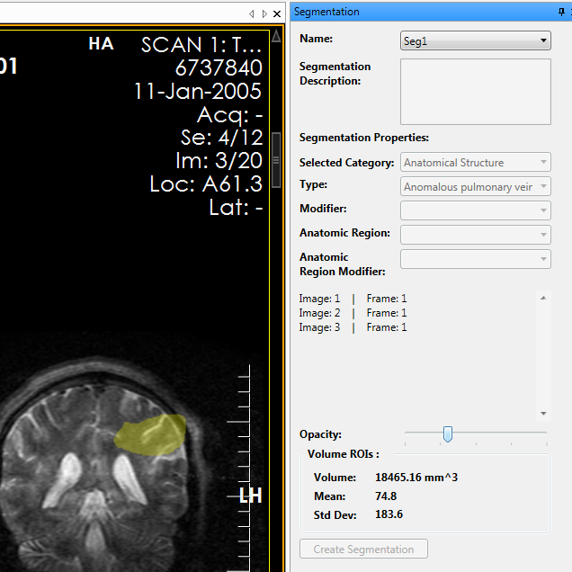
During the second week of November, the AIM team worked on the following issues.
- Fixed UI bugs including assignment of renamed ROIs to segmentation objects.
- Currently fixing CIELab color conversion code to meet DICOM requirements.
- Working with Vlad to implement the import and export of DICOM segmentation objects with assistance from Jasper at ClearCanvas.
  - Consulted with ClearCanvas on proper implementation of DICOM modules
  - Created new classes that represent Segmentation Series and Segmentation Images DICOM modules.
  - It's still under discussion whether or not we need to synchronize our working code with the latest from ClearCanvas GitHub to pick up the latest changes.
  - Near-term work will include implementation of the remaining DICOM modules and classes for creating actual Segmentation objects.
During the third week of November, the AIM team worked on the following issues.
- We continued creating new DICOM classes for Segmentation data.
- Also, a number of required DICOM classes are available in the new ClearCanvas code base.
- Our code update from GitHub and integration is in progress.
- Fixed a bug involving the renaming of polygonal ROI graphics that was preventing some graphics from being included in the segmentation under certain situations.
- Fixed several issues with the conversion of RGB and LAB colors.
- Currently working with Vlad on DICOM IOD's, reading, and writing of DICOM segmentation objects.
During the fourth week of November, David and the AIM team worked on the following issues. See the figure below.
- Upgraded workstation code and projects to use the latest change set from ClearCanvas to make use of added DICOM classes.
- Vlad has implemented the IOD classes we need for the segmentation project.
- We are currently working on reading in DICOM files and deserializing them to populate the segmentation data model within the workstation, using example DICOM segmentation objects from David Clunie.
- We're also working on reading in DICOM files to create the image segmentation graphics rendered by the Workstation.
- Writing the segmentation data model and segmentation graphics to DICOM will follow, as well as testing of the DICOM objects.
- Make an appointment to meet with David Clunie on Wed 4th to review DICOM segmentation capability on Workstation 4.5.

Description of Work Completed During the Month

External Meetings
Date | Topic | Project Attendees (Optional)
November 2013 | JIRA issues (addition and updates) | Pat, Vlad, Skip
November 2013 | Weekly telephone conference  - Continued weekly report | Ed Helton, Jonathan Lin, Ulli Wagner, Tin, Vlad, Skip, Pat
November 2013 | Worked with SAIC-F project managers  - Received an approval for AIM governance document to be published on AIM wiki  - Submitted extending AIM model document version 8.0 for review  - Submitted an AIM Foundation paper for approval for publication  - Submitted AIM 4.1.0.0 workstation for approval for public release  - Exchanged e-mail about adding Preston to AIM wiki  - Received an approval from Ed about the AIM Foundation paper | Ulli, Alex Konev, Ed Helton, Vlad, Skip, Preston Wood, and Pat
November 2013 | Worked with QA team at SAIC-F on the following.  - Worked on testing AIMWS-219 fix  - Worked on AIM 4.1 workstation release, AIMWS-172  - Submitted ATS for 3rd AppScan  - Worked and exchanged e-mails with QA on releasing AIM WS 4.1 and AIM Toolkit 4.1  - Worked and exchanged e-mails with QA on accessing AIM WS 4.1 on Amazon EC2  - Worked with Tin on ATS issues, AIMES-194, AIMES-196  - Exchanged e-mails on AIM Data Service 2.0 user accounts  - Exchanged e-mail about an ATS test installation at NCI on performance issues  - potential memory leak  - Certificate issues | Tin, Vlad, Skip, and Pat
November 2013 | Worked with Carolyn Klinger on the following.  - Continued to update AIM wiki.  - Sent AIM Governance for upload to wiki  - Uploaded AIM Governance document to wiki and exchanged e-mails about the document  - https://wiki.nci.nih.gov/x/EoX8CQ  - Weekly reports on wiki  - https://wiki.nci.nih.gov/x/bwPiCQ  - Monthly report on wiki  - https://wiki.nci.nih.gov/x/goB8C  - Released AIM Workstation 4.1 for public use  - Worked on AIM Toolkit 4.1 release notes page  - https://wiki.nci.nih.gov/x/poF4B  - Released AIM Workstation 4.1 user’s guide  - https://wiki.nci.nih.gov/x/XgiGCQ  - Sent September monthly report to be posted on wiki  - Requested to add Preston Wood to AIM wiki  - Sent Extending AIM document for upload to wiki  - https://wiki.nci.nih.gov/x/VAEECg  - Requested the PDF format for the extending AIM document  - Updated AIM Citations  - https://wiki.nci.nih.gov/x/sQOGAg  - Sent new RadLex 3.10 and NCIm (NCI MetaThesaurus) to Carolyn to upload the AIM wiki site  - Advised where to place AIM toolkit 4.1 on NCI wiki page  - 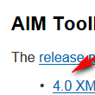  - Advised where to place AIM workstation 4.1 on NCI wiki page.  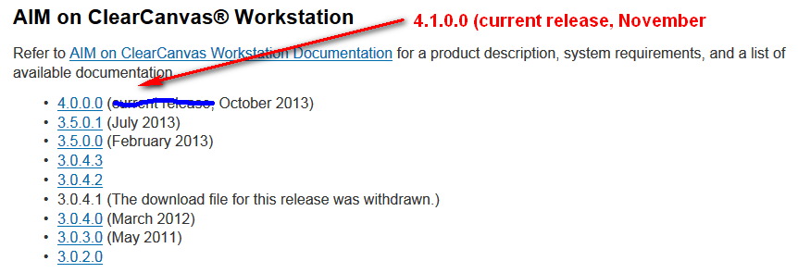 | Carolyn Klinger, Ulli Wagner, and Pat
November 2013 | Worked with Gregory Sharp on CMake  - Telephone conferences  - Exchanged e-mails about features required on Windows, Linux, and Mac OS X.  - Worked on CMake documentation for Windows, Linux, and Mac OS X. | Gregory Sharp, Vlad Kleper, Pat
November 2013 | DICOM Segmentation  - Telephone conferences with ClearCanvas team  - Continued to work on the following issues:  - DICOM segmentation library support  - Segmentation GUI  - CIELab to RGB color conversion code  - Exchanged e-mails with David about meeting at RSNA’13 so, we can test DICOM segmentation. | David Clunie, Vlad, Skip, ClearCanvas team, and Pat
November 2013 | Worked with Justin Kirby (CIP)  - Worked on missing ATB template on 4.1 beta 2 workstation (AIMWS-129)  - Justin approved AIMWS-129 fix  - Worked and exchanged e-mails with Justin on AIM 4.1 workstation installation on Amazon E2C  - Provided login information to workstation on E2C  - Sent download URL for downloading AIM workstation 4.1  - Exchanged e-mails about how to connect AIM workstation 4.1 and AIM Data Service 2.0  - Worked with Justin on an AIM annotation import error notification on 4.1 workstation  - The workstation will not import AIM annotations (XML and SR) that have a code larger than 16 characters.  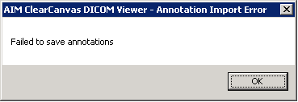  - Telephone conference and web sharing to discuss about missing labels on markup  - Worked with Justin and Nadir on how-to connect AIM workstation with AIM data service 2.0 deployed for CIP | Justin Kirby, Nadir, Vlad, Skip, and Pat
November 2013 | Consultation and Collaboration  - Exchanged e-mails with Daniel about importing RadLex lexicon to ATB.  - Worked with Robert and Brendan at RSNA on RadLex lexicon export for ATB.  - Exchanged e-mails with Bobby (Robert at RSNA) about RadLex lexicon used to imported to ATB  - Worked on conversion of RadLex in Excel file format to the format that ATB requires  - Exchanged e-mails with Hakan about using audit function in the AIM model  - Web conference with Hakan on the use of AIM 4.0 (1hr)  - Answered Hakan question about an attribute that can store any information on the AIM model  - Provided consultation to Hakan about mapping AIM 3.0 attributes to AIM 4.0 | Daniel Rubin, Hakan Bulu, Robert Boden, Brendan Wright, Vlad, and Pat
November 2013 | Worked with ClearCanvas  - Exchanged e-mails related to code upgrade and DICOM segmentation implementation.  - Telephone conferences with Jasper Yeh. | Jasper, Vlad, Skip, and Pat
November 2013 | Worked with Emory University team members  - Provided AIM workstation 4.1  - Answered e-mails related to AIM workstation 4.1 setup and usage  - Verified AIM Data Service 2.0 availability  - Notified Nadir about non-functional AIM Data Service 2.0  - Exchanged e-mails related to AIM Data Server 2.0 user accounts | Yusuf Nadir, Vlad, and Pat
November 2013 | Worked with Tharak at MD Anderson  - Justin provided AIM contact to Tharak  - Provided URLs to download AIM software and looking at AIM documents  - Exchanged e-mails about AIM resources  - Telephone conference with Tharak about his imaging study and AIM needs at MD Anderson | Tharakeswara K Bathala, Justin Kirby, and Pat
November 2013 | Participated in NBIA Prototype Reviews | Pat
November 2013 | Provided consultation on using ATS and how to create a caGrid account  - Sent an e-mail to NCICBIIT for assistance on creating caGrid account and using caGrid authentication. #155484 Application Support Request - caGrid Account  - Sent an e-mail with screen capture to NCI CBIIT  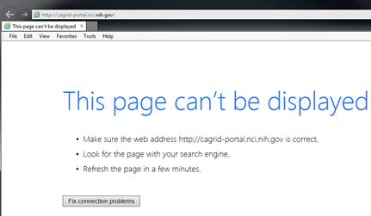 | Marco Pinho (MGH) and Pat

Project Progress
Activity | Description
NCI’s JIRA | Continue updating:  - AIM Enterprise Service (ATB & ATS), https://tracker.nci.nih.gov/browse/AIMES  - AIM Model, https://tracker.nci.nih.gov/browse/AIMWS  - AIM Workstation, https://tracker.nci.nih.gov/browse/AIM
Software upload to SFTP | - Upload software products to NCI’s SFTP  - http://cbiit-download.nci.nih.gov/aim/releases/AIM_WS/4.1.0.0/AIM_WS_4.1.0.0_x86.rar

Status of Milestones
Milestone | Delivery Date | Status
AIM Governance documentation on wiki | November 2013 | Released Nov 2013
AIM 4.1 workstation | November 2013 | Released Nov 2013
AIM library 4.1 with CMake | November 2013 | Released Nov 2013
Released RadLex 3.10 for ATB 2.0 to public | November 2013 | Released Nov 2013
Released NCIm for ATB 2.0 to public | November 2013 | Released Nov 2013

Work Planned for Next Month
Activity | Description
AIM DICOM Segmentation Release | In progress
ATS AppScan update | In progress
ATS 2.0 Release | In progress

Travel Planned for Next Month
Attendees | Travel Purpose | Description
Not applicable

Issue Management
No issues at this time.

Risk Management
ID | Description | Owner | Potential Impact | Priority (H, M, L) | Status (Open, Closed)
1 | NBIA and caGRID 1.4 test | NCIP | Software development may not be fully working with the new NBIA and caGRID 1.4. | H | Done

External Dependencies
No external dependencies at this time.

Status of Deliverables
See MS Project.

