Northwestern University

Monthly Status Report
Annotation and Image Markup (AIM)
12XS577
December 2013
Pattanasak Mongkolwat
p-mongkolwat@northwestern.edu
Reported: December 20, 2013

Contents
Project Background/Objectives 2
Personnel Roster 2
Contract Overview 3
Current Project Status 3
Update AIM wiki pages 3
ClearCanvas 4
AIM Workstation 4.5 and DICOM Segmentation 4
AIM ATS and AIM DOS 5
Extending AIM Foundation 5
AIM at RSNA 2013 5
Description of Work Completed During the Month 9
External Meetings 9
Project Progress 11
Status of Milestones 11
Work Planned for Next Month 11
Travel Planned for Next Month 11
Issue Management 11
Risk Management 11
External Dependencies 12
Status of Deliverables 12

Project Background/Objectives
The objective of this project is to continue to develop the Annotation and Imaging Markup (AIM) software library and tools based on the AIM v4.0 model to meet the challenge of targeted multiple imaging domains, including Radiology and Radiation Oncology. The AIM model establishes a solid foundation for the growth of AIM in specific areas such as clinical trials and life science. The AIM standard has demonstrated its usefulness by collecting the descriptive information of images with user-generated graphical symbols, computational results, and textual descriptors placed on the images in a single common information source. The AIM model is necessarily complex and comprehensive. Typically, users do not want to understand the model comprehensively. We consider AIM users as belonging to one of two types: end-user or software developer. We provide them with appropriate software products and a programming library along with a referenced implementation of the library.
The AIM template is designed to abstract the complexity and reduce the number of activities for both types of AIM users. A template consists of a collection of questions and corresponding answers to each question. It increases AIM usability and improves experiences for users who create AIM data in their specific domain areas.
The AIM template project has two components: AIM Template Builder (ATB) and AIM Template Service (ATS). ATB allows creation and modification of AIM templates via a software application with a simple graphical user interface. A template constrains AIM users to consistently create structured AIM data with standardized semantic vocabulary and controlled terminologies. ATS allows AIM users to search, share, download, and upload their templates.
The outcome of the project includes the AIM 4.0 Foundation model, AIM 4.0 imaging model for (but not limited to) radiology and oncology, AIM Toolkit (library in C++ and a conversion tool), AIM on ClearCanvas Workstation, AIM Template Builder, and AIM Template Service. The AIM software products will enable imaging interpreters, image researchers, and associated sciences personnel from different domains to adopt standardized annotations and imaging markup in conducting their clinical trials and translation medicine research.

Personnel Roster
Personnel | Roles | Organization
Pattanasak (Pat) Mongkolwat | Principal Investigator (PI), project manager and software engineer | Northwestern University
Vladimir Kleper | Researcher and software engineer | Northwestern University
Skip Talbot | Software engineer | Northwestern University
David Clunie | Consultant (DICOM, imaging and clinical expert) | PixelMed Publishing, LLC
Gregory Sharp | Consultant (CMake)
Daniel Rubin | Consultant (AIM and clinical expert) | Stanford University
Carolyn Klinger | Consultant (Technical Writer) | Independent
Tin Tran | Quality Assurance (QA) | SAIC-F

Contract Overview
The purpose of this project is to provide guidelines for extending the AIM model and to enhance existing AIM tools (AIM Toolkit, ATS, and AIM on ClearCanvas workstation), develop additional AIM capabilities, and provide support given the historical workload and available resources.
The AIM project consists of the development of the AIM information models, AIM Toolkit, AIM on ClearCanvas Workstation, AIM Template Builder, and AIM Template Service. At the end of this research and development phase, we will accomplish the following.
- First, deliver a technical document on how to extend the AIM foundation model and library.
- Second, deliver the AIM C++ toolkit for Linux, OS X, and Windows platforms.
- Third, ATS shall have Representational State Transfer (REST, RESTful conforms to REST constraints) APIs for other applications to consume ATS services.
- Fourth, AIM on ClearCanvas workstation will support creation and use of DICOM segmentation objects along with related AIM objects. The workstation will create and store AIM 4.0, import imaging studies from the eXtensible Neuroimaging Archive Toolkit (XNAT), communicate with the AIM Data Service via RESTful APIs, validate markup creation, and integrate a centralized imaging security service. An AIM plugin for the ClearCanvas workstation will be provided. A demonstration of the workstation installed on Amazon cloud will be provided.
- Fifth, AIM Data Object Service (DOS) will offer web services to create and manipulate AIM data.
The following tools were used in this project.
- Altova XMLSpy 2013 (Altova)
- Berkeley DB XML by Oracle
- Boost C++ library version 1.34.1 (Boost.org)
- caCORE SDK 4.1.1 (caBIG®)
- CMake 2.8.x and above
- DCMTK version 3.6.x (OFFIS e. V.)
- Eclipse (Eclipse Foundation, Inc.) for Windows and Linux
- Enterprise Architect version 10.x (Sparx Systems)
- Homebrew Package Installer for Mac OS X
- Java JDK 6 (Sun Microsystems)
- Linux OSes (Debian 6.0.x and above and Ubuntu version 11 and above)
- Mac OS X 10.7.5 (Lion)
- Microsoft Visual Studio 2008 and 2010 (Microsoft) with STL
- Windows XP SP3 and Windows 7 64-bit
- Xcode 4.6.x and Xcode command line utilities
- Xerces XML library version 3.0.1 (Apache Software Foundation)

Current Project Status

Update AIM wiki pages
We continue to update the AIM pages on the NCI Wiki as needed with new information as well as weekly and monthly reports.

ClearCanvas
We continue to have many discussions with Jasper and other engineers at ClearCanvas.
The first week of December, the AIM team was at RSNA 2013 meeting. There was no weekly call.
    - We met with the ClearCanvas team during the RSNA meeting. We talked with some of the ClearCanvas engineers who came to the meeting about AIM and the DICOM segmentation implementation on the latest ClearCanvas workstation that is available on GitHub.

During the second and third week of December, the AIM team continued to exchange e-mails with ClearCanvas engineers about DICOM segmentation implementation.

AIM Workstation 4.5 and DICOM Segmentation
Workstation 4.1 has been released for public use. We continue working on implementing DICOM segmentation for Workstation 4.5.
During the first week of December, the AIM team was at RSNA. We did the following as well.
    - Met with David Clunie
- Discussed segmentation positioning and orientation on the image
- Fixed internally identified UI issues
    - Able to perform partial read of existing segmentation data
During the second week of December, the AIM team worked on the following issues for the AIM Workstation 4.5.
- Implementing AIM Workstation DICOM segmentation proceeded at a slow pace during RSNA 2013 meeting week. We continued implementation of reading existing segmentation objects.
- During the RSNA, we had a working meeting with DICOM experts to discuss implementation details and numerous variations of possible DICOM Segmentation objects.
  - how to handle the reading of DICOM segmentation objects
  - how to place segmented regions using only the image position, patient position, and image orientation patient information.
- Fixed several UI bugs, including the handling of switching between multiple studies with different segmentation data, and switching between segmentation objects that are on different frames within the same image
- A couple other bugs remain, including an issue when closing the study with the segmentation panel open, and missing ROI information.
- DICOM segmentation objects can be read and the data model partially populated.
- Remaining work includes
  - creating the segmentation graphics from DICOM objects
  - positioning them when no image reference is available
  - writing out the DICOM objects when segmentations are created.
During the third week of December, the AIM team worked on the following issues for AIM Workstation 4.5.
- Sent Workstation 4.5 alpha 5 to David for review
  - David performed tests and provided comments
- Working with David on using 3D vectors from image position and patient and image position orientation to match segmentations to corresponding images without image references
- Reading and display of basic segmentation objects:
  - Can open instances with BitAllocated = 1 or 8
  - Can open single and multi-frame instances
  - Can correctly display same-sized instances when Referenced SOP Instance UID and frame are provided
- Segmentation UI supports:
  - One or more ROIs on multi-frame and regular stacks
  - Functional dropdown property modifiers (require appropriate XML files configuration under Tools > Preferences> Segmentation)
  - Creation of dummy segments with opacity and volumetric calculations from the polygonal ROI markups.
- Remaining work includes addressing the following issues:
  - Positioning relies on Referenced SOP Instance UID and Referenced Frame Number info encoded in the segmentation instances only.
  - Loaded segmentation instances are not repositioned if necessary.
  - Loaded instances are not connected to the UI yet.
  - When loading segmentation instances with a lot of frames/segmentations (e.g. Brain Atlas Head Neck Muscles with 6463 frames), the workstation becomes unresponsive due to unoptimized loading process.
  - Segmentation shown in wrong color.
  - Add a default DICOM segmentation property.
  - Sort DICOM segmentation property.
  - Statistics are shown in the segmentation panel.
  - Display segmentation properties for imported DICOM segmentation objects.
  - Write out the DICOM objects when segmentations are created.

AIM ATS and AIM DOS
The AIM team will continue to work on ATS and AIM DOS after we finish implementing DICOM segmentation. The current estimate is to resume working on ATS at the end of December to early January 2014.

During the first week of December, the AIM team was at the RSNA meeting. Development effort was spent primarily on DICOM segmentation. In addition, the following was done that week.
- Vlad worked on using an official certificate for secured (SSL) deployment for ATS.

Extending AIM Foundation
The Extending AIM Foundation document has been released on the AIM wiki site at https://wiki.nci.nih.gov/x/VAEECg.

AIM at RSNA 2013
The AIM team presented three related AIM educational exhibits at RSNA 2013 as follows.
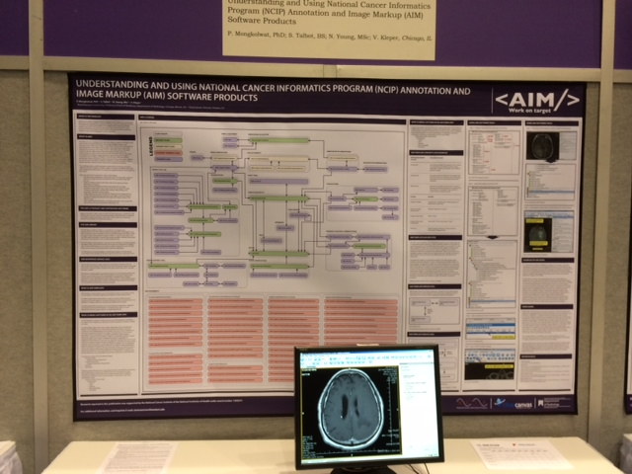
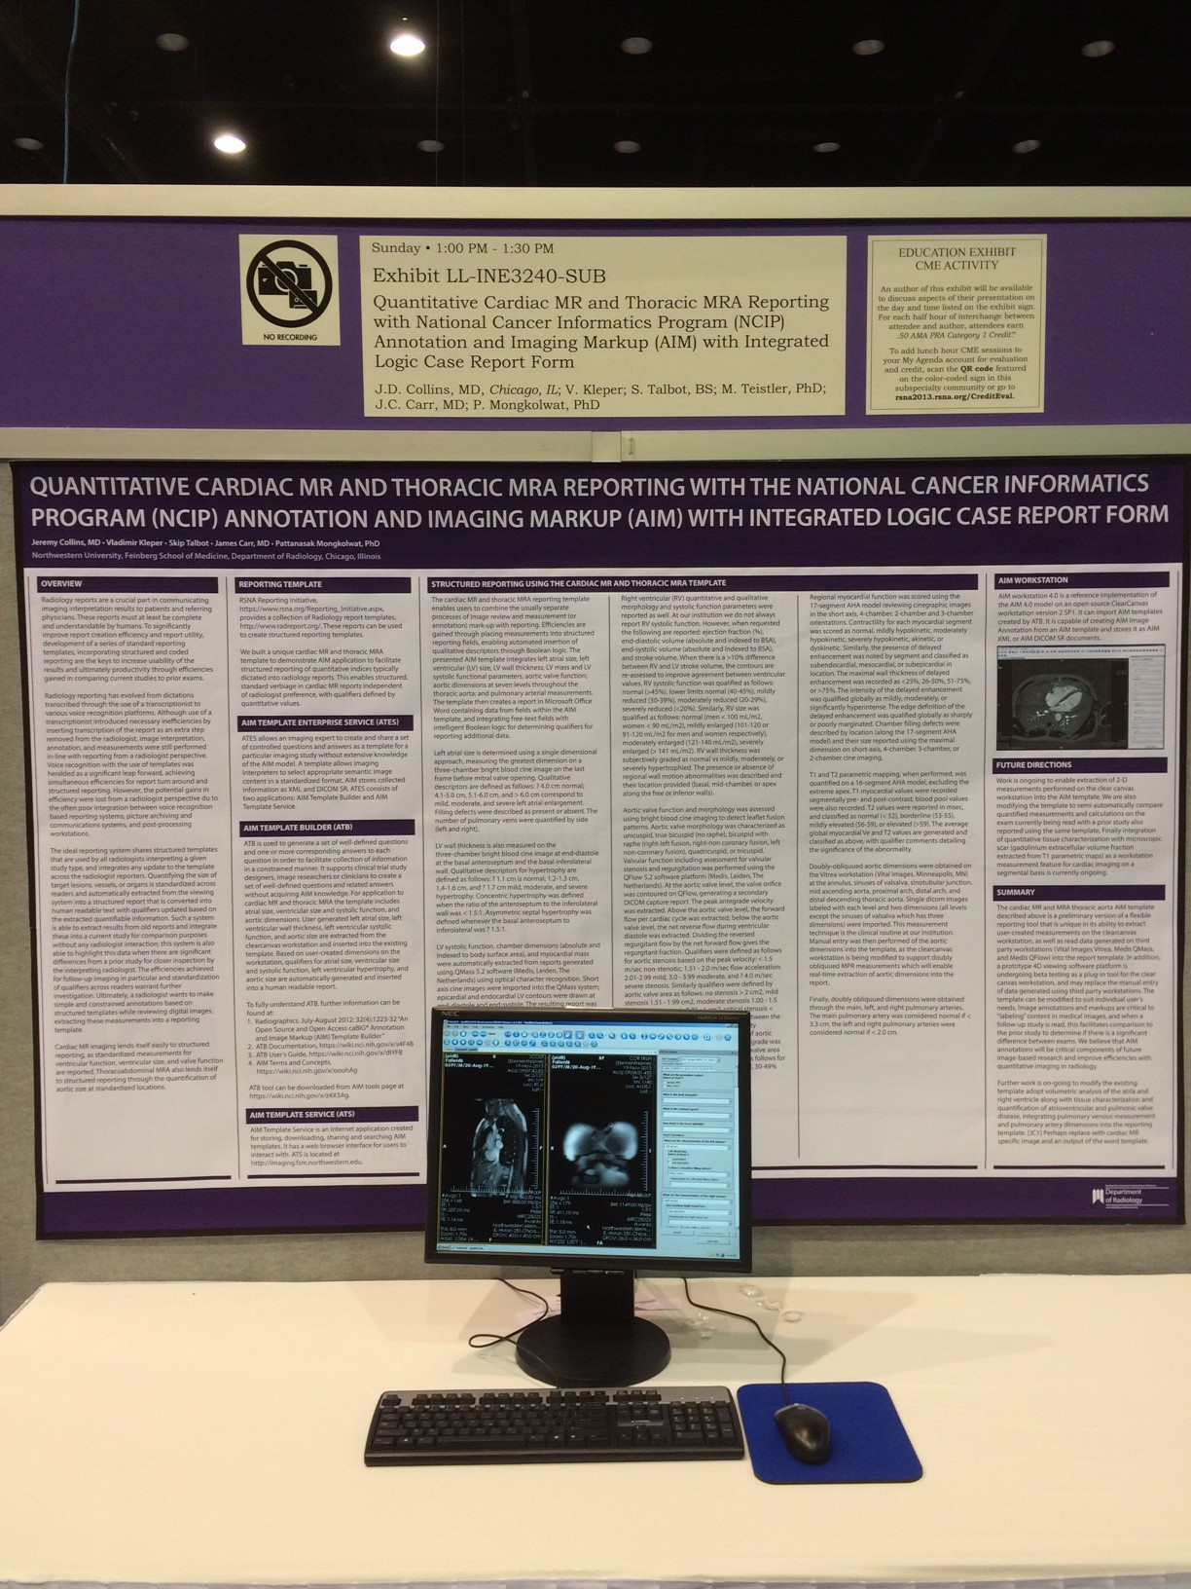
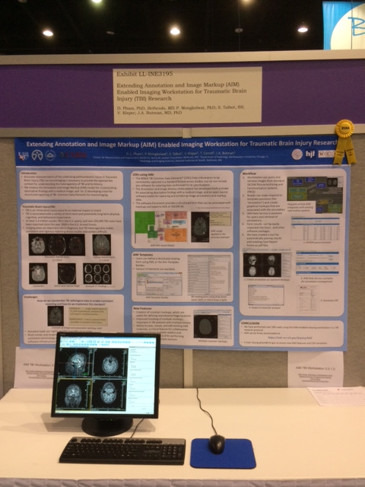

Description of Work Completed During the Month

External Meetings
Date | Topic | Project Attendees (Optional)
December 2013 | JIRA issues (addition and updates) | Pat, Vlad, Skip
December 2013 | Weekly telephone conference  - Continued weekly report  - Skipped weekly meeting during RSNA week. However, a weekly report was submitted for 12/6/2013. | Ed Helton, Jonathan Lin, Ulli Wagner, Tin, Vlad, Skip, Pat
December 2013 | Worked with Leidos project managers  - Received an approval for AIM governance document to be published on AIM wiki | Ulli, Alex Konev, Ed Helton, Vlad, Skip, Preston Wood, and Pat
December 2013 | Worked with QA team at Leidos on the following.  - Exchanged e-mail about an ATS test installation at NCI on the following performance issues:  - Potential memory leak  - Certificate issues | Tin, Vlad, Skip, and Pat
December 2013 | Worked with Carolyn Klinger on the following.  - Continued to update AIM wiki.  - Weekly reports on wiki  - https://wiki.nci.nih.gov/x/AYX8CQ  - Monthly report on wiki  - https://wiki.nci.nih.gov/x/goB8C  - Fixed broken link for caGrid user account request  - Reviewed AIM 4.1 user’s guide and corrected user’s guide content  - Sent update request  - Working on 4.5 DICOM segmentation user’s manual  - Working with Carolyn on AIM DOS document on MS Word and AIM Wiki  - Working on modifying access request, https://wiki.nci.nih.gov/display/AIM/Registering+for+a+caGrid+Account  - Working on 4.5 DICOM segmentation user’s manual, https://wiki.nci.nih.gov/x/YwI8Cg | Carolyn Klinger, Ulli Wagner, and Pat
December 2013 | DICOM Segmentation  - A meeting with David Clunie during RSNA 2013  - Exchanged e-mails with David about meeting at RSNA 2013 so that we can test DICOM segmentation  - Provided workstations for David to test the workstation 4.5  - David provided DICOM segmentation examples for testing purposes | David Clunie, Vlad, Skip, ClearCanvas team, and Pat
December 2013 | Consultation and Collaboration  - Advised Debra how to use AIM and DICOM reference to capture DICOM segmentation. Explained how to design Debra’s imaging application to support access to AIM instances based on Study Instance UID, Series Instance UID, and SOP Instance UID during RSNA 2013 | Debra (Stanford) and Pat
December 2013 | Worked with ClearCanvas  - Exchanged e-mails related to code upgrade and DICOM segmentation implementation. | Jasper, Vlad, Skip, and Pat
December 2013 | Provided AIM hands-on demonstration class during RSNA 2013 | Pat, Vlad, Skip and Justin Kirby

Project Progress
Activity | Description
NCI’s JIRA | Continue updating:  - AIM Enterprise Service (ATB & ATS), https://tracker.nci.nih.gov/browse/AIMES  - AIM Model, https://tracker.nci.nih.gov/browse/AIMWS  - AIM Workstation, https://tracker.nci.nih.gov/browse/AIM
Software upload to SFTP | - Upload software products to NCI’s SFTP  - http://cbiit-download.nci.nih.gov/aim/releases/AIM_WS/4.1.0.0/AIM_WS_4.1.0.0_x86.rar

Status of Milestones
Not applicable

Work Planned for Next Month
Activity | Description
AIM DICOM Segmentation on Workstation 4.5 Release | In progress and expected to be released
AIM 4.5 User’s Guide | In progress and expected to be released
ATS AppScan update | In progress and expected to be released
AIM DOS User’s Guide | In progress and expected to be released
ATS 2.0 Release | In progress and expected to be released

Travel Planned for Next Month
Attendees | Travel Purpose | Description
Not applicable

Issue Management
No issues at this time.

Risk Management
ID | Description | Owner | Potential Impact | Priority (H, M, L) | Status (Open, Closed)
1 | NBIA and caGRID 1.4 test | NCIP | Software development may not be fully working with the new NBIA and caGRID 1.4. | H | Closed

External Dependencies
No external dependencies at this time.

Status of Deliverables
See MS Project.

