Northwestern University

Monthly Status Report
Annotation and Image Markup (AIM)
12XS577
July 2013
Pattanasak Mongkolwat
p-mongkolwat@northwestern.edu
Reported: August 10, 2013

Contents
Project Background/Objectives 2
Personnel Roster 2
Contract Overview 3
Current Project Status 3
Update AIM wiki pages 3
ClearCanvas 4
AIM Library 4.1 4
CMake and AIM 4.0 library 4
AIM Workstation 5
XNAT 6
AIM 4.0 RESTFul interface with AIM Data Service 6
AIM on GitHub 7
Working with QA team 7
AIM DOS 7
AIM ATS 7
ATS Appscan evaluation 8
AIM Wiki 8
DICOM Segmentation 8
Description of Work Completed During the Month 11
External Meetings 11
Project Progress 13
Status of Milestones 13
Work Planned for Next Month 14
Travel Planned for Next Month 14
Issue Management 14
Risk Management 14
External Dependencies 14
Status of Deliverables 14

Project Background/Objectives
The objective of this project is to continue to develop the Annotation and Imaging Markup (AIM) software library and tools based on the AIM v4.0 model to meet the challenge of targeted multiple imaging domains, including Radiology and Radiation Oncology. The AIM model establishes a solid foundation for the growth of AIM in specific areas such as clinical trials and life science. The AIM standard has demonstrated its usefulness by collecting the descriptive information of images with user-generated graphical symbols, computational results, and textual descriptors placed on the images in a single common information source. The AIM model is necessarily complex and comprehensive. Typically, users do not want to understand the model comprehensively. We consider AIM users as belonging to one of two types: end-user or software developer. We provide them with appropriate software products and a programming library along with a referenced implementation of the library.
The AIM template is designed to abstract the complexity and reduce the number of activities for both types of AIM users. A template consists of a collection of questions and corresponding answers to each question. It increases AIM usability and improves experiences for users who create AIM data in their specific domain areas.
The AIM template project has two components: AIM Template Builder (ATB) and AIM Template Service (ATS). ATB has been developed to allow creation and modification of AIM templates via a software application with a simple graphical user interface. A template constrains AIM users to consistently create structured AIM data with standardized semantic vocabulary and controlled terminologies. ATS allows AIM users to search, share, download, and upload their templates.
The outcome of the project includes the AIM 4.0 foundation model, AIM 4.0 imaging model for (but not limited to) Radiology and Oncology, AIM toolkit (library in C++ and a conversion tool), AIM workstation, and AIM template software. The AIM software products will enable imaging interpreters, image researchers, and associated sciences personnel from different domains to adopt standardized annotations and imaging markup in conducting their clinical trials and translation medicine research.

Personnel Roster
Personnel | Roles | Organization
Pattanasak (Pat) Mongkolwat | Principal Investigator (PI), project manager and software engineer | Northwestern University
Vladimir Kleper | Researcher and software engineer | Northwestern University
Skip Talbot | Software engineer | Northwestern University
David Clunie | Consultant (DICOM, imaging and clinical expert) | PixelMed Publishing, LLC
Gregory Sharp | Consultant (CMake)
Daniel Rubin | Consultant (AIM and clinical expert) | Stanford University
Carolyn Klinger | Consultant (Technical Writer)
Tin Tran | Quality Assurance (QA) | SAIC-F

Contract Overview
The purpose of this project is to provide guidelines for extending the AIM model to enhance existing AIM tools (C++ toolkit, ATS and AIM for ClearCanvas workstation), develop additional AIM capabilities, and provide support in line with the historical workload and available resources.
The AIM project consists of the AIM information model, C++ Application Programming Interfaces (APIs), ATS, and AIM-enabled workstations. At the end of this research and development phase, we will accomplish the following.
- First, deliver a technical document on how to extend the AIM foundation model and library.
- Second, deliver the AIM C++ toolkit for Linux, OS X, and Windows platforms.
- Third, ATS shall have a Representational State Transfer (REST, RESTful conforms to REST constraints) APIs for other applications to consume ATS services.
- Fourth, AIM on ClearCanvas workstation will support creation and use of DICOM segmentation objects along with related AIM objects. The workstation will create and store AIM 4.0, import imaging studies from the eXtensible Neuroimaging Archive Toolkit (XNAT), communicate with AIM Data Service via RESTful APIs, validate markup creation and integrate a centralized imaging security service. An AIM plugin for the ClearCanvas workstation will be provided. A demonstration of the workstation installed on Amazon cloud will be provided.
- Fifth, AIM Data Object Service (DOS) will offer web services to create and manipulate AIM data.
The following tools were used in this project.
- Altova XMLSpy 2013 (Altova)
- Berkeley DB XML by Oracle
- Boost C++ library version 1.34.1 (Boost.org)
- caCORE SDK 4.1.1 (caBIG®)
- CMake 2.8.x and above
- DCMTK version 3.6.x (OFFIS e. V.)
- Eclipse (Eclipse Foundation, Inc.) for Windows and Linux
- Enterprise Architect version 10.x (Sparx Systems)
- Homebrew Package Installer for Mac OS X
- Java JDK 6 (Sun Microsystems)
- Linux OSes (Debian 6.0.x and above and Ubuntu version 11 and above)
- Mac OS X 10.7.5 (Lion)
- Microsoft Visual Studio 2008 and 2010 (Microsoft) with STL
- Xcode 4.6.x and Xcode command line utilities
- Xerces XML library version 3.0.1 (Apache Software Foundation)

Current Project Status

Update AIM wiki pages
We continue updating the AIM pages on the NCI Wiki as needed. We updated the release notes and user’s manual for the AIM workstation 3.5.x.

ClearCanvas
We had first contact with the ClearCanvas engineer in the second week of July. The engineer will be assisting AIM team on code issues and technical aspects of the work via weekly half hour meetings and emails as needed.

AIM Library 4.1
The AIM team worked on the AIM library tasks as follows during the first week on July.
- Ongoing QA testing
- We are going to create a new test bundle on Friday or the week after with the latest changes.

During the second week of July, we worked on the following issues on the AIM library.
- Ongoing QA testing
- New test bundle is coming this week that will allow testing of Linux and Windows changes.

The third week of July, the AIM team worked on the following tasks.
- Ongoing QA testing
- New test bundle sent to Tin. It allows testing of Linux and Windows changes, http://www.hightail.com/download/bWJvck93Mm1CMTd2bk1UQw.

During the fourth week, the AIM team continues to wait for QA team to finish testing the updated library. The below items summarize the tasks completed for the new version of the AIM library.

- Fixed UID validation routine to check for zero-padded UID component values; for example, 1.2.009.02 is invalid because non-zero UID component cannot start with 0.
- Fixed time value validation to allow for 00:00 time values. This issue showed up with de-identified dates.
- Improved consistency of AIM Converter parameters. Now parameter for XML documents is "XML" instead of the old "AIM"
- Improved error reporting by AIM Converter by not silently ignoring some of library error messages
- Implemented validation for allowed length of every component of a coded element (code value, code meaning, coding scheme designator, and coding scheme version).

During the last week of July, the AIM team worked on release notes for AIM Toolkit 4.1, which will be published to the NCI Wiki.

CMake and AIM 4.0 library
Greg and the AIM team worked on the following issues during the first week of July.
- Linux packaging and installer are done. For Debian, packager will create .deb and .tar.gz bundles. Build instructions are updated as well.
- OSX and Windows packaging and installer work is next.
- Packages and executables will contain the AIM Library version number. The number is a configuration option in the CMake script file.

Greg and the AIM team performed the following tasks during the second week of July.

- Windows debug and release builds are buildable with CMake.
- Still need to teach CMake about Windows 64-bit Xerces-c library configuration.
- OSX and Windows packaging and installer work remains.

During the third week of July, Greg and the AIM team performed the following tasks.
a. Initialization order problem in AIM Converter
i. Workaround complete but need to inform DCMTK developers
b. Support for shared libraries
ii. Support for Linux complete (AIMLib.so.4.0 naming with symlink)
iii. Investigate library naming on Mac
iv. Investigate library naming on Windows
c. Check best method for users to install Xerces on Mac
d. Telephone conference with Greg this Thursday
During the fourth week of July, Greg and the AIM team performed the following tasks.
- Windows 64-bit compilation is done.
- Windows versioning and packaging is done.
- There will be an untested compiler warning on Windows if compiler other than Visual Studio 2008 or Visual Studio 2010 is used.
- Working on OSX support and testing

AIM Workstation
We released AIM workstation 3.5.0.1 for public use. The 4.0 workstation is in a testing state. We continue to implement the AIM 4.1 workstation, upgrading the workstation to the latest source code from ClearCanvas. We continue working on implementing DICOM segmentation, an addition to the existing ClearCanvas workstation to support DICOM segmentation capability on the workstation 4.5.
During the first week of July, the AIM team worked on the following issues.
  - For 3.5.0.1, the release is almost done. The build is uploaded to the NCI SVN. Currently, we are waiting for QA testing approval and an official release announcement.
  - For 4.0, the latest build has been released to QA. We are waiting on QA results.
  - For 4.1, we are finishing work on the new infrastructure for annotation tracking within the workstation (AIM annotation cache and AIM Annotation Monitor). (This new infrastructure will allow us to track additions and removal of individual annotations from DICOM studies. Different plugins will use these facilities to get updates when annotations change in a study). The plan is to have an initial QA release within the next couple of weeks.
During the second week of July, the AIM team worked on the following issues.
  - For 3.5.0.1, the release is done. Remaining work is an official release announcement.
  - For 4.0, the latest build has been released to QA. An issue with importing AIM Annotations was identified and fixed. We are waiting on full QA results.
  - For 4.1, we are still working on the new infrastructure for annotation tracking within the workstation (AIM annotation cache and AIM Annotation Monitor). (This new infrastructure will allow us to track additions and removal of individual annotations from DICOM studies. Different plugins will use these facilities to get updates when annotations change in a study). The plan is to have an initial QA release within the next week or so.
During the third week of July, the AIM team worked on the following issues.
- For 3.5.0.1, the software is available at AIM wiki page for download. The release has been posted on AIM wiki page. Remaining work is an official release announcement.
- For 4.0, we are waiting on full QA results. We removed setup option to install the workstation for all Windows users on the system. Due to private nature of all workstation data and singularity of workstation service, shared installations cannot be supported.
- For 4.1, the new workstation’s AIM Monitor and AIM Cache infrastructure components are being internally debugged and tested. This week, when the infrastructure work is complete, we will transition to 4.1 as the main development code branch.

During the fourth week of July, the AIM team worked on the following issues.

- Finished working on required markup (available in version 4.1). Ready for QA testing with workstation 4.1.
- Performed bug fixes for AIM data service (available in version 4.0)
- Released with workstation 4.0 alpha 8 for QA
- Exchanged e-mails for bug fixes. See https://tracker.nci.nih.gov/browse/AIMWS

XNAT
This feature passed QA process.

AIM 4.0 RESTFul interface with AIM Data Service
The AIM team continued to work with Emory as follows.
Week of July 1st, 2013
    - UI and backend implementation are done.
    - We are working on parsing XML returned by the AIM Data Service into separate valid annotations.
    - We are working on resolving threading issue with Login prompt. When the AIM Data Service requires logging in, UI needs to be invoked on the main application thread instead of the background thread of the data service.
    - After the two issues above are resolved, we’ll do a basic functional testing before release a build to QA.
Week of July 8th, 2013
  - AIM Data Service implementation is done.
  - Internal testing continues. This week we should be able to release a build that contains the plugin to QA.
Week of July 15th, 2013
        - The next workstation QA build will have this plugin for testing.
        - We sent the following data service configuration and instructions to Carolyn to be used for new user’s manual 4.5.

Configuration of the AIM Data Service 2.0 plugin from within the ClearCanvas Workstation:
- Click the Workstation's Tools menu -> Options -> AIM -> AIM Data Service 2.0
- Enter in the AIM Data Service URL: http://imaging.cci.emory.edu/rest/aime-test/middleware/services/AIME/AIME4
- Enter in the Secure Token Service Login URL: http://imaging.cci.emory.edu/rest/aime-test/middleware/securityTokenService
- Click OK

Using the AIM Data Service 2.0 plugin
- Click the Explorer tab within the Workstation
- Click the AIM Data Service 2.0 tab
- Enter search criteria in the search fields to narrow your search, or leave them blank to retrieve a list of all annotations
- Click Search
- Enter your user name and password for the Secure Token Service when presented with the log in dialog.
- Click Log in. The search will be performed and results displayed in the results pane at the bottom of the tab.
- Click on an annotation from the list of results to select it
- Click the Retrieve Selected Annotation button or right click a selected annotation and select Retrieve Selected Annotation from the context menu to download and import the annotation into the workstation.

Week of July 22nd, 2013
- Bug fixes for AIM Data Service 2.0
https://tracker.nci.nih.gov/browse/AIMWS-179
https://tracker.nci.nih.gov/browse/AIMWS-180

AIM on GitHub
The AIM team found out that the GitHub is not suitable for ordinary users to download software products. Typical users must use a Git client to download an application in order to be able to download software. Git is designed for software developers.

Working with QA team
The AIM team started working with the QA team to test the AIM Workstations and CMake with the AIM 4.0 library.
  - Continue to test workstation versions 3.5.0.1 and 4.0.
  - Continue to test ATS deployments in 32 and 64-bit.
  - Continue to fix and test XNAT on workstation 4.0.
  - Continue to test CMake test.
  - Worked on ATS

AIM DOS
A simple XML schema has been created to collect necessary AIM data without using ISO 21090. The second part is a web service with a RESTful interface to submit an XML document created based on the schema to generate a full AIM 4.0 XML document or DICOM SR object. We are working on the simple XML schema.
Week of July 1st, 2013
- Working Simpler AIM XML schema is done for both Image Annotation and Annotation of Annotation.
- Finished AIM XML documents for Image Annotation and Annotation of Annotation.
- Continue to work on mapping simple AIM XML schema to AIM 4.0 XML schema
Week of July 8th, 2013
- Working AIM Data Service implementation is done.
- Internal testing continues. This week we should be able to release a build that contains the plugin to QA
Week of July 15th, 2013
- Performed additional AIM DOS schema testing by creating a XML example for Image Annotation and Annotation of Annotation.

AIM ATS
Week of July 1st, 2013.
- ATS HTTPS/SSL configuration mostly worked, except for two issues.
- First, some browsers block non-HTTPS content within a page delivered over HTTPS. This affected our login page as it links to a JQuery script in the Google CDN over HTTP. ATS code modification is required.
- The second issue was STS self-signed certificate and its import into the local Java Trust Store. Tin succeeded in using ATS over HTTPS with his STS LDAP instance and account. We’ll have STS certificate creation and importation steps for a local Java Trust Store.
- Tin has documented his ATS HTTPS/SSL configuration options and Java self-signed certificates creation and their usage within the ATS.
- Just received results of another AppScan of ATS configured with HTTPS/SSL. We are in the process of reviewing the results.
Week of July 8th, 2013.
- Reviewed HTTPS/SSL configuration options and Java self-signed certificates creation and their usage within the ATS.
- Reviewed results of another AppScan of ATS configured with HTTPS/SSL. As expected, the earlier identified code improvements will address remaining AppScan issues

ATS Appscan evaluation
We are grouping the issues into broad categories by the type of work that is required to address the issues. While AppScan did not test for and uncover critical ATS problems that affect immediate application functionality and performance, the identified issues may potentially adversely affect user security and perceived ATS reliability.

Problem Group | Estimated Solution | Estimated Time
Login page and other parameters need to be passed over HTTPS/SSL. Switch ATS to work over SSL/HTTPS only. | 1. Configure server to work over SSL/HTTPS  2. Verify that ATS can correctly function over SSL/HTTPS  3. Make necessary code changes to ensure that ATS will always run over SSL/HTTPS | 1 = 3 days  2 & 3 = 2 weeks
Perform early validation for each accepted parameter by the server. This affects every server URL. | 1. Create and use validators for each application parameter.  2. Change code to never report original input parameters back to client in error messages.  3. Change code to report errors as soon as expected parameters' validation fails  4. Audit code to make sure that only explicitly validated parameters are used. | 1 = 4 days  2 = 4 days  3 & 4 = 5 days
Adjust HTTP headers | 1. Clarify the exact issues that AppScan identified  2. Research and implement identified required changes | 1 = 1 day  2 = TBD
Application cookies as a source of security issues | 1. Clarify how cookies are tested by AppScan  2. Determine if this is still an issue if ATS is switch to run over SSL/HTTPS  3. Define and implement any other changes | 1 & 2 = 2 days  3 = TDB

AIM Wiki
During the first week of July, the AIM team worked on the following issues.

- A web conference between Carolyn and Pat about XNAT features
- Continue to work on AIM Workstation 4.0 user’s manual
- Added a user notice for ANIVATR usage

DICOM Segmentation
The AIM team and David Clunie worked on the following issues.
  - Working on a draft version of background information
  - Working on requirements
  - Finalized workstation requirements
    - Load any type of DICOM (raster not surface) segmentation and separate segments/slices into named ROIs
    - Display loaded (and created) segmentations as "brush like" translucent overlay, with value (binary or continuous) controlling opacity
    - Create ROIs as polygons (existing tools) and add "convert to segmentation" button, after which they are not editable, and behave as binary valued segmentations
    - For each segmentation, have similar computed values displayed as existing polygon ROIs
    - For each segmentation, allow renaming similar to existing ROIs
    - Use commonality of ROI name to figure out which segment to use when saving a segmentation (i.e., no multiple ROI semantics beyond common name)
    - The two figures below depict how segmentation the workstation can be created.
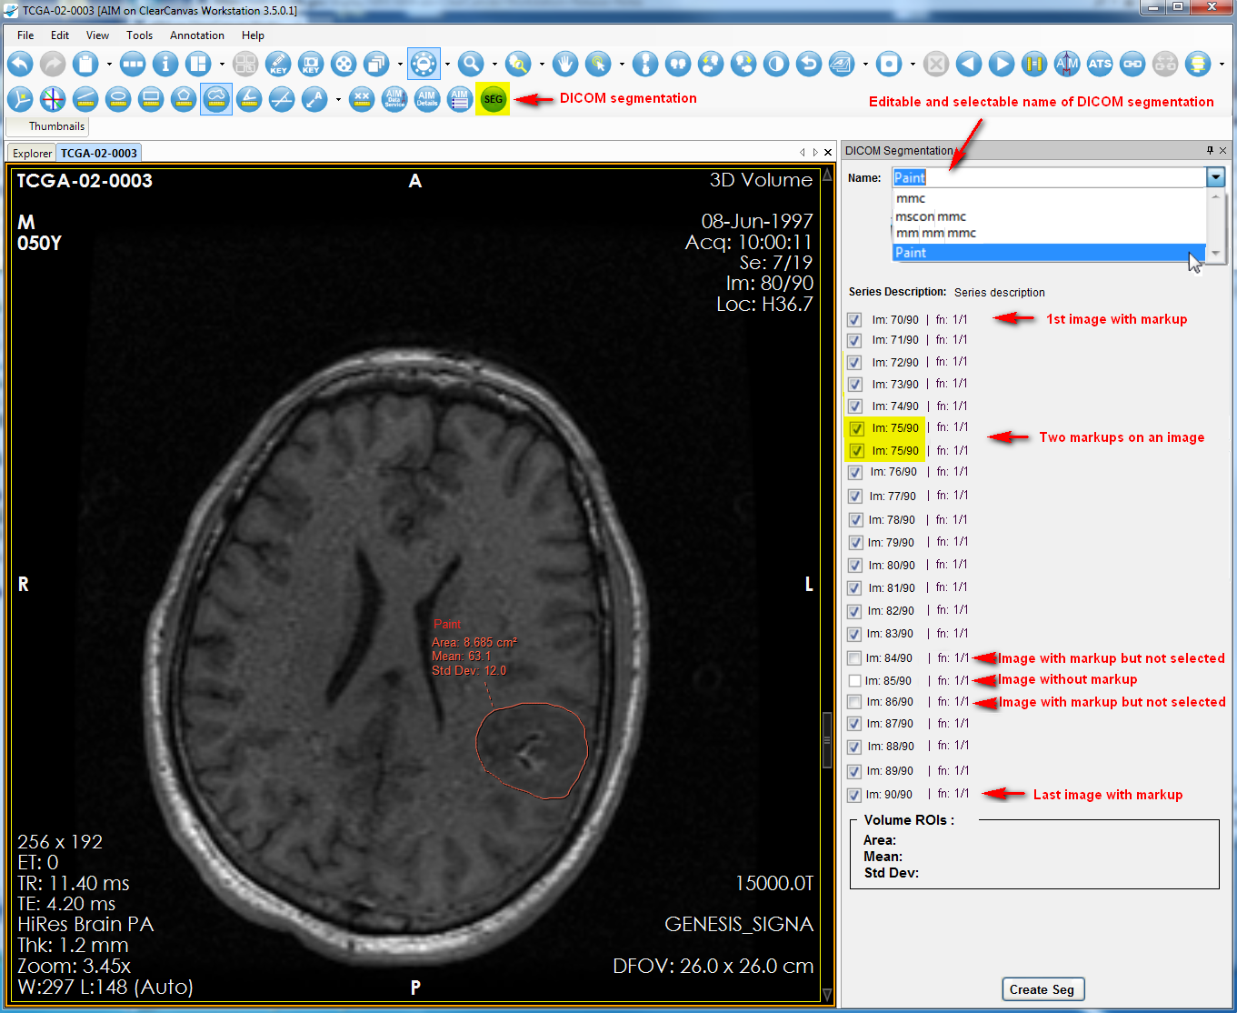

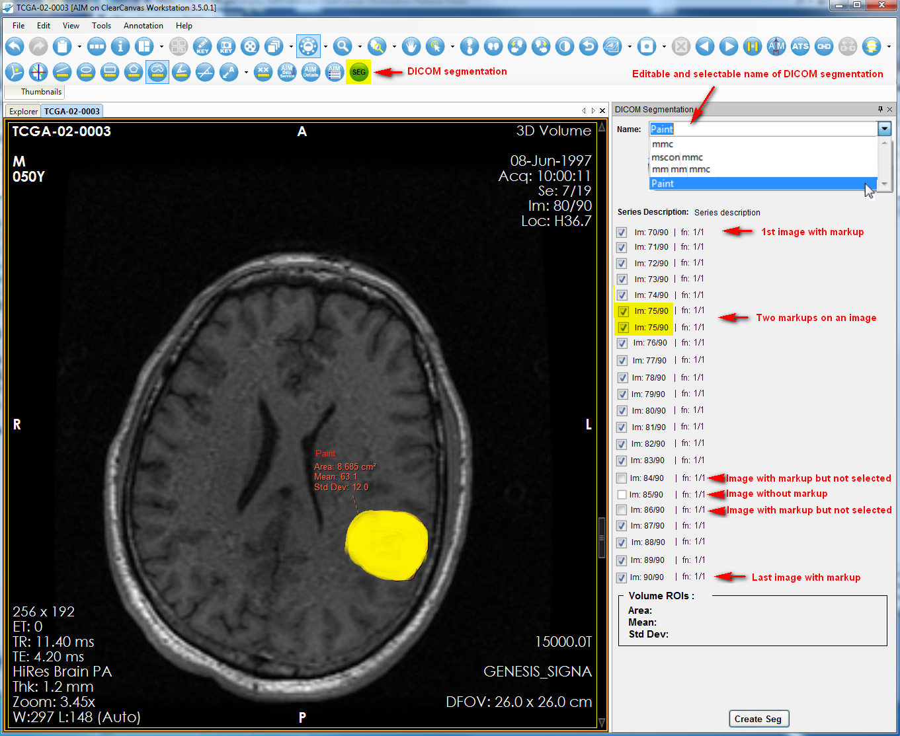

Description of Work Completed During the Month

External Meetings
Date | Topic | Project Attendees (Optional)
July 2013 | JIRA issues (addition and updates) | Pat, Vlad, Skip
July 2013 | Weekly telephone conference  - Continued weekly report  - Reported problem downloading a large file (>1MB) from GitHub. We will use secured FTP server hosted at NCI to fix this problem.  - Interim solution is to revert back to SVN. Carolyn Klinger performed URL changes.  - Contacted Hemant about an alternative to download a large file from GitHub  - Exchanged e-mails and answered Jonathan’s e-mail about HTTPS ATS 1.1 AppScan result  Telephone conference with Ed about DICOM SR issues. | Ed Helton, Jonathan Lin, Ulli Wagner, Hemant Undale, Tin, Vlad, Skip, Pat
July 2013 | Worked with SAIC-F project managers  - Requested an alternative software product hosting beside GitHub  - A telephone conference call with Hemant about  - ATS AppScan additional development time required  - AIM Data Service 2.0 been submitted for QA test and Vlad is supporting the QA team to perform test  - Download a large file on GitHub | Ulli, Hemant Undale, Alex Konev, Vlad, Skip and Pat
July 2013 | Participated in NCI Case Report Form Harmonization Working Group on Imaging | Pat
July 2013 | Presented AIM and AIM tools to be used for epilepsy research at University of Ibadan and University College Hospital in Ibadan  - Dr. Mayowa Owolabi performs imaging research with stroke patients. He and his team are defining a Case Report Form (CRF) to collect data for stroke patients. His team is translating the CRF to an electronic CRF or an AIM template in order to collect information in a structured manner. Dr. Mongkolwat spent time teaching a few members of his staff how to use AIM template builder (ATB, used to create an electronic CRF) and how to import the CRF to the AIM enabled workstation 3.5.0.1. The AIM workstation and AIM stroke template will be used to collect stroke patient data from eight other sites beside University College Hospital. | Pat
July 2013 | Work with QA team at SAIC-F  - Received STS HTTPS setup instructions from Tin  - Tin requested a new AppScan test on STS HTTPS  - Received and reviewed Appscan results  - Created a response to the Appscan results along with estimated time required for improving ATS  - Answered question about NBIA feature on the workstation  - E-mail exchange about AIM workstation 4.0 with XNAT capability and bug fixes  - Answering ANIVATR, an AIM conversion tool, and error reporting from Tin. Vlad provided a new workstation that contains a bug fix.  - Provided AIM library 4.1 for QA  - Sent AIM 4.0 workstation alpha7, alpha8 for QA  - Filled QA entrance criteria checklist #1 to #9  - Answered CMake related questions | Tin, Vlad, Skip and Pat
July 2013 | Worked with Carolyn Klinger on  - Created, reviewed, and posted AIM weekly and monthly reports  - Reviewed weekly reports uploaded to wiki  - Sent workstation installation and usage limitation to be posted on AIM workstation  - Exchanged e-mails on Workstation 4.0 User’s Guide (XNAT), https://wiki.nci.nih.gov/x/Fy64Bw  - Exchanged e-mails on Workstation 4.1 User’s Guide  - Uploaded AIM Foundation Model and 4.0 as PNG files  - Requested information about storage location for large files. Temporary use SVN until a better solution is found.  - Worked on uninstall and reinstall AIM on ClearCanvas workstation | Carolyn Klinger and Pat
July 2013 | Provided a download URL for AIM workstation 3.5.0.1 to Marco | Marco Pinho (MGH) and Pat
July 2013 | Worked with Gregory Sharp on CMake  - Telephone conferences  - Exchanged e-mails about features required on Windows, Linux, and Mac OS X | Gregory Sharp, Vlad Kleper, Pat
July 2013 | DICOM Segmentation  - Received DICOM segmentation background information and requirements from David  - Telephone conference with David Clunie about segmentation requirements and features  - Worked on the below  1. Load any type of DICOM (raster not surface) segmentation and separate segments/slices into named ROIs  2. Display loaded (and created) segmentations as "brush like" translucent overlay, with value (binary or continuous) controlling opacity  3. Create ROIs as polygons (existing tools) and add "convert to segmentation" button, after which they are not editable, and behave as binary valued segmentations  4. For each segmentation, have similar computed values displayed as existing polygon ROIs  5. For each segmentation, allow renaming similar to existing ROIs  6. Use commonality of ROI name to figure out which segment to use when saving a segmentation (i.e., no multiple ROI semantics beyond common name) | David Clunie, Vlad, Skip, ClearCanvas team and Pat
July 2013 | Worked with Justin Kirby (CIP)  - E-mail exchanges about including AIM library and AIM DOS to CTK/ITK/VTK toolkits  - E-mail exchanges about AIM workstation 3.5.0.1 to be used with Blackford Matched Crosshair  - E-mail exchanges with Blackford Analysis: Evaluation versions of Matched Crosshair plugin for ClearCanvas  - E-mail exchanges about releasing AIM Data Service 2.0 with the workstation 4.0 | Justin Kirby, John Freymann, Skip Amiot, Peter Maxwell, Richard Moffett, Larry Tarbox and Pat
July 2013 | Consultation  - Exchanged e-mails and instructions to Daniel to uninstall and reinstall AIM workstation  - Answered Daniel’s question about AIM post coordination  - Answered Daniel’s question about installing AIM workstation is only available for the user who installed the workstation  - Answered cdgridID related questions | Daniel Rubin, Debra Willrett, Hakan Bulu and Vlad
July 2013 | Worked with ClearCanvas  - Participated in web conferences  - Exchanged e-mails related to code upgrade  - Telephone conference with Jasper Yeh  - Workstation 4.1 slow import imaging studies  - Discussed about DICOM Segmentation implementation | Clinton Chau, Julia Geer Jasper, Vlad, Skip and Pat

Project Progress
Activity | Description
NCI’s JIRA | Continue updating:  - AIM Enterprise Service (ATB & ATS), https://tracker.nci.nih.gov/browse/AIMES  - AIM Model, https://tracker.nci.nih.gov/browse/AIMWS  - AIM Workstation, https://tracker.nci.nih.gov/browse/AIM
AIM SVN for GitHub | - Verified AIM 3.0, AIM foundation, AIM 4.0 and related source code to the models

Status of Milestones
Milestone | Delivery Date | Status
AIM FY’13 design document |  | Ongoing
AIM 3.5.0.1 workstation | 06/26/2013 | Final
AIM FY’13 design document |  | Ongoing

Work Planned for Next Month
Activity | Description
AIM FY’13 Design | In progress
AIM 4.0 with CMake | In progress
AIM 4.0 workstation | Delivered a beta version for QA
AIM 4.0 RESTFul interface with AIM Data Service | In progress
Bug fixes for AIM workstation, ATB and ATS | In progress

Travel Planned for Next Month
Attendees | Travel Purpose | Description
Not applicable

Issue Management
No issues at this time.

Risk Management
ID | Description | Owner | Potential Impact | Priority (H, M, L) | Status (Open, Closed)
1 | NBIA and caGRID 1.4 test | NCIP | Software development may not be fully working with the new NBIA and caGRID 1.4 | H | Open

External Dependencies
Dependency | Date | Status | Comments
NBIA | Today - | Waiting | We are waiting for NBIA in order to test caGRID authentication in C#.

Status of Deliverables
See MS Project.

