Northwestern University

Monthly Status Report
Annotation and Image Markup (AIM)
12XS577
October 2013
Pattanasak Mongkolwat
p-mongkolwat@northwestern.edu
Reported: November 10, 2013

Contents
Project Background/Objectives 2
Personnel Roster 2
Contract Overview 3
Current Project Status 3
Update AIM wiki pages 3
ClearCanvas 4
CMake and 4.1 library 4
AIM Workstation 5
AIM ATS and AIM DOS 6
Extending AIM 6
DICOM Segmentation 6
Description of Work Completed During the Month 8
External Meetings 8
Project Progress 9
Status of Milestones 10
Work Planned for Next Month 10
Travel Planned for Next Month 10
Issue Management 10
Risk Management 10
External Dependencies 10
Status of Deliverables 10

Project Background/Objectives
The objective of this project is to continue to develop the Annotation and Imaging Markup (AIM) software library and tools based on the AIM v4.0 model to meet the challenge of targeted multiple imaging domains, including Radiology and Radiation Oncology. The AIM model establishes a solid foundation for the growth of AIM in specific areas such as clinical trials and life science. The AIM standard has demonstrated its usefulness by collecting the descriptive information of images with user-generated graphical symbols, computational results, and textual descriptors placed on the images in a single common information source. The AIM model is necessarily complex and comprehensive. Typically, users do not want to understand the model comprehensively. We consider AIM users as belonging to one of two types: end-user or software developer. We provide them with appropriate software products and a programming library along with a referenced implementation of the library.
The AIM template is designed to abstract the complexity and reduce the number of activities for both types of AIM users. A template consists of a collection of questions and corresponding answers to each question. It increases AIM usability and improves experiences for users who create AIM data in their specific domain areas.
The AIM template project has two components: AIM Template Builder (ATB) and AIM Template Service (ATS). ATB has been developed to allow creation and modification of AIM templates via a software application with a simple graphical user interface. A template constrains AIM users to consistently create structured AIM data with standardized semantic vocabulary and controlled terminologies. ATS allows AIM users to search, share, download, and upload their templates.
The outcome of the project includes the AIM 4.0 Foundation model, AIM 4.0 imaging model for (but not limited to) radiology and oncology, AIM toolkit (library in C++ and a conversion tool), AIM workstation, and AIM template software. The AIM software products will enable imaging interpreters, image researchers, and associated sciences personnel from different domains to adopt standardized annotations and imaging markup in conducting their clinical trials and translation medicine research.

Personnel Roster
Personnel | Roles | Organization
Pattanasak (Pat) Mongkolwat | Principal Investigator (PI), project manager and software engineer | Northwestern University
Vladimir Kleper | Researcher and software engineer | Northwestern University
Skip Talbot | Software engineer | Northwestern University
David Clunie | Consultant (DICOM, imaging and clinical expert) | PixelMed Publishing, LLC
Gregory Sharp | Consultant (CMake)
Daniel Rubin | Consultant (AIM and clinical expert) | Stanford University
Carolyn Klinger | Consultant (Technical Writer) | Independent
Tin Tran | Quality Assurance (QA) | SAIC-F

Contract Overview
The purpose of this project is to provide guidelines for extending the AIM model to enhance existing AIM tools (C++ toolkit, ATS and AIM for ClearCanvas workstation), develop additional AIM capabilities, and provide support in-line with the historical workload and available resources.
The AIM project consists of the AIM information model, C++ Application Programming Interfaces (APIs), ATS, and AIM-enabled workstations. At the end of this research and development phase, we will accomplish the following.
- First, deliver a technical document on how to extend the AIM foundation model and library.
- Second, deliver the AIM C++ toolkit for Linux, OS X, and Windows platforms.
- Third, ATS shall have Representational State Transfer (REST, RESTful conforms to REST constraints) APIs for other applications to consume ATS services.
- Fourth, AIM on ClearCanvas workstation will support creation and use of DICOM segmentation objects along with related AIM objects. The workstation will create and store AIM 4.0, import imaging studies from the eXtensible Neuroimaging Archive Toolkit (XNAT), communicate with the AIM Data Service via RESTful APIs, validate markup creation, and integrate a centralized imaging security service. An AIM plugin for the ClearCanvas workstation will be provided. A demonstration of the workstation installed on Amazon cloud will be provided.
- Fifth, AIM Data Object Service (DOS) will offer web services to create and manipulate AIM data.
The following tools were used in this project.
- Altova XMLSpy 2013 (Altova)
- Berkeley DB XML by Oracle
- Boost C++ library version 1.34.1 (Boost.org)
- caCORE SDK 4.1.1 (caBIG®)
- CMake 2.8.x and above
- DCMTK version 3.6.x (OFFIS e. V.)
- Eclipse (Eclipse Foundation, Inc.) for Windows and Linux
- Enterprise Architect version 10.x (Sparx Systems)
- Homebrew Package Installer for Mac OS X
- Java JDK 6 (Sun Microsystems)
- Linux OSes (Debian 6.0.x and above and Ubuntu version 11 and above)
- Mac OS X 10.7.5 (Lion)
- Microsoft Visual Studio 2008 and 2010 (Microsoft) with STL
- Windows XP SP3 and Windows 7 64-bit
- Xcode 4.6.x and Xcode command line utilities
- Xerces XML library version 3.0.1 (Apache Software Foundation)

Current Project Status

Update AIM wiki pages
We continue to update the AIM pages on the NCI Wiki as needed with new information as well as weekly and monthly reports. The AIM workstation 4.0 has been approved for public use. The documents related to the workstation have been available for public viewing at https://wiki.nci.nih.gov/x/sIF4B.

ClearCanvas
We continue to have many discussions with Jasper, the ClearCanvas engineer assigned to the AIM team.
The first week of October, the AIM team discussed the following issues with the ClearCanvas team:
- We are going to share the Segmentation requirements document with ClearCanvas.
- Jasper asked us if the AIM plugin is ready for ClearCanvas to take it. We said that all major development is done. Only bug fixes and code cleanup remains.
    - We talked about strange workstation behavior on my machine where Workstation Explorer would show different studies depending on whether workstation was run as Administrator or not. Windows created a shadow Program Data folder in Vlad’s Windows profile which was read before the actual folder. Once we deleted that old shadow folder, the workstation was able to function properly.

During the second week of October, the AIM team discussed the following issues with Jasper.
- Jasper is still reading the Segmentation requirements document that was sent to him last week. We reviewed UI designs for segmentation creation and display. He agreed with what we have so far.
- There might be a future desire to change some of the aspects of the UI depending on how the implementation works at a later stage.

During the third week of October, the AIM team discussed with ClearCanvas team about the following issues:
- During t-con with ClearCanvas, we discussed segmentation graphics implementation details as well as the importance of the FrameReference class to the implementation. The ClearCanvas developer answered our implementation questions.
- We talked about the availability of a new ClearCanvas code release on GitHub. After follow-up investigation, it was decided to only update as a last resort due to the presence of disruptive changes for our current code base.

During the fourth week of October, the AIM team worked with Jasper as follows.
- During our regular call with ClearCanvas, we verified that our graphics opacity implementation is correct.
- We also talked about methods for volume calculation. In addition to some older samples available in the current code base, we were given code snippets from their latest implementation that is still under development. Other volume calculation considerations, such as making sure that images are in parallel planes, were discussed.

CMake and 4.1 library
During the first week of October, the AIM team performed the following tasks.
- Xcode will not be supported. There are outstanding CMake Xcode issues with DCMTK that prevent Xcode support. Greg will email us a description of the OSX DCMTK CMake issue to log into JIRA. We can track the issue for future DCMTK updates.
- There will be one more Xcode test performed against the latest code from DCMTK to see if CMake support issues are fixed.
- Documentation will be updated to direct users to build using "make" on OSX.
- Documentation will be updated with installation instructions for binaries on each of the supported platforms.
- Documentation is updated with building instructions for CentOS 6.4 32-bit.
- Documentation will be updated with Windows packaging instructions.
- All instructions will be migrated to the readme.txt file in the AIMLib directory.
During the second week of October, the AIM team requested Greg to update the CMake-related document.
- Required CMake version 2.8, https://tracker.nci.nih.gov/browse/AIM-130
During the third week, the AIM team worked on the following issues.
- All documentation is migrated into a readme.txt file. The first part of the file has user installation instructions and the rest contains instructions for building the AIM Toolkit.
- Windows compilation was tested and instructions were added.
- The next meeting will be in 3 weeks on October 31, 2013 due to Greg's travel on the 24th.
- Overall the work is almost done. Pending test results, the only other remaining work is to test DCMTK Xcode build issues against DCMTK trunk code and to test 32-bit Linux builds.
During the fourth week, the AIM team worked with Greg on the following issues.
- Build instruction sent to Tin for verification purposes:
  - Installing AIM binaries - CentOS
  - Installing AIM binaries - Debian/Ubuntu
  - Installing AIM binaries - OSX instruction
  - Installing AIM binaries - Windows instructions
  - Building AIM - Linux instructions (Tested on Debian 6.0.7 and Centos 6.4)
  - Building AIM - OSX instructions (Tested on OSX 10.7.5 "Lion")
  - Building AIM - Windows instructions (Tested on 32-bit windows XP SP3 and 64-bit Windows 7 SP1)
  - Packaging - Linux instructions
  - Packaging - OSX instructions
  - Packaging - Windows instructions
- No telephone conference in the past week. The next call is on Oct 31st.

AIM Workstation
The 4.0 workstation has been approved for public release. We continue to work on software bugs for AIM 4.1 workstation. We created many workstation 4.1 alpha versions for QA. We will continue working on implementing DICOM segmentation, an addition to the existing ClearCanvas workstation to support DICOM segmentation capability on the workstation 4.5.
During the first week of October, the AIM team worked on the following issues.
Workstation 4.0
- We got an approval for releasing the workstation for public use.
- Notified Carolyn Klinger to make wiki pages for release notes and user’s manual available for public.

Workstation 4.1
- Alpha 4 build released waiting for QA
- Carolyn to provide URLs for release notes and user’s manual.
- Updated AIM Users Guide URL to 4.1 (https://tracker.nci.nih.gov/browse/AIMWS-206)
- Added version # to the WS title (https://tracker.nci.nih.gov/browse/AIMWS-207)
- Fixed permission on the WS logs folder. It's writing to the log now for all users! (https://tracker.nci.nih.gov/browse/AIMWS-208)
- Enforced correct AIM templates validation with multiple required markup components (https://tracker.nci.nih.gov/browse/AIMWS-209)
- Prevented display of an empty Group Label on the AIM form when all of a group's components are not displayable (shouldDisplay=false) (https://tracker.nci.nih.gov/browse/AIMWS-210)
- Changed AIM SR DICOM Series number from 1 to be the next available series number of the study (max series number plus one). This can be viewed under Series Details view in the Workstation Explorer. (https://tracker.nci.nih.gov/browse/AIMWS-211)
- Updated referenced AIMLib binaries to support the Series Number change (https://tracker.nci.nih.gov/browse/AIM-129)
During the second week of October, the AIM team worked on the following issues for AIM workstation 4.0 and 4.1.
Workstation 4.0
- The URLs for AIM workstation 4.0 for release notes, software download, and user’s manual were sent to Ulli and Carolyn to make a public announcement and make the resources ready for public use.
Workstation 4.1 (Code updated to the latest ClearCanvas code on GitHub)
- Waiting for QA
- Check missing answers, https://tracker.nci.nih.gov/browse/AIMWS-212
During the third week of October, the AIM team worked on the following issues for AIM workstation 4.0 and 4.1.
Workstation 4.0
- Waiting for approval to make an announcement

Workstation 4.1 (Updated code to the latest ClearCanvas code on GitHub)
- Waiting for QA

During the fourth week of October, the AIM team worked on the following issues for AIM workstation 4.0 and 4.1.
Workstation 4.0
- Waiting for approval to make an announcement.
Workstation 4.1 (Updated to the latest ClearCanvas code on GitHub)
- Bug fixed AIMWS-215, AIMWS-217 and AIMWS-218 as reported by Tin.
  - AIMWS-215: spelling correction in the second AIM Details tab.
  - AIMWS-217: an updated link to a version of the ClearCanvas User's Guide. While the link points to the commercial version of the ClearCanvas help file, instructions for basic imaging features are the same for the open source workstation. There is no local ClearCanvas help file made available for the open source version.
  - AIMWS-218: fix for closed polygonal markup's last spatial coordinate index. Now the value is a proper consecutive number instead of being 0. This change will enable AIM Converter to properly assign coordinate indices during conversion.
- Created AIM Workstation 4.1 beta 2 for QA.
- Fixed "no more questions" option doesn't work properly with multiple selections, https://tracker.nci.nih.gov/browse/AIMWS-219 (Justin Kirby)
  - If a question is skipped multiple times by different template nodes, deselecting those nodes can erroneously reactivate the skipped controls even if other template nodes that enabled the skip are still selected. The template logic was changed to account for questions being skipped multiple times.

AIM ATS and AIM DOS
The AIM team continued to work on ATS and AIM DOS during the first week of October.
- For the ATS, logging out now correctly removes the ATS cookie.
- The work on AIM DOS RESTful API has started.

During the second week of October, the AIM team worked on the following issues.
- The work continues on the AIM DOS implementation. Document creation API is defined. Used REST library and its dependencies are updated to the latest versions that support document uploading. ATS server data validation, data object generation, processing, and unit tests are being currently worked on.

The third week of October, the AIM team was working on the following issues.
- In the ATS, we continued implementation of AIM DOS and created API and unit tests. Now we are able to accept an uploaded document and store the document for further processing within the ATS. The work on converter and additional ways to upload document continues.

During the fourth week of October, the AIM team worked on the following issues.
- ATS work included finishing implementation of AIM document converter API (AIMES-201).
- Unit tests implementation may happen at later time.
- Received and reviewed ATS 1.1 second AppSan results.
- We investigated issues identified by the latest App Scan. All issues were fixed:
  - setting secure flag on login cookie when using HTTPS/SSL,
  - making static resource directory non-browseable, and
  - preventing static resource requests from accessing OS known files.
- Also, small application refactoring took place to allow code reuse between AIM DOS and older ATS code.
- Remaining is API work on improving ease of use, documentation, and testability.

AIM Workstation on Amazon Cloud (E2C)
The AIM team installed AIM workstation 4.1 on Amazon Cloud E2C. The workstation functions as expected. There is a performance issue since the AIM team installed the workstation on a virtual machine that has only 650MB of RAM. See the figure below.
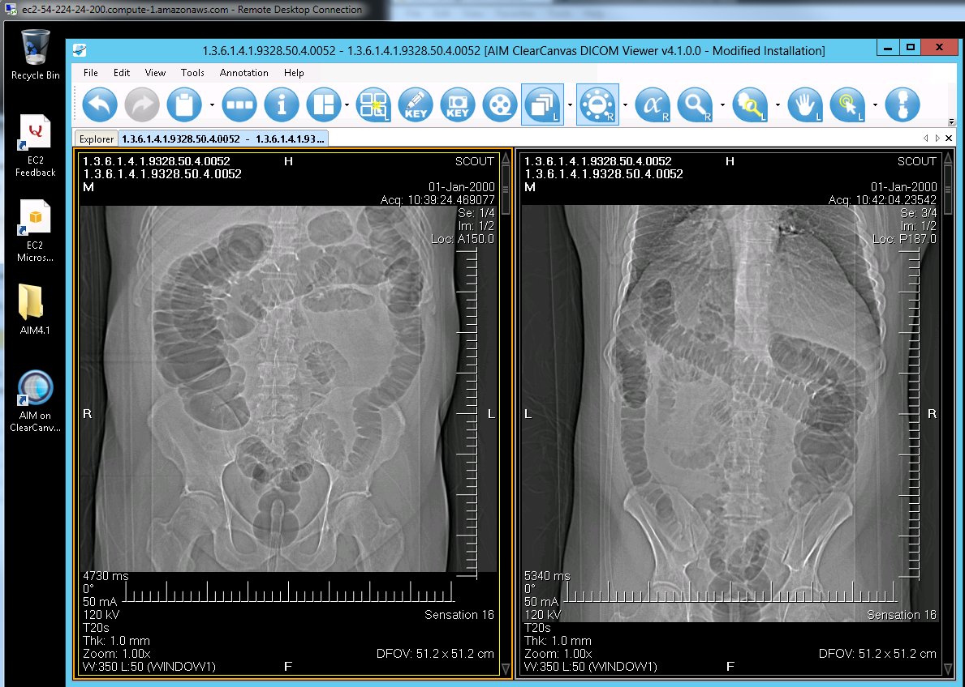

During the third week of October, the AIM team carried out a performance test with a deployed instance of AIM workstation 4.1 on Amazon Cloud. The login information is as follows.
- Use Windows RDP to log in.
  - Server is not running 24x7 and requires startup.
  - http://aws.amazon.com/
    - Pat’s account
  - Address for RDP: ec2-174-129-155-134.compute-1.amazonaws.com (Not permanent)
  - Password: Aimws41#
- Slow performance due to small memory (tiny and free option)
  - Windows 2012 server
  - AIM workstation 4.1 Alpha 4
  - No budget to upgrade to larger virtual machine

During the fourth week of October, the AIM team installed of AIM workstation 4.1 beta 2 on Amazon cloud. The login information is as follows.
- Use Windows RDP to log in.
  - Server is not running 24x7 and requires startup.
  - http://aws.amazon.com/
    - Pat’s account
  - Address for RDP: ec2-54-234-56-29.compute-1.amazonaws.com (currently running)
  - Password: Aimws41##
- Acceptable performance on tiny deployment environment
  - Windows 2008 server
  - AIM workstation 4.1 beta 2
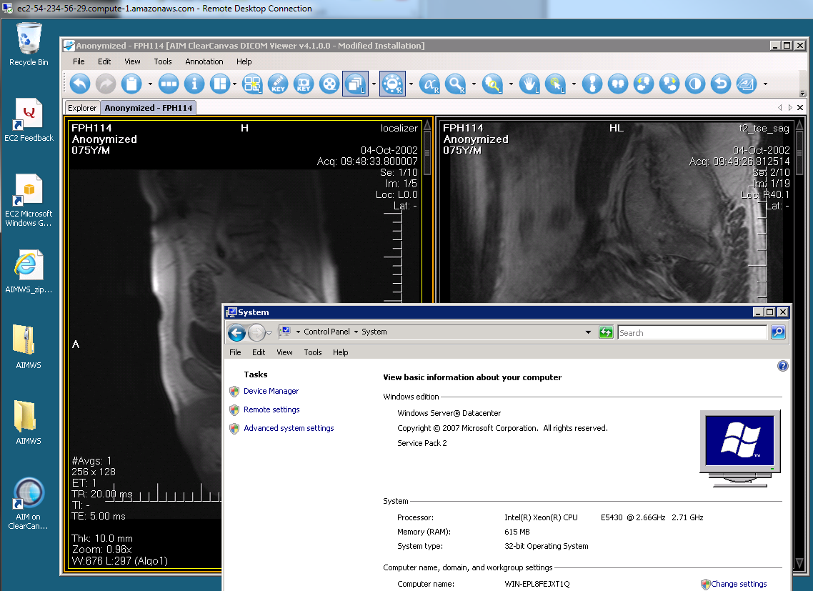

Extending AIM
The AIM team submitted the document to Dr. Daniel Rubin, Ulli, Jonathan, and Ed for reviewing and commenting. The team received the document back from Dr. Rubin with minor modification requests. The team reviewed the document and modified the document as needed. The team is waiting for comments from Ulli, Jonathan, and Ed.

DICOM Segmentation
The AIM team and David Clunie worked on the following issues during the first week of October.
- Worked on a polygon being turned into a pixel image segmentation. The first shows a continuous polygonal ROI that was drawn and labeled "Seg1". This ROI was selected from the Segmentation Name dropdown list. After the user clicks Create Segmentation, the polygon vector graphic converts to pixels as a grayscale image overlay and the original graphic is deleted. This is just a quick test of creating the segmentation image from a graphic.
- There is quite a bit of work to do to clean up the graphics class and add features such as opacity. After we complete that, we'll add the checks for the conditions to create a new segmentation object and the reading of the segmentation properties configuration file. We can then read and write the DICOM segmentation objects.
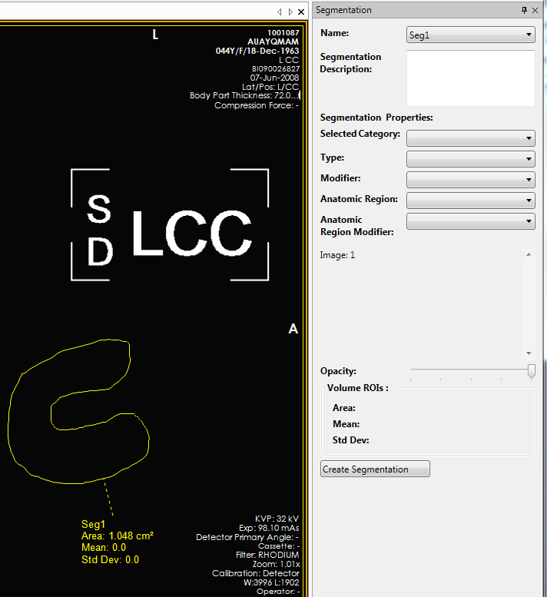

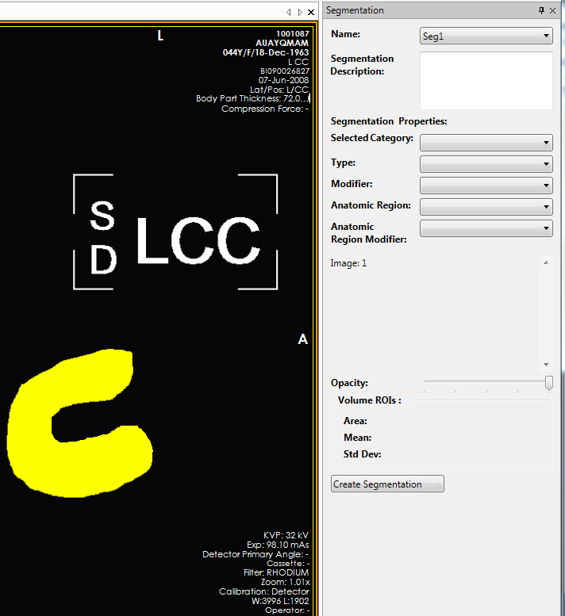
- Discussion about color conversions from CIE PCS to sRGB
  - Challenging test segmentation objects from Brain Atlas
During the second week of October, the AIM team worked on the following issues.
- Reviewed DICOM segmentation objects sent by David
- Exchanged e-mails with David about CIELab to RGB color conversion code
- David will be on vacation between 10/24 – 11/22.
- Working on adding the CIELab to RGB color conversion.
- Working on XML schema to provide DICOM segmentation options while creating a segmentation
During the third week of October, the AIM team continued worked on the following issues.
- Continue working on AIMWS-205 tasks
- Included the selection of the last created ROI object and differentiation between ROIs and segmentation in the UI.
- Added support for creating segmentation images with partial opacity. Additional work is needed to make the opacity dynamically change (need to contact Jasper for help on this issue).
- Exchanged e-mails about telephone conference on Oct. 15th.
During the fourth week of October, David and the AIM team worked on the following issues. See the figure below.
- Telephone conference with David
- David provided DICOM segmentation example along with images.
- Asked David to provide an statistical calculation example.
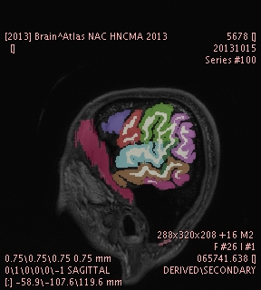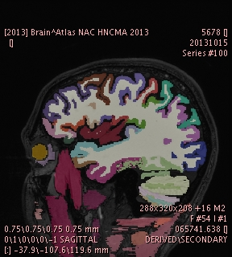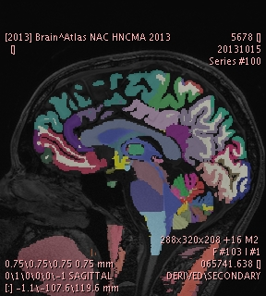

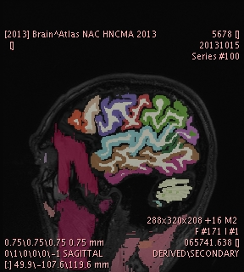
- A CIE Lab to RGB color converter was added. The lab value will be stored in the DICOM object and the RGB value will be used by the workstation to render the graphics. The workstation will now convert between these values.
- A configuration page was added to the workstation settings to configure various settings for creating segmentations.
  - These options include whether to display confirmation prompts and the locations of configuration files used for selecting categories, types, and modifiers which describe the segmentation objects.
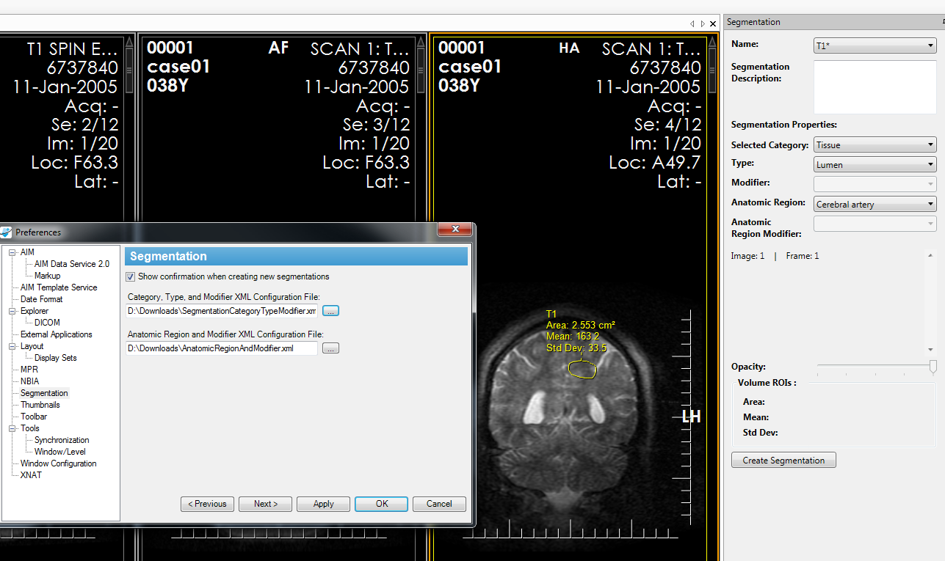
- Calculation of Volume ROIs will be added next as well as a few more UI changes including the addition of a context menu for segmentation selection.
- Then support for creating DICOM segmentations within the workstation will be added, as well as support for reading and displaying existing DICOM segmentations.

Description of Work Completed During the Month

External Meetings
Date | Topic | Project Attendees (Optional)
October 2013 | JIRA issues (addition and updates) | Pat, Vlad, Skip
October 2013 | Weekly telephone conference  - Continued weekly report  - Sent weekly report for 10/8 and 10/15. No telephone conference during these two weeks because of government shutdown  - Ed approved the release of AIM workstation 4.0 10/29/13 | Ed Helton, Jonathan Lin, Ulli Wagner, Hemant Undale, Tin, Vlad, Skip, Pat
October 2013 | Worked with SAIC-F project managers  - Submitted AIM governance document for a review and comment  - Submitted extending AIM model document for review  - AIM 4.0.0.0 workstation approved for public release  - Worked with Alex, Michael, and Heidi about invoices  - Provided potential costs associated in the event a stop work order is issued to be provided by Michael and Heidi  - Moved weekly telephone conference to Thursday at 10am  - Reviewed release announcement for AIM on ClearCanvas Workstation 4.0  - Sent Ulli PowerPoint presentation for AIM project update | Ulli, Alex Konev, Vlad, Skip, Heidi Maes, Preston Wood, and Pat
October 2013 | Worked with QA team at SAIC-F on the following.  - Worked on fixing AIM 4.1 workstation  - Submitted AIM WS 4.1 alpha 2-4, beta 1 for review  - Exchanged e-mail about AIMWS-206, https://tracker.nci.nih.gov/browse/AIMWS-206  - Clarified questions about JIRA issues AIM-122, AIM-126, AIM-127. and AIM-129  - Vlad added replies for JIRA issues AIM-122, AIM-126, AIM-127. and AIM-129 and sent an e-mail to notify Tin  - Closed AIM issues: AIM-117, AIM-120, AIM-122, AIM-127, AIM-126, AIM-128, AIM-129, AIM-130, AIMWS-208, AIMWS-209, AIMWS-210, AIMWS-211, AIMWS-212  - Exchanged e-mail with Tin about AIM 4.1 features for testing purposes  - Bug fixed AIMWS-215, 217, 218 reported by Tin  - Worked with Tin how to view AIM annotation content. In order to do so, an AIM annotation must have a markup and the markup must be selected.  - Received 2nd ATS 1.1 AppScan from Tin on 10/22/13  - Worked on AIM CMake instructions for Windows, Linux and Mac OS X  - Sent AIM WS 4.1 beta 3 for QA | Tin, Vlad, Skip, and Pat
October 2013 | Worked with Carolyn Klinger on the following.  - Continued to update AIM wiki.  - Weekly reports on wiki  - https://wiki.nci.nih.gov/x/AoSYCQ  - Monthly report on wiki  - https://wiki.nci.nih.gov/x/goB8C  - Released AIM workstation 4.0 for public use  - Workstation 4.1  - 4.1 User’s Guide: https://wiki.nci.nih.gov/x/XgiGCQ  - 4.1 Release Notes container page: https://wiki.nci.nih.gov/x/poF4B  - 4.1 Release Notes content to include when ready to publish: https://wiki.nci.nih.gov/x/WQiGCQ  - Worked on AIM Toolkit 4.1 release notes page  - Ulli reported a broken AIM link (URL) to Carolyn.  - Carolyn reviewed AIM paper for JDI | Carolyn Klinger, Ulli Wagner, and Pat
October 2013 | Worked with Gregory Sharp on CMake  - Telephone conferences  - Exchanged e-mails about features required on Windows, Linux, and Mac OS X.  - Worked on CMake documentation for Windows, Linux, and Mac OS X. | Gregory Sharp, Vlad Kleper, Pat
October 2013 | Worked with University College Hospital, Ibadan, Nigeria  - AIM template for proforma stroke | Mayowa Ojo Owolabi, Issa Kehinde, Pat
October 2013 | DICOM Segmentation  - Telephone conferences with David and ClearCanvas team  - Reviewed and updated requirements documents and DICOM segmentation objects  - Exchanged e-mails with David about CIELab to RGB color conversion code  - Challenging test segmentation objects from Brain Atlas  - Scheduled telephone conference for Oct. 15th.  - Sent meeting agenda about DICOM segmentation implementation  - David provided sample images and DICOM segmentation  - Exchanged e-mails about test cases for DICOM segmentation  - Question about non-coplanar and DICOM segmentation. | David Clunie, Vlad, Skip, ClearCanvas team, and Pat
October 2013 | Work with NBIA team  - Continued to participate in NBIA user interface and API improvements telephone conference and e-mail exchanges. | Pan Qinyan, Vlad, Skip, and Pat
October 2013 | Worked with Justin Kirby and John Freymann(CIP)  - E-mail exchanged and worked on AIM 4.1 installation on Amazon E2C and telephone conference  - Asked Justin to test AIM 4.1 on E2C and Windows Server 2012  - Asked Justin to test the workstation 4.1 on E2C with Windows 2012  - Installed AIM 4.1 beta 2 on E2C with Windows 2008 and asked Justin to test the workstation  - Justin reported AIMWS-129 | Justin Kirby, John Freymann, Vlad, Skip, and Pat
October 2013 | Consultation and Collaboration  - Telephone conference with Daniel about AIM 4.x and ATB  - Sent Extending AIM document for Daniel to review  - Received a review of AIM extension document back from Daniel. | Daniel Rubin, Vlad, and Pat
October 2013 | Worked with ClearCanvas  - Exchanged e-mails related to code upgrade and DICOM segmentation implementation.  - Telephone conferences with Jasper Yeh. | Jasper, Vlad, Skip, and Pat
October 2013 | Worked with Drs. Butman and Pham Center for Neuroscience and Regenerative Medicine  - Exchanged e-mails related to AIM workstation features  - Demonstrated workstation features via desktop sharing  - The AIM team had a telephone conference with Drs. Butman and Pham about workstation features. | John Butman, Dzung Pham, Vlad, Skip, and Pat
October 2013 | Worked University College Hospital  - Exchanged e-mails related to usage of AIM workstation  - Provided an advice on AIM template for imaging stroke  - Provided an advice how to convert AIM XML to Excel | Mayowa Ojo Owalabi, Issa Kehinde, and Pat

Project Progress
Activity | Description
NCI’s JIRA | Continue updating:  - AIM Enterprise Service (ATB & ATS), https://tracker.nci.nih.gov/browse/AIMES  - AIM Model, https://tracker.nci.nih.gov/browse/AIMWS  - AIM Workstation, https://tracker.nci.nih.gov/browse/AIM
Software upload to SFTP | - Upload software products to NCI’s SFTP

Status of Milestones
Milestone | Delivery Date | Status
AIM 4.0 workstation | September 2013 | Released Oct 2013

Work Planned for Next Month
Activity | Description
AIM library 4.1 with CMake | Delivered a beta version for QA and release the library
AIM 4.1 workstation | Delivered a beta version for QA and release the workstation
AIM DICOM Segmentation Support | In progress
ATS AppScan update | In progress

Travel Planned for Next Month
Attendees | Travel Purpose | Description
Not applicable

Issue Management
No issues at this time.

Risk Management
ID | Description | Owner | Potential Impact | Priority (H, M, L) | Status (Open, Closed)
1 | NBIA and caGRID 1.4 test | NCIP | Software development may not be fully working with the new NBIA and caGRID 1.4. | H | Done

External Dependencies
Dependency | Date | Status | Comments

Status of Deliverables
See MS Project.

