BDA Dashboard & Home Page
BDA Statistics
- Total Projects = 27
- Fully BDA Certified Projects (As of 07/02/10) = 12
- Projects Shy of 2 or Lesser Indicators (As of 07/02/10) = 1
- Current Projects under Progress = 2 (caNano, caB2B)
- Future Potential Projects (beginning 3rd quarter) = caTissue
Release Schedule
Release 1.7 (End of July)
- Tomcat DAC Support: An ability to create a new Tomcat installation to minimize trouble shooting time for teams.
- Enhance Property Validation: An automated capability for teams to enter/validate required properties for a specific setup in correct order.
Release 1.8 (End of October)
- Enhance GUI Installer: An ability for project teams to configure properties via GUI vs. command line.
Template Integration Testing

BDA News & Updates
- Starting July 1st, 2010, BDA team will only provide support for R1.6, R1.5, R1.4, and R1.3. The BDA team will assist you in moving to the supported versions.
- The next BDA Brown Bag session, “Release 1.7 Features” is scheduled for July 30th.
BDA Dashboard
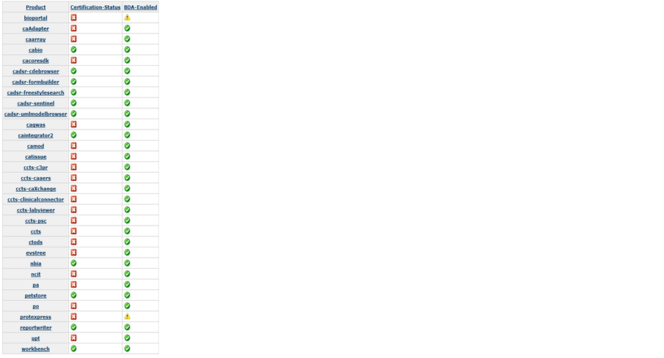
Last BDA Certified
06/27/10
Last Action Taken
06/27/10, ( Email to PM, COTR, & PO)
BDA Diagnostics
Incorrect Properties File

