System and Software Test Report

Build and Deployment Automation

29XS218 TO 07

1/7/2011

Background

Automated tests were developed by the BDA team and were incorporated into the continuous delivery model employed by the team. The two large components of the BDA solution, the BDA Framework and the BDA Dashboard, are themselves built and delivered using continuous delivery practices and both have automated test suites incorporated into their respective models.

To the best of our knowledge, no independent testers or quality assurance team ever reviewed, contributed, or executes their own testing on the BDA work products.

The test suites limit themselves to unit and functional testing. While it might be worthy to implement automated usage tests

Test Source

Test source (code, data, etc.) is maintained in an SVN repository and can be found here:

BDA Framework:

https://ncisvn.nci.nih.gov/svn/automation/trunk/software

BDA Dashboard:

http://gforge.nci.nih.gov/svnroot/automation/branches/bda-dashboard-1.0.1/software/src/test

Test Execution

Both test suites were executed via a Hudson continuous integration servers.

The BDA Framework’s test suite is continually being run on Stelligent-hosted Huson continuous integration server. The NCI is encouraged to establish their own continuous integration server, and to employ the same tests. We believe the level of testing performed on the BDA framework represents an ideal that all development teams at NCI should be striving to achieve.

Readers are encouraged to navigate to the test server and read the live system and software test report that is generated as a by-product of the automated testing:

http://deploy.stelligent.com:48080/hudson/view/nci/job/bda-build-template-tests/

In September of 2010, on request of the NCI CBIIT, the BDA Dashboard was retired. It has not been maintained since that time. Its test suite, however, is still capable of bring run, but in the interest of resource management, has been shut down.

Test Results

The BDA Framework is continuously being tested. The latest report of status of the testing can be viewed here:

http://deploy.stelligent.com:48080/hudson/view/nci/job/bda-build-template-tests/

Here is a representative screenshot of the main test page:

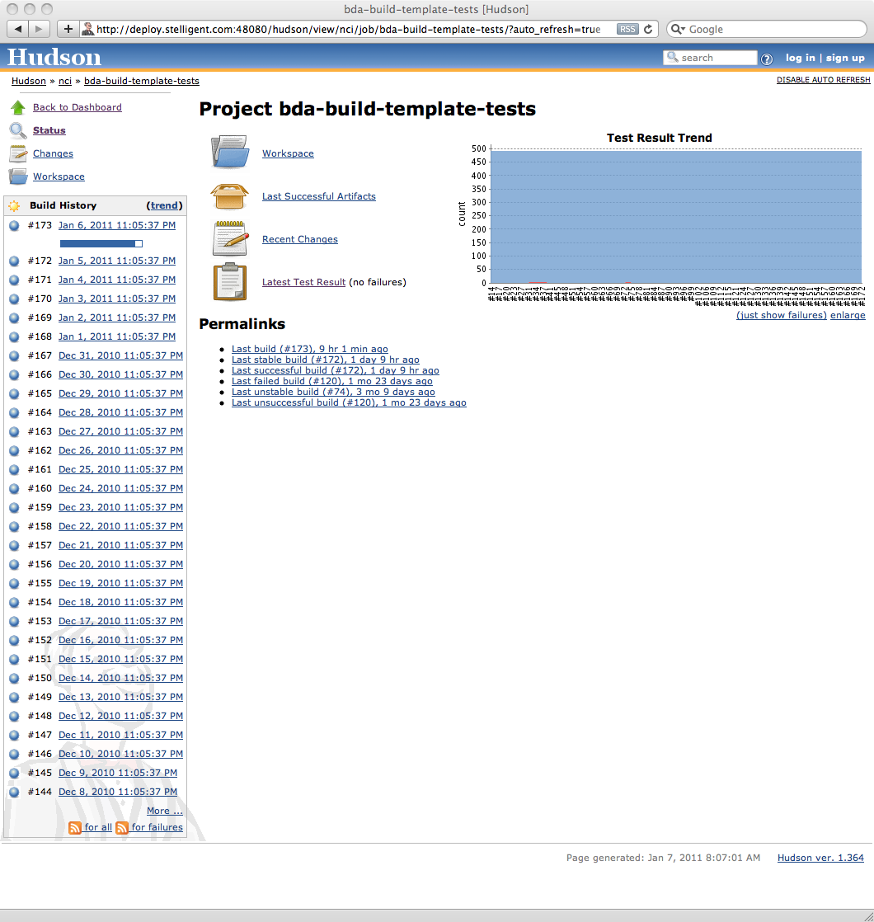
Figure 1 - Representative screenshot of continuous testing platofrm for the BDA Framework. Tests run automatically as part of its continuous delivery model.

Navigating into the latest test results section, one finds the tests grouped according to similar test cases (e.g., test cases that test passing conditions, or test cases that test exceptional/fail conditions). The next figure illustrates that page:

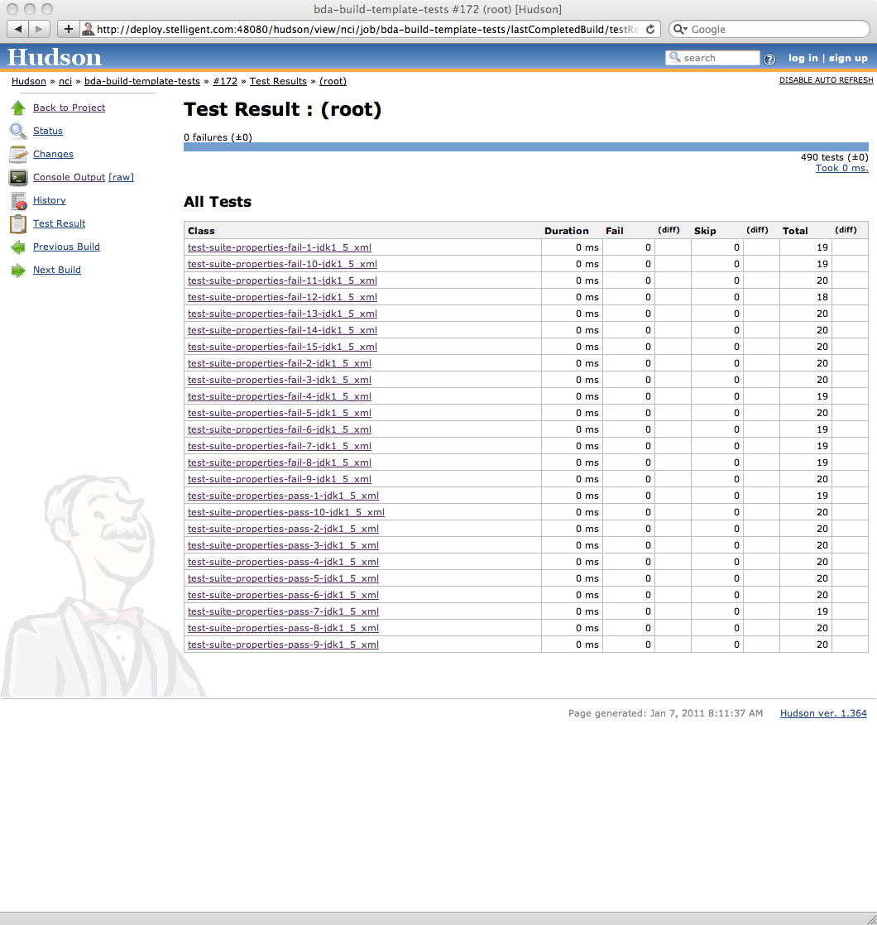
Figure 2 - Summary page of latest test results.

Delving further, one can navigate into any one of the class of tests to see the actual test cases that were executed in that class, as well as their execution status.

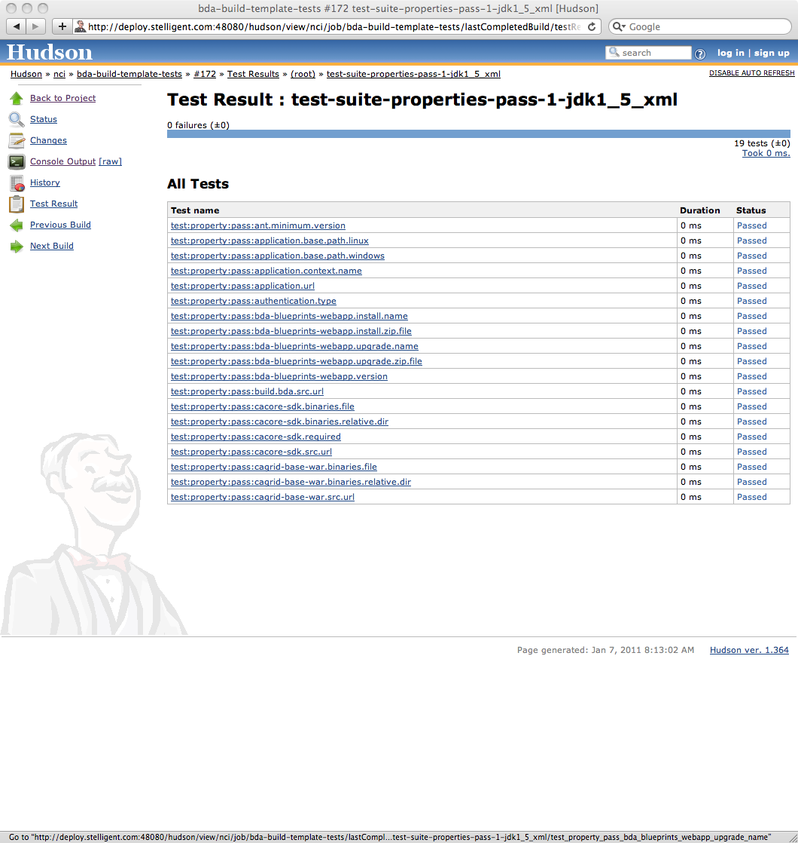
Figure 3 - Representative screen illustrating a collection of test cases and their most recent execution status.

Finally, one can examine the actual test console log for any given test case that executed.

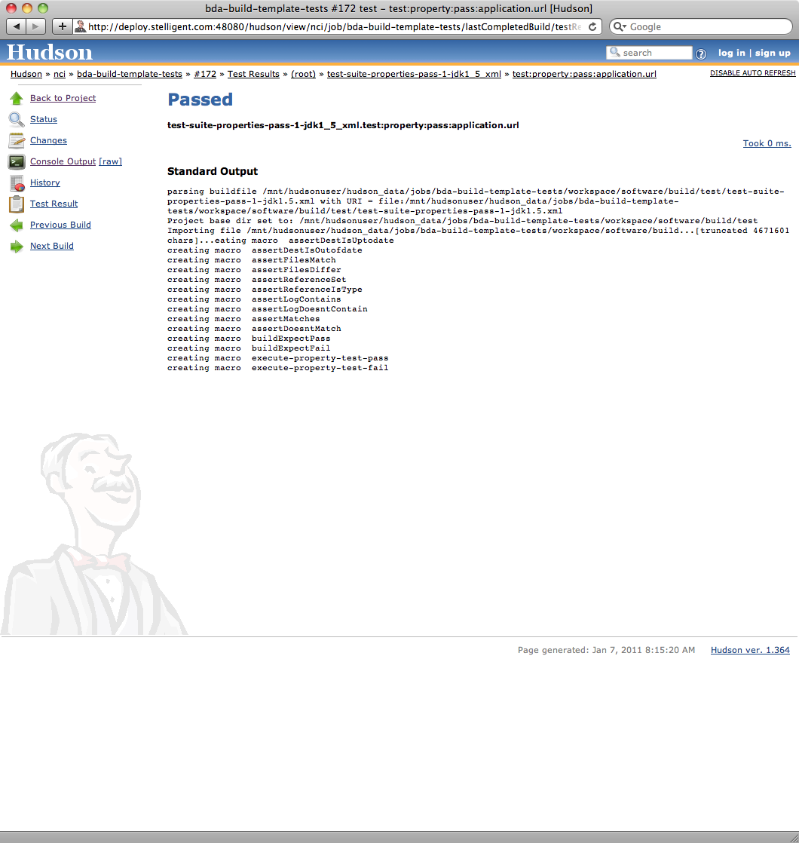
Figure 4 - Representative test console log for a completed test case execution.

Summary

This document, like so many other deliverables for the BDA project, represents an overview of the real deliverable desired: a test suite that completely tests the work product, and that can be run over and over again without involving people or consuming their time until needed (i.e., in the case of a test suite, only when tests fail).

At the time of this test report’s writing, the continuous test server was reporting the following:

- Last build (#173), 9 hr 13 min ago
- Last stable build (#173), 9 hr 13 min ago
- Last successful build (#173), 9 hr 13 min ago
- Last failed build (#120), 1 mo 23 days ago
- Last unstable build (#74), 3 mo 9 days ago
- Last unsuccessful build (#120), 1 mo 23 days ago

Readers are encouraged to navigate to, and read through all test results for themselves:

http://deploy.stelligent.com:48080/hudson/view/nci/job/bda-build-template-tests/

