NCI CBIIT
Knowledge Center Code Management Process
Draft - For Review by Subversion Task Force
9/16/2008

Introduction
The purpose of this document is to provide a starting point for a process for managing feature and bug fix contributions from the caBIG Knowledge Centers (KC) within the context of an actively developed product.
For any process to be successful there must be a clear understanding of the roles and responsibilities of everyone involved and the clear boundaries within which they must operate. A successful process must be repeatable, transparent and flexible to evolve to meet the needs of caBIG, CBIIT and NCI.
This document is divided into two major parts – the first part deals with the overall process of delivering changes from the Knowledge Centers from a Product Management perspective and the second part delves into the details of managing the development process using various SCM tools and technologies from a software development perspective.
Figure 1 below summarizes the overall flow of information toward building a unified KC process view.
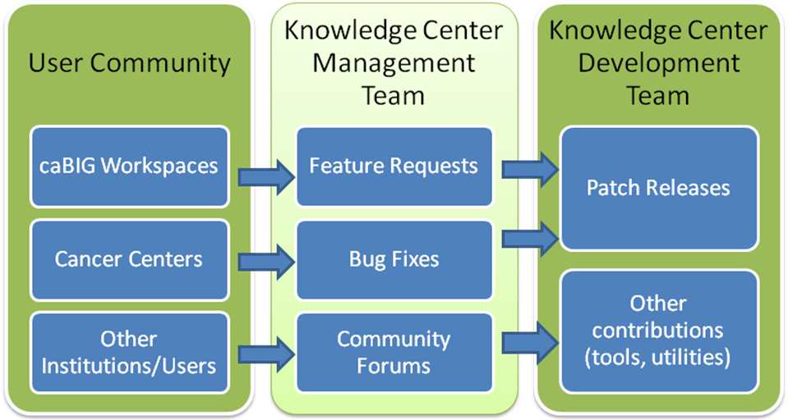
Figure 1 caBIG KC Components

Terms and Definitions
The following terms are used throughout this document. The readers should familiarize themselves with these terms to extract maximum benefit from this document
SCM: Software Configuration Management – management of change in code repositories.
SVN: Subversion – A version control system – used to maintain current and historical versions of files.
CVS: Concurrent Versioning System – Another version control system

PART I – Product Management Perspective

KC Stakeholders and their Responsibilities
User Community: The User Community (Cancer Centers, caBIG Workspace, Product Users) provides the key input to the KC regarding new feature requests, urgent bug fixes, etc.
Knowledge Center Management Team: This team provides the steering and prioritization function to the KC development teams. This team consists of the KC Program Manager and the Product Managers for each of products under the respective KCs. Interrelated product managers (e.g. LSD, caIntegrator, etc.) may also be included in this team.
KC Development Team: The KC development team works in close coordination with the KC Management team to schedule releases, provide support, test features. The lead for each KC communicates project progress to KC management on a regular basis and provides updates on schedules and deliverables. For the purpose of this document, the KC Development team is considered a separate entity from the primary product development team (if the product is under active development).

The Product Management Process
For the purpose of this document, the following key roles and responsibilities are defined as:
KC Program Manager: The KC Program Manager is responsible for the overall management of the Knowledge Centers. They may assign designees to perform day to day management and scheduling functions.
Product Manager: Each product (e.g. caArray, NCIA, caTissue, etc.) under the KCs must have an NCI CBIIT assigned product manager responsible for oversight of KC source contribution alignment with the active product development. The product manager works closely with the KC Program Manager to prioritize, schedule and deliver/accept changes from the KCs into the mainstream product development cycle.
The following are the key steps involved in the product management process within each KC:
- A Change request(s) or bug fix(es) is/are identified for a certain product
- KC Program Manager (KC PM) reviews change request and accepts it for submission to KCs
- KC PM assigns change request to NCICBIIT Product Manager for review.
- CBIIT Product Mgr reviews change request and approves. Depending upon the scope of the change request, the CBIIT Product Manager may decide to decline the change request (complexity of change and duplicity of effort may be some of the reasons for this). A declined change request is closed in the KC change management system with an appropriate reasoning.
- CBIIT PM assigns Release Manager (see Part II below for details on Release Management Process)
- Product teams Release Manager creates Branch in SVN repository (To Do: Branch Naming Convention)
- KC Works on Branch to deliver changes to support a.
- KC PM lets Release Mgr know when work has been completed.
- Release Manager inspects changes and accepts (merges) to trunk.
- Product Manager informs KC PM of accepted/rejected status of changes.
Figure 2 below summarizes this process.

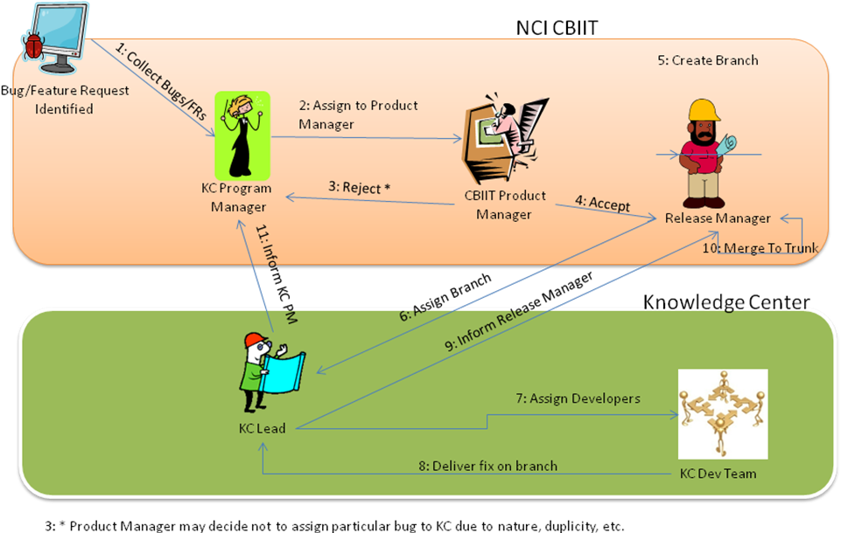
Figure 2 Knowledge Center Product Management Process

PART II – The Software Development Perspective

Goals
- Consistent, easy-to-use process for making changes in parallel
- Single SVN project repository for existing projects hosted at CBIIT
- Merge back to trunk often

Recommendations
- Discover any merge conflicts at least once a day
- Run Continuous Integration on trunk and branches
- Use automation to make tagging, branching and entire process less error-prone and more efficient

Development Process Perspective
There are three flavors of development covered in this process: Mainline, Branches and New Products/Utilities. Mainline (trunk) development is typically used by development teams for Major or Minor releases of the software product. Every release from such development generates an SVN tag.
Branch development is always based upon an SVN tag. Often, branches are created when making a modification to code and the developers do not wish to disrupt mainline (trunk) development. These are usually bug fixes and may sometimes include emergency patches and minor feature enhancements.
New Product development is when new functionality is provided for a specific need. A typical scenario for new development may be when Knowledge Centers create solutions for specific cancer centers that are not a part of the overall software product. In this case, developers may interface with the product's API (i.e. client JAR file) only. Other examples may include support for new data types - e.g. support for a new imaging modality in NCIA or support of a new microarray platform in caArray, etc. For the purpose of this document, New Product development is out of scope for the Knowledge Centers.

Source Code Recommendation
The following recommendations are being made at this time to allow for multiple development teams to work on the product simultaneously.
- Products initiated and funded by caBIG/CBIIT need to migrate their code base to the KC provided subversion.
  - All subsequent development (mainline and branch – see below for details) must take place on this subversion.
  - Bugs/Feature requests for these products must be handled via the bugzilla and the KC tech stack.
  - The following products fall under this category:
Tissue/Biospecimen Banking and Technology Tools: caTissue Core, caTissue Suite, caTIES Molecular Analysis Tools: caIntegrator Clinical Trials Management System: Cancer Center Participant Registry (C3PR),Cancer Adverse Events Reporting System (caAERS), Patient Study Calendar (PSC),caXchange, Labviewer, C3D Connector
- Products initiated and funded by caBIG/CBIIT that are already under CBIIT SVN will remain there. KC software development on these products will happen on branches of that products mainline. The following products fall under that category:
Tissue/Biospecimen Banking and Technology Tools: N/A
Molecular Analysis Tools: caArray
Clinical Trials Management System: CTODS

- Products that existed before caBIG/CBIIT provided funding need to provide a snapshot of their repository (the latest stable version) for hosting at CBIIT.
  - The KC’s must build and deploy the product successfully from this snapshot.
  - Subsequent open development should happen on branches of this main line.
  - If the product is under active development at other location, manual merges may be needed (by creating SVN patches) to move features/bugs back and forth.
  - The following products fall under this category:
Tissue/Biospecimen Banking and Technology Tools: N/A
Molecular Analysis Tools:geWorkbench, GenePattern
Clinical Trials Management System:
Vocabulary: LexBIG, Protégé

SVN Migration Plan
- If your repository is in CVS, use the cvs2svn utility. It can be downloaded at http://cvs2svn.tigris.org/. If your repository is already in Subversion, you can skip this step.
- Log into the machine where the Subversion server is hosted. On this machine, you will create a Subversion dump file. The example below demonstrates creating a dump file by passing in the location of the Subversion repository . The actual path could be different in your environment.

svnadmin dump /usr/local/svn/repos

- Send the dump file to the SCM team at CBIIT, by attaching the dump file to an email message sent to ncicb@pop.nci.nih.gov

Mainline (Trunk)
Assumption: Teams that have scheduled major/minor releases will apply changes to the mainline (SVN trunk). Knowledge Centers will not perform Mainline (Trunk) development if another designated team is also working on the product on behalf of CBIIT. If a product is not under active development, KC’s may perform development on the trunk. The steps below are illustrated in Figure X.
- The project's Release Manager determines the features that will be a part of the next major/minor release and specifies these features in GForge/Bugzilla .
- Developers commit all code to the mainline (SVN trunk)
- (Optional) The Release Manager configures a Hudson job to poll SVN trunk and run an integration build
- When the development team is ready to release, the Release Manager creates an SVN tag based on the trunk
- When the development team is ready to release (e.g. after several weeks), the Release Manager promotes the software into production. For recommended approaches, see the Build Promotion Checklist (https://wiki.nci.nih.gov/x/yqB8).
Figure 3 below summarizes this process.

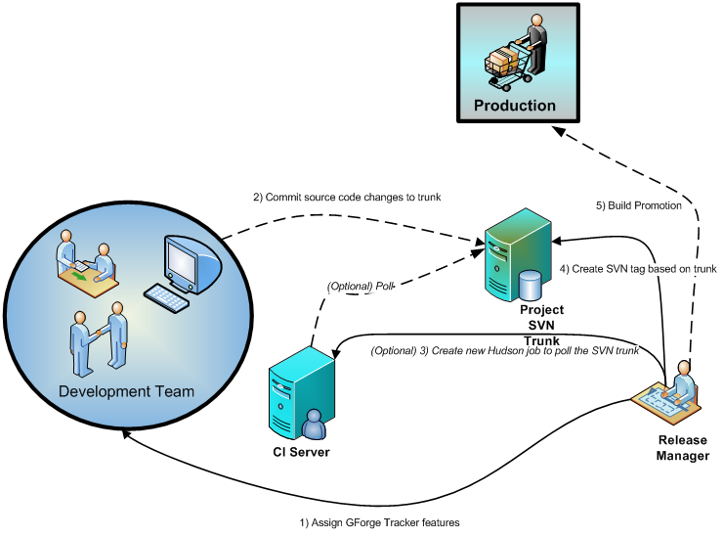
Figure 3 Mainline Development

Branches
A new branch will be created for every new version outside the mainline (SVN trunk). A new version could be an emergency patch, set of features/bugs that a KC might have been assigned. Here's a scenario of applying a change (such as fixing a group of defects). The release manager will often be creating branches based on the latest release tag designated for a specific KC.
Example: A KC development team spends five days fixing defects for a set of items assigned to them.
- A KC developer is assigned trackers in GForge/Bugzilla.
- The CBIIT development team's Release Manager creates a branch based on the latest production release SVN tag.
- (Optional) The CBIIT development team's Release Manager configures a new Hudson (CI server) job to poll the newly created SVN branch.
- Developer(s) merge changes to the trunk (without committing). (Optional: Configure a CI job to execute against the product’s release tag). It’s recommended teams test merges often (such as once a day).
- When the Knowledge Center development team is ready to release, the Release Manager merges and commits changes from the branch to the trunk.
- When the Knowledge Center development team is ready to release, the Release Manager creates an SVN tag based on the branch.
- When the development team has completed changes (e.g. after the five days), the Release Manager promote the software into production. For an example, see the Build Promotion Checklist (https://wiki.nci.nih.gov/x/yqB8).
Note: Creating branches shouldn't be used as a technique for managing product variations (e.g. cancer-center specific code). All code should have a path back to the product's mainline
Figure 4 below summarizes this process.
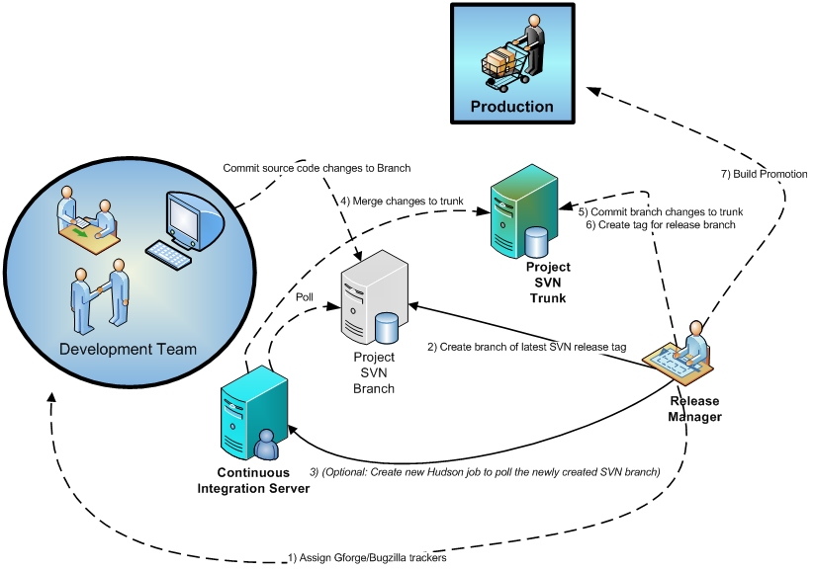
Figure 4 Branch Development

Community Development
Because of the Open Development Initiative, anyone can anonymously access any of the source code repositories at CBIIT. Developers from the community that do not have access to the CBIIT source code repository can submit changes by providing a “diff” of the changes. After a CBIIT developer (Knowledge Center or other) review these changes based on established project procedures for security, code quality, etc., the changes are committed to the CBIIT Subversion repository.

Additional Recommendations
The following are guidelines and recommendations for successful implementation of parallel development. Individual project managers will provide specific guidance on project policies.

Recommendation | Description
Assign Release Manager role | Create a new Release Manager role per project - caArray, caIntegrator, NCIA, etc.
CI VM per project | Each project team (e.g. caArray, caIntegrator, etc.) should have a Continuous Integration Virtual Machine (CI VM) provisioned that runs an integration build with every change applied to trunk and branches. One Hudson CI server per project running multiple jobs. A [CI VM can be requested https://wiki.nci.nih.gov/x/VAGU] from the CBIIT Systems team. A Hudson job should be configured for:  - SVN trunk for project  - Each SVN branch per project
Branches per patch | An SVN branch should be created anytime a team is working on a patch
Branches should always use an SVN tag | Branches should never be based off the mainline (trunk) – only a release tag
Commit ALL source files to trunk/branch every day | All developers should be committing ALL source files to trunk/branch at least once a day
Configure CI job to merge branch against trunk daily | One of the CI jobs should merge a particular branch with the trunk once a day, without committing code against the trunk (to resolve merging issues early in the process)
Centralized SVN repository | All developers should be working from the same CBIIT Subversion repository for a particular development project
SVN tag per release | At a minimum, create a new SVN tag for every new release (major, minor or patch)

