November 2008
National Cancer Institute | Build and Deployment Automation Team


NCI/CBIIT | [Build and deployment automation – Roadmap and implementation plan]

Rollout Plan
- Two 2-3 hour training sessions with the rest of the development teams
- Screencasts for every step from development to production
- Email to all CBIIT teams about vision and plan
  - Set June 2009 deadline
- Wiki updates: complete working guide for BDA (from Development to Production)
- AntHill Pro 3 management
- BDA Productivity Tools
  - BDA Archetype
- Auditing and Governance (monthly basis)
  - The Matrix
  - Automated and Manual Analysis
  - Deliver one-page report on ALL BDA projects to Director of Application Engineering

TODO
- Create diagram of rollout plan, schedule
- CBIIT Ready to Release Index
  - Code Quality
  - Security

Ongoing
- Answering questions from development, QA, Systems, etc.
- Helping development teams implement BDA features
- Regular (monthly) releases of BDA Utils (Common Ant macros that all development teams use)

BDA Architecture
- https://wiki.nci.nih.gov/x/GAKy
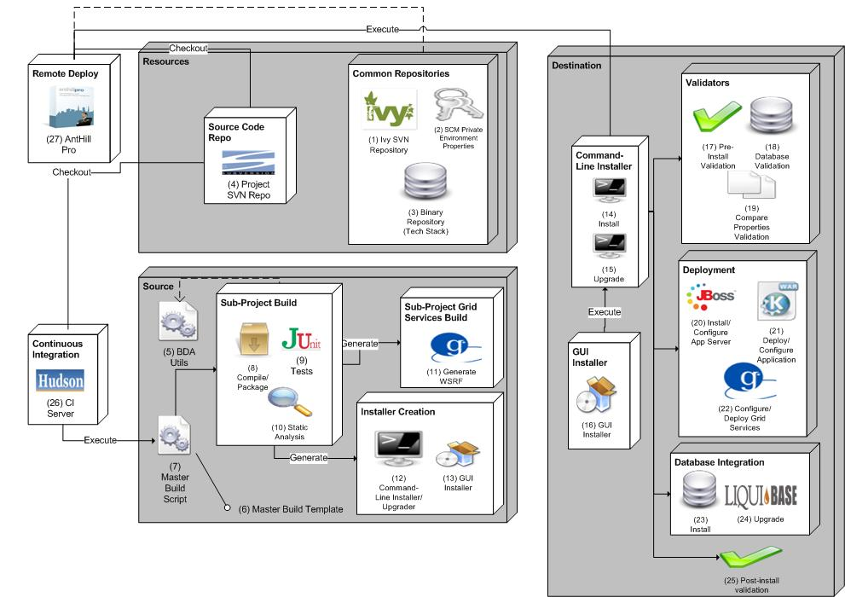

Special Projects
- See Current Projects: https://wiki.nci.nih.gov/x/-7Ol
- Deployment Request Tracker (DRT)
- Disposable Application Containers
- GForge to JIRA migration
- Security checklist
- Coding standards checklist
- SVN migration
- LSD installation support
  - Four new products in 1.2
- Securing JBoss
- SVN support (hooks, etc.)

Wiki Updates
BDA Team will update the NCI wiki

Communication
Director of Application Engineering at CBIIT will send an email to (and perhaps meet with) development, QA, product manager and Systems teams informing them of the new BDA mandate. All new projects must become BDA-certified within the first three months of their project. All active CBIIT projects must become BDA Certified by June 2009. These active projects must submit a project plan to Application Engineering director for implementing the BDA features (NOTE: BDA team should develop a Microsoft Project template for teams)

Training
The BDA team will conduct two, two-hour training sessions for each development team to cover all aspects of the BDA’s “rules and tools” for successfully deploying software in any CBIIT environment. We’ll also have an open session for any development teams once every two weeks.

Additional Training
- Specific guidance on Database Integration and Upgrades (using BDA and Liquibase)
- Using Ivy for Dependency Management

Screencasts

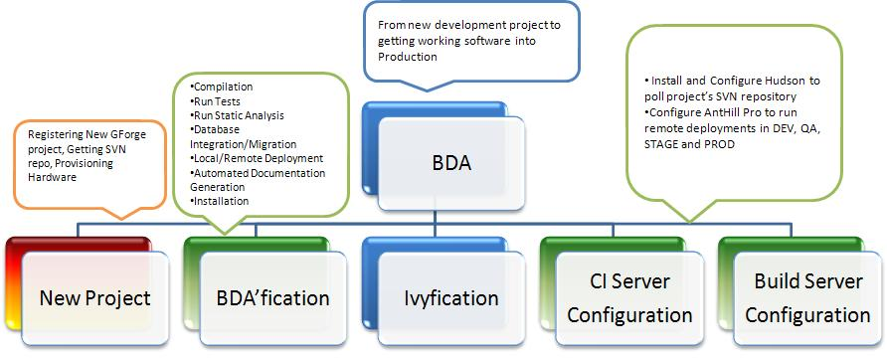

The BDA Team will be developing screencasts for development teams to view. The screencasts will walk them through each step in creating a BDA-certified development and deployment environment capable of promoting from DEV to QA to STAGE in less than two hours. A draft script is being maintained at https://wiki.nci.nih.gov/x/_Q6Z and https://wiki.nci.nih.gov/x/GQqZ. At a high-level, the screencasts will cover:
- Creating a new project at CBIIT
  - Requesting a GForge project
  - Using Deployment Request Tracker System
    - Architectural Requirements Checklist
    - Build Promotion
  - Other Systems requests
- Automating build and deployment using BDA scripts/configuration
  - Compilation/Packaging
  - Database Integration/Upgrades
  - Testing
  - Static Analysis
  - Remote Deployment
  - Installers
  - Developer Documentation
- Using Ivy for dependency management
- Configuring a Continuous Integration environment
  - Requesting CI virtual machine from Systems team
  - Configuring Hudson CI server and jobs
- Performing Build Management
  - Configuring AntHill Pro
  - Creating DEV, QA, etc. tracks to run builds

Schedule
Proposed schedule for the training sessions the BDA team will deliver to development teams along with the proposed completion date when development teams must be BDA certified. Time prior to this will be spent on fleshing out (and clarifying) content on the Wiki, creating script and screencasts and BDA special projects.

Project | Training | BDA Certification Date
Firebird | January 5, 2009 | April 30, 2009
caNanoLab | January 8, 2009 | April 30, 2009
Firebird | January 12, 2009 | April 30, 2009
caNanoLab | January 15, 2009 | April 30, 2009
Rembrandt | January 20, 2009 | April 30, 2009
I-SPY | January 22, 2009 | April 30, 2009
Rembrandt | January 26, 2009 | April 30, 2009
I-SPY | January 29, 2009 | April 30, 2009
caDSR | February 2, 2009 | May 31, 2009
caCore and SDK | February 5, 2009 | May 31, 2009
caDSR | February 9, 2009 | May 31, 2009
caCore and SDK | February 12, 2009 | May 31, 2009
caB2B | February 16, 2009 | May 31, 2009
trWorkbench | February 19, 2009 | May 31, 2009
caB2B | February 23, 2009 | May 31, 2009
trWorkbench | February 26, 2009 | May 31, 2009
caMOD | March 2, 2009 | June 30, 2009
caBIO | March 5, 2009 | June 30, 2009
caMOD | March 9, 2009 | June 30, 2009
caBIO | March 12, 2009 | June 30, 2009
CPAS | March 16, 2009 | June 30, 2009
CDS | March 19, 2009 | June 30, 2009
CPAS | March 23, 2009 | June 30, 2009
CDS | March 26, 2009 | June 30, 2009

Support
- AntHill Pro management
- SCM support
- CI server troubleshooting questions

Certification
- TODO: Checklist for what it means to be certified. See https://wiki.nci.nih.gov/x/jaB8 (Automation Maturity Checklist)
- All projects identified by the Director of Application Engineering (BDA will start with https://wiki.nci.nih.gov/x/KZx8) will be analyzed by the BDA team at least once a month to maintain certification. A report will be provided to the Director of Application Engineering at CBIIT.

Item | Description
TBD | TBD
TBD | TBD
TBD | TBD
TBD | TBD
TBD | TBD
TBD | TBD
TBD | TBD
TBD | TBD

Auditing
The BDA team will be developing scripts that can automatically analyze certain aspects of projects to determine if they are within compliance to the BDA mandate. The BDA team will setup jobs to analyze these projects on a regular interval. These automated scripts will be coupled by an expert manual analysis that the BDA team performs on a monthly basis against all active development projects.

Item | Description
TBD | TBD

Here is a list of BDA Components: https://wiki.nci.nih.gov/x/X7Sl

Steps to BDA
- [Find link for this info]
- Install Java SDK
- Install Ant
- Install Database server (e.g. MySQL)
- Install SVN client
- Download necessary BDA files from https://gforge.nci.nih.gov/frs/download.php/5233/bda-download.zip
- Following proposed directory structure, create directories
- Modify the BDA template for your project
- Request CI VM
- Install and configure Hudson server
- Configure AntHill DEV and QA tracks

Checkpoints
- After each step, provide a way for a developer to verify they’ve performed the step correctly

Other BDA team projects
- Deployment Request Tracking System
- Securing JBoss web containers
- Disposable Application containers
- See list of current BDA projects here: https://wiki.nci.nih.gov/x/-7Ol

